EEE241L Multisim Assignment
Electrical Circuits II Lab
Name: |  | Student ID:
Section: | EEE241L.4 | Date: | 8/9/2026

Objective
To simulate inductive and capacitive load circuits in NI Multisim, measure peak voltages and time differences using an oscilloscope, and calculate load current, phase angle, and power drawn by the load.

General Instructions
- Recreate each circuit exactly as shown in the given schematic.
- Use the AC source values shown in the circuit: 5 V peak, 50 Hz, 0 degree phase.
- Use the oscilloscope to measure peak values and time differences. Attach the required screenshots as evidence for the readings.
- Use proper units for every measured and calculated value.
- Show the necessary calculation steps below each table.

Circuit Schematics
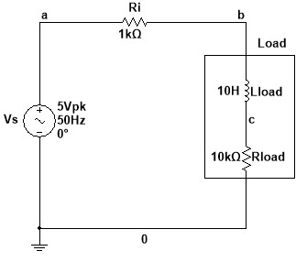 | 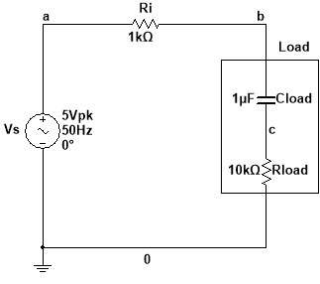
Figure 1: Inductive load in a series circuit | Figure 2: Capacitive load in a series circuit

Problem 1: Inductive Load in a Series Circuit
Simulate the inductive load circuit shown in Figure 1. Measure the load voltage, the voltage across Ri, and the required time differences using the oscilloscope. Then complete Table 1 and calculate the load current and power drawn by the load.

Table 1: Inductive Load
Reading | Parameter | Value
1 | V_Load (peak) | 4.58 V_{pk}
2 | Δt for load voltage | 80μs
3 | θ for load voltage | θ = (Δt ×f ×360) = (80 ×10⁻⁶ ×50 ×360) = +1.50°
4 | V_Ri (peak) | 450 mV_{pk}
5 | Δt for Ri voltage | -880μs
6 | θ for Ri voltage / current | θ = (Δt ×f ×360) = (-880 ×10⁻⁶ ×50 ×360) = -15.84°
7 | I_{s} ∠ θ | I_{s} $=\frac{V\left(Ri\right)}{Ri}=\frac{450∠-15.84}{1000}$ = 0.450 mA_{pk} ∠-15.84°
8 | Power drawn by the load, P | P = ($\frac{1}{2}$ I_{pk}² ×R_{load} )= 0.5×(0.450×10⁻³)² ×10000 = 1.0125 mW

Required screenshots:
- Circuit with oscilloscope connection for Reading 1
- Zoomed oscilloscope screen for Reading 1
- Zoomed oscilloscope screen for Reading 2
- Zoomed oscilloscope screen for Reading 4
- Zoomed oscilloscope screen for Reading 5
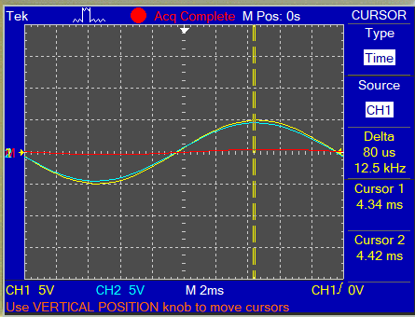
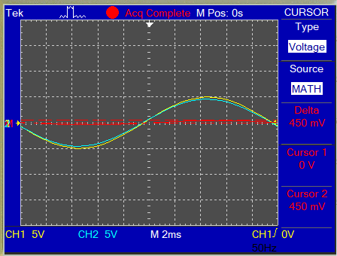
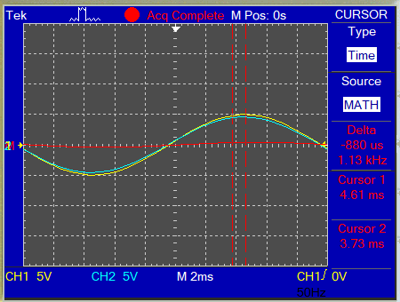
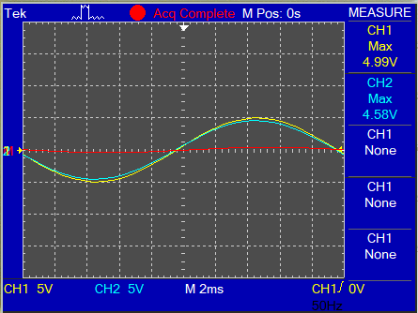
Reading: 2
Reading: 4
Reading: 5
Reading: 1
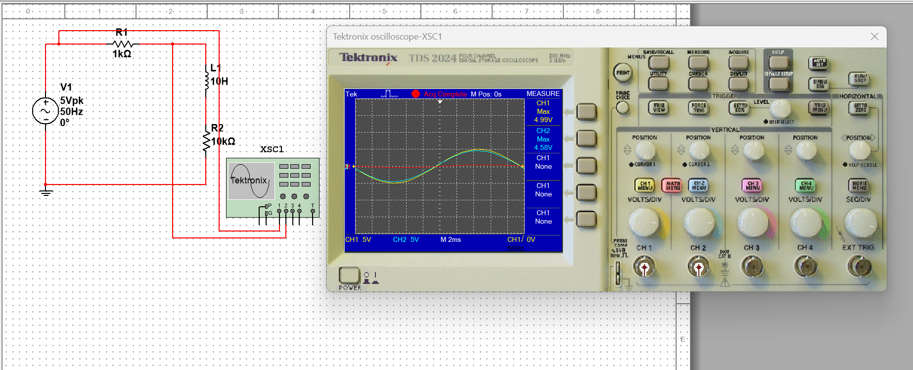
Reading:1 (FULL)

Problem 2: Capacitive Load in a Series Circuit
Simulate the capacitive load circuit shown in Figure 2. Measure the load voltage, the voltage across Ri, and the required time differences using the oscilloscope. Then complete Table 2 and calculate the load current and power drawn by the load.

Table 2: Capacitive Load
Reading | Parameter | Value
1 | V_Load (peak) | 4.54 mV_{pk}
2 | Δt for load voltage | -80 μs
3 | θ for load voltage | θ = (Δt ×f ×360) = (-80 ×10⁻⁶ ×50 ×360) = -1.44°
4 | V_Ri (peak) | 450 mV_{pk}
5 | Δt for Ri voltage | 900 μs
6 | θ for Ri voltage / current | θ = (Δt ×f ×360) = (900 ×10⁻⁶ ×50 ×360) = +16.2°
7 | I_{s} ∠ θ | I_{s} $=\frac{V\left(Ri\right)}{Ri}=\frac{450∠16.2}{1000}$ = 0.450 mA_{pk} ∠16.2°
8 | Power drawn by the load, P | P = ($\frac{1}{2}$ I_{pk}² ×R_{load} )= 0.5×(0.450×10⁻³)² ×10000 =1.0125mW

Required screenshots:
- Circuit with oscilloscope connection for Reading 1
- Zoomed oscilloscope screen for Reading 1
- Zoomed oscilloscope screen for Reading 2
- Zoomed oscilloscope screen for Reading 4
- Zoomed oscilloscope screen for Reading 5

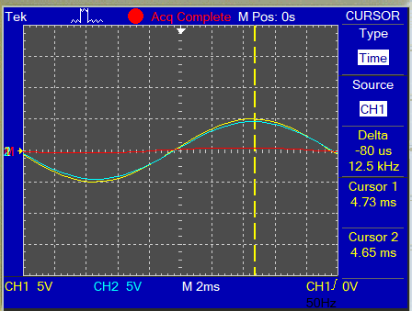
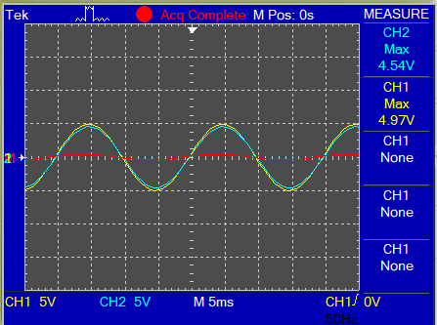
Reading: 2
Reading: 1
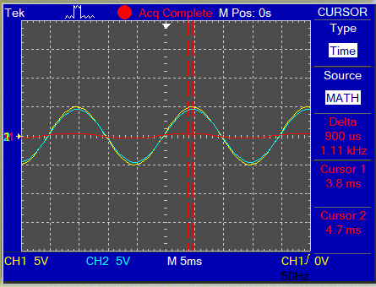
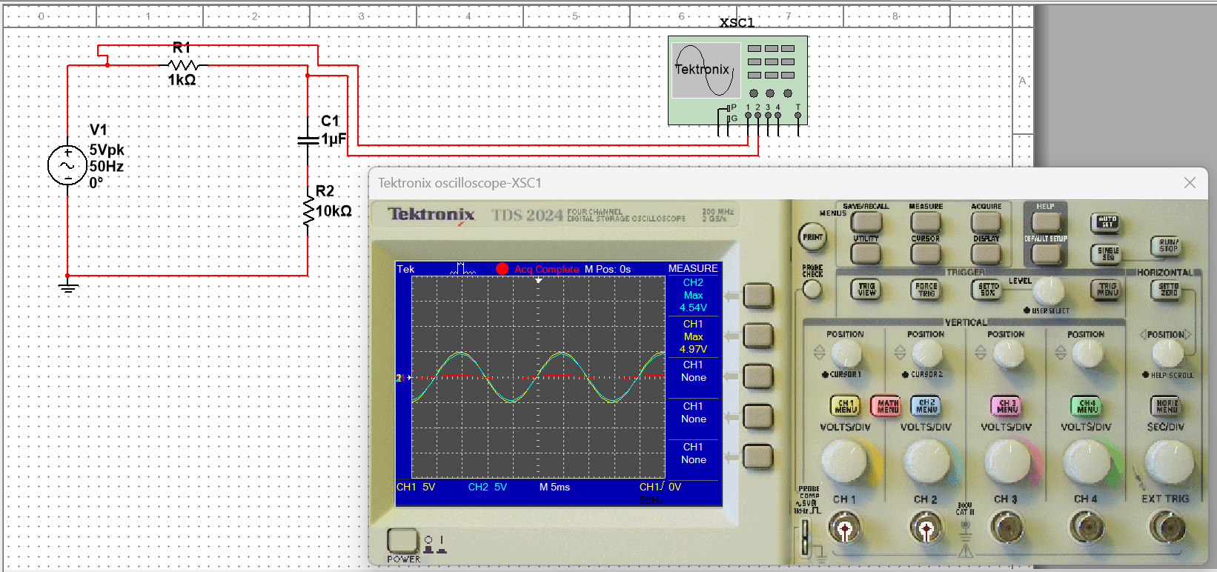
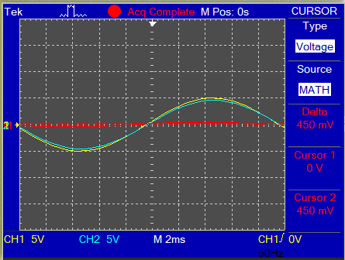
Reading: 5
Reading: 1 (FULL)
Reading: 4

Screenshot Requirements
For each circuit, attach the following screenshots:
- Full circuit showing the oscilloscope connection for Reading 1.
- Zoomed oscilloscope screen for Reading 1.
- Zoomed oscilloscope screen for Reading 2.
- Zoomed oscilloscope screen for Reading 4.
- Zoomed oscilloscope screen for Reading 5.

Submission Instructions
- Submit one PDF file through the assigned submission platform.
- The file must include completed tables, units, and the required screenshots.
- Name the submitted file using this format: StudentID_Name_EEE241L_Multisim_Assignment.
- Unreadable screenshots or missing calculation steps may reduce marks.

Mark Distribution
Assessment item | Marks | Notes
Problem 1: Inductive load readings, screenshots, and calculations | 8 | Table 1 and required screenshots
Problem 2: Capacitive load readings, screenshots, and calculations | 8 | Table 2 and required screenshots
Presentation, unit consistency, and final submission quality | 4 | Clean formatting and correct units
Total | 20

