Engineering Economics

Demand and Supply:
Demand: Demand is the quantity of a good or service that consumers are willing and able to buy at various price levels.

Supply: Supply is the quantity of a good or service that producer are willing and able to sell at various price levels.

Interest: The return earned on an investment is known as interest.
Interest = amount owned now – principal amount

Interest rate: Interest paid over a time period expressed as a percentage of principal
Interest rate = (Interest accrued per time unit / principal) x 100% .

Rate of return: The rate of return is the gain or loss of an investment over a certain period of time.

Interest rate refers to the cost of borrowing money or the gain from landing it.

Rate of return (ROR) measures the gain or loss on an investment over a specified period.

ROR = ((Current value – initial value) / initial value) * 100 %
* ROR > 0 means gain on investment
* ROR < 0 means loss

Commonly used symbols
t = time
P = principal amount
F = value or amount of money after some period of time, i.e after t = n time.
A = amount of money after n years including interest
n = years / interest period
i = interest rate

Cash Flow Terms

Cash Inflows: Revenues(R), receipts, incomes, savings generated by projects and activities that flow in

Cash Outflows: Disbursements(D), costs, expenses taxes caused by projects and activities flow out.

Net Cash Flow(NCF): For each time period:
NCF = cash inflows – cash outflows
=> NCF = R – D

Simple Interest: Interest is calculated using principal only.
Interest, I = Pni = Principal * number of years * interest rate
Example: $100,000 lent for 3 years at simple i = 10% per year. What is repayment after 3 years?
Interest = 100,000(3)(0.10) = $30,000
Total due = 100,000 + 30,000 = $130,000

Compound Interest: Interest is based on principal plus all accrued interest
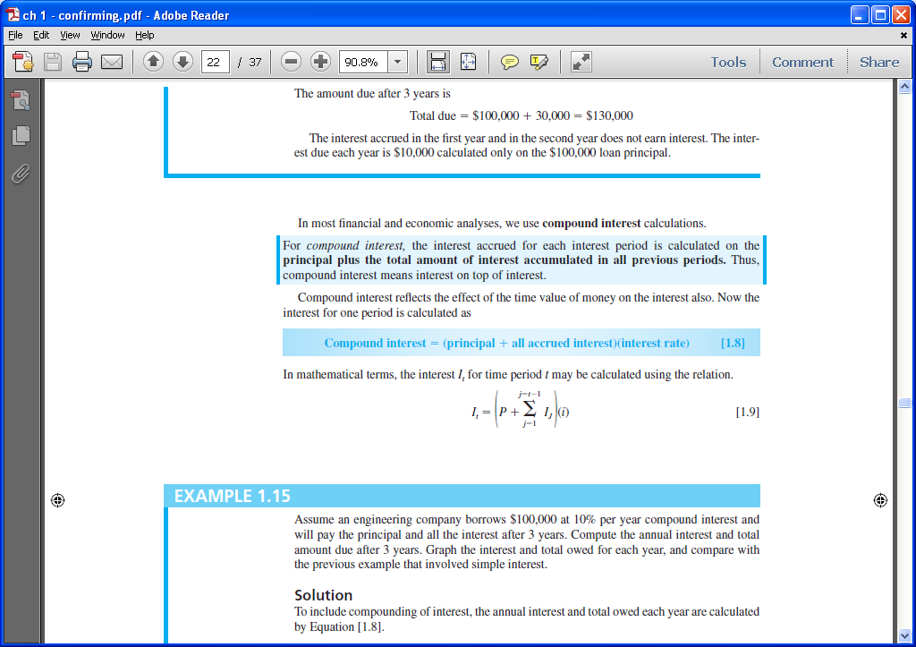

Example: $100,000 lent for 3 years at i = 10% per year compounded. What is repayment after 3 years?
Interest, year 1: I1 = 100,000(0.10) = $10,000
Total due, year 1: T1 = 100,000 + 10,000 = $110,000

Interest, year 2: I2 = 110,000(0.10) = $11,000
Total due, year 2: T2 = 110,000 + 11,000 = $121,000

Interest, year 3: I3 = 121,000(0.10) = $12,100
Total due, year 3: T3 = 121,000 + 12,100 = $133,100
Compounded: $133,100 Simple: $130,000

Arithmetic Gradients: An arithmetic gradient series is a cash flow series that either increase or decrease by a constant amount each period.

Chapter 2
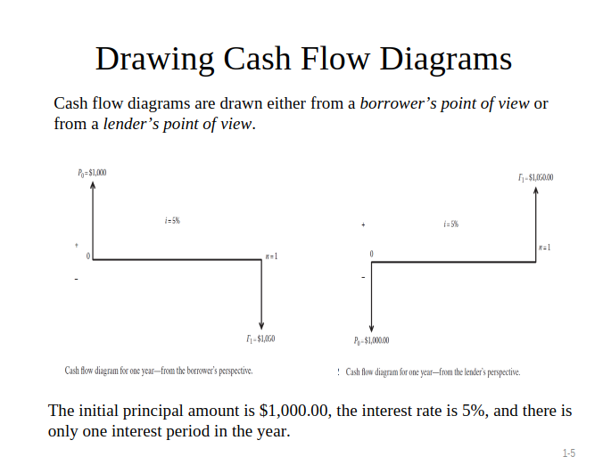
How time and interest affects money
Things to know,
Present worth(PW), Present value(PV) and principal(P) all are same
PW = PV = P

Future worth (FW), Future value(FV) and (F) or (Fn) are same
FW = FV = F = Fn

Single Payment factor (F/P and P/F)

F = P (1 + i)^{n} = (F/P, i, n) , Here F is to get and P,i,n is given

Future value F is calculated using FV function = FV(i%, n ,,P)
Present value P is calculated using PV function = PV(i%, n ,,F)
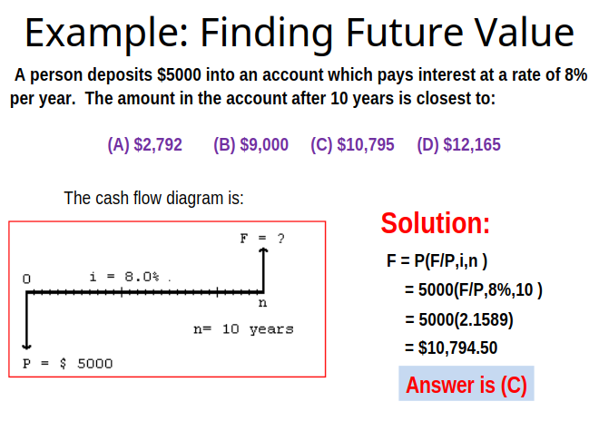

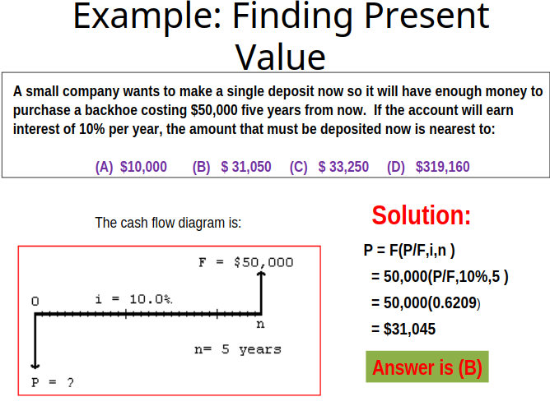

Chapter 3
Nominal and Effective Interest rate

Interest period: Period of time over which interest is expressed.
Compounding period (CP): Shortest time unit over which interest is charged or earned.
Compounding frequency (m): Number of times compounding occurs within the interest period t.

A nominal interest rate (r) is obtained by multiplying an interest rate that is expressed over a short time period by the number of compounding by the number of compounding periods in a longer time period.
r = interest rate per period * number of compounding periods

Effective interest rate (i) take compounding into account

Effective rate per CP, i = r% time period t / m compounding periods per t = r / m.

Effective annual interest rate i_{a} = (1 + i)^{m –} 1

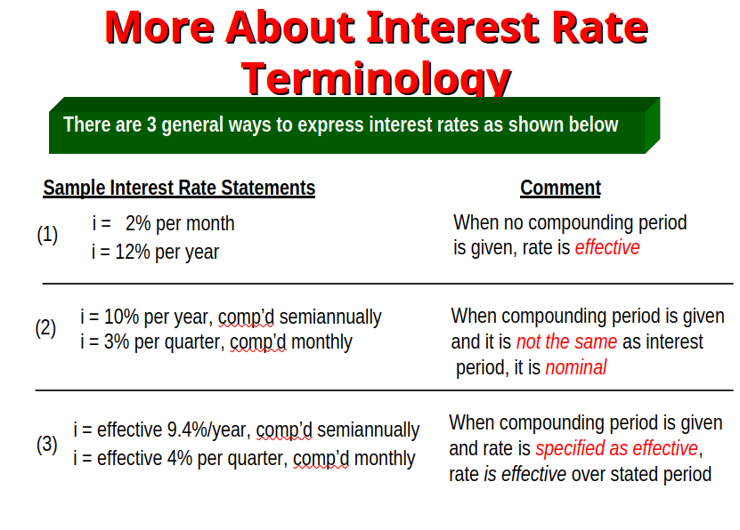

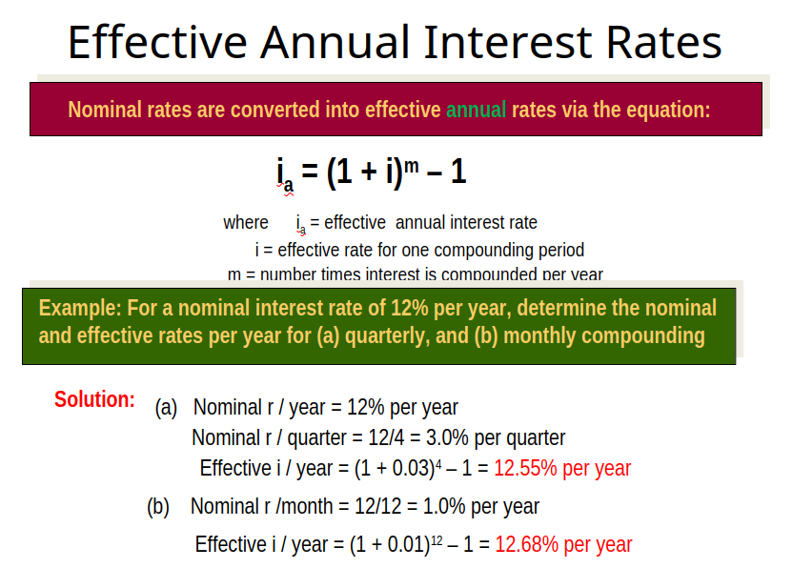
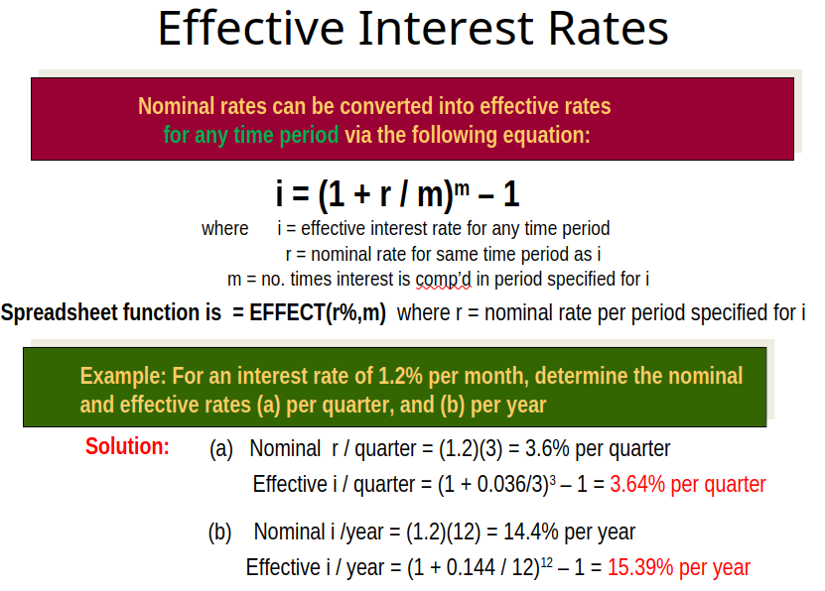

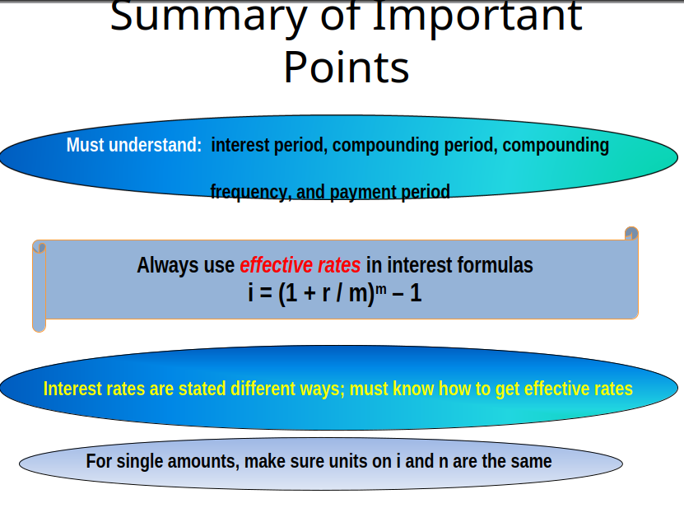

Chapter 5
Inflation

1. What is inflation?
=> Inflation refers to the sustained increase in the general price level of goods and services in an economy over a period of time.

2. What is inflation rate?
=> Inflation rate is the percentage increase in the general price level of goods and services over a period of time.

3. How does inflation happen?
=> Several factor can cause in inflation. Some of them are:

Money supply: The amount of money in our national economy has an effects on its purchasing power. If there is too much money in the system, we need to spend much money to purchase goods and services that means value of dollars decrease. If there is fewer money in the system they become more valuable.

Demand pull: As the demand rises, if the supply of goods and services doesn’t keep up price start to increase. This type of inflation is called demand pull inflation.

Cost push: When the costs of production increase, producer raise prices to maintain profit margins.

External factors: Events like natural disasters, geopolitical tensions or supply chain disruption can reduce supply and increase costs.
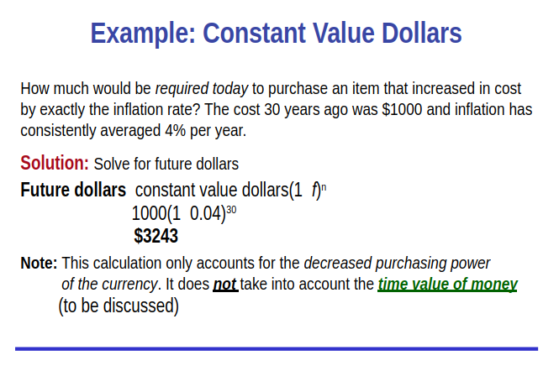
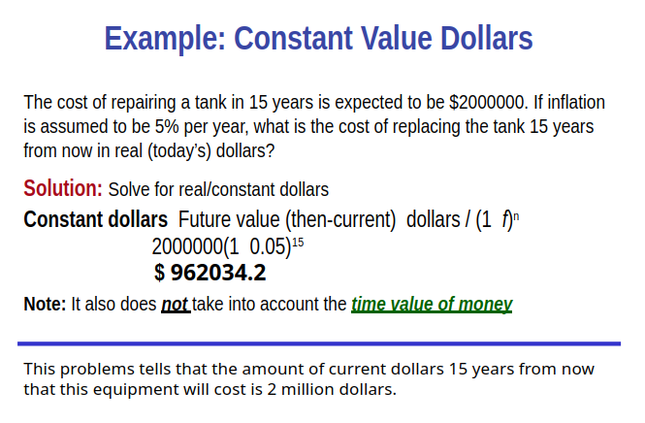

Future value dollars = Constant value dollars * (1 + f)^{n}
Constant value dollars = Future value dollars / (1 + f)^{n}

f = inflation rate, n = years

Inflation rate = f
Real interest rate = i`
Market interest rate = I

Market interest rate, i = i` + f + (i`)(f)

Market interest rate, MARRc = MARRr + f + (MARRc * f)

Chapter 4
Benifit / Cost Analysis

1. What is the primary purpose of a public sector projects?
=> The primary purpose of public sector projects is to provide essential services and infrastructure that enhance the quality of life of citizens at no profit.

2. Differences between public and private projects?
