

**Department of**

**Computer Science & Engineering**

**Lab Assignment 01**

**Course No: C.S.E 455**

**Course Name: Multimedia & Animation Techniques**

**Name of the Assignment: Creating typeface for U+985 and U+995**

**using font forge**

**SUBMITTED BY** **:**

**NAME:**  **Raihan Nahar Tofa**

**ROLL NO:** **364**

**SESSION:** **2016-17**

**SUBMITTED TO:**

[Dr. Mohammad Zahidur Rahman](https://www.juniv.edu/teachers/rmzahid)

Professor at

Department of Computer Science and Engineering,

Jahangirnagar University.

**SUBMISSION DATE:** 17.02.2021

**Objectives:**

Developing a new typeface of the following characters in H980x Unicode using the Font forge tool.

অ and ক.

**Tools used:**

1. Font Forge

**Procedures:**

1. I have designed the U+0985 font “ অ “ by free hand.

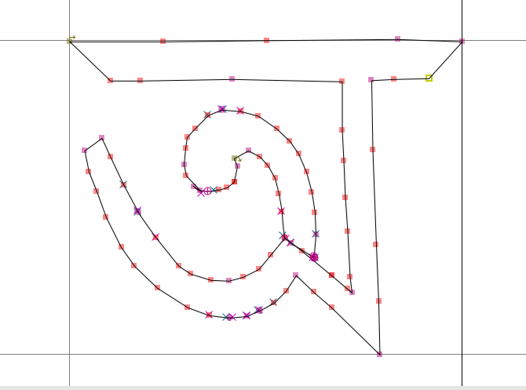

1. I have designed the U+0995 font “ ক “ by free hand.

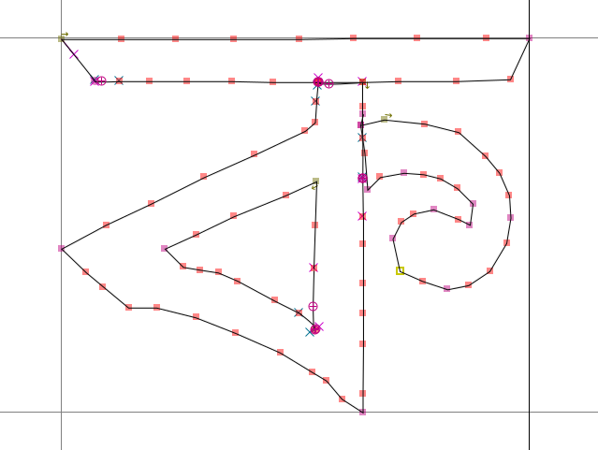

1. Final design

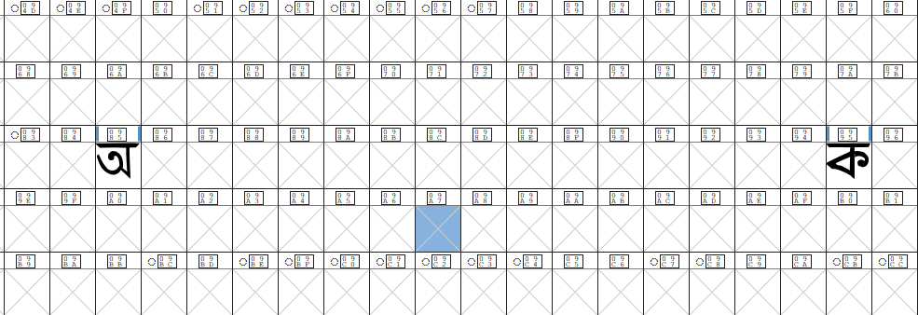

**Resources**:

<https://github.com/raihan38/Multimedia-CSE-456/tree/master/LAB_01>