Higher National School of Computer Science
Module: Probability and Statistics (PRST2)

Project Report
Hypothesis Testing Analysis of Network Traffic Attacks Using the UNSW-NB15 Dataset

Student: MEKCI RAIHAN
Group: B1
Academic year: 2025/2026

Supervisor: Mrs. KHADIDJA CHAMI

Table of Contents
1. Introduction ..................................................................... 3
2. Dataset description ........................................................... 3
3. Methodology ..................................................................... 4
4. Hypothesis tests on means ............................................... 5
5. Hypothesis tests on proportions ........................................ 8
6. Results and discussion ..................................................... 10
7. Conclusion ........................................................................ 11
Appendix: Code .................................................................... 12

1. Introduction
Cyberattacks against computer networks are becoming more frequent and more diverse. Detecting them in the network traffic is therefore an important problem. The UNSW-NB15 dataset was created by the Cyber Range Lab of UNSW Canberra in order to study this problem on realistic modern traffic. In this project we use the UNSW-NB15 testing set to formulate and test simple statistical hypotheses about the differences between normal and attack traffic, and between different attack categories.
The methods used are taken directly from Chapter 3 of the course (Hypothesis Testing): the Student t-test and its normal approximation for the means, the Fisher F-test for the variances, and the chi-squared goodness-of-fit and homogeneity tests for the proportions. All decisions are taken at the significance level alpha = 0.05 using critical values read from the statistical tables.
This work is the continuation of a first descriptive statistics project on the same dataset. It moves from describing the data to making inferential statements supported by formal tests.

2. Dataset description
The UNSW-NB15 testing set contains 82,332 records of network connections with 45 features. Each record is labelled either as normal (label = 0) or as attack (label = 1), and attacks are further classified into 9 categories: Generic, Exploits, Fuzzers, DoS, Reconnaissance, Analysis, Backdoor, Shellcode and Worms.
The main numerical features used in this project are:
- dur: duration of the connection in seconds
- rate: packet rate of the connection (packets per second)
- proto: protocol used (tcp, udp, unas, etc.)
- attack_cat: attack category (or Normal for non-attack traffic)

Class balance:
Class | Count | Proportion
Normal | 37,000 | 44.94%
Attack | 45,332 | 55.06%
Total | 82,332 | 100.00%

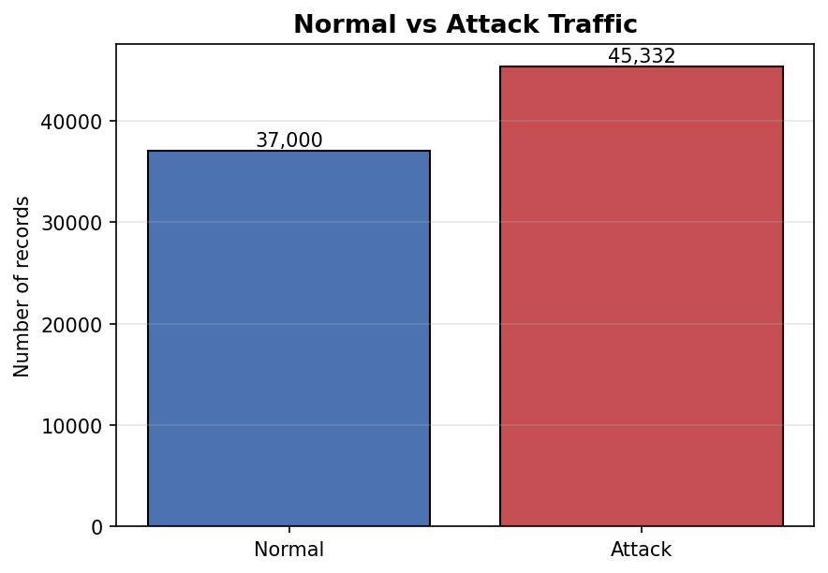
Figure 1. Normal versus Attack traffic.

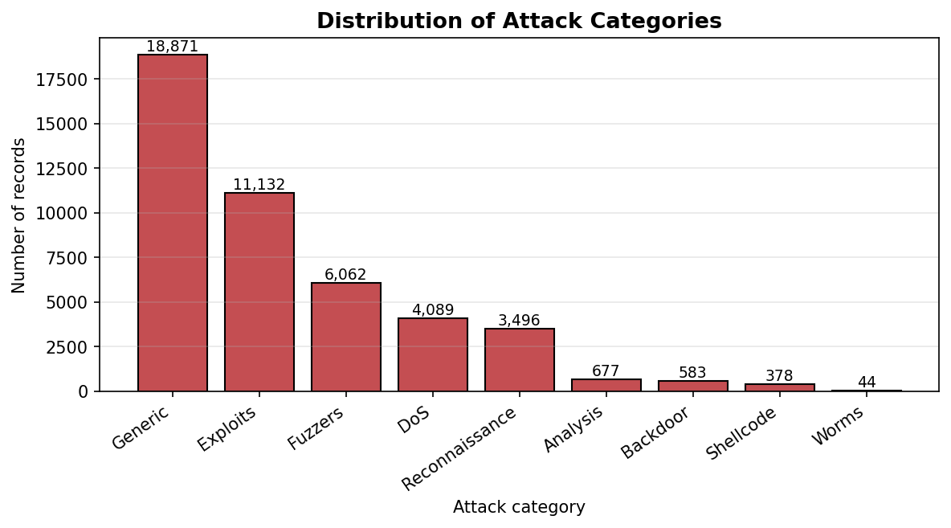
Figure 2. Distribution of the attack categories.

3. Methodology
Each test follows the same structure taught in the course:
- Formulate H0 (null hypothesis) and H1 (alternative hypothesis).
- Choose the test statistic (Z, t, F, or chi-squared).
- Compute the observed value of the statistic from the sample.
- Determine the critical value from the corresponding statistical table at alpha = 0.05.
- Build the acceptance region A.
- Compare the observed value with A and accept or reject H0.
- Give a short interpretation of the result.

3.1 Tests on means
To compare two means we use the two-sample test. For two normal samples X (size n) and Y (size p) with equal variances, the statistic
Z = sqrt( n*p*(n+p-2) / (n+p) ) * ( mean(X) - mean(Y) ) / sqrt( sum( (X - mean(X))^2 ) + sum( (Y - mean(Y))^2 ) )
follows the Student distribution t(n+p-2) under H0. When n and p are large (in practice > 30), the Student distribution is replaced by the standard normal N(0,1) by the Central Limit Theorem. Because the dataset contains tens of thousands of observations, we apply both versions: the normal approximation on the full data, and the Student t-test on a random sample of size 200 per group.
Before comparing the means of two samples, the course requires to first verify the equality of variances with a Fisher F-test based on F = S_X^2 / S_Y^2, which follows F(n-1, p-1) under H0.

3.2 Chi-squared tests
To test a distribution we use the chi-squared distance
D_n = sum_{i=1}^{k} ( d_i - n_i )^2 / d_i
where n_i is the observed count in class i and d_i = n * f_i is the expected count under H0. By Cochran's theorem, D_n follows chi-squared(k-1) for a goodness-of-fit test, and chi-squared((k-1)(l-1)) for a homogeneity test on a k by l contingency table. The acceptance region is A = [0; a] where a is the critical value at level alpha = 0.05.

4. Hypothesis tests on means

Test 1 — Mean duration: Normal vs Attack (full data)
H0: mean_dur(Normal) = mean_dur(Attack)
H1: mean_dur(Normal) ≠ mean_dur(Attack)
Test used: Z statistic (normal approximation since n = 37,000 and p = 45,332).
Quantity | Value
mean(Normal) | 1.0127
mean(Attack) | 1.0019
var(Normal) | 16.5138
var(Attack) | 26.8202
Z observed | 0.3366
Z critical (two-sided, alpha=0.05) | ± 1.96
Acceptance region | [−1.96 ; 1.96]
Decision | Accept H0
Interpretation: |Z| = 0.34 lies inside the acceptance region, so we accept H0. The two groups have very similar mean durations because both contain large outliers (long-lasting connections) that inflate the variances and hide the difference.

Test 1b — Same test on a random sample of n = p = 200 (Student t)
Quantity | Value
mean(Normal sample) | 1.0343
mean(Attack sample) | 1.6370
degrees of freedom | 398
Z observed | −0.9792
t critical (two-sided) | ± 1.9659
Decision | Accept H0
The smaller sample gives the same conclusion: no significant difference between the mean durations.

Test 2 — Mean rate: Normal vs Attack (full data)
H0: mean_rate(Normal) = mean_rate(Attack)
H1: mean_rate(Normal) ≠ mean_rate(Attack)
Quantity | Value
mean(Normal) | 28,349.99
mean(Attack) | 126,535.42
Z observed | −104.3750
Z critical | ± 1.96
Decision | Reject H0
Interpretation: Z is far outside the acceptance region. The mean packet rate is much higher for attacks (≈ 126,535) than for normal traffic (≈ 28,350). This is consistent with the burst-style behaviour of many attacks such as scans and DoS.

Test 2b — Same test on a random sample of n = p = 200 (Student t)
Quantity | Value
Z observed | −7.3147
t critical (df = 398) | ± 1.9659
Decision | Reject H0
Same conclusion as with the full data.

Test 3 — F-test: variance of dur, Generic vs Exploits
This test is the precondition required before comparing the means of two samples.
H0: var_dur(Generic) = var_dur(Exploits)
H1: var_dur(Generic) ≠ var_dur(Exploits)
Quantity | Value
var(Generic) | 0.8157
var(Exploits) | 34.5765
F observed (larger / smaller) | 42.3880
F critical interval | [0.9673 ; 1.0336]
Decision | Reject H0
Interpretation: variances are very different. The equal-variance assumption is not satisfied. For the next test we therefore rely on the normal approximation with separate variances, which is valid for large samples.

Test 4 — Mean duration: Generic vs Exploits (full data)
H0: mean_dur(Generic) = mean_dur(Exploits)
H1: mean_dur(Generic) ≠ mean_dur(Exploits)
Quantity | Value
mean(Generic) | 0.0611
mean(Exploits) | 1.7160
Z observed | −29.4893
Z critical | ± 1.96
Decision | Reject H0
Interpretation: Exploits last on average much longer than Generic attacks (1.72 s vs 0.06 s). Generic attacks are very short bursts, while Exploits are slower multi-step interactions.

Test 4b — Same test on a random sample of n = p = 200 (Student t)
Quantity | Value
mean(Generic sample) | 0.0143
mean(Exploits sample) | 1.5417
Z observed | −4.2441
t critical (df = 398) | ± 1.9659
Decision | Reject H0
The conclusion is the same with the small sample.

5. Hypothesis tests on proportions
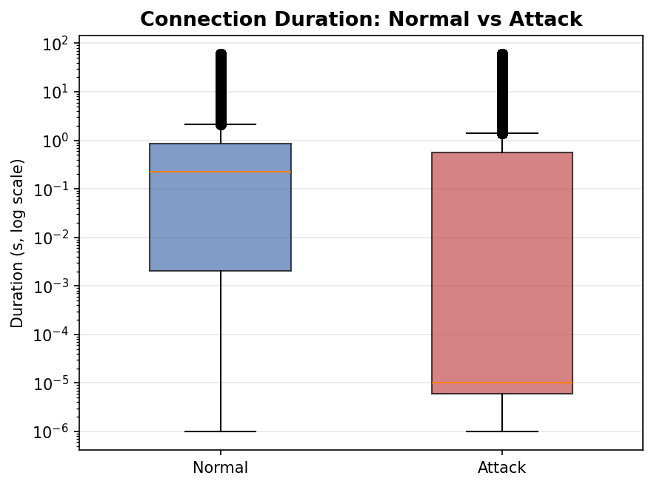
Figure 3. Boxplot of the connection duration (log scale).

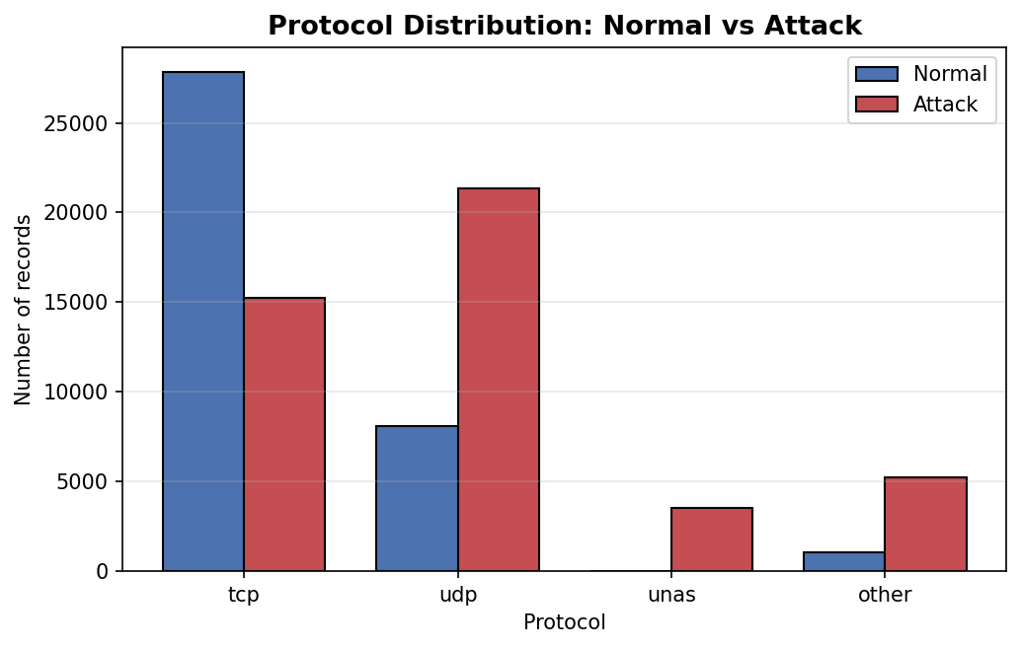
Figure 4. Protocol distribution: Normal vs Attack.

Test 5 — Goodness-of-fit: are attack categories uniformly distributed?
H0: the 9 attack categories follow a uniform distribution
H1: the distribution is not uniform
Observed counts per category:
Attack category | Observed | Expected
Generic | 18,871 | 5,036.89
Exploits | 11,132 | 5,036.89
Fuzzers | 6,062 | 5,036.89
DoS | 4,089 | 5,036.89
Reconnaissance | 3,496 | 5,036.89
Analysis | 677 | 5,036.89
Backdoor | 583 | 5,036.89
Shellcode | 378 | 5,036.89
Worms | 44 | 5,036.89

Quantity | Value
D observed | 63,201.04
degrees of freedom (k-1) | 8
chi-squared critical (alpha = 0.05) | 15.5073
Acceptance region | [0 ; 15.51]
Decision | Reject H0
Interpretation: D = 63,201.04 is far above the critical value. The attack categories are very unbalanced: Generic and Exploits dominate, while Shellcode and Worms are rare.

Test 6 — Homogeneity: protocol distribution Normal vs Attack
H0: the protocol distribution (tcp, udp, unas, other) is the same for Normal and Attack
H1: the distributions differ
Contingency table:
Protocol | Normal | Attack | Row total
other | 1,055 | 5,249 | 6,304
tcp | 27,848 | 15,247 | 43,095
udp | 8,097 | 21,321 | 29,418
unas | 0 | 3,515 | 3,515
Col total | 37,000 | 45,332 | 82,332

Quantity | Value
D observed | 15,247.19
degrees of freedom (3 × 1) | 3
chi-squared critical (alpha = 0.05) | 7.8147
Decision | Reject H0
Interpretation: protocols are used very differently. Normal traffic is mostly tcp, while attacks use udp and unas much more. The unas protocol is almost absent in normal traffic.

Test 7 — Homogeneity: protocol distribution Generic vs Exploits
H0: the protocol distribution is the same for Generic and Exploits
H1: the distributions differ
Contingency table (top 3 protocols within the Generic + Exploits subset):
Protocol | Exploits | Generic
other | 1,876 | 35
tcp | 7,754 | 520
udp | 250 | 18,303
unas | 1,252 | 13

Quantity | Value
D observed | 26,655.58
degrees of freedom (3 × 1) | 3
chi-squared critical (alpha = 0.05) | 7.8147
Decision | Reject H0
Interpretation: Generic is almost only udp, while Exploits is mostly tcp. The protocol is a strong signature of the attack type.

6. Results and discussion
The table below summarises the seven tests:
Test | Question | Test used | Decision
1 | Mean dur Normal vs Attack (full) | Z (normal approx.) | Accept H0
1b | Mean dur Normal vs Attack (n = 200) | Student t(398) | Accept H0
2 | Mean rate Normal vs Attack (full) | Z (normal approx.) | Reject H0
2b | Mean rate Normal vs Attack (n = 200) | Student t(398) | Reject H0
3 | Variance dur Generic vs Exploits | Fisher F | Reject H0
4 | Mean dur Generic vs Exploits (full) | Z (normal approx.) | Reject H0
4b | Mean dur Generic vs Exploits (n = 200) | Student t(398) | Reject H0
5 | Attack categories uniformly distributed? | chi-squared GoF | Reject H0
6 | Protocol: Normal vs Attack | chi-squared hom. | Reject H0
7 | Protocol: Generic vs Exploits | chi-squared hom. | Reject H0

Several findings stand out:
- The packet rate is a strong discriminator between normal and attack traffic (mean rate is about 4.5 times higher for attacks).
- The mean duration does not separate normal from attack traffic globally, but it does separate attack types: Exploits last much longer than Generic attacks on average.
- The attack categories are highly unbalanced: Generic and Exploits together account for most of the attack records, while Worms, Shellcode and Backdoor are rare.
- The protocol is a strong signal: tcp dominates normal traffic and Exploits, udp dominates Generic attacks, and the unas protocol almost exclusively appears in attack traffic.

Limitations: the tests assume the samples are drawn from independent distributions. The dataset contains heavy-tailed variables (duration, rate) with many outliers, so the normality assumption is only satisfied asymptotically through the Central Limit Theorem. The chi-squared tests are valid because all expected counts are well above 5.

7. Conclusion
This project applied the hypothesis testing methods from Chapter 3 of the course to the UNSW-NB15 testing set. Seven tests were carried out at significance level alpha = 0.05 using the Student t-test, its normal approximation, the Fisher F-test, and the chi-squared goodness-of-fit and homogeneity tests. All decisions were taken from critical values of the statistical tables.
The main statistical conclusions are that the packet rate clearly separates normal from attack traffic, that connection duration is useful to separate attack types but not normal from attack globally, that the attack categories are far from being uniformly distributed, and that the protocol used is a strong signature of both attack vs normal and of the attack type itself.
These results extend the descriptive analysis from the first project with formal statistical evidence, and they provide a solid basis on which more advanced methods (for example a machine learning intrusion-detection model) could be built in future work.

Appendix: Code
All computations were performed in Python using NumPy, pandas, SciPy and Matplotlib. The complete code is provided in the companion Jupyter notebook UNSW_NB15_Hypothesis_Testing.ipynb. The structure is:
- Data loading and exploration
- Four figures (Normal vs Attack, attack categories, duration boxplot, protocol distribution)
- Tests 1 to 4 on the means using Z and Student t
- Test 3 (F-test) for the equality of variances before Test 4
- Tests 5 to 7 using the chi-squared distance from the course

Key code snippets (extracts):
Two-sample t (course formula):
z = sqrt(n*p*(n+p-2)/(n+p)) * (mean(x) - mean(y)) / sqrt(sum((x-mean(x))**2) + sum((y-mean(y))**2))
Critical values from the tables via scipy.stats:
t_crit = stats.t.ppf(1 - alpha/2, df)
z_crit = stats.norm.ppf(1 - alpha/2)
F_crit_l = stats.f.ppf(alpha/2, df1, df2)
F_crit_h = stats.f.ppf(1 - alpha/2, df1, df2)
chi_crit = stats.chi2.ppf(1 - alpha, df)
Chi-squared distance:
D = ((observed - expected)**2 / expected).sum()

