RAIHAN MAHMUD
ID: 161-35-1542

Question-i Does the following command exist, if the program fails, what is printed and Where?
“date”

Ans: Yes, “date” command is exist and it will print present date and time.
Fig-1 will show output of “date” command.
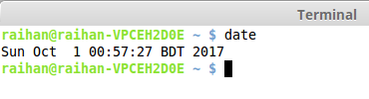
Fig-1: Output of “date” command in bash terminal.

Question-ii Does the following command exists, if the programs fails, what is printed and Where?
“hello”

Ans: No, “hello” command does not found in this package. This will be found in “* hello
* hello-debhelper” package.
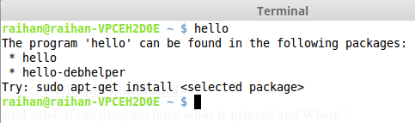
Fig-2 will show output of “hello” command.
Fig-2: Output of “hello” command in bash terminal.

Question-iii Explain the following command.
“ls -al”

Ans: “ls” command file show folder but “ls -al” command show hidden file also.
Fig-3 will show output of “ls -al” command.
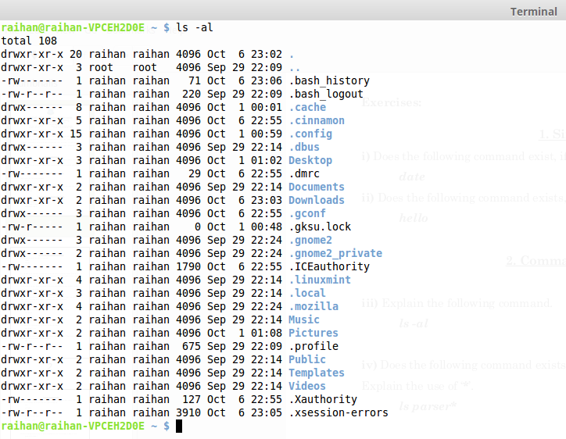
Fig-3: Output of “ls -al” command in bash terminal.

Question-iv Does the following command exists, if the programs fails, what is printed and Where?
Explain the use of ‘*’.
“ls parser*”

Ans: No, “ls parser*” command does not exist. If no string is not saved “ls parser*” command will fail. If some string saved in the memory “ls parser*” show this string. “*” helped to find string by matching word.
Fig-4 will show output of “ls parser*” command.
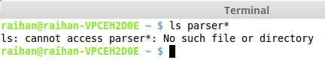
Fig-4: Output of “ls parser*” command in bash terminal.

Question-v Explain the following three commands.
“ls -al > tmp.1
cat < tmp.1 > tmp.2
diff tmp.1 tmp.2”

Ans: If we enter “ls -al > tmp.1
cat < tmp.1 > tmp.2
diff tmp.1 tmp.2” command one by one we cannot see any output. But “diff tmp.1 tmp.2” will show difference between two temporary file.
Fig-5 will show output of “ls -al > tmp.1
cat < tmp.1 > tmp.2
diff tmp.1 tmp.2” command.
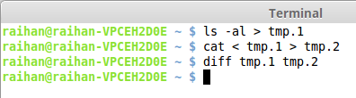
Fig-5: Output of “ls -al > tmp.1
cat < tmp.1 > tmp.2
diff tmp.1 tmp.2” command in bash terminal.

Question-vi Explain the following three commands.
“top&
top &
top
ps”

Ans: ps - Display currently active processes.
top - Display all running processes.
Fig-6.1, 6.2 & 6.3 will show output of following command.
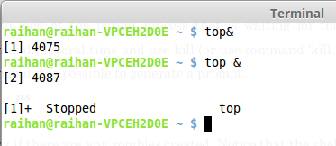
Fig-6.1: Output of “top” command in bash terminal.

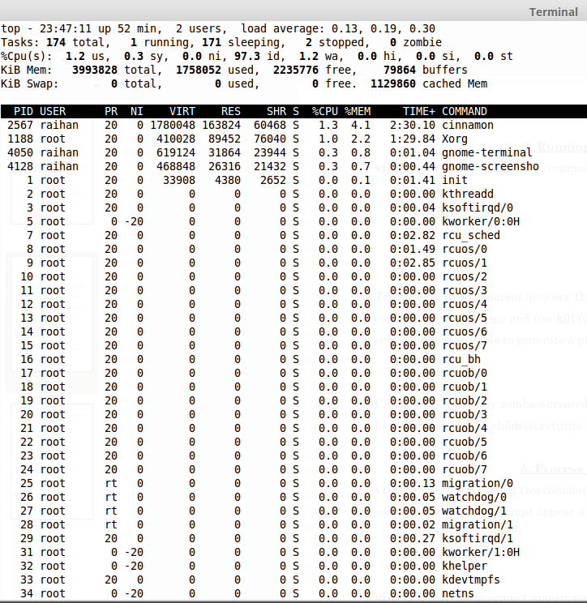
Fig-6.2: Output of “top” command in bash terminal.

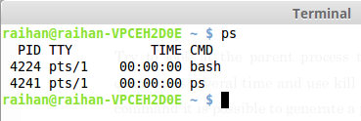
Fig-6.3: Output of “ps” command in bash terminal.

Question-vii Explain the following two commands. What are the main differences between two
commands? Does the prompt appear after the output of the command?
“ls -al | wc
ls | sort –r”

Ans: wc - print newline, word and byte counts for each file.
sort - sort lines of text files.
Fig-7 will show output of “ls -al | wc
ls | sort –r” command.
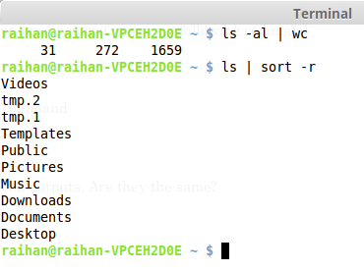
Fig-7: Output of “ls -al | wc
ls | sort –r” command in bash terminal.

Question-viii When does the prompt appear now if you enter following command
“ls | wc &”

Ans: I cannot see any effective output from “ls | wc &” command.
Fig-8 will show output of “ls | wc &” command.
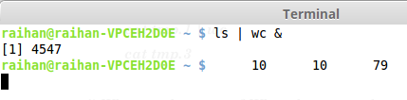
Fig-8: Output of “ls | wc &” command in bash terminal.

Question-ix Explain the following command
“cat < tmp.1 | wc > tmp.3”

Ans: No output found from “cat < tmp.1 | wc > tmp.3” command.
Fig-9 will show output of “cat < tmp.1 | wc > tmp.3” command.
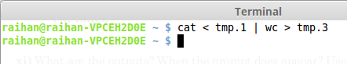
Fig-9: Output of “cat < tmp.1 | wc > tmp.3” command in bash terminal.

Question-x Compare the following two outputs. Are they the same?
“cat tmp.1 | wc
cat tmp.3”

Ans: Yes, Output of “cat tmp.1 | wc
cat tmp.3” command is same.
Fig-10 will show output of “cat tmp.1 | wc
cat tmp.3” command.
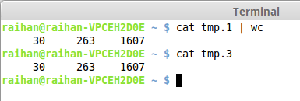
Fig-10: Output of “cat tmp.1 | wc
cat tmp.3” command in bash terminal.

Question-xi What are the outputs? When the prompt does appear? Use Ctrl-D if necessary to let the
grep finish and to the shell process takes over.
“abf | wc
ls | abf
grep apa | ls”

Ans: 1st and 2nd command will show no command found but 3rd command will show default folder.
Fig-11 will show output of “abf | wc
ls | abf
grep apa | ls” command.
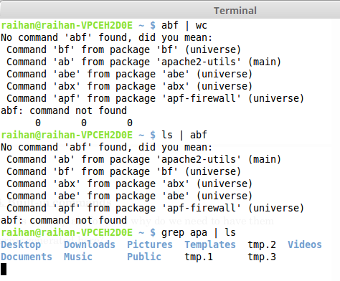
Fig-11: Output of “abf | wc
ls | abf
grep apa | ls” command in bash terminal.

Question-xii Try each of the following commands and explain for each why do we need to have them
as built-in commands? Is there an error generated here?
“cd ..
cd lab1
cd tmp.tmp”

Ans: By giving “cd ..
cd lab1
cd tmp.tmp” command terminal shows “No such file or directory” because no file is not created in my pc.
Fig-12 will show output of “cd ..
cd lab1
cd tmp.tmp” command.
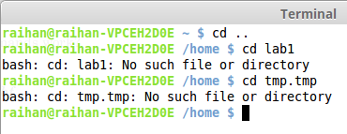
Fig-12: Output of “cd ..
cd lab1
cd tmp.tmp” command in bash terminal.

Question-xiii Does the commands work?
“cd ..
cd lab1 | abf
ls
cd”

Ans: “cd ..
cd lab1 | abf
ls
cd” command does not fully work.
Fig-13 will show output of “cd ..
cd lab1 | abf
ls
cd” command.
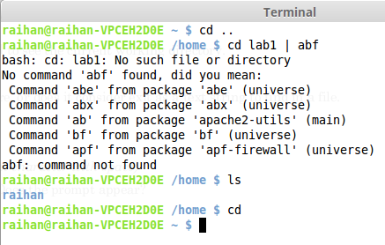
Fig-13: Output of “cd ..
cd lab1 | abf
ls
cd” command in bash terminal.

Question-xiv Does the shell quits here, or does it consider exit as a text string to find in a file.
“grep exit < tmp.1
% exit”

Ans: By giving this command terminal will show no such job.
Fig-14 will show output of “grep exit < tmp.1
% exit” command.
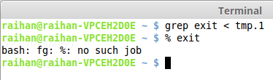
Fig-14: Output of “grep exit < tmp.1
% exit”command in bash terminal.

Question-xv Is there an error here? Does the prompt appear?
“grep exit | hej
grep cd | wc”

Ans: Yes, here is a error so this command don't found.
Fig-15 will show output of “grep exit | hej
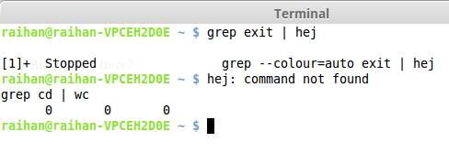
grep cd | wc” command.
Fig-15: Output of “grep exit | hej
grep cd | wc” command in bash terminal.

Question-xvi Are there any zombies now?
“exit”

Ans: Yes, here is no zombies because “exit” command close terminal.
Fig-16 will show “exit” command.
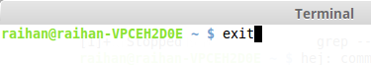
Fig-16: “exit” command in bash terminal.

Question-xvii Are there any errors here?
“ls | wc-”

Ans: Yes, here is a error because this command not found.
Fig-17 will show output of “ls | wc-” command.
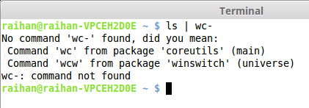
Fig-17: Output of “ls | wc-” command in bash terminal.

- - -

