RAIHAN MAHMUD
ID: 161-35-1542
#A piece of code to get process id information.
Q-1: Correct the code in Figure 1.
Ans: Fig-1 will show correct code
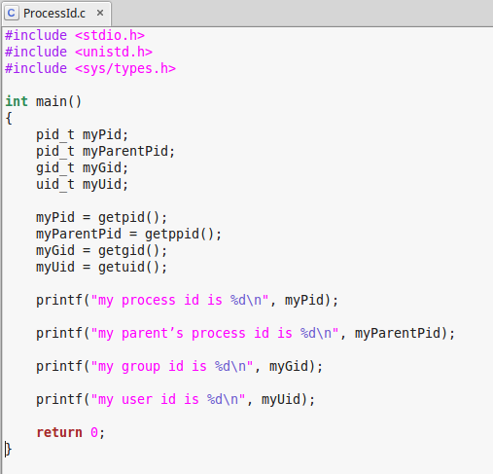
Figure-1: Correct code.

Q-2: Explain the role of the routines getpid(), getppid(), getgid() and getuid()
Ans: getpid() function to get the current process ID.
getppid() function to retrieve the process’s parent ID.
getgid() returns the real group ID of the calling process.
getuid() returns the real user ID of the calling process.

Q-3: Explain the output of the code briefly.
Ans: Fig-2 will show output of process id, parent's process id, group id, user id. Every process in GNU/Linux has a unique identifier called a process ID (or pid ). Every process also has a parent (except for the init process).
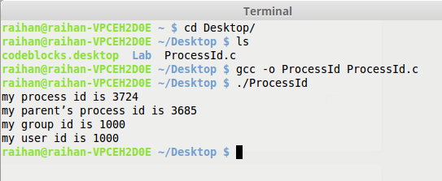
Figure-2: Output of correct code.

#Create parent and child process.
Q-4: Correct the code in the Figure 2.
Ans: Fig-3 will show correct code
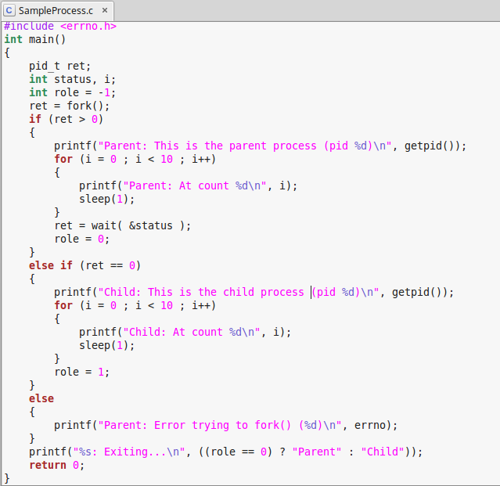
Figure-3: Correct code.

Q-5: Explain the output of the code briefly.
Ans: Fig-4 will show output of create parent and child process id and counter.

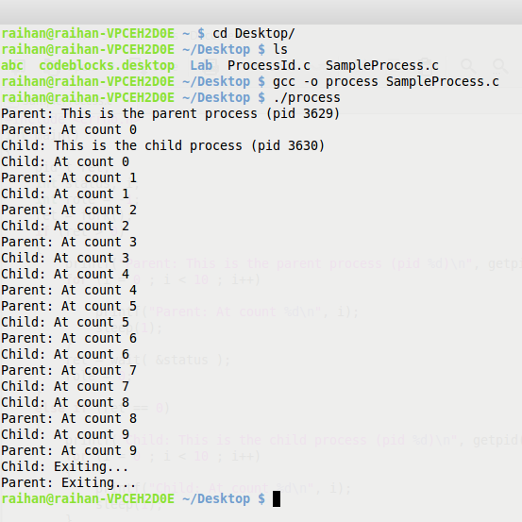
Figure-4: Output of correct code.

Q-6: Maximum how many child process able to create using your PC.
Ans: 3000+ child process will able to create using my PC.

#How to catch signal.
Q-7: Correct the code in the Figure 3.
Ans: Fig-5 will show correct code
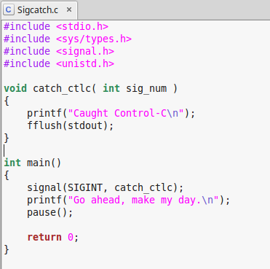
Figure-5: Correct code.

Q-8: Explain the output of the code briefly.
Ans: This code is a combination some customize function. Output of this code will show “Go ahead, make my day.” After get this output we can write some text in the terminal but we can not exit terminal by giving command. This is the main thing in this code.
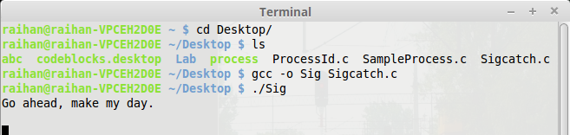
Figure-6: Output of correct code.

#Create own shell prompt to execute shell commands.
Q-7: Correct the code.
Ans: Fig-7 will show correct code
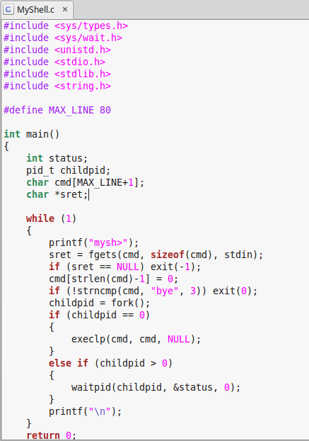
Figure-7: Correct code.
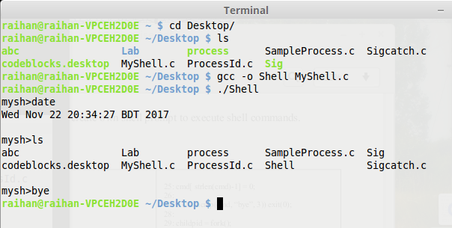
Q-8: Explain the output.
Ans: I can see that after executing the shell, the prompt is displayed, indicating
that commands can be entered. The date command is entered first, which provides
the current date and time. Next, I do an ls , which gives the contents of the cur-
rent directory. Finally, I exit the shell using the bye internal command.
Figure-8: Output of correct code.

#Create a message queue for IPC.
Q-9: Correct the code.
Ans: Fig-9 will show correct code
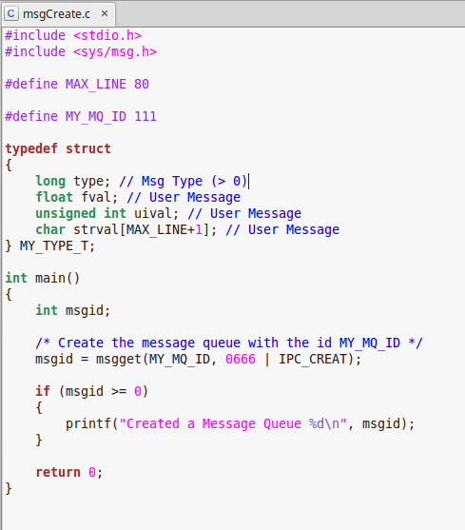
Figure-9: Correct code.

Q-10: Explain the output.
Ans: In code 1st define “#define MY_MQ_ID 123” and compile then define “#define MY_MQ_ID 111” and compile. So, create 2 message.
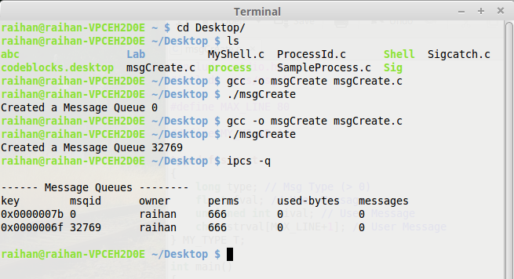
Figure-10: Output of correct code.

#Send message to another process.
Q-11: Correct the code.
Ans: Fig-11 will show correct code
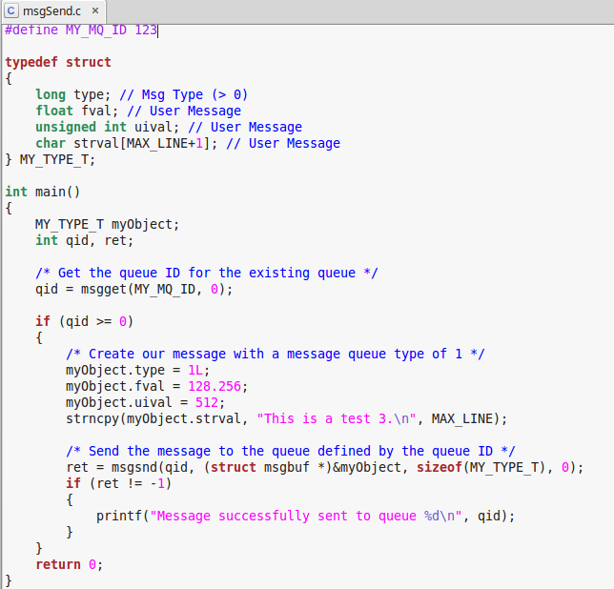
Figure-11: Correct code.

Q-12: Explain the output.
Ans: In code 1st define “#define MY_MQ_ID 123” and compile then define “#define MY_MQ_ID 111” and compile. So, send 2 message.
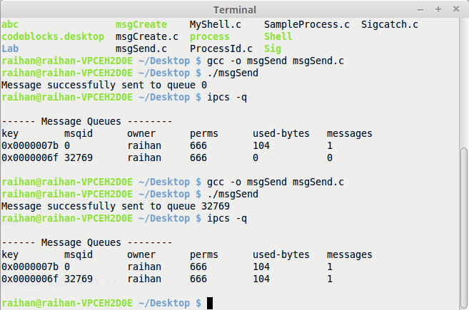
Figure-12: Output of correct code.

#Receive message to another process.
Q-13: Correct the code.
Ans: Fig-13 will show correct code
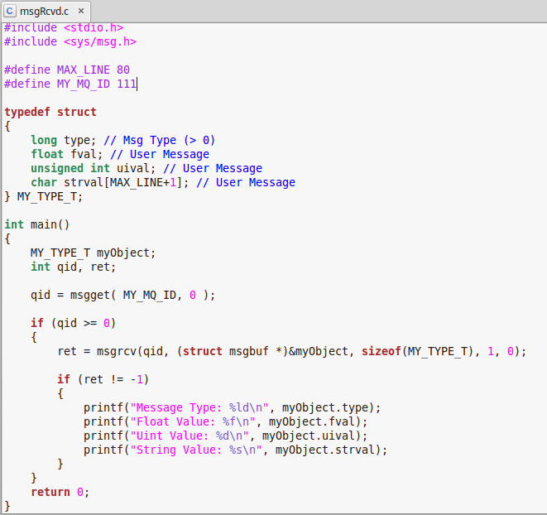
Figure-13: Correct code.

Q-14: Explain the output.
Ans: In code 1st define “#define MY_MQ_ID 123” and compile then define “#define MY_MQ_ID 111” and compile. So, received 2 message.
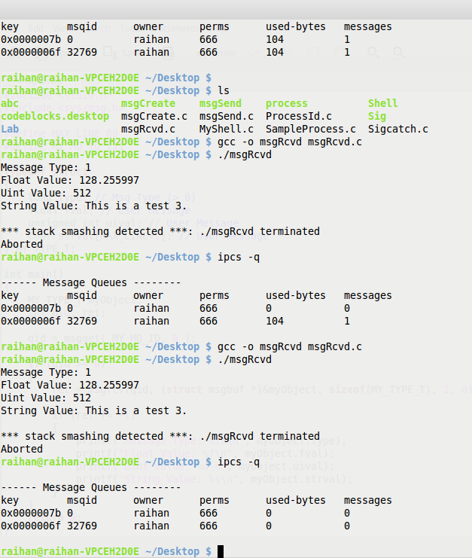
Figure-14: Output of correct code.

===XXX===

