

The Impact of Gross Fixed Capital Formation and Gross Domestic Savings on Economic Growth in India: An ARDL Approach (1990-2025)

SUBMITTED BY:

Raihan Sadath 2333442

SUBMITTED TO:

Dr. Augustine Joseph

CIA-I
ECO403-7 Applied Econometrics

DEPARTMENT OF ECONOMICS
CHRIST (DEEMED TO BE UNIVERSITY), BRC

10th July, 2026

Declaration of AI Usage
This report was prepared with assistance from OpenAI’s GPT-5 model, which was used only to edit language, improve clarity, and summarise content provided by the authors. All ideas, arguments, and research findings originate entirely from the authors. The AI tool’s role was limited to language refinement and summarisation.

1. Introduction
One of the primary goals of macroeconomic policy has been economic growth, especially in developing economies like India, where growth is crucial to sustain the quality of life, employment and structural transformation. Empirically, the Harrod-Domar growth model focuses on the importance of saving to finance investment and growth of productive capacity (Harrod, 1939; Domar, 1946), while the neoclassical growth model places a greater emphasis on growth arising from capital accumulation (Gross Fixed Capital Formation (GFCF) in the economy (Solow, 1956; Romer, 1986). The Indian context also suggests that increases in investment and savings have often been associated with accelerated economic expansion (Ahluwalia, 2002) and that macroeconomic variables may exhibit different orders of integration to sluggishly adjust to the impacts of economic shocks; static estimation techniques can lead to incorrect or incomplete conclusions about the long-run relationships between macroeconomic variables (Engle and Granger, 1987).
To overcome this limitation, the current study examines the ARDL approach for studying long-run and short-run dynamics among GDP growth, Gross Fixed Capital Formation (GFCF) growth, and Gross Domestic Savings (GDS) in India between 1990 and 2025 and concludes with an understanding of India's growth dynamics.

2. Literature Review
Empirical evidence generally supports the existence of a positive relationship between savings, investment, and economic growth, although the magnitude and direction of these relationships differ across countries and methodologies. In a study titled “Dynamic Interaction Between Savings, Investment and Economic Growth in India”, (Varghese, 2025) employed the ARDL framework and found a long-run cointegrating relationship among Gross Domestic Savings (GDS), Gross Fixed Capital Formation (GFCF), and GDP. In the short run, however, the study found that savings and investment are significant factors in influencing GDP growth, but there is little evidence. Similarly, “The Impact of Gross Capital Formation on Economic Growth: Evidence from India” (Reddy & Ramaiah, 2020) used annual Indian data and the ARDL approach to conclude that gross capital formation exerts a positive and statistically significant effect on economic growth, reinforcing the importance of investment-led growth strategies.
Evidence from broader macroeconomic studies also highlights the significance of capital formation in promoting long-run development. In the paper titled “Determinants of Economic Growth in India: A Time Series Analysis”, (Das, M.K., 2020) established that among the key macroeconomic determinants of economic growth, capital formation plays an important role but the impact of capital formation on economic growth depends on the macroeconomic environment and policy measures.
3. Research Methodology

This study employs a quantitative time-series research design to examine the relationship between GDP growth, Gross Fixed Capital Formation (GFCF), and Gross Domestic Savings in India over the period 1990-2025. Secondary data were collected from reputed Indian sources, namely the RBI (Handbook of Statistics on the Indian Economy), MoSPI (National Account Statistics), and NITI Aayog, which were further compiled and organised using Microsoft Excel before being imported into EViews 9 for statistical processing and econometric analysis. The methodology begins with descriptive statistics to summarise the characteristics of the variables, followed by testing for stationarity using graphs, correlograms, and unit root tests. Gross Domestic Savings were made stationary at the 1st difference, post which ARDL was run using level values of the dependent variable (GDP growth rate) and GFCF growth rate as the first independent variable. Further on, coefficient and residual diagnostic tests have been run to check for the validity and quality of the data, along with checking for the length of the relationship between the variables.

Justification for ARDL Model:
The ARDL model was selected because the variables exhibit a mixed order of integration, with GDP Growth and GFCF Growth integrated of order zero, I(0), and Gross Domestic Savings integrated of order one, I(1). Unlike conventional cointegration techniques, the ARDL approach permits the estimation of models containing both I(0) and I(1) variables, provided none is I(2) (Pesaran et al., 2001). Additionally, the method is appropriate for small sample sizes and enables the estimation of both short-run dynamics and long-run equilibrium relationships within a unified framework.
(Note: All EViews screenshots are included in the appendix)

4. Data Analysis and Interpretation

4.1 Summary Statistics
Table 1: Summary Statistics
Statistic | Observations | GDP Growth (%) (DV) | GFCF Growth (%) (IV-1) | GDS (% of GDP) (IV-2)
Mean | 36 | 6.15 | 7.81 | 28.80
Std. deviation | 36 | 2.80 | 6.75 | 4.01
Min | 36 | -5.77 | -7.70 | 21.63
Max | 36 | 9.68 | 22.19 | 34.37
Jarque-Bera (p-values) | 36 | 0.00 | 0.78 | 0.18

Analyses here are based on 36 annual observations covering the period 1990-2025. The average GDP growth rate is 6.15%, while Gross Fixed Capital Formation (GFCF) records a mean growth rate of 7.81%, indicating relatively higher investment growth over the sample period. Gross Domestic Savings (GDS) averages 28.80% of GDP, reflecting a stable level of domestic savings in the Indian economy. Among the variables, GFCF exhibits the highest variability (standard deviation = 6.75), suggesting that investment growth experienced greater fluctuations than GDP growth and GDS. The Jarque-Bera normality test indicates that GFCF (p = 0.78) and GDS (p = 0.18) are normally distributed, whereas GDP growth (p = 0.00) deviates from normality, likely due to extreme economic shocks during the study period. However, the ARDL methodology does not require the explanatory variables to be normally distributed, and therefore the non-normality of GDP growth does not affect the suitability of the model.

4.2 Correlation Matrix
Table 2: Pearson correlation matrix
 | GDP Growth (%) | GFCF Growth (%) | GDS (% of GDP)
GDP Growth (%) | 1.00 | 0.62 | 0.35
GFCF Growth (%) | 0.62 | 1.00 | 0.15
GDS (% of GDP) | 0.35 | 0.15 | 1.00

GDP growth exhibits a moderately positive correlation with GFCF growth (r = 0.624), suggesting that higher investment growth is associated with higher economic growth. GDP growth also shows a weak positive correlation with GDS (r = 0.353), while the correlation between GFCF growth and GDS is weak (r = 0.151). Overall, none of the correlation coefficients exceeds the commonly accepted threshold of 0.80, indicating that severe multicollinearity is unlikely to be a concern in the model.

4.3 Stationarity Analysis
4.3.1 Graphical Analysis
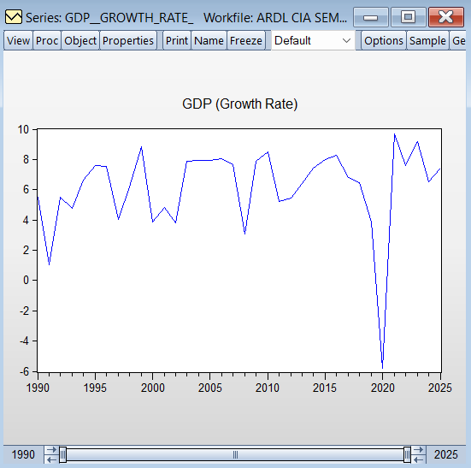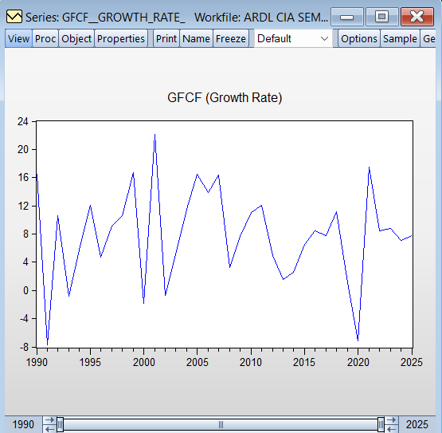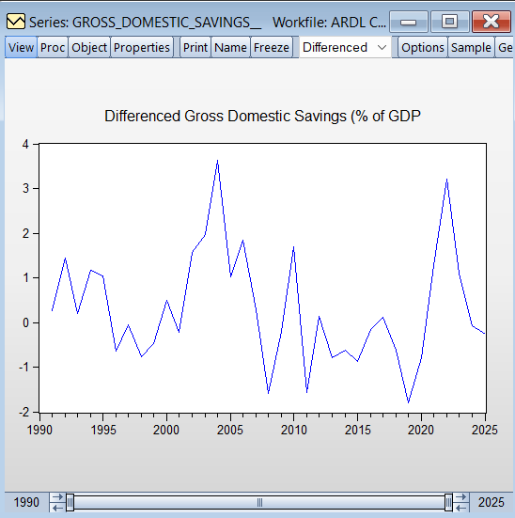
[figures 1,2,3 in order of GDP, GFCF, d(GDS)]

GDP and GFCF growth fluctuate around a relatively constant mean with no persistent trend, suggesting stationary behaviour at level. In contrast, GDS exhibited a clear upward trend at level, hence the first-differenced series of GDS is presented, providing preliminary evidence of stationarity.

4.3.2 Correlogram Analysis
This was run to check the immediate presence of Autocorrelation and Partial Autocorrelation, but the spikes were within the controlled region as indicated by the boundaries. An exception was noted in the case of GDS at level, but at 1st difference, it was corrected.
(Note: Correlograms were generated using the default lag length of 16, automatically selected by EViews, check Appendix for results)

4.3.3 Unit Root Tests
Table 3: Summary of ADF and Phillips-Perron Unit Root Test Results
Variable | P-value (ADF) | P-value (PP-test) | Stationarity | Order of Integration
GDP Growth (%) | 0.00 | 0.00 | At level | I(0)
GFCF Growth (%) | 0.00 | 0.00 | At level | I(0)
GDS (% of GDP) | 0.0076 | 0.0072 | First difference | I(1)
(Note: For GDS, the reported p-values correspond to the first-differenced series; the lag length selection criterion has been automatically set by the software)

H₀: Variable has a unit root
H_{a}: Variable does not have a unit root

The results of the Augmented Dickey-Fuller (ADF) and Phillips-Perron (PP) unit root tests conducted to determine the order of integration of the variables indicate that the dependent variable, GDP Growth and the independent variable, Gross Fixed Capital Formation (GFCF) Growth, are stationary at level, as both the ADF and PP tests reject the null hypothesis of a unit root at the 5% significance level. In contrast, Gross Domestic Savings (GDS) as the second independent variable is found to be non-stationary at level but becomes stationary after first differencing, indicating that the variable is integrated of order one, I(1). None is integrated of order I(2); the application of the Autoregressive Distributed Lag (ARDL) approach is considered appropriate for the present study. Also, the KPSS test is not run here because of enough supporting evidence suggesting stationarity in the chosen variables.

4.4 Autoregressive Distributed Lag method and analysis (ARDL)
Table 4: Summary of ARDL (1,0,0)
Variable | Coefficient | Std. Error | t-stat | p-value | Inference
GDP Growth (-1) | 0.108 | 0.13 | 0.83 | 0.41 | Insignificant
GFCF Growth | 0.261 | 0.05 | 4.60 | 0.00 | Significant
D (Gross Domestic Savings) | 0.478 | 0.30 | 1.59 | 0.12 | Insignificant
Constant | 3.378 | 1.00 | 3.35 | 0.002 | Significant

Model Equation: GDP_{t}​ = β₀ ​+ β₁GDP_{(t-1)}​ + β₂​GFCF_{t} + β₀​D(GDS_{t}​) + ε_{t}
Substituting Coefficients: 3.37 ​+ 0.108[GDP_{(t-1)}​] + ​0.261[GFCF_{t}] + 0.478 [​D(GDS_{t}​)] + ε_{t}

Table 5: Model Summary
Statistic | Value
Sample Period | 1990-2025
Observations | 35
R² | 0.47
Adjusted R² | 0.42
Durbin-Watson | 1.97
Lag Length (AIC) | 2; both the dependent variable and regressors

The model, based on the lowest AIC (Akaike info criterion), a value of 4.526, has chosen just one lag for the dependent term and has kept the regressors with no lags at level. At the 5% level of significance, the lagged coefficient of GDP Growth(-1) is 0.108 and is statistically insignificant (p = 0.41). This implies that past economic growth does not statistically exert an influence on the current growth of the economy. Gross Fixed Capital Formation (GFCF) Growth exhibits a positive and highly significant relationship with GDP growth. A coefficient of 0.2613 with a (p = 0.00) indicates that a one percentage point increase in GFCF growth is associated with an approximately 0.26 percentage point increase in GDP growth. This finding is consistent with the Harrod-Domar and Solow Growth Models, which state that capital accumulation directly enhances productive capacity. The coefficient of D(Gross Domestic Savings) is 0.478, indicating a positive but statistically insignificant relationship with (p = 0.12), possibly because savings influence growth indirectly through investment and financial intermediation rather than immediately (King & Levine, 1993). Additionally, with respect to the time period, the insignificance of variables could also be equated with the global financial crisis of 2008 (Bhanumurthy & Kumawat, 2009) and the COVID-19 pandemic (Dev & Sengupta, 2020). The significant constant term is indicative of a positive baseline growth recorded in the Indian GDP at 3.35%. The explanatory power of the model is satisfactory at a moderate level of 0.47, which is justifiable for any macroeconomic data. Along with this, there is no trace of autocorrelation, which is indicated by a near-perfect Durbin-Watson statistic of 1.97.
4.4.1 Bounds Test, ARDL Cointegrating and Long Run Form
ARDL is limited or bounded by the information on the existence of a relationship between the selected variables in our model. This limitation is overcome by the bounds test, which determines the presence of a long-run equilibrium relationship along with long-run form, and the ARDL cointegrating test tells about the short-run relationship.

Bounds Test Hypothesis:
H₀: No long run relationships exist
H_{a}: Long-run relationships exist

The corresponding F-stat value is 13.003, which is greater than the I1 bounds at 5% and 1%. This rejects the null hypothesis, indicating that the variables share a stable long-run equilibrium relationship despite short-run fluctuations.

ARDL Cointegrating and Long Run Form:
A p-value less than 5% level of significance indicates the presence of a short and long-run relationship between the variables present in the model. For GFCF, there is a presence of both short and long run relationships with GDP growth rate, and it is positive, unlike GDS, which is insignificant here. The error correction coefficient is negative and statistically significant, satisfying the theoretical requirement for a valid ECM (error correction model). The coefficient of -0.8911 indicates that approximately 89.1% of any short-run disequilibrium is corrected within one year.
Note: The selected ARDL specification is ARDL(1,0,0), which contains only one lagged dependent variable and no lagged regressors. Since there are no multiple lag coefficients or linear restrictions to test jointly, a Wald test would be redundant, as the individual coefficient significance is already evaluated through the corresponding p-value. Check the Appendix for cointegrating table values.

4.5 Summary of Post-estimation Diagnostic Tests
Table 6: Diagnostics Summary
Diagnostic Test | Null Hypothesis | Test Statistic | p-value | Decision | Inference
Breusch-Pagan-Godfrey | Error variances are homoscedastic | F = 1.72 | 0.18 | Fail to reject  H₀ | No evidence of heteroskedasticity
Breusch-Godfrey LM | No serial correlation exists | F = 0.02 | 0.97 | Fail to reject  H₀ | Residuals are free from serial correlation
Jarque-Bera Normality | Residuals are normally distributed | JB = 27.05 | 0.00 | Reject H₀ | Residuals are not normally distributed
VIF | No multicollinearity exists | ~1.05 | - | - | No multicollinearity (VIF < 5)
Ramsey RESET | Model is correctly specified | F = 27.79 | 0.00 | Reject H₀ | Possible model misspecification/ omitted variables

The model qualifies for the majority of the post-estimation diagnostic tests, wherein the model is homoscedastic, free from autocorrelation and multicollinearity. The model, however, fails to follow normality and is technically not correctly specified. Theoretically, omitted variable bias and improper lag selection cause model misspecification; however, this study is focused on Gross Fixed Capital Formation and Gross Domestic Savings as factors affecting economic growth, whilst ignoring factors such as inflation, government expenditure, foreign direct investment, trade openness, and technological progress. Consequently, the estimated model may not fully capture the complexity of India's growth process. Combined with the small sample size and complexities in any macroeconomic data, it has tended towards a Ramsey RESET statistic suggesting model misspecification.

5. Limitations
The study is based on a relatively small sample of 36 annual observations, affecting the robustness of the estimated relationships. Here, Gross Fixed Capital Formation and Gross Domestic Savings were considered as determinants of economic growth, leaving out other macroeconomic factors; this may partly explain the Ramsey RESET test results indicating possible model misspecification. Lag selection criterion has no fixed method, and changing the automated software values can potentially manipulate the results too; this calls for a limitation that could have arisen from using just EViews.

6. Conclusion
The main findings from this study suggest that investment plays a much stronger role than domestic savings alone. Gross Fixed Capital Formation (GFCF) was found to have a significant positive long-run impact on GDP growth, indicating that expanding productive capacity through investments in infrastructure, machinery, and other fixed assets contributes directly to economic growth. At the same time, Gross Domestic Savings (GDS) did not have a statistically significant direct effect on economic growth. This suggests that while savings are essential, they contribute to growth only when they are effectively converted into productive investment through means of either greenfield or brownfield investments. Simply increasing the level of savings may not be sufficient unless the financial system efficiently channels those resources into investment opportunities. Therefore, for a developing economy like India, policies should focus not only on encouraging savings but, more importantly, on improving investment efficiency and promoting sustained capital formation. Overall, the findings indicate that how resources are invested matters more for economic growth than how much is saved.

References
Ahluwalia, M. S. (2002). Economic Reforms in India Since 1991: Has Gradualism Worked? Journal of Economic Perspectives, 16(3), 67–88. https://doi.org/10.1257/089533002760278721
Bhanumurthy, N. R., & Kumawat, L. (2009). Global Economic Crisis and Indian Economy. Review of Market Integration, 1(2), 123–135. https://doi.org/10.1177/097492920900100202
Das. (2020). Determinants of economic growth in India: A time series perspective. Https://Store.Ectap.Ro/; Theoretical and Applied Economics. https://store.ectap.ro/articole/1466.pdf
DBIE. (2024). Rbi.Org.In. https://data.rbi.org.in/#/dbie/home
Domar, E. D. (1946). Econometrica, 14(2), 137. https://doi.org/10.2307/1905364
Engle, R. F., & Granger, C. W. J. (1987). Co-Integration and Error Correction: Representation, Estimation, and Testing. Econometrica, 55(2), 251–276.
Harrod, R. F. (1939). An Essay in Dynamic Theory. The Economic Journal, 49(193), 14. https://doi.org/https://doi.org/10.2307/2225181
Koti, T. (n.d.). THE IMPACT OF GROSS CAPITAL FORMATION ON ECONOMIC GROWTH : EVIDENCE FROM INDIA [Review of THE IMPACT OF GROSS CAPITAL FORMATION ON ECONOMIC GROWTH : EVIDENCE FROM INDIA]. Retrieved July 8, 2026, from https://www.ashwinanokha.com/resources/ijeb%20v19-1-4.pdf
Lackman, C. L. (1982). A Note on the Stability Limitations in “A Stable Price Adjustment Process.” The Quarterly Journal of Economics, 97(3), 541. https://doi.org/10.2307/1885877
Liya Varghese. (2025). Dynamic interaction between savings, investment and economic growth in India: Evidence from ARDL approach [Review of Dynamic interaction between savings, investment and economic growth in India: Evidence from ARDL approach]. Srusti Management Review. https://doi.org/10.63340/samt/10011
Mahendra Dev, S., & Sengupta, R. (2020). Covid-19: Impact on the Indian economy. http://www.igidr.ac.in/pdf/publication/WP-2020-013.pdf
Ministry of Statistics and Program Implementation | Government Of India. (n.d.-a). Esankhyiki.Mospi.Gov.In. Retrieved July 8, 2026, from https://esankhyiki.mospi.gov.in/
National Data and Analytics Platform. (n.d.-b). Ndap.Niti.Gov.In. Retrieved July 8, 2026, from https://ndap.niti.gov.in/
Romer, P. M. (1986). Increasing Returns and Long-Run Growth. Journal of Political Economy, 94(5), 1002–1037. https://www.jstor.org/stable/1833190
Wong, K. (2018, January 2). Peasaran et al. (2001) Bound Test and ARDL cointegration Test [Review of Peasaran et al. (2001) Bound Test and ARDL cointegration Test]. https://www.researchgate.net/publication/322208483_Peasaran_et_al_2001_Bound_Test_and_ARDL_cointegration_Test

Appendix
NOTE: The word count accounts for nearly 400 words in the table alone as part of the overall word count; this is the reason for a first inference high word count, rather than possible extensions in unnecessary words. Stating this just for ease of clarity and no other motives.
Table 1: Descriptive Statistics
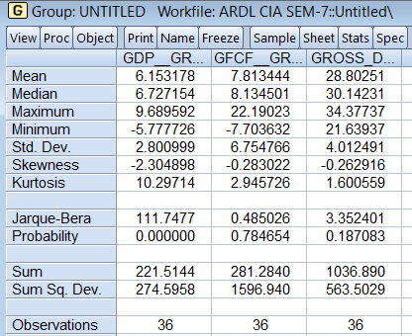
Table 2: Pearson Correlation Analysis
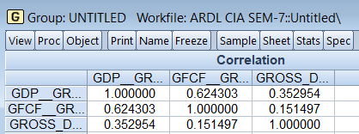
Table 3: GDP Growth Rate Correlogram
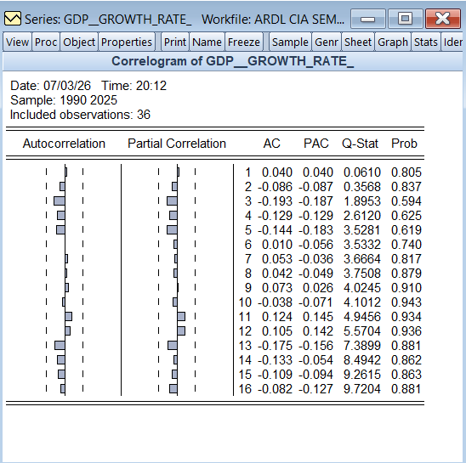
Table 4: GFCF Growth Rate Correlogram
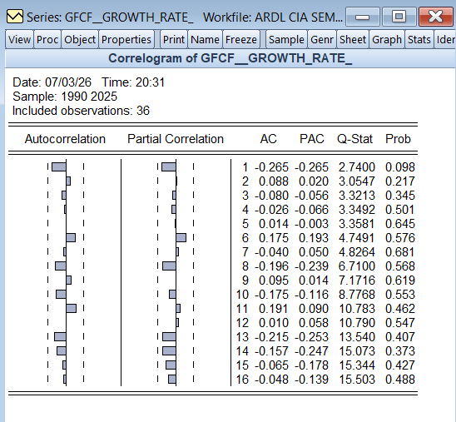
Table 4: GDS Correlogram (at level)
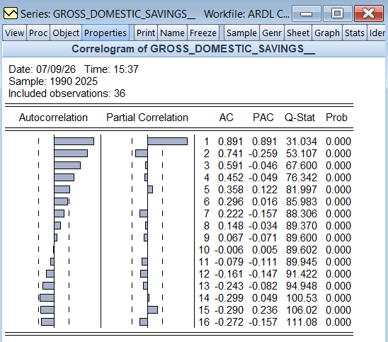

Table 5: GDS Correlogram (at first-difference)
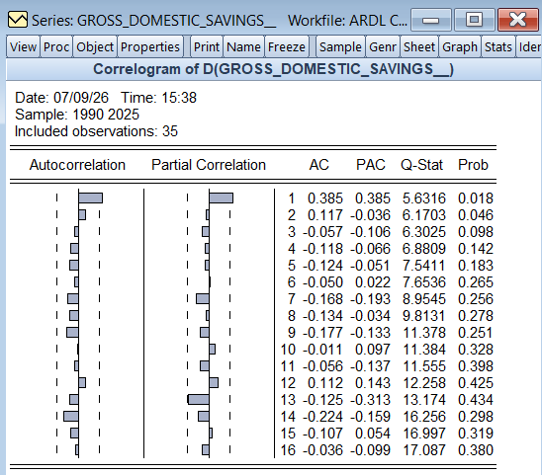
Table 5: ADF for GDP
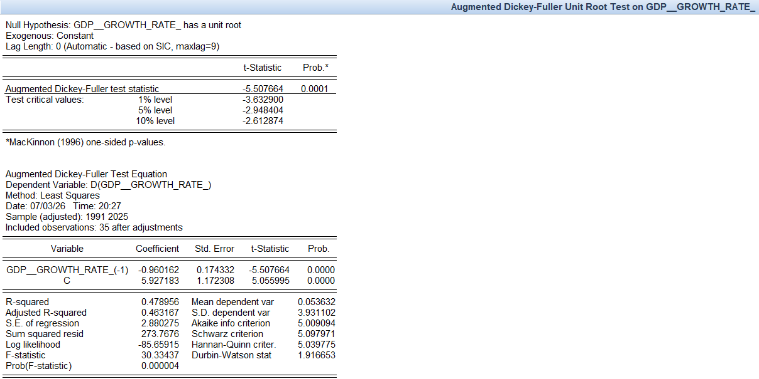

Table 6: PP test for GDP
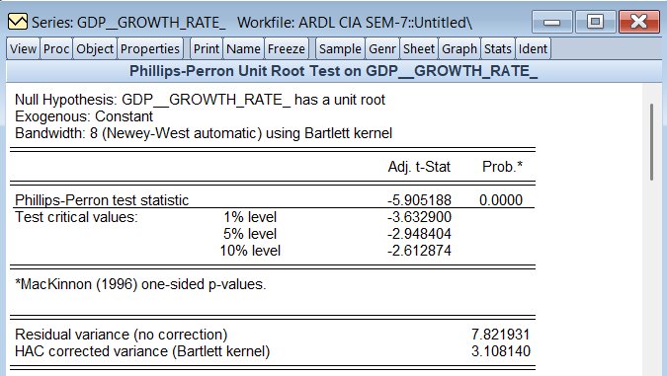
Test 7: ADF for GFCF Growth Rate
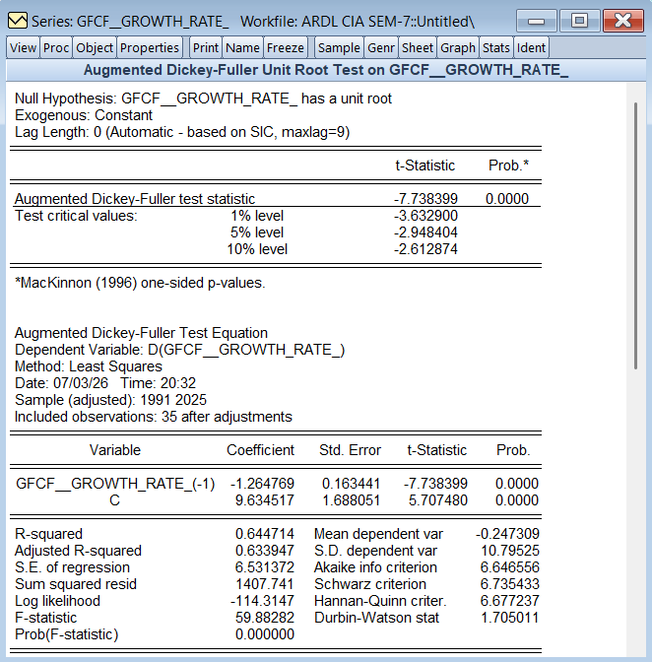

Test 8: PP Test for GFCF Growth
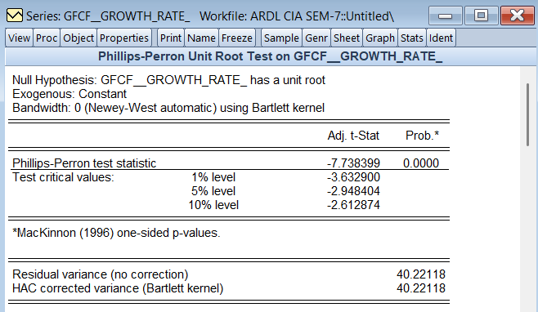
Test 9: ADF for GDS at level
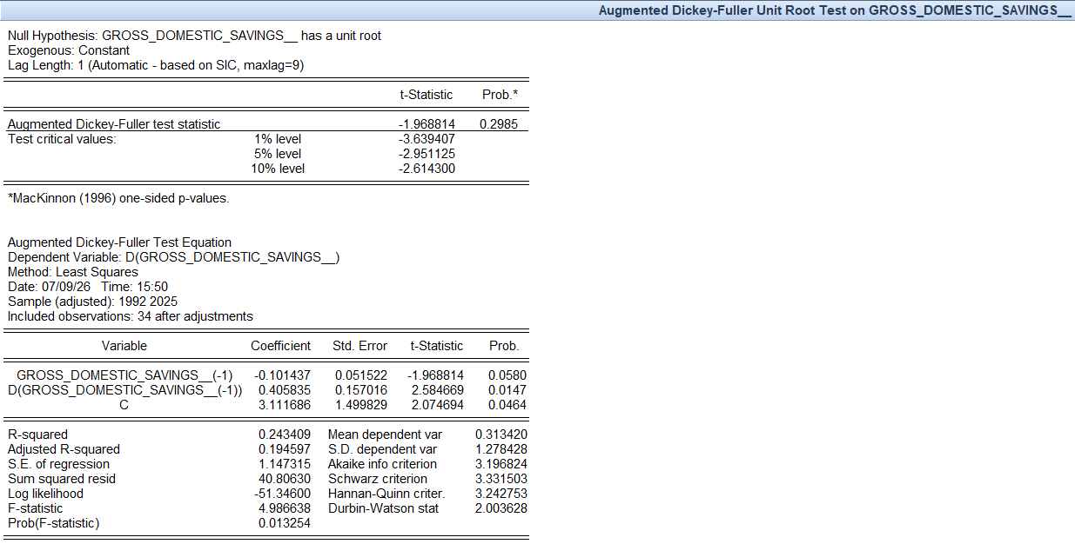

Test 10: ADF for GDS (first difference)
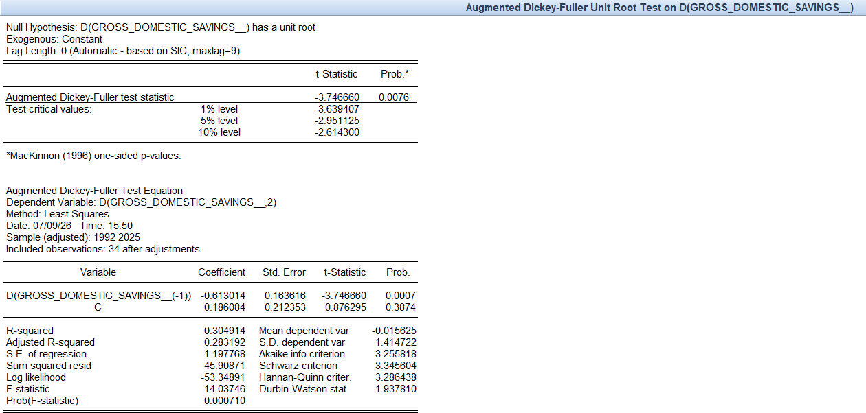
Test 11: PP Test for GDS (at level)
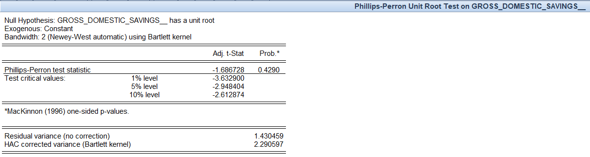
Test 12: PP Test for GDS (first difference)
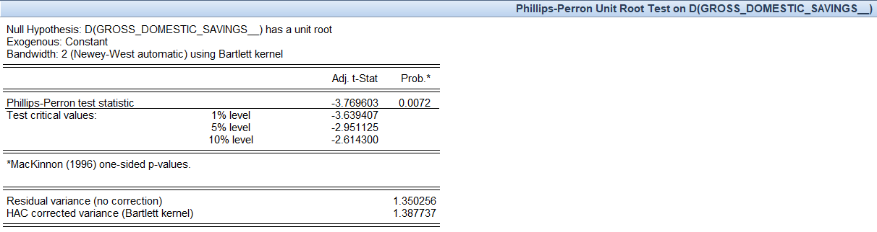
Test 13: ARDL Model
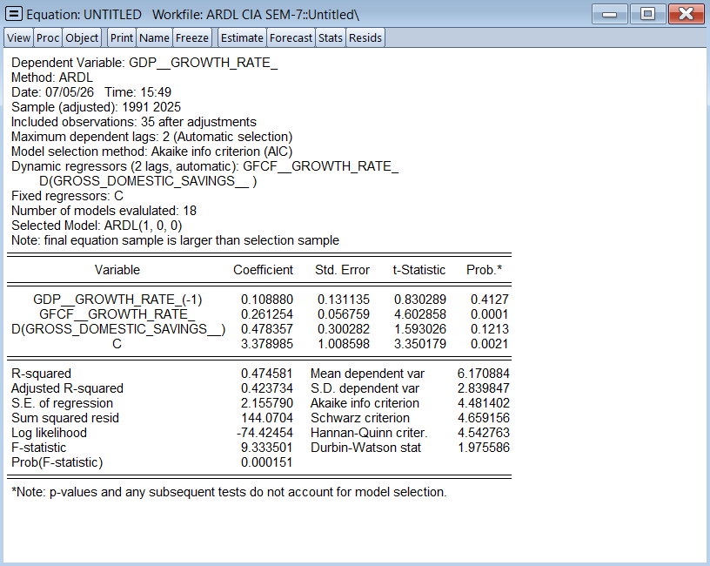

Test 14: Bounds Test
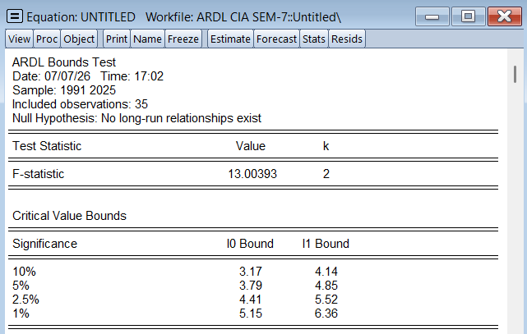
Test 15: Long-run cointegrating test
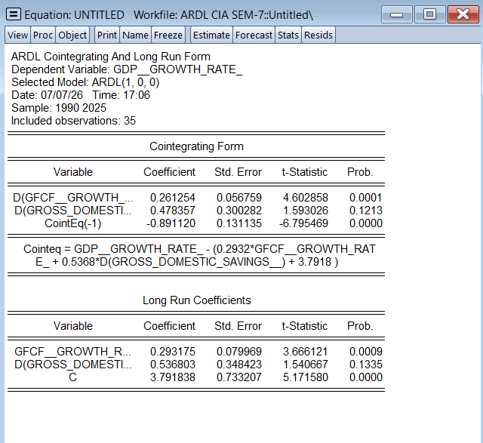

Test 16: Heteroscedasticity
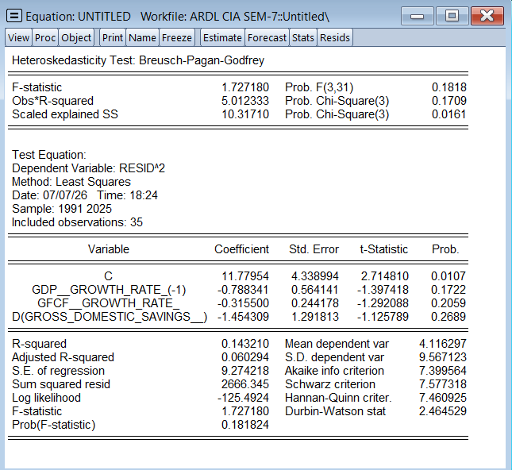
Test 17: Serial Correlation Test
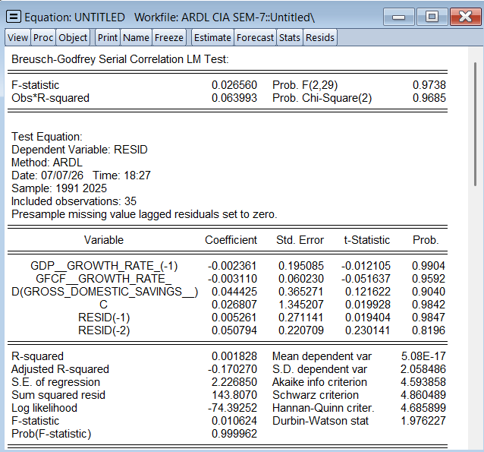

Test 18: Jarque-Bera Normality Test
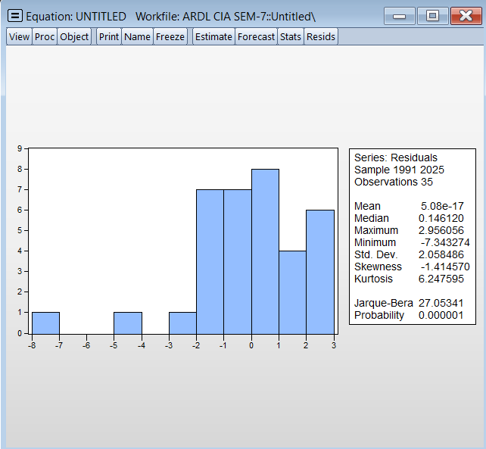
Test 19: Variance Inflation Factor
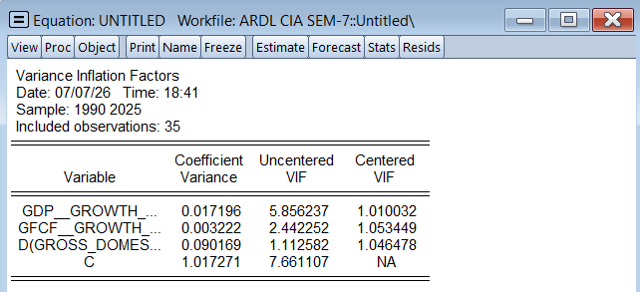

Test 20: Ramsey RESET Test
