## Resources (HTML ,CSS and JS)

1. Web developer job roles, salary and opportunities. [Collegegrad](https://collegegrad.com/careers/web-developers)

2. How to become web developer in 2021?[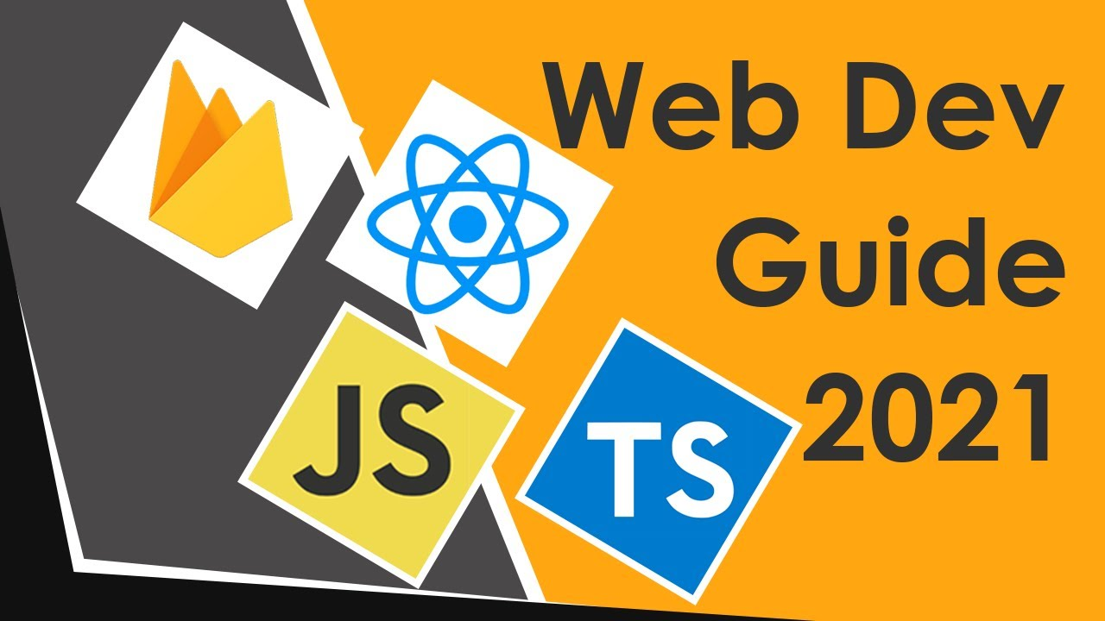](https://www.youtube.com/watch?v=AWeWihbC0YU)

3. [Take a look at this](https://www.w3schools.com/whatis/)

4.Resources for Learning HTML , CSS and JS.

HTML Crash course by

1. [Traversy Media](https://www.youtube.com/watch?v=UB1O30fR-EE) 1Hr posted 3 years ago

2. [Programming with Mosh](https://www.youtube.com/watch?v=qz0aGYrrlhU). 1hr 9 mins posted 3 months ago

HTML full course on

1. [freecodecamp.org](https://www.youtube.com/watch?v=pQN-pnXPaVg) youutube 2hrs posted 2 years ago
2. [Code with harry](https://www.youtube.com/watch?v=BsDoLVMnmZs) youtube 3hrs 11mins posted 1 month ago

HTML CSS combined course

1. [DevEd](https://www.youtube.com/watch?v=vQWlgd7hV4A) 4hr posted 1 year ago
2. [DesignCourse](https://www.youtube.com/watch?v=D-h8L5hgW-w) 2hr 17 mins posted 2months ago

5. Websites for learning Web development

1. [freecodecamp.org](http://freecodecamp.org)
2. [W3 Schools](https://www.w3schools.com/whatis/).

6. JS learning resources

1. [freecodecamp.org](https://www.youtube.com/watch?v=PkZNo7MFNFg) 3hr 26mins 2years ago
2. [Clever programmer](https://www.youtube.com/watch?v=Qqx_wzMmFeA) 8hr posted 1year ago
3. [Traversy media](https://www.youtube.com/watch?v=hdI2bqOjy3c) 1hr 40mins posted 2years ago

4. [Programming with mosh](https://www.youtube.com/watch?v=W6NZfCO5SIk) 48mins 2years ago

Tips -

1 . All of the resources and links are of youtubers that I watch and have learned a lot from all of them .All of them are great but follow the course of the YouTuber whose styling of teaching you like the most. (Programming with mosh is my recommendation for beginners)

2. If your are starting out pick the courses of shortest duration so that you don’t end up quitting in between.

3. Try to finish what you start.

4.Always follow along the tutorials and try on your own computer.

5.All of the course teach the same things but more duration = more topics covered

Note - There are a lots of other resources that you can get on the internet . I have listed only a handful of them. Don’t worry if a course is 2 or 3 year old , it is still valid today .