Introduction:

One Byte Food is a platform as a service app providing users the platform to reserve their preffered restaurants through it. One Byte Food consists of multiple different core technologies and functionalities required it to function correctly and according to the client’s requirement. Those requirements were divided into two sprint to make sure the proper delivery of the app. The different tasks also known as issues were selectively chosen for the sprint and was assigned to developers. Personally the issues assigned to me included various functionality of the like the user location, search, button routing and many more I was also assigned to develop different widgets needed for the app like image carousel, reviews,etc. The issues assigned to me were made sure of completion through the different learning process and graphs which included the tutorials and mainly digging into the documentation. The issues assigned were collaborated through Github repo.

Image Carousel

This issue required the developer to create a image slider which would be able to display he images of the restaurant. Different methods of creating a carousel were looked upon and different plugins were also searched. Upon the research of multiple elements, I finally settled with the plugin called FLutterCarousel. The carousel consists of multiple properties like items, width, height, autoScroll and many others which could be tweaked create the perfect carousel needed as per the requirement of the app.

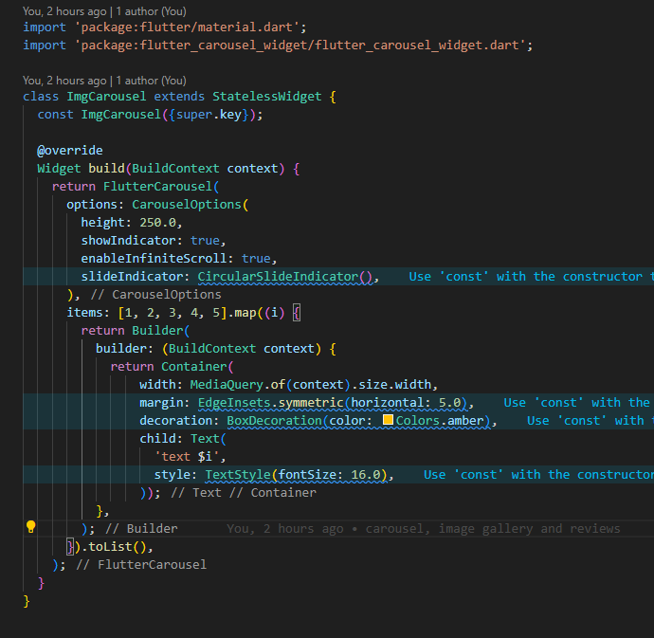

User Location

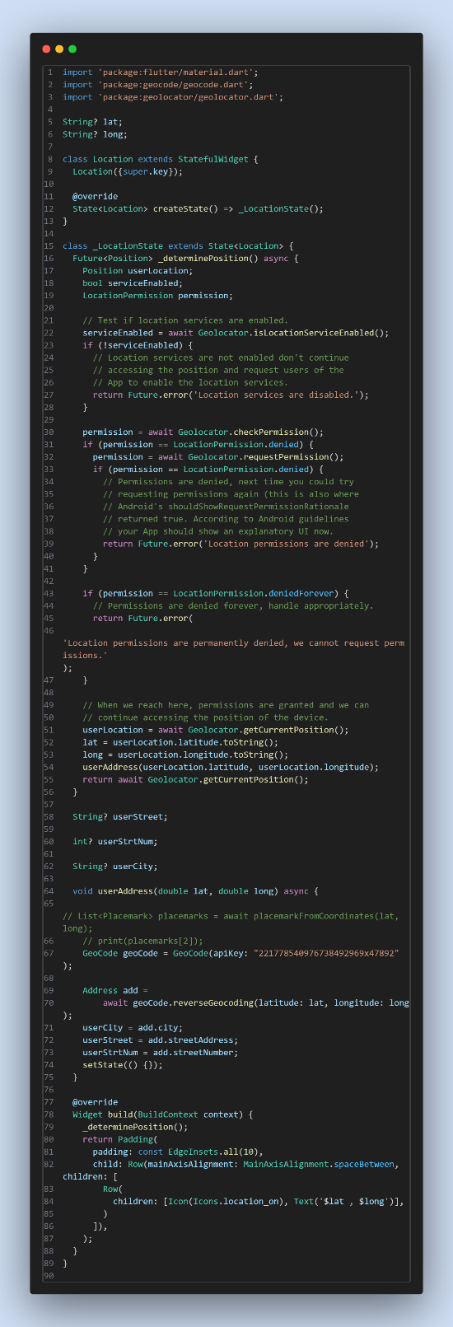The ability to track the location of the user precisely was tough nut to crack. This was being a issue with slightly higher difficulty mainly because of the inability to use the Goggle Maps Api which had pay to use procedure. Furthermore, the ability to ask the user for their permission and the background usage had to be configured also. The code basically uses functionality of two plugins ( Location and GeoCode). The location provides latitude and longitude of the user where the geocode is used to perform reverse geo coding and get the actual street name and city name of the user. The permission asking functionality was setup individually for the android and iOS through their respective native builds which was then further used into the code to make sure to get the location of the user only inf the permission was allowed.

User Search

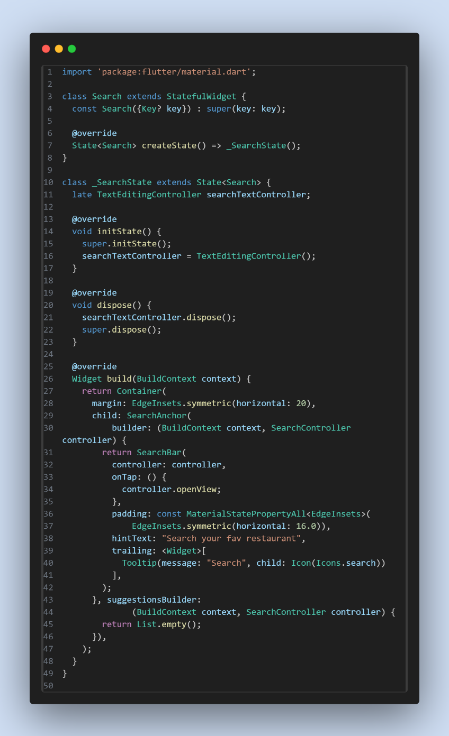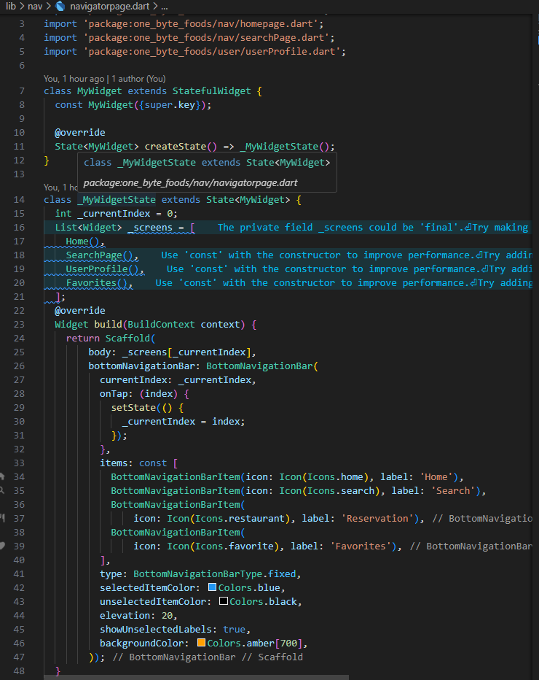The user search consistd of two sub taks inside it Firlty was the search task navigation page and secondly was to create a custom widget to integrate in the homepage. The search used the functionality of in built widget called SearhBar. This along with the suffix actions and the text editing contoller allowed the user to search there needs.

Reviews

The reviews sectionw as created through the custom widget development. A custom widget was developed with different Columns, rows and Containers to prvoide the user to ability to view the review of the restaurant

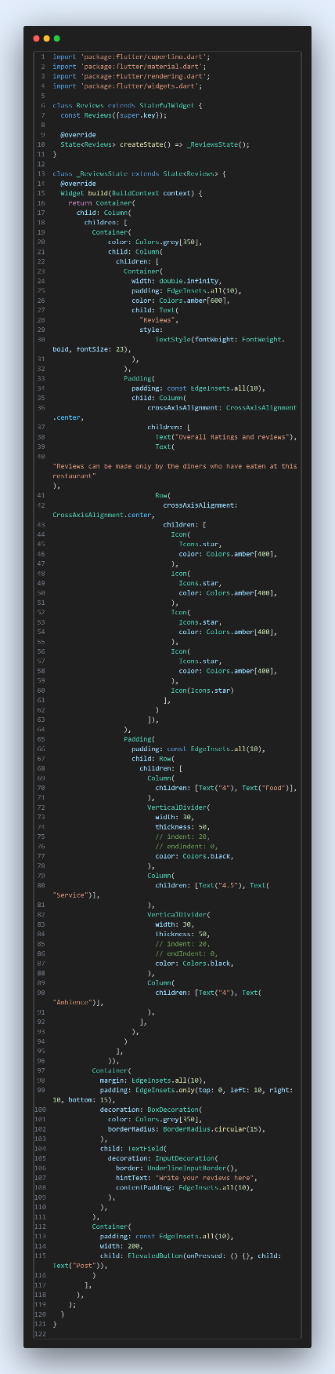

Conclusion

To sum up, the sprint one consisted of multiple issues of multiple difficulties personally assigned to me. Each and all issues were completed with proper dedication and on time. The codes were then pushed and after completing each issue into the github repository to provide proper version control and for the collaboration.

