APT Tennis Club

Member Access & Tweener

STATUS  Draft |  | OWNER  APT Management |  | LAST UPDATED  August 11, 2026

Authors | APT Product & Engineering
Reviewers | APT Management
Related docs | APT_BRAIN.md; PRODUCT.md; DESIGN.md
Scope | Authenticated member access, constrained management updates and club community links.

1. Abstract
APT Hub provides a mobile-first member area and a constrained management workflow for participation and community access. Next.js owns the UI/API boundary, Supabase is the canonical store, and Tweener/WhatsApp remain external destinations. Active members receive community links; administrators can set limited overrides with an audit trail.
This design serves authenticated members and administrators. It excludes external group APIs, card or CPF handling, manual financial status changes, migrations, deployment and production billing.

2. Goals and Non-Goals
Goals | Non-goals
Active members reach Tweener and WhatsApp from one safe portal section. | No external group membership automation.
Management changes only permitted manual participation states. | No manual active or delinquent financial status.
Every override is validated and auditable. | No card, CPF, secret or payment collection.
Mobile cards remain usable at 375px; desktop retains a table. | No deploy, migration or production billing in this task.

3. Background and Problem Statement
The portal had member-link fields but did not consistently expose the club defaults, and management had no bounded, auditable correction path. A desktop-oriented table was also awkward on a phone.
Only payment-owned state grants normal active access. The server accepts pending_payment, courtesy and inactive from management; active/delinquent financial status remains outside this control plane. Community URLs are returned only after member authentication and active access evaluation.

4. Proposed Architecture

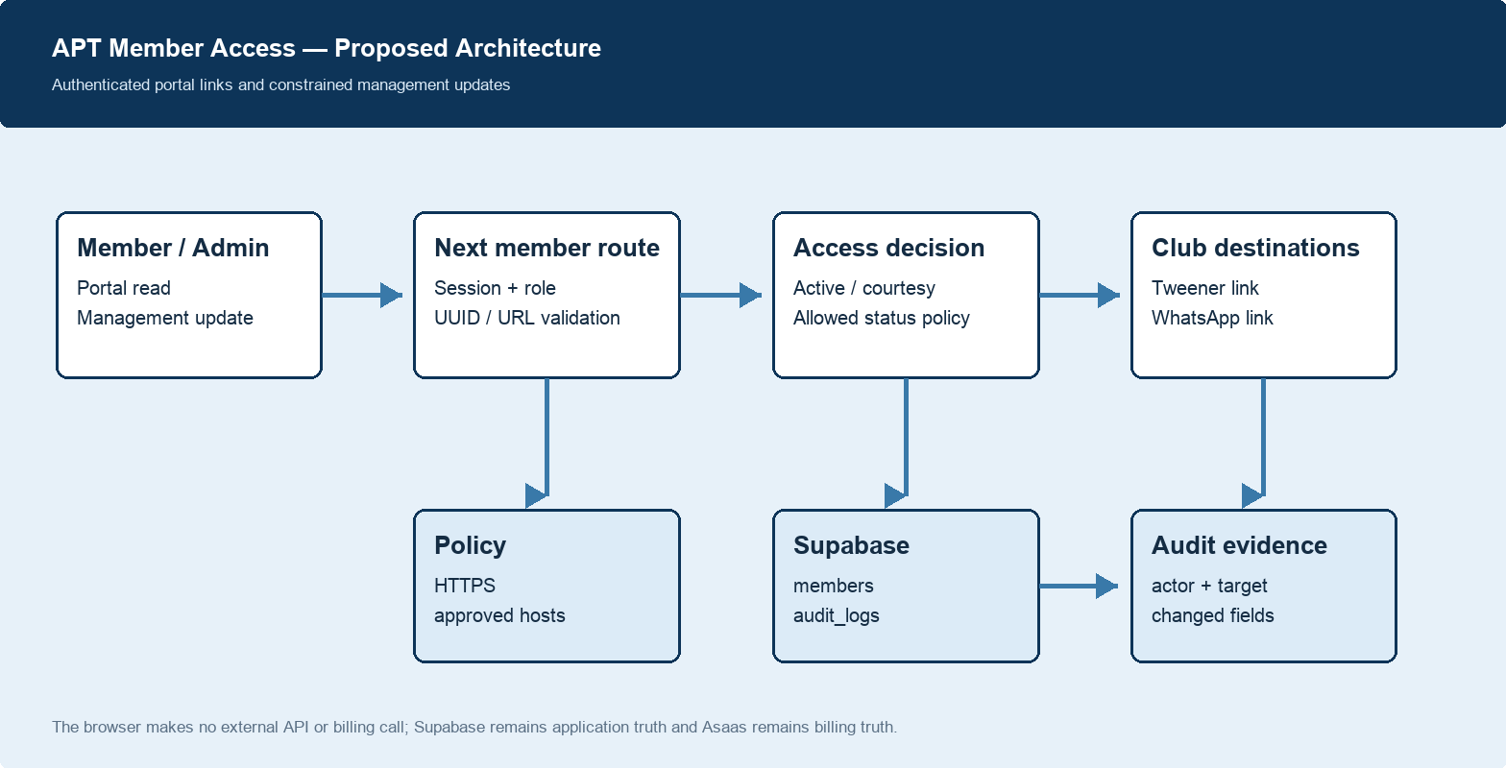
Figure 1. Proposed system architecture.

Core components

Component | Responsibility | Primary storage | Failure behavior
Member portal | Shows safe links after member authentication and access resolution. | Supabase members/subscriptions | Links absent when access is inactive.
Management UI | Phone-first cards and bounded form for member updates. | Browser state | Keeps server error inline.
Next member route | Authorizes admin; validates input; returns safe member projection. | Server runtime | Rejects invalid status, ID, URL or host.
Supabase | Canonical members fields and audit_logs event. | Postgres | Returns failure; no external action follows.
Tweener / WhatsApp | External destination after deliberate click. | External service | No API integration or retry exists.

5. Request Lifecycle
- An authenticated member requests portal data, or an authenticated administrator submits a management update.
- The route verifies session and role, validates UUIDs, normalizes optional input, and rejects unsafe URLs, hosts and manual financial states.
- Portal resolution loads member and subscription state. Management reads the administrator identity and existing member record.
- Portal access resolves active participation, paid-through cancellation or explicit courtesy. Management updates only permitted supplied fields.
- Supabase members is canonical durable state; successful management writes append a member.management_updated audit event with changed field names.
- Tweener and WhatsApp are opened only through deliberate browser links. No service API call, retry queue, or billing action is introduced.
- The browser receives safe updated fields, refreshes the card and announces success. Inline errors remain visible; audit proof remains a test gate.

6. API and Data Contracts

Primary data contract

Field | Type | Required | Description
id | UUID | Yes | Existing member identifier; server validated.
participationStatus | enum | No | pending_payment, courtesy or inactive only.
twinnerUrl | HTTPS URL | No | Empty clears; otherwise tweener.club only.
whatsappCommunityUrl | HTTPS URL | No | Empty clears; chat.whatsapp.com only.
actor | server session | Yes | Derived from authenticated administrator.
changedFields | string array | Yes on write | Audit metadata, without URL contents.
accessActive | boolean | Read only | Controls whether portal links exist.

Contract guarantees

- Authorization and URL/status validation must complete before a member write or portal link is returned.
- Member ID and actor identify every request. Repeating the same change is state-stable; audit timestamps distinguish intentional retries.
- Audit metadata captures actor, target and changed field names; it does not retain link values, card data, CPF, API keys or secrets.
- Supabase members is application truth. Asaas remains billing truth. Portal data is a safe projection, not a billing command.
The implementation contract is published in
app/api/membros/route.ts and APT_BRAIN.md; update both with each approved contract change.

7. Consistency, Idempotency, and Replay

The UI sends only changed values. A management update and audit insertion are separate REST writes today, so the first integrated test must prove both records. A future database RPC may make the pair transactional if the reliability requirement becomes active.
Scenario | Expected behavior | Reasoning
Repeated same request | Member state stays the same; a new intentional audit event is distinguishable by actor and timestamp. | No payment or external side effect is created.
Required write fails | Return a clear error and leave UI state unchanged. | The browser can safely retry after correction.
Invalid URL or status | Reject before database write. | HTTPS host and financial-status boundaries are server-enforced.
Financial state changes externally | Portal reads current subscription projection on the next request. | Asaas remains billing truth; management cannot override it.

8. Security and Privacy Considerations

- All reads and writes require authenticated routes; management also requires administrator authorization.
- No browser receives a Supabase secret, Asaas credential, card data or CPF. Audit metadata stores changed fields rather than URL contents.
- Server secrets remain in the backend runtime secret manager and never enter client code, tables, logs, chat or version control.
- Management cannot manually set active or delinquent. URLs require HTTPS plus fixed allowed hosts. New tabs use noreferrer.
- Audit retention is an ownership decision. Production is blocked by existing APT-018 and APT-019 gates plus Asaas sandbox verification.

9. Operational Readiness
Signal | SLO or alert | Owner | Launch gate
Static contract checks | 13 focused checks passing | APT Engineering | Required
Typecheck and build | No failures; metadataBase warning tracked separately | APT Engineering | Required
Authenticated integration | Admin update, portal access and audit row verified in isolated non-production | APT Management | Required
Production safety gates | APT-018, APT-019 and Asaas sandbox evidence complete | APT Management | Required
Audit integrity sample | Inspect target, actor and changed fields after first-run scenarios | APT Management | Required

10. Alternatives Considered

Alternative | Why it was considered | Why it was not selected
Direct Tweener/WhatsApp integration | Could automate community membership. | Adds external permissions and lifecycle complexity outside the need.
Manual active/delinquent state | Seems operationally flexible. | Bypasses payment truth and can grant unpaid access.
Public community URLs | Avoids portal checks. | Exposes member access outside authentication and participation.
New service or table | Could isolate access controls. | Existing member fields and audit table are the smaller correct boundary.

11. Open Questions
- Should individual overrides eventually use a fixed approved group list instead of host validation?
- Who owns the first isolated non-production administrator and member test identities?
- Is a single database transaction for member update plus audit required before wider rollout?
- What retention policy applies to management audit events?

12. Decision and Next Steps
Adopt the constrained Next plus Supabase flow. First pass local checks. Then, in isolated non-production, set a test member to courtesy, verify quick links appear, set inactive, verify they disappear, and inspect the audit event. Only then move APT-008 to VERIFY; no production action is authorized.
Milestone | Deliverable | Exit criteria
M1 | Local code and static checks | Typecheck, focused tests and build pass.
M2 | Isolated non-production integration | Admin/member flow and audit record are inspected.
M3 | APT-008 verification decision | Evidence is recorded in APT_BRAIN.md; no production action implied.
M4 | Future rollout review | Existing security, schema and billing gates are independently complete.

Use footnotes for definitions, assumptions, or terms that need precision without interrupting the main narrative.

