**1.Write a program to display course details by responsive card using bootstrap like given below ?**

<!DOCTYPE html>

<html lang="en">

<head>

    <meta charset="UTF-8">

    <meta name="viewport" content="width=device-width, initial-scale=1.0">

    <link href="https://cdn.jsdelivr.net/npm/bootstrap@5.3.1/dist/css/bootstrap.min.css" rel="stylesheet" integrity="sha384-4bw+/aepP/YC94hEpVNVgiZdgIC5+VKNBQNGCHeKRQN+PtmoHDEXuppvnDJzQIu9" crossorigin="anonymous">

    <title>Assignment 1</title>

</head>

<body>

    <div class="container">

        <div class="container-fluid">

        <h1>ExcelR Courses</h1>

        <div class="row" id="banner-row">

            <div class="col-md-4" id="service-col1">

                <div class="card" style="width: 18rem;">

                    <img src="https://logowik.com/content/uploads/images/731_java.jpg" class="card-img-top" alt="JAVA Logo">

                        <div class="card-body">

                            <h5 class="card-title">Java Full Stack</h5>

                            <p class="card-text">Java is the most widely used programming language for developing the websites and apps.</p>

                            <a href="#" class="btn btn-primary">Enroll Now</a>

                        </div>

                </div>

            </div>

            <div class="col-md-4" id="service-col1">

                <div class="card" style="width: 18rem;">

                <img src="https://angular.io/assets/images/logos/angularjs/AngularJS-Shield.svg" class="card-img-top" alt="Angular Logo" width="180px" height="215px">

                    <div class="card-body">

                        <h5 class="card-title">Angular</h5>

                        <p class="card-text">Angular is a typescripting language used for frontend part of the websites.</p>

                        <a href="#" class="btn btn-primary">Enroll Now</a>

                    </div>

                </div>

            </div>

            <div class="col-md-4" id="service-col1">

                <div class="card" style="width: 18rem;">

                    <img src="https://encrypted-tbn0.gstatic.com/images?q=tbn:ANd9GcRoM0LMdlC3BgAHbk_D34In97owHdtEzbcwMG78IPCoP6mTkUj7y4slX_R8ydUFz5f3euU&usqp=CAU" class="card-img-top" alt="Spring Boot Logo"  width="180px" height="215px">

                        <div class="card-body">

                            <h5 class="card-title">Spring Boot</h5>

                            <p class="card-text">Spring Boot is a sub module of the Spring and it performs all the operations performed by Spring</p>

                            <a href="#" class="btn btn-primary">Enroll Now</a>

                        </div>

                </div>

            </div>

        </div>

    </div>

</div>

    <div class="container" style="margin-top: 80px;">

        <div class="container-fluid">

        <div class="row" id="banner-row">

            <div class="col-md-4" id="service-col1">

                <div class="card" style="width: 18rem;">

                    <img src="https://encrypted-tbn0.gstatic.com/images?q=tbn:ANd9GcQ5o3Ona6Wyr_qhl9FMe0UCxdzamKn1DejAvNHyQr8dA5UeQUyOn19fDZiOBQoghTbCRl4&usqp=CAU" class="card-img-top" alt="JavaScriptLogo" width="50px" height="215px">

                        <div class="card-body">

                            <h5 class="card-title">Java Script</h5>

                            <p class="card-text">Java Script is a Scripting language used for creating the Dynamic web pages.</p>

                            <a href="#" class="btn btn-primary">Enroll Now</a>

                        </div>

                </div>

            </div>

            <div class="col-md-4" id="service-col1">

                <div class="card" style="width: 18rem;">

                <img src="https://encrypted-tbn0.gstatic.com/images?q=tbn:ANd9GcSUEwABgjTSVj9mXFKriiA7XEJ3rD_M-5BGD12JBmGehXYksxfWy8ezEXDU_GFiFO_FRcY&usqp=CAU" class="card-img-top" alt="SQL Logo" height="215px">

                    <div class="card-body">

                        <h5 class="card-title">SQL</h5>

                        <p class="card-text">Sql is a Structered Query Language used for Database operations</p>

                        <a href="#" class="btn btn-primary">Enroll Now</a>

                    </div>

                </div>

            </div>

            <div class="col-md-4" id="service-col1">

                <div class="card" style="width: 18rem;">

                    <img src="https://www.drupal.org/files/styles/grid-3-2x/public/project-images/bootstrap5.jpeg?itok=wkBtyvSM" class="card-img-top" alt="Bootstrap Logo" height="215px">

                        <div class="card-body">

                            <h5 class="card-title">Bootstrap</h5>

                            <p class="card-text">Bootstrap is used for creating the Responsive web layouts.</p>

                            <a href="#" class="btn btn-primary">Enroll Now</a>

                        </div>

                </div>

            </div>

        </div>

    </div>

</div>

</body>

</html>

**Output:**

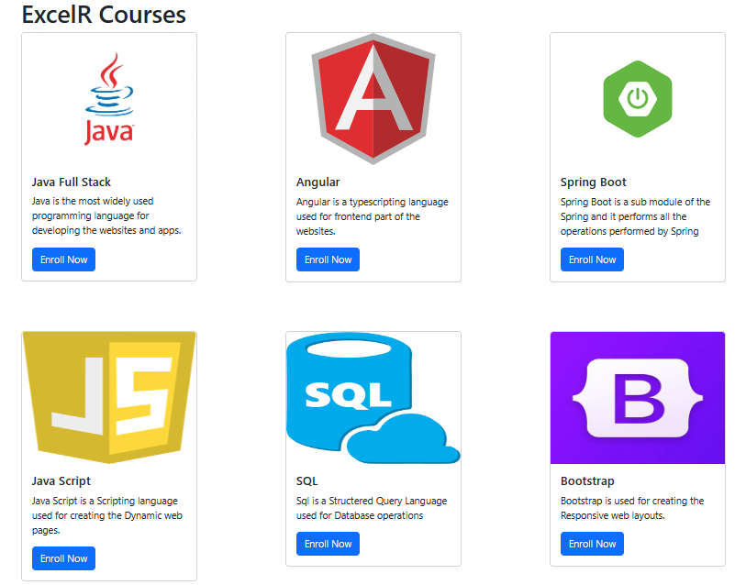

**2.Write a program to show bootstrap text, background, and color properties like mentioned below?**

<!DOCTYPE html>

<html lang="en">

<head>

    <meta charset="UTF-8">

    <meta name="viewport" content="width=device-width, initial-scale=1.0">

    <link href="https://cdn.jsdelivr.net/npm/bootstrap@5.3.1/dist/css/bootstrap.min.css" rel="stylesheet" integrity="sha384-4bw+/aepP/YC94hEpVNVgiZdgIC5+VKNBQNGCHeKRQN+PtmoHDEXuppvnDJzQIu9" crossorigin="anonymous">

    <title>Assignment 2</title>

</head>

<body>

    <section id="service">

        <div class="container" id="service-container">

            <div class="row" id="banner-row">

            <div class="col-md-6" id="service-col1">

                <div class="p-3 mb-2 bg-primary text-white">

                    <h4>Primary Background with white text</h4>

                    <p>This is an exm of using a Bootstrap's primary bg color with the white text.</p>

                </div>

            </div>

            <div class="col-md-6" id="service-col2">

                <div class="p-3 mb-2 bg-dark text-white">

                    <h4>Dark Background with white text</h4>

                    <p>This is an example of using Bootstrap's Dark background color with the white text.</p>

                </div>

            </div>

            <div class="col-md-6" id="service-col1">

                <div class="p-3 mb-2 bg-light text-danger">

                    <h4>Danger text color</h4>

                    <p>This is an example of using a Bootstrap's danger text color.</p>

                </div>

            </div>

            <div class="col-md-6" id="service-col2">

                <div class="p-3 mb-2 bg-info text-white">

                    <h4>Info Background with white text</h4>

                    <p>This is an example of using Bootstrap's info background color with the white text.</p>

                </div>

            </div>

        </div>

        </section>

</body>

</html>

Output:

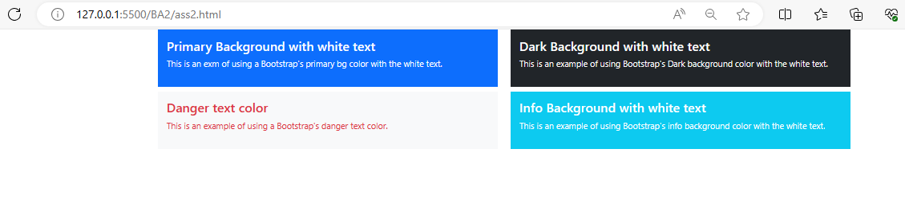

**3.Write a program to show all types of gutters in bootstrap?**

<!DOCTYPE html>

<html lang="en">

<head>

    <meta charset="UTF-8">

    <meta name="viewport" content="width=device-width, initial-scale=1.0">

    <title>Bootstrap Gutters</title>

    <!-- Link to Bootstrap CSS -->

    <link href="https://cdn.jsdelivr.net/npm/bootstrap@4.5.2/dist/css/bootstrap.min.css" rel="stylesheet">

    <style>

        /* CSS*/

        .col-content {

            background-color: #f8f9fa;

            margin-bottom: 20px;

        }

    </style>

</head>

<body>

  <h1>Bootstrap Gutters</h1>

  <h2>Default Gutter</h2>

  <div class="container-fluid">

        <div class="row">

            <div class="col col-content">

               column 1

            </div>

            <div class="col col-content">

                column 2

            </div>

            <div class="col col-content">

                column 3

            </div>

        </div>

  </div>

  <h2>No Gutter</h2>

  <div class="container-fluid">

        <div class="row no-gutters">

            <div class="col col-content">

                column 1

            </div>

            <div class="col col-content">

                column 2

            </div>

            <div class="col col-content">

               column 3

            </div>

        </div>

  </div>

  <h2>Custom Gutter</h2>

  <div class="container-fluid">

        <div class="row Custom-gutter">

        <div class="content col-md-6">

          column 1

        </div>

        <div class="content row-md-6">

          column 2

        </div>

        <div class="content col-md-6">

          column 3

        </div>

        <div class="content row-md-6">

          column 4

        </div>

        <div class="content col-md-6">

          column 5

      </div>

      <div class="content row-md-6">

          column 6

      </div>

        </div>

        </div>

</body>

</html>

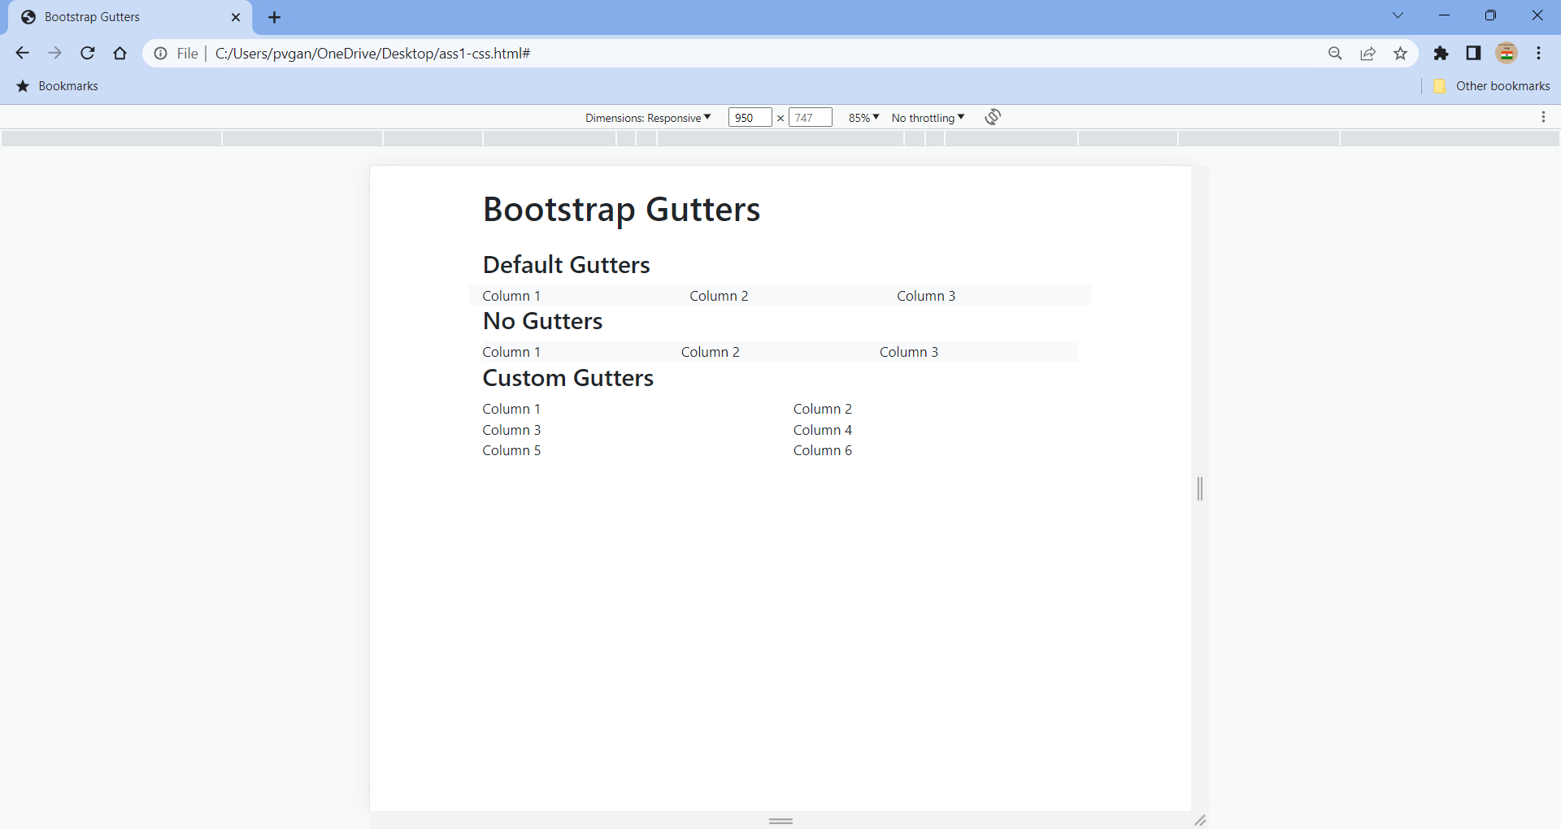

**4.Write a program to create responsive web layout using Bootstrap like given below?**

**Html:**

<!DOCTYPE html>

<html lang="en">

<head>

    <meta charset="utf-8" />

    <meta name="viewport"

        content="width=device-width,

                initial-scale=1" />

    <link

    href="https://cdn.jsdelivr.net/npm/bootstrap@5.0.0-beta2/dist/css/bootstrap.min.css"

    rel="stylesheet"

    integrity="sha384-BmbxuPwQa2lc/FVzBcNJ7UAyJxM6wuqIj61tLrc4wSX0szH/Ev+nYRRuWlolflfl"

    crossorigin="anonymous"

    />

    <link rel="stylesheet"

        href="ass4.css" />

    <link rel="preconnect"

        href="https://fonts.gstatic.com" />

    <link

    href="https://fonts.googleapis.com/css2?family=Roboto+Condensed&display=swap"

    rel="stylesheet"

    />

    <title>assignment 4</title>

</head>

<body>

    <div class="container">

    <section id="navbar">

    <nav class="navbar navbar-expand-lg navbar-light">

        <div class="container">

                <a class="navbar-brand" href="#">

                    <h3>ExcelR Training</h3>

                </a>

        <button

            class="navbar-toggler"

            type="button"

            data-bs-toggle="collapse"

            data-bs-target="#navbarSupportedContent"

            aria-controls="navbarSupportedContent"

            aria-expanded="false"

            aria-label="Toggle navigation"

        >

            <span class="navbar-toggler-icon"></span>

        </button>

        <div class="collapse navbar-collapse"

            id="navbarSupportedContent">

            <ul class="navbar-nav m-auto">

            <li class="nav-item">

                <a class="nav-link active"

                aria-current="page"

                href="#">Home</a>

            </li>

            <li class="nav-item">

                <a class="nav-link"

                href="#about">About Us</a>

            </li>

            <li class="nav-item">

                <a class="nav-link"

                href="#service">Services</a>

            </li>

            <li class="nav-item">

                <a class="nav-link"

                href="#Contact">Contact Us</a>

            </li>

            </ul>

        </div>

        </div>

    </nav>

    </section>

    <section id="banner">

    <div class="container-fluid" id="banner-container">

        <div class="row" id="banner-row">

        <div class="col-md-6" id="banner-col">

            <h3>

                Wlecome to ExcelR Training

            </h3>

            <p>

                This is a simple example of responsive web layout using Bootstrap

            </p>

        </div>

        </div>

    </div>

    </section>

    <!-- sections -->

    <section id="service">

    <div class="container" id="service-container">

        <div class="row" id="banner-row">

        <div class="col-md-6" id="service-col1">

            <h3>Section 1</h3>

            <p>

                ExcelR offers all emerging technologies from the industry with live training and industry experts.

            </p>

        </div>

        <div class="col-md-6" id="service-col2">

            <h3>Section 2</h3>

            <p>

                ExcelR offers all emerging technologies from the industry with live training and industry experts.

            </p>

        </div>

    </div>

    </section>

    <!-- footer -->

    <section id="footer">

        <div class="footer">

            <p> &copy; 2023 My website. All rights reserved </p>

        </div>

    </section>

    <script src="https://cdn.jsdelivr.net/npm/bootstrap@5.0.0-beta2/dist/js/bootstrap.bundle.min.js" integrity="sha384-b5kHyXgcpbZJO/tY9Ul7kGkf1S0CWuKcCD38l8YkeH8z8QjE0GmW1gYU5S9FOnJ0" crossorigin="anonymous"></script>

</div>

</body>

</html>

**Css:**

*{

    margin: 0;

    padding: 0;

    font-family: 'Roboto Condensed', sans-serif;

}

/* navbar */

.navbar-nav{

    margin-right: 0 !important;

    padding-right: 100px;

}

.navbar{

    background-color: #f3f4f8;  /**/

    color: rgb(1, 0, 0) !important;

}

.nav-item a{

    color: rgb(0, 0, 0) !important;

}

.nav-item{

    padding-left: 2px;

}

.navbar-brand{

    color: rgb(0, 0, 0) !important;

    padding-left: 100px;

}

#navbar button{

    color: white !important;

}

/* banner */

#banner-container{

    background-color: #0a193d;

    color: white !important;

    padding-top: 40px;

    padding-bottom: 40px;

}

#banner-row h3, p{

    padding-left: 20px;

    padding-top: 20px;

}

#banner-col{

    padding-left: 20px;

}

/* section */

#service{

    padding-top: 20px;

    padding-bottom: 20px;

    font-family: 'Times New Roman', Times, serif;

}

/* footer */

.footer{

    background-color: #0a193d;

    color: #f3f4f8;

    padding: 5px;

}

**Output:**

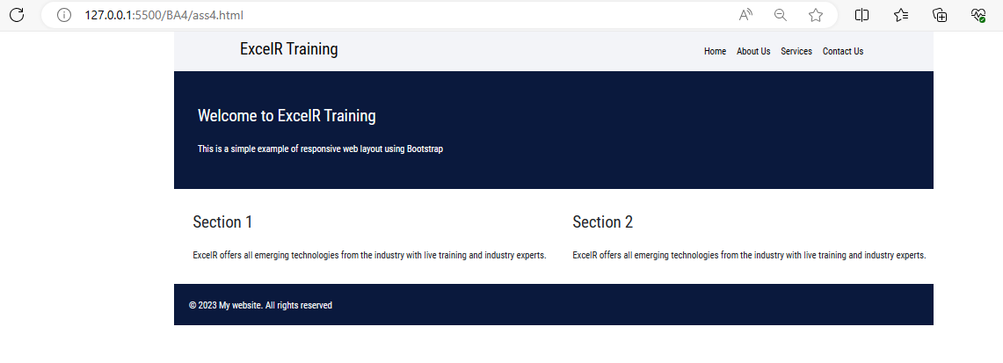

**5.Write a program to create employment registration forms using bootstrap like given below?**

**Html:**

<!DOCTYPE html>

<html lang="en">

<head>

    <meta charset="UTF-8">

    <meta name="viewport" content="width=device-width, initial-scale=1.0">

    <title>Employment Registration Form</title>

    <link rel="stylesheet" href="https://maxcdn.bootstrapcdn.com/bootstrap/4.5.2/css/bootstrap.min.css">

</head>

<body>

    <div class="container">

        <h2>Employment Registration Form</h2>

        <form>

            <!-- Common Fields Visible on All Screens -->

            <div class="form-group d-block">

                <label for="fullName">Full Name:</label>

                <input type="text" class="form-control" id="fullName" >

            </div>

            <!-- Fields Hidden on XS Screens -->

            <div class="form-group d-none d-sm-block">

                <label for="email">Email:</label>

                <input type="email" class="form-control" id="email" >

            </div>

            <!-- Fields Hidden on SM Screens -->

            <div class="form-group d-none d-md-block">

                <label for="password">Password:</label>

                <input type="password" class="form-control" id="password">

            </div>

            <!-- Fields Hidden on MD Screens -->

            <div class="form-group d-none d-lg-block">

                <label for="age">Age:</label>

                <input type="number" class="form-control" id="age" >

            </div>

            <!-- Fields Hidden on XL Screens -->

            <div class="form-group d-xl-none">

                <label for="department">Department:</label>

            <select class="form-control" id="department">

                <option value="">Select department</option>

                <option value="hr">Human Resources</option>

                <option value="it">Information Technology</option>

                <option value="finance">Finance</option>

                <option value="marketing">Marketing</option>

            </select>

            </div>

            <!-- Register Button (Green, Full Width) -->

            <div class="form-group">

                <button type="submit" class="btn btn-success btn-block">Register</button>

            </div>

        </form>

    </div>

    <script src="https://code.jquery.com/jquery-3.5.1.slim.min.js"></script>

    <script src="https://cdn.jsdelivr.net/npm/@popperjs/core@2.5.3/dist/umd/popper.min.js"></script>

    <script src="https://maxcdn.bootstrapcdn.com/bootstrap/4.5.2/js/bootstrap.min.js"></script>

</body>

</html>

**Output:**

