

## INFORMATION TECHNOLOGY EDUCATION DEPARTMENT

**ITEI223**

(Advanced Programming)

MODULE

4

INTRODUCTION TO POINTERS

LABORATORY EXERCISE 4 - 01

**Simple Pointer**

NAME OF STUDENT Michael Jacinto DATE January 17, 2019

1. Write a little program which declares an integer variable and initiates it to the value 25. Then declare a pointer to that value. Print the value by means of the pointer.
2. Write a program similar to the previous applying it to the string with your own name instead of an integer.
3. Write a program that reads 5 integer to an array. The integer should then be printed. Use pointer arithmetic.

|  |  |  |  |
| --- | --- | --- | --- |
|  | **CRITERIA** | **SCORE** | |
| 1 | Implementation of pseudo code | 30 |  |
| 2 | Identification of Input, Process, and Output requirement | 20 |  |
| 3 | Correctness and appropriateness of selected solution | 40 |  |
| 4 | Overall structure and design of the program source code | 10 |  |
|  | **TOTAL** | 100 |  |

**COMMENTS/REMARKS**

**Evaluated by / Date**

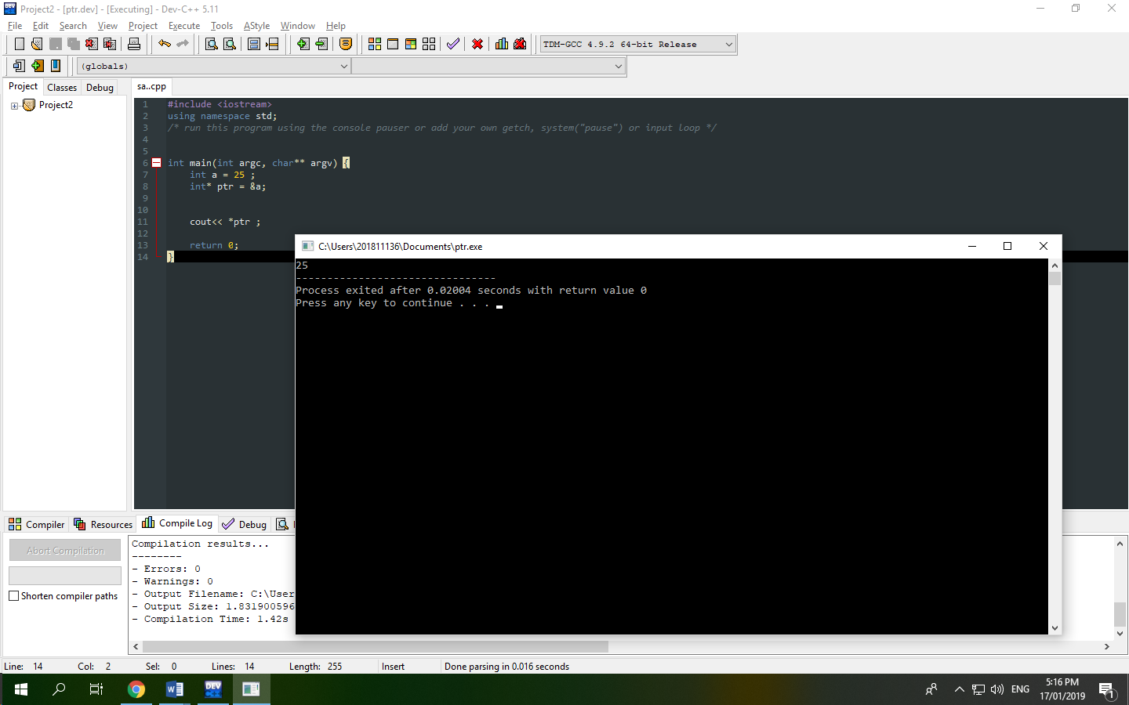**1.**

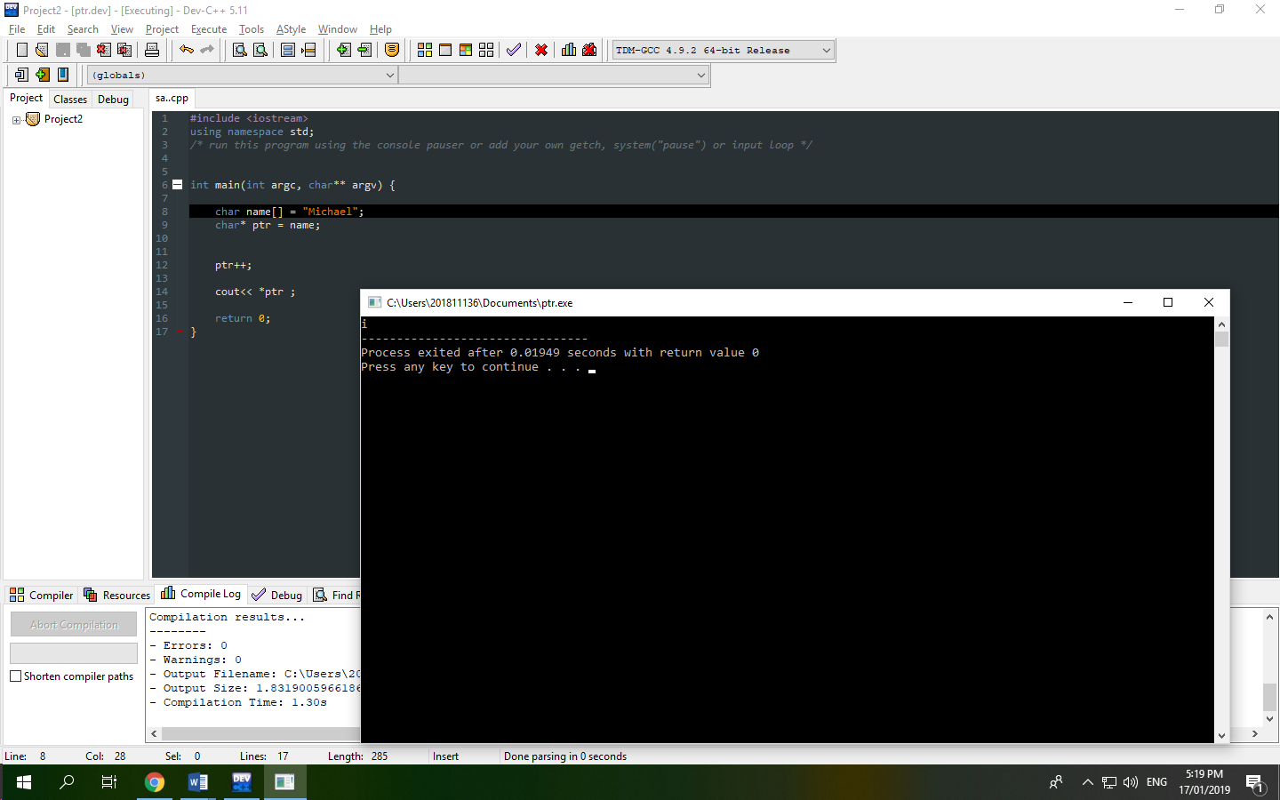**2.**

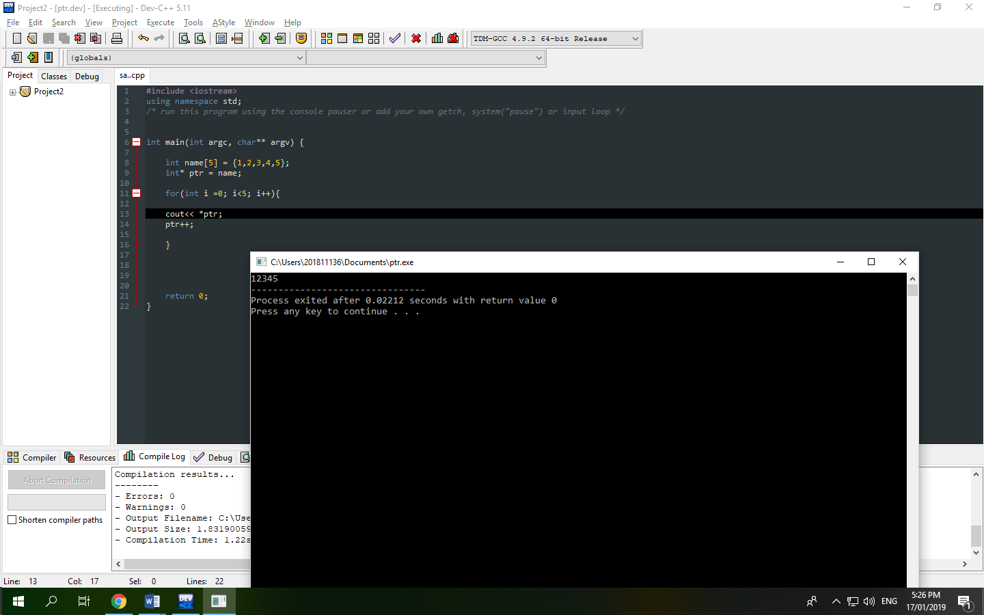3.