**COMP3121 ASSIGNMENT1 QUESTION2**

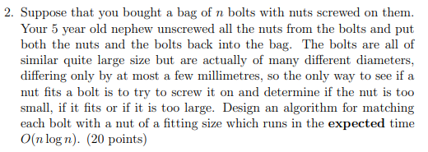

**Answer:**

We can use double quicksort algorithm to solve this question. Chose one of the bolts to test all the nuts and split it to three part. Too small, Too large and fitting. Then use the matching nut to split all the bolts to the similar part. Chose one of big part bolts and do same thing to the big part nuts…etc. Continue until all nuts and bolts are matching. We need to apply this partitioning recursively on the large and small part of both nuts and bolts. so it will take time O($2⋅n⋅\log{n}$) in total, and the expected time complexity is O($n⋅\log{n}$).