**COMP3121 ASSIGNMENT1 QUESTION3**

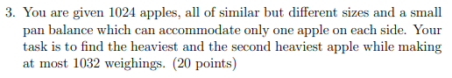

**Answer:**

At first, we randomly divided 1024 apples into 512 groups, each group have two apples. Then for each group we weight apple to find heavier apple. Then we put the 512 heavier apples in pairs then weight 256 times and get the 256 heavier apples. Then continue to do that, in the end it will only two apple and weight it we will get the heaviest apple. And it should weight 512 + 256 + 128 + 64 + 32 + 16 + 8 + 4 + 2 + 1 = 1023 times to find the heaviest apple.

For the second heaviest apple we need to compare every apple that be weighed by heaviest apple. It should have 10 apples. Choose one of the apples weigh the other apples, keep heavier apple every weighting. And we should weigh 9 times to find the heaviest apples in 10 apples which is second heaviest apple. 1023 + 9 = 1032

Thus, we can find the heaviest apple and second heaviest apple in 1032 weighing.