ASSIGNMENT2 QUESTION3

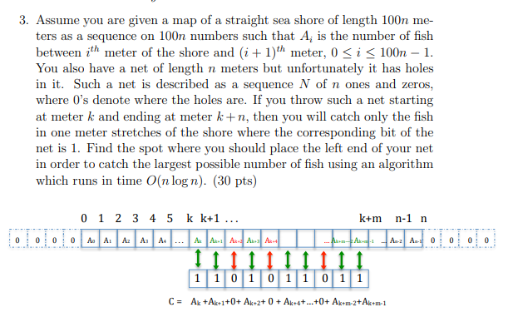

**Answer:**

Let N’ be the net sequence in the reverse order; the associated polynomial is $P_{N’}\left(x \right)=N_{0}+N_{1}x+…+N_{n-1}x^{n-1}$.And for sequence A we have polynomial $P_{A}\left(x\right)=A_{0}+A_{1}x+…+A_{100n-1}x^{100n-1}$ Then we will find the convolution of A*N $’$, We can do this use FTT in $\left(100n-1+n-1\right)\log\left(100n-1+n-1\right)$ time which is $O(n\log\left(n\right))$. So we get $P_{C}\left(x\right)=A_{0}N_{0}+\left(A_{0}N_{1}+A_{1}N_{0}\right)x+…+(A_{100n-1}⋅N_{n-1})x^{101n-2}$ we need to know the peak coefficient $P_{C}\left(x\right)$. We will go through all coefficient of $P_{C}\left(x\right)$ and it will take O(n) time. The final will be $O\left(n\log\left(n\right)\right)+O\left(n\right)=O(nlogn)$.