ASSIGNMENT2 QUESTION4

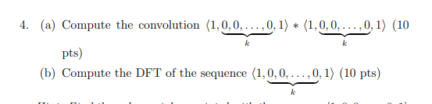

**Answer:**

(a).For $seq=\left\langle 1,k number of zeros,1\right\rangle$ the associated polynomial is $S\left(x\right)=1+x^{k+1}$; thus the convolution of itself are the coefficients of the polynomial $S^{2}\left(x\right)={\left(1+x^{k+1}\right)}^{2}=x^{2k+2}+2x^{k+1}+1$.

$So we get \left\langle 1,k number of zeros,2,k number of zeros,1\right\rangle$

(b) For $seq=\left\langle 1,k number of zeros,1\right\rangle$ the associated polynomial is $S\left(x\right)=1+x^{k+1}$.

$DFT\left(s\right)=\left\langle P_{s}\left(ω_{k+2}^{0}\right),P_{s}\left(ω_{k+2}^{1}\right),⋯P_{s}\left(ω_{k+2}^{k+1}\right)\right\rangle$

$=⟨1+ω_{k+2}^{0⋅\left(k+1\right)},\begin{aligned}1+ω_{k+2}^{1⋅\left(k+1\right)}\end{aligned},⋯,\begin{aligned}1+ω_{k+2}^{(k+1)⋅\left(k+1\right)}⟩\end{aligned}$

$=⟨2,\begin{aligned}1+ω_{k+2}^{k+1}\end{aligned},1+ω_{k+2}^{2\left(k+1\right)},⋯,\begin{aligned}1+ω_{k+2}^{{\left(k+1\right)}^{2}}⟩\end{aligned}$