ASSIGNMENT3 QUESTION2

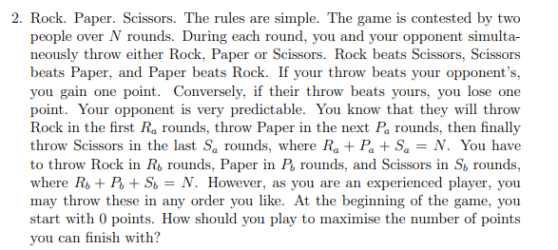

**Answer:**

As we know that opponent will throw Rock, Paper, Scissors in order and we know the $R_{a},P_{a},S_{a} value$. To win with maximum point we need won point and not lose point as possible. So we need use Paper to counter rock in the first $R_{a}$ rounds as possible, then use Scissor to counter Paper as possible in next $P_{a}$ rounds as possible, finally use rock to counter with Scissors in last $S_{a}$ rounds as possible. Unfortunately, we cannot choose the $R_{b},P_{b},S_{b} value$. It means that it is possible we still have Paper left after we finished counter with rock, or we run out of our paper before we finished counter with rock.

In that case, In first $R_{a}$ rounds, we will counter rocks, we use paper as possible, if paper has been run out, we use rocks, if rocks has been run out, we use scissors.

For the next $P_{a}$ rounds, we will counter papers, we use scissors as possible, if scissors has been run out, we use paper as possible, if paper has been run out, we use rocks.

In the last $S_{a}$ rounds, we will counter scissors, we use rocks as possible, if rocks has been run out, we use scissors as possible, if scissors has been run out, we use paper.

If we want to draw first, we may would not get point which is not optimal. Similar for to lose first, in the worst case, we may get minus point which is also not optimal.

If we reserve win point as possible, we will also cause some point must be lose, Since we cannot choose the value. That is optimal as my answer.

In a word, we avoid lose point until we have to, in this case we will get the maximum points.