ASSIGNMENT3 QUESTION3

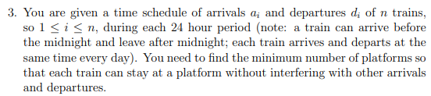

**Answer:**

At first, we need to go through the time schedule one by one to find the number of trains that arrive before midnight and departing after midnight. This is the initial value of counter since they all need individual platform to stay during the midnight.

For the rest of trains, we will merge arrival and departure time of trains and consider them in increasing sequence of times. Like (8.00, a) (8.30, a) (9.00, d) (22.00, d)

Then go through this list, if train is scheduled to arrive next, we increase the counter by 1, if train is scheduled to depart next, we decrease the counter by 1. We keep recording the biggest counter. If there are two trains are scheduled to arrive and depart at the same time, we depart the train first. After we go through this list, the biggest counter number in the record is the minimum number of platforms so that each train can stay at a platform without interfering with other arrivals and departures.