ASSIGNMENT3 QUESTION5

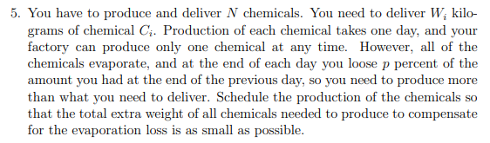

**Answer:**

To make the extra weight as small as possible, we must make loss weight as small as possible every day. Since we are going to produce and deliver N chemicals, and for every chemical we have different kilograms need. We will cost n days to produce all chemical and chemical will disappear p percent per day. So, we should make the weight of chemical produced as small as possible, but meet the needs of it, which can lead we loss less.

If you produce the chemical $C_{i}$ on day k, we need produce just enough kilograms to make it equal to demand in the deliver day. It means the weight of we produced should be sustain the full N – K day loss. If we produce more than we need instead so we will have more than $W_{i}$ kilograms in the deliver day. The greater the mass, the greater the loss for chemical, which means it will loss more than our answer during the N- K days, and it is not optimal. If we produce less than we need so we will have less than $W_{i}$ kilograms in the deliver day, so this is not be valid. So, we always produce just enough kilograms of chemical sustain the full N - K days. In that case, our evaporation loss is as small as possible for single chemical.

For N chemicals, we are going to sort the $W_{i}$ kilograms in increasing order and determine the less demand chemical first. Then we will produce chemical according to increasing order and produce just enough kilograms to make it equal to demand in the deliver day. In this case, we can make our evaporation loss as small as possible.

If we do not choose the lowest demand chemical produce first, we must produce more chemical to sustain the full N - 1 days because other chemicals have more weight request. A larger initial amount means a larger amount lost per day. We want loss as small as possible. That is not optimal.

In this way, our answer is optimal answer.