ASSIGNMENT4 QUESTION1

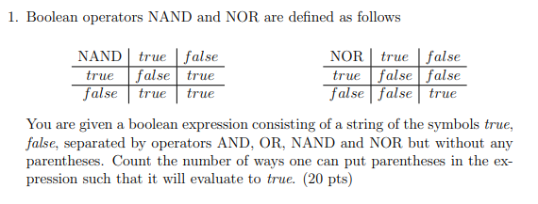

**Answer:**

We have a Boolean expression consisting of a string [i:j], and for every part of string, we want to know the numbers of way that it be true and false.

Let T[i , j] be the number of ways of parenthesizing between the string [i : j] evaluates to TRUE. F[i , j] be the number of ways of parenthesizing between between the string [i : j] evaluates to False. Include I j. (I $≤$ j)

Then the total[i , j] = T[i, j] + F[i , j]

T[i , j] and F[i , j] can be expressed by the following recursive formulations:

$$T\left[i,j\right]=\sum_{k=i}^{j-1}{\left\{\begin{aligned} T\left[i,k\right]⋅T\left[k+1,j\right] if S\left[k\right]=AND \\ total\left[i, k\right]· total\left[k + 1, j\right]- F\left[i, k\right]· F\left[k + 1, j\right] if S[k] = OR \\ total\left[i, k\right]· total\left[k + 1, j\right]- T\left[i, k\right]· T\left[k + 1, j\right] if S[k] = NAND \\ F\left[i, k\right]· F\left[k + 1, j\right] if S[k] = NOR\end{aligned}\right. }$$

$$F\left[i,j\right]=\sum_{k=i}^{j-1}{\left\{\begin{aligned}total\left[i, k\right]· total\left[k + 1, j\right]- T\left[i,k\right]⋅T\left[k+1,j\right] if S\left[k\right]=AND \\ F\left[i, k\right]· F\left[k + 1, j\right] if S\left[k\right]= OR \\ T\left[i, k\right]· T\left[k + 1, j\right] if S\left[k\right]= NAND \\ total\left[i, k\right]· total\left[k + 1, j\right]-F\left[i, k\right]· F\left[k + 1, j\right] if S\left[k\right]= NOR\end{aligned}\right.}$$

And we have this base case:

T[i , i] = 1 if S[i] = True

T[i , i] = 0 if S[i] = False

F[i , i] = 0 if S[i] = True

F[i , i] = 1 if S[i] = False

The final answer will be given by T[1,n] since we use all string [1:n]. and we want the string evaluate to true.

The time complexity for this question should be $O\left(n^{3}\right)$ since we have $O\left(n^{2}\right)$ sub-problems and $O\left(n\right)$ to solve each problems .