ASSIGNMENT4 QUESTION2

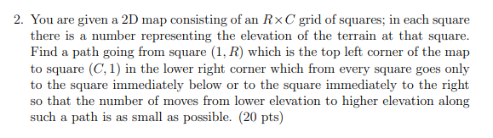

**Answer:**

Since we only go right or below, for every squares in the first line, it must be the top left corner square move to right, and for every squares in the first column, it must be the top left corner move down. Then we will draw a same 2D map consisting R x C grid of squares and we will put the number of minimum lower to higher moves from top left corner to this square. And we will quick get the number of top line square and left column square since their path is unique. If this is a lower to higher move, we increase 1.For the square that is not in the top line and left column, they can be from the up square or left square. So the number should be it min(up square number + whether lower to high move, left square number + whether lower to high move).

For every square we will to find the minimum low to high move from left top corner.

Let M[I, J] be the number of minimum move from left top corner to square(I,J).

Lowtohigh[(I,J),(M,N)] will return 1 when square(I,J) to square (M,N) is a low to high move, else will be 0.

The recursion is:

$$M[I , J] = Min( M [ I -1 , J ] + Lowtohigh[ ( I - 1 , J) , ( I , J ) ] ,$$

$$M [ I , J + 1 ] + Lowtohigh[ ( I , J + 1) , ( I , J) ] )$$

And base case M[1,R] = 0

And for all *M[1,X] = Lowtohigh [(1 , $X$ + 1) , (1 , $X$)] + M [ 1 , X + 1 ]* ($1≤X<R$),

*M[X,R] = Lowtohigh [( $X$- 1 , R) , ($X$, R)] + M[$X$-1, R]* ($1<X≤C$)

Final solution will be given by M[C,1]

The time complexity for this question is $O\left(RC\right)$ Since RC is the size of table .we need to go through another same table And compute the value inside.