ASSIGNMENT4 QUESTION3

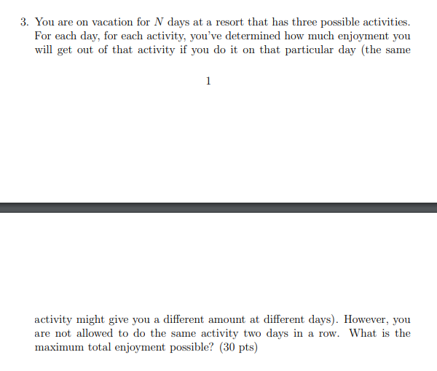

**Answer:**

For each day $ⅈ≤N$ and have three possible activities $a_{j}$ to do. J = 1, 2 ,3 .

Let $P\left(ⅈ,j\right)$ represent the maximum enjoyment up to day $ⅈ$ and do activity $j$ on day $ⅈ$.

Let $enjoyment\left(i,j\right)$ represent the enjoyment do activity $j$ on day $ⅈ$.

Solve the subproblems in the order P(1, J), . . . , P(N, J). For j = 1, 2, 3

For all $ⅈ≤N$ we have:

$P\left(ⅈ,j\right)= enjoyment\left(i,j\right)+\max\left(P\left(ⅈ-1,k\right), P\left(ⅈ-1,k\right)\right) K=1, 2, 3 but not equal to j$

And we have Base case:

$P\left(0,j\right)=0 for j=1, 2,3$

$P\left(1,j\right)=enjoyment\left(1,j\right) for j=1, 2,3$

The final solution will be given by $\max{(P\left(N,1\right),P\left(N,2\right),P\left(N,3\right) )}$

The time complexity for this solution will be $O\left(3N\right)=O\left(N\right)$ since we will compute for each activity for N days.