ASSIGNMENT4 QUESTION4

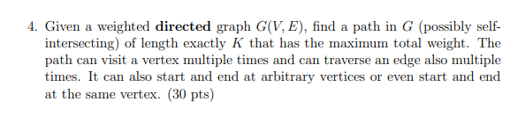

**Answer:**

For every node $i$ and every $1≤k≤K$ we need to find the maximum weight path of length exactly k.

Let $P\left(i, k\right)$ be the maximum weight path of length exactly $k$ which end at $i$.

Let $Weight\left(x,y\right)$ is the weight of edge from node x to node y.

Solve the subproblems in the order $P\left(i, 1\right)$, … , $P\left(i, K\right)$ for every node i.

For every $1≤k≤K$ we have:

$P\left(i, k\right)= max⁡(P\left(m, k-1\right)+Weight\left(m, i\right)){}$ For all node m can go to i.

**To be noticed, if $P\left(m, k-1\right)$ = 0, then $Weight\left(m, i\right)$ should also be 0, since there is no path that have length exactly (k-1) to m node. Try other m. If there is no more m make $P\left(m, k-1\right)$ $≠$ 0, It means there is no path that have exactly length (k) to the node I, so $P\left(i, k\right)=0$**

And we have some base case:

$P\left(i, 1\right)= \max\left( Weight\left(x,i\right)\right) For all node x can go to node i.$ If there is no such node x, $P\left(i, 1\right)=0$

The final solution will be given by $\max\left(P\left(i, K\right)\right) for all node i.$

The time complexity for this solution will be $O(V^{2}E).$ Since we will check every node and every edge it connected the node.