ASSIGNMENT5 QUESTION1

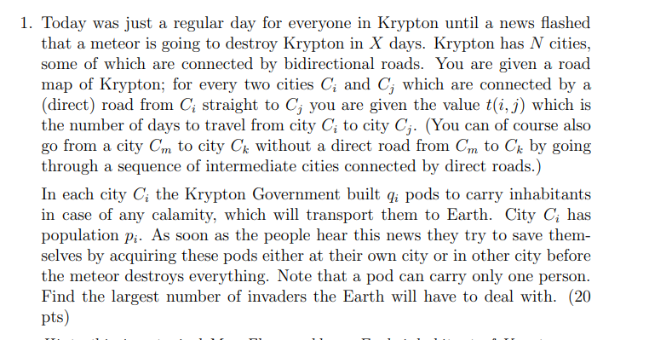

**Answer:**

This is a max flow problem. To find the largest number of invaders the earth will deal, we should determine for each city $C_{i}$ the set of cities that can reach within X days. We can use Dijkstra algorithm to determine every city that the shortest path (time) to other city. And filter city that can reach within X days. Then we get the set of cities that can reach within X for each city. To make the representation compact, make a bipartite graph with vertices corresponding to all cities both on the left and on the right side but with different interpretation: on the left vertices represent populations of the corresponding cities; on the right the vertices represent the set of ponds in the corresponding cities. Add a super-source on the left and connect it to all left vertices by edges of $P_{i}$. Add a super-sink on the right and connect it to all right vertices by edges of $q_{i}$.Then connect the left side city with the set of right city that can be reached in X days include itself by edges of infinite capacities. Then we turn this to a flow network and we need to find the maximum flow. We can Edmonds-Karp Max Flow algorithm to find the maximum flow and we can find the largest number of invaders the Earth will have to deal with.