ASSIGNMENT5 QUESTION2

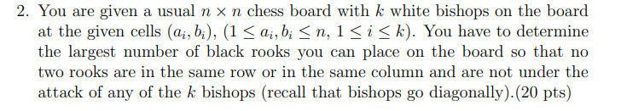

**Answer:**

Make a bipartite graph with all the columns as vertices on the left hand side and all the rows as vertices on the right hand side. Each square $s_{ij}$ can now be represented by an edge from column j to row i. Add a super-source on the left and connect it to all left vertices by edges of 1. And add a super-sink on the right and connect it to all right vertices by edges of 1.Since we would not want the two rook are in same row or same column. Connect each left vertices to all right vertices by edges of 1 capacities.

Then we know there will k white bishops on board at the given cells $\left(a_{i},b_{i}\right),1≤a_{i},b_{i}≤n,1≤i≤k$ and bishops go diagonally. We are going to delete the edge that is invalid. And we should delete all edge that represent square $s_{a_{i}b_{i}}$ and all edge represent diagonal square of $\left(a_{i},b_{i}\right)$. Which represent the square $s_{{(a}_{i}-x)(b_{i}-x)},s_{{(a}_{i}-x)(b_{i}+x)},s_{{(a}_{i}+x)(b_{i}-x)},s_{{(a}_{i}+x)(b_{i}+x)}$ where $1≤a_{i}{-x,a}_{i}+x,b_{i}+x,b_{i}-x≤n,1≤i≤k$. $1≤x≤n$

Then we turn this problem to a max flow problem and we can Edmonds-Karp Max Flow algorithm to find the maximum flow and we can find the largest number of black rooks can place on the board.