ASSIGNMENT5 QUESTION2

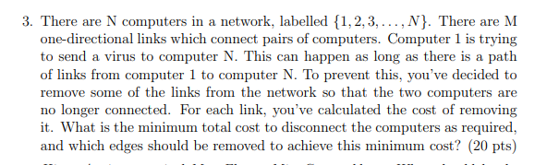

**Answer:**

This is a Max Flow - Min Cut Problem. At first, we need to create a flow network which source is computer 1 and sink is computer N. Vertices is the computer and edge is the the link which connect pairs of computers and edge capacity is the cost that link remove. Then we can use Edmonds-Karp Max Flow algorithm to find the maximum flow from computer1 to computer N. Minimum cost should equal to the maximum flow value since Max-flow min-cut theorem. Then we need to find the set of edges which need to removed. We can use bfs/dfs on the residual flow network and marking the vertices. And we will find a set of vertices that can reach from computer 1 in the residual network. we should remove the

edges which from reachable vertices to non-reachable vertices.

Thus we can know the minimum total cost and the edge we should remove.