|  |  |
| --- | --- |
| **use case document** | 14 Aug 2014 |

USE CASE DOCUMENT

SHARE MY CAKE PROJECT

CREATED BY

R.SUREKA PRIYA

**Confidentiality and Non-disclosure Notice**

The information contained in this document is confidential and proprietary to Rails Factory [Reg: Sedin Technologies Pvt. Ltd]. This information may not be disclosed, duplicated or used for any other purposes. The information contained in this document may not be released in whole or in part outside Rails Factory [Reg: Sedin Technologies Pvt. Ltd] for any purpose without the express written permission of Rails Factory [Reg: Sedin Technologies Pvt. Ltd].

CONTENTS

1.INTRODUCTION 5

General Information: 5

Purpose: 5

Objectives: 5

2.USE CASES ON FUNCTIONALITIES 6

Use Case 01: Member Registration (Sign up) process6

Wireframe 5

User / Fan Registration Process 7

Description 8

Assumption 8

Primary Flow 8

Negative Flow / Validations 8

Form Elements 9

End State 9

Use Case 02: User Sign in Process10

Wireframe 11

Description 11

Assumption 11

Primary Flow 11

Negative Flow / Validations 11

Alternate Flow 12

Form Elements 12

End State 12

Use Case 03: SMC Member after sign in page 13

Wireframe 13

Description 14

Assumption 14

Primary Flow 14

Negative Flow 14

Alternate Flow 14

Form Elements 14

End State 14

Use Case 04: SMC Celebrant home page 14

Wireframe 15

Description 14

Assumption 14

Primary Flow 15

Negative Flow 15

End State 15

***Use Case 05: SMC Celebrant Profile Page*** 15

Wireframe 15

Description 15

Assumption 15

Primary Flow 15

Negative Flow 16

End State 16

### Use Case 06: SMC Event Creation............................................16

Wireframe 16

Description 17

Assumption 17

Primary Flow 17

Negative Flow 17

Form Elements 17

End State 18

***Use Case 07: SMC Invitee after login Page*** 18

Description 18

Assumption 18

Primary Flow 18

Form Elements 19

End State 19

***Use Case 08: SMC admin login Page***

Description 20

Assumption 20

Primary Flow 20

Form Elements 21

End State 21

# INTRODUCTION

## General Information:

Share my cake is for the people who wants to invite their friends for his/her birthday party.

## Purpose:

The purpose of this documentation is to make an easy understanding of the business logic of SFC application and understand the perspectives of the project. All attempts have been made in using mostly business terminology and business language while describing the requirements in this document. The document shows the flow of the project using use cases and gives us an ideal view of the project. The Use cases are provided to describe in detail the functionality and its process with alternate and negative Flows.

## Objectives:

The objective of the project is to build a web portal for the people who wants to invite their friends for his/her birthday party by sending invitations to them.And the invitee can send amount as a gift to the celebrant.And the celebrant will provide some part of his gift amount to any organisation.

# USE CASES ON FUNCTIONALITIES

## 

## Use Case 01: Member Registration (Sign up) process

This use case explains about how a member signs up during the registration process in SMC Application.

|  |  |  |  |
| --- | --- | --- | --- |
| **User Case Name** | Member Registration (Sign up) process | **Use Case Type** | Business Flow |
| **Use case ID** | UC_SMC_01 | **Priority** | High |
| **Primary Actors** | All Users | | |
| **Other Actors** | NA | | |

### Wireframe

Page # 1 Home page in Wireframe document

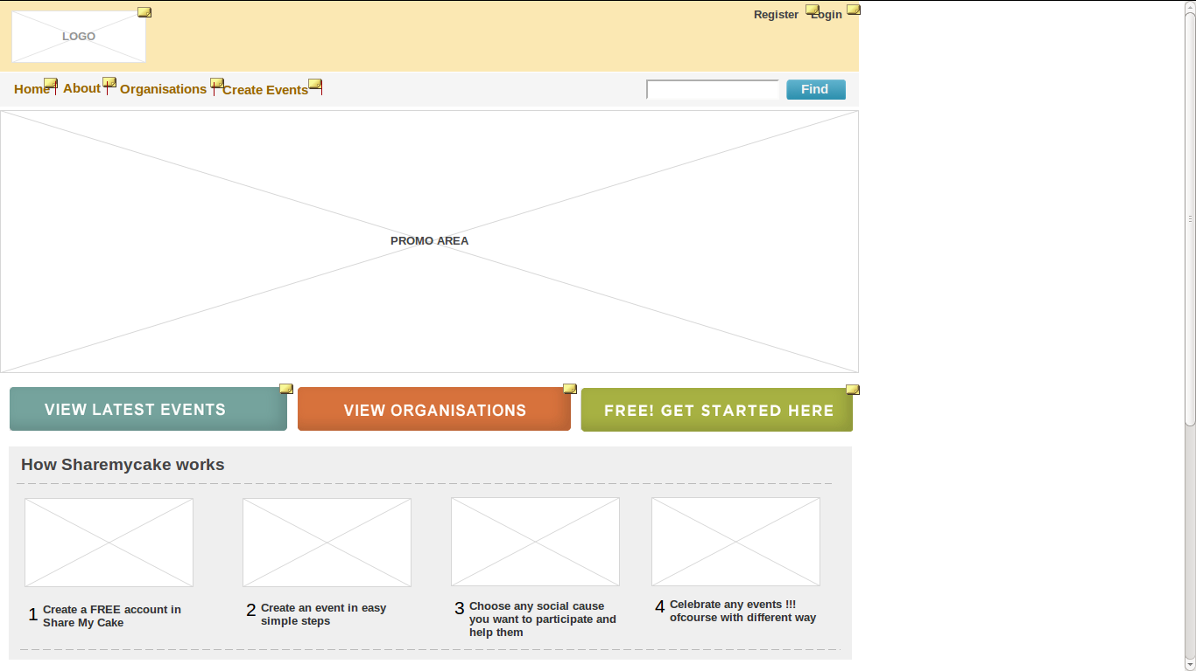

Page # 2 : Registration in Wire Frame document

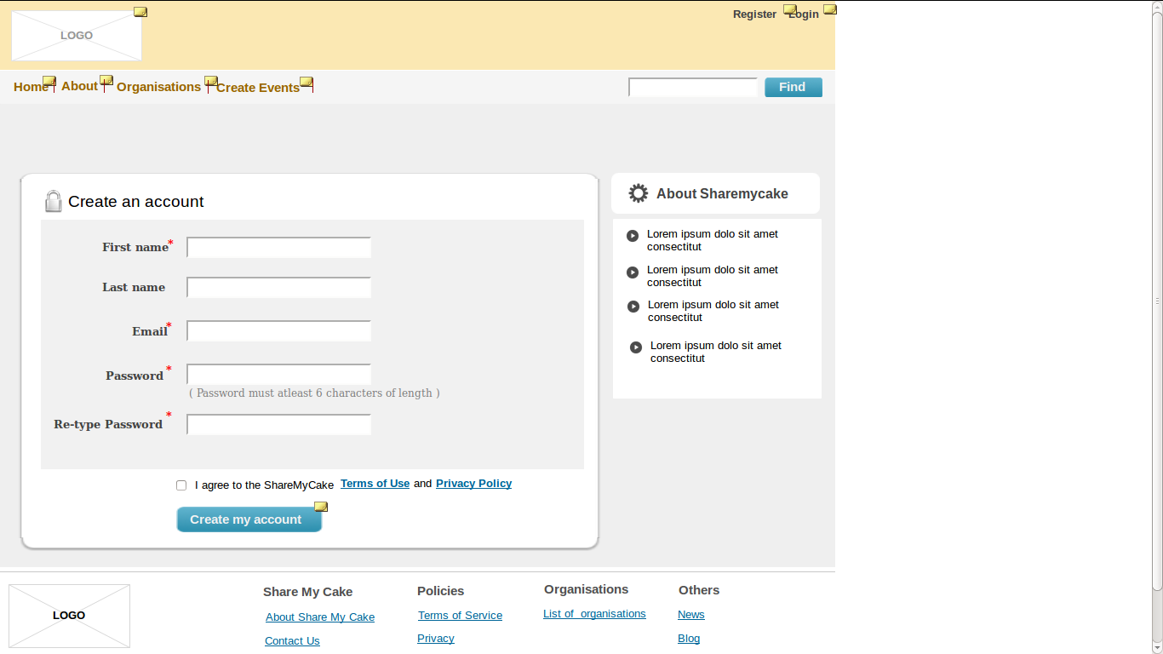

### 

### 

### Description

New users / Member can register themselves in SMC application by providing their personal information and filling out the registration form.

### 

### Assumption

The user is in SMC registration page. If he clicks on the button “create my account” it will redirect to the home page.

### Primary Flow

***Step 1:*** If the user clicks the Register button at the top left of the home page (Wireframe page # 1), they will be redirected to user registration / user Sign up page.

***Step 2:*** User inputs all the information given in the “User Registration Process” screen as shown above by filling up all the fields and clicks on “create my account” button.

### 

### Negative Flow / Validations

***Step 1:*** If the user inputs invalid email / Unique email then the system / screen should display an error message “***Enter a valid email id”*** / **Enter Unique email**”

***Step 2:*** The user should input the same password in the “Re-type password” field and the “Password” field if not then the system should display an error message “***Passwords in both the fields should match”***

### 

### Form Elements

|  |  |  |  |  |
| --- | --- | --- | --- | --- |
| **#** | **Label(UI)** | **Data Type** | **Field / Action** | **Mandatory Fields** |
| 1 | First Name | String | Input / Text field | Yes |
| 2 | Last Name | String | Input / Text field | No |
| 3 | Email | String | Input / Text field | Yes |
| 4 | Password | String | Input / Text field | Yes |
| 5 | Retype Password | String | Input / Text field | Yes |
| 6 | Create My Account | Button | Click | Yes |

### End State

An Email confirmation will be sent to the user’s registered email and

the user can see the sign in page.

## Use Case 02: User Sign in Process

This use case explains about how a user signs in to SMC Application.

|  |  |  |  |
| --- | --- | --- | --- |
| **User Case Name** | User Sign in | **Use Case Type** | Business Flow |
| **Use case ID** | UC_ SMC _02 | **Priority** | High |
| **Primary Actors** | Registered Users / Members | | |
| **Other Actors** | NA | | |

### 

### Wireframe

Page #3: User Sign in Page of Wireframe document.

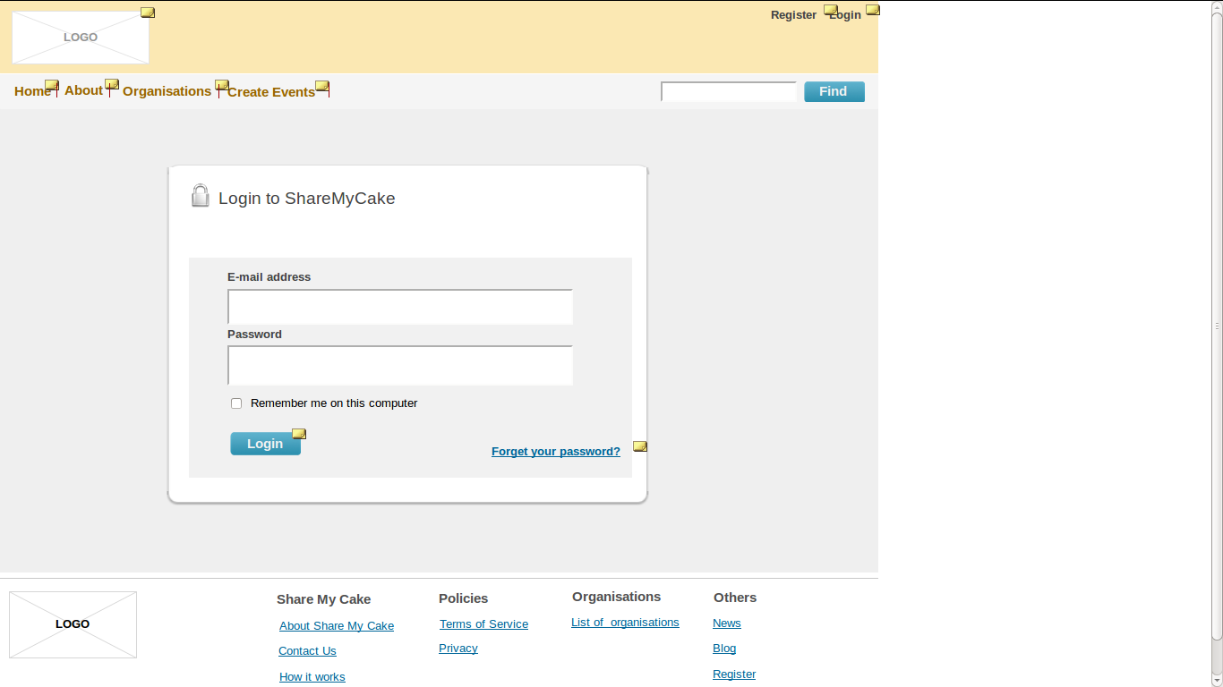

***Description***

Users can sign in by entering the required details like email id and password as shown in the user sign in page.

### Assumption

The user has clicked on the “Log in” button on the Home page and is redirected to the Sign in page.

### Primary Flow

***Step 1:*** The user has to enter the mandatory fields “Email Address” & “Password”.

***Step 2:*** The User has to click on “Login”.

***Step 3:*** If the user has forgotten their password the user has to click on “Forgot password” button and provide their email address and an email with link to change the password will be email to the user

### Negative Flow / Validations

***Step 1:*** If the user inputs invalid email id then the system / screen should display an error message “***Enter a valid email id”***

***Step 2:*** If the user inputs a wrong password then the system should display an error message “***The Password you entered is incorrect”***

### 

### ***Form Elements***

|  |  |  |  |  |
| --- | --- | --- | --- | --- |
| **#** | **Label(UI)** | **Data Type** | **Field / Action** | **Mandatory Fields** |
| 1 | Email address | String | Input / Text field | Yes |
| 2 | Password | String | Input / Text field | Yes |
| 3 | Login | Button | Click | Yes |

### End State

User has signed in to SMC successfully.

## Use Case 03: SMC Member after sign in page

This use case explains about how a page should be after the the member

signed in.

|  |  |  |  |
| --- | --- | --- | --- |
| **User Case Name** | **SMC after sign in** | **Use Case Type** | Business Flow |
| **Use case ID** | UC_ SMC _03 | **Priority** | High |
| **Primary Actors** | Registered users / members | | |
| **Other Actors** | NA | | |

### Wireframe

Page #4:member after signed in of wireframe documentation

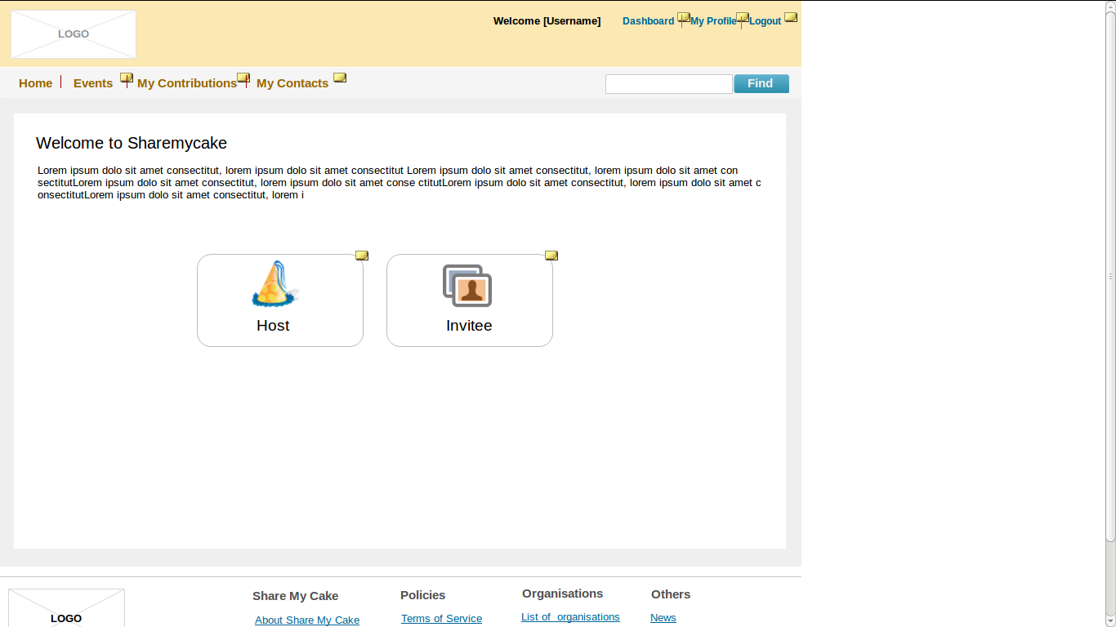

***Description***

After the member signed in to the application then they should select their role either as host(celebrant) or invitee.

### Assumption

If the member wants to send invitation then should select host or if he wants to see the invitations from his friends then should select invitee.

### Primary Flow

***Step 1:*** The user has to click host button if he wants to send the invitations to his/her friends.

***Step 2:*** The User has to click invitee button if he wants to see the invitations that came from his/her friends.

### 

### Negative Flow / Validations

N/A

### Form Elements

|  |  |  |  |  |
| --- | --- | --- | --- | --- |
| **#** | **Label(UI)** | **Data Type** | **Field / Action** | **Mandatory Fields** |
| 1 | Host | Button | Click | Yes |
| 2 | Invitee | Button | Click | Yes |

### 

### End State

Member has entered as either host(celebrant) or invitee.

### Use Case 04: SMC Celebrant Home Page

This use case explains about how a page should be after the the member

signed in as a celebrant.

|  |  |  |  |
| --- | --- | --- | --- |
| **User Case Name** | **SMC Member**  **Home Page** | **Use Case Type** | Business Flow |
| **Use case ID** | UC_ SMC _04 | **Priority** | High |
| **Primary Actors** | Registered users / members | | |
| **Other Actors** | NA | | |

***Wireframe***

Page #5 : Celebrant after signed in of wireframe documentation

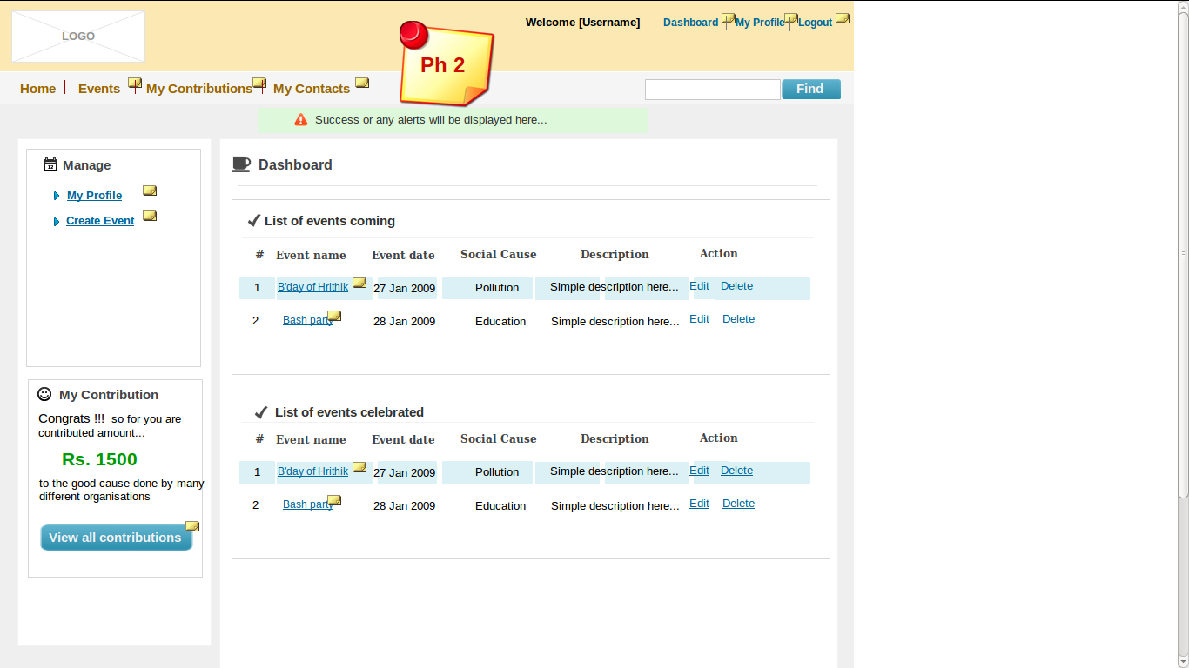

***Description***

The dashboard contains list of events of a Celebrant.

### Assumption

The Member already entered as a host(celebrant).

### Primary Flow

***Step 1:*** The Celebrant can do the following in the screen.

* view their list of events
* view their contributions
* can view their contact list

***Step 2:*** The User has to click my events link if he wants to see the invitations from friends.

***Step 3:*** The User has to click create an event link if he wants to create his own event.

***Negative flow/Validations***

N/A

### Form Elements

|  |  |  |  |
| --- | --- | --- | --- |
| **#** | **Label(UI)** | **Field / Action** | **Mandatory Fields** |
| 1 | My Events | Click | Yes |
| 2 | Create an event | Click | Yes |
| 3 | View all contributions | Button/Click | Disable/Enable |

### End State

Celebrant can view their list of events,contributions and contacts.And they

can create own events.

***Use Case 05: SMC Celebrant Profile Page***

This use case explains about how a fan Profile page and its features.

|  |  |  |  |
| --- | --- | --- | --- |
| **User Case Name** | **SMC Member**  **Profile Page** | **Use Case Type** | Business Flow |
| **Use case ID** | UC_ SMC _05 | **Priority** | High |
| **Primary Actors** | Registered users | | |
| **Other Actors** | NA | | |

### Description

Once the member signed in as a celebrant they can view their profile page

### 

### Assumption

The celebrant is already signed in to SMC application.

### Primary Flow

***Step 1:*** The celebrant can view the following information in this page as shown below

1. Firstname,Lastname
2. Email
3. Mobile number

***Step 2****:* The celebrant can edit his/her profile page with the following additional fields.

1. address line1 & line2

2. city

3. state & country

### Negative Flow

***N/A***

### 

### ***Form Elemen******ts***

|  |  |  |  |  |
| --- | --- | --- | --- | --- |
| **#** | **Label(UI)** | **Data Type** | **Field / Action** | **Mandatory Fields** |
| 1 | My profile | Alpha numeric | Text box | Yes |
| 2 | Change password | Alpha numeric | Text box | Yes |
| 3 | Update | button | click | Yes |

***Wireframe***

Page #5 : Celebrant profile page of a wireframe document

### 

### End State

Celebrant can see their profile information in detail and can update their profile.

### Use Case 06: SMC Event Creation

This use case explains about how a page should be for creating a new event.

|  |  |  |  |
| --- | --- | --- | --- |
| **User Case Name** | **SMC event creation** | **Use Case Type** | Business Flow |
| **Use case ID** | UC_ SMC _06 | **Priority** | High |
| **Primary Actors** | Registered users | | |
| **Other Actors** | NA | | |

***Wireframe***

Page #7 : Event creation

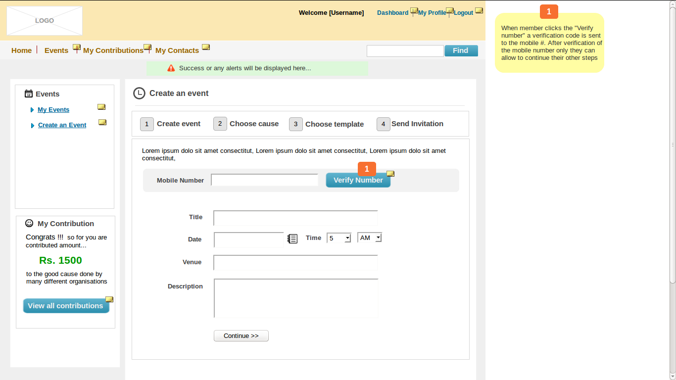

### Description

Once the member signed in as a celebrant / invitee they can create their event.

### 

### Assumption

Celebrant is signed in to SMC application as either celebrant or invitee.

### 

### Primary Flow

***Step 1:*** The user can crete event with following fields.

* Create event
* choose cause
* choose template
* send invitation

***Step 2****:* a.The user should select the cause.

b.select the template and enter the amount click continue

c.send invitations by adding friends.

***Negative Flow***

***N/A***

### 

### ***Form Elemen******ts***

|  |  |  |  |  |
| --- | --- | --- | --- | --- |
| **#** | **Label(UI)** | **Data Type** | **Field / Action** | **Mandatory Fields** |
| 1 | Create event | Alpha numeric | Text box | Yes |
| 2 | Choose cause | button | click | Yes |
| 3 | Choose template | button | click | Yes |
| 4 | Enter amount | integer | Text box | Yes |
| 5 | Add friend | button | click | Yes |

### End State

User has sent their invitations.

***Use Case 07: SMC Invitee after login Page***

This use case explains about how a page should be after the invitee login.

|  |  |  |  |
| --- | --- | --- | --- |
| **User Case Name** | **SMC Invitee after login** | **Use Case Type** | Business Flow |
| **Use case ID** | UC_ SMC _07 | **Priority** | High |
| **Primary Actors** | Registered users | | |
| **Other Actors** | NA | | |

### Description

Once the member signed in as a invitee they can see the list of invitations came from their friends.

### 

### Assumption

user is signed in to SMC application as invitee.

***Step 1:*** The invitee can do the following actions.

* can see the invitations
* can create event
* can see their events

***Step 2****:* a.The invitee can post their wishes.

b.The invitee can gift a pyment.

***Negative Flow***

***N/A***

***Wirefram***

Page #8 : invitee after login

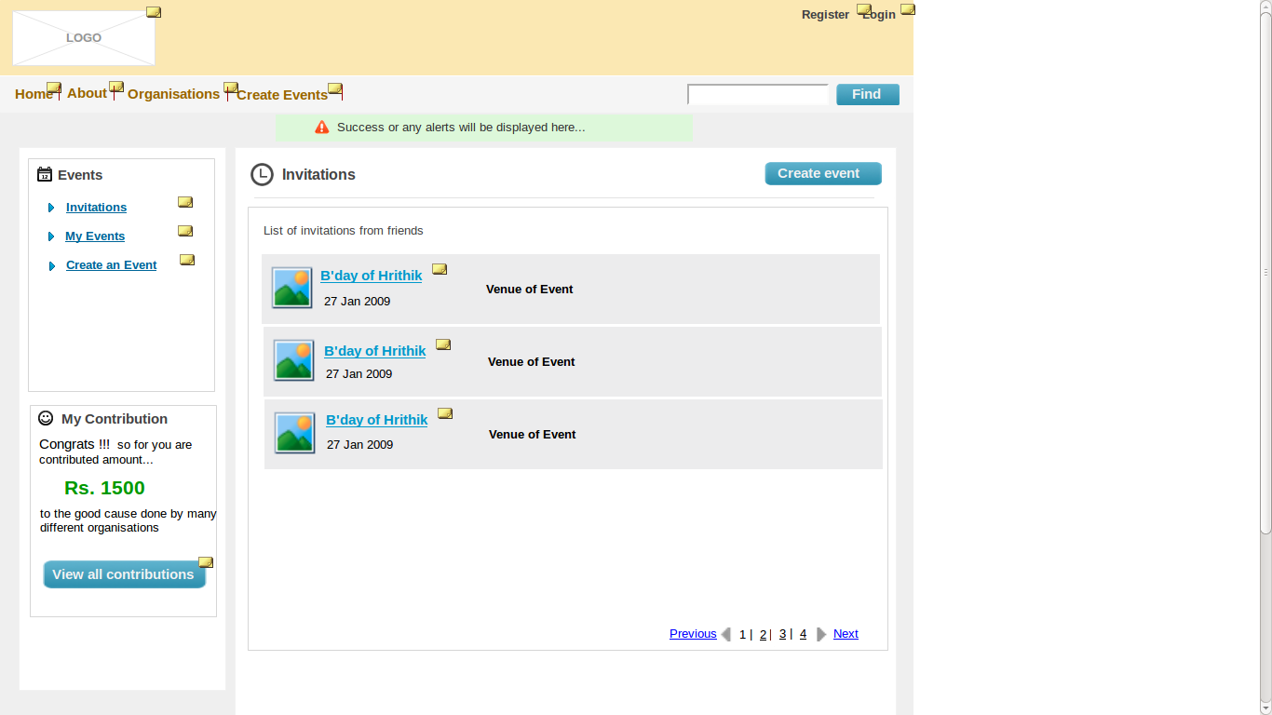

***Wireframe***

Page #9 : payment page with event name

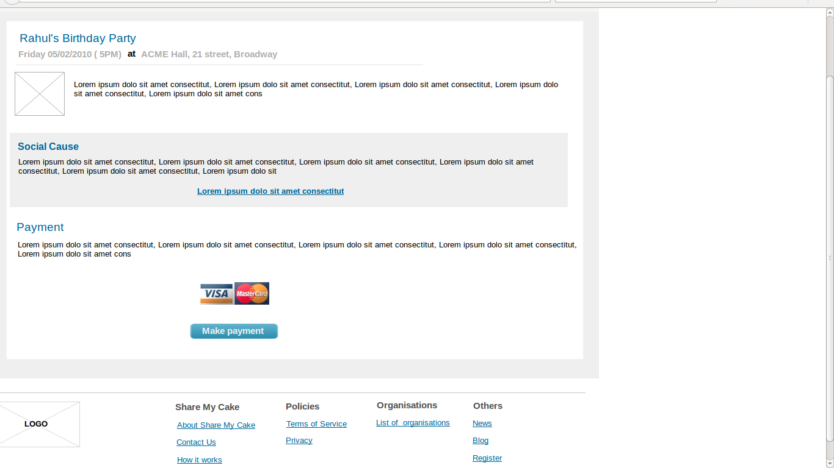

### 

***Wireframe***

Page #10 : payment amount page

### 

### 

***Form Elements***

|  |  |  |  |  |
| --- | --- | --- | --- | --- |
| **#** | **Label(UI)** | **Data Type** | **Field / Action** | **Mandatory Fields** |
| 1 | Post your wish | Alpha numeric | Text box | Yes |
| 2 | Gift now | button | click | Yes |
| 3 | Make payment | button | click | Yes |

### End State

Invitee has sent their gift and post their wishes.

***Use Case 08: SMC admin login Page***

This use case explains about how a page should be after the invitee login.

|  |  |  |  |
| --- | --- | --- | --- |
| **User Case Name** | **SMC admin login** | **Use Case Type** | Business Flow |
| **Use case ID** | UC_ SMC _07 | **Priority** | High |
| **Primary Actors** | Admin | | |
| **Other Actors** | NA | | |

### Description

The admin should sign in with correct emailid and password.

### 

### Assumption

Admin successfully signed in to SMC.

### 

### Primary Flow

***Step 1:*** The admin can do the following actions.

* Can see list of events
* Can see list of organisations
* Can see list of invoices
* Can see list of payments

***Step 2****:* a.admin can see the pending requests

b.admin can add and edit the organisation.

c.admin can edit members and payments.

***Negative Flow***

***Step 1:*** If the admin inputs invalid email / Unique email then the system / screen should display an error message “***Enter a valid email id”*** / **Enter Unique email**”

## ***Step 2:*** The admin should input the valid “Password” field if not then the system should display an error message “***email and password not match”***

***Form Elements***

|  |  |  |  |  |
| --- | --- | --- | --- | --- |
| **#** | **Label(UI)** | **Data Type** | **Field / Action** | **Mandatory Fields** |
| 1 | update | Alpha numeric | Text box | Yes |
| 2 | Add organisation | button | click | Yes |
| 3 | Edit organisation | button | click | Yes |
| 3 | Make payment | button | click | Yes |

***Wireframe***

Page #11: admin login page

### 

***Wireframe***

Page #12: admin home page

### 

### End State

Admin can view the list of events,members,organisations and invoicess.And he can update the details.