API AUTHENTICATION

MeetLinkShare
Version 1.0

Confidentiality and Non-discloser Notice

The information contained in this document is confidential and proprietary to RailsFactory [Reg: Sedin Technologies Pvt Ltd]. This information may not be disclosed, duplicated or used for any other purposes. The information contained in this document may not be released in whole or in part outside RailsFactory [Reg: Sedin Technologies Pvt Ltd] for any purpose without the express written permission of RailsFactory [Reg: Sedin Technologies Pvt Ltd].
© RailsFactory [Reg: Sedin Technologies Pvt Ltd] 2007

Document Information and Approvals

Version History
Version # | Date |  | Revised By | Reason for change
1.0 | 22-07-2011 |  | Priya/Senthil | Draft version

Document Approvals
Approver Name | Project Role |  | Signature/Electronic Approval | Date

Table of Contents

General Information 1
Purpose 1
Scope 1
Benefits 1
Authentication 1
Terminology 2
Types of consumers 3
Authentication protocols 3
Credentials based Authentication 3
OAuth Authentication 6
OAuth Process flow – sample request and response 8
ClientApp 8
consumer/clientapp/register 8
consumer/clientapp/delete 9
Key 9
consumer/key/generate 9
consumer/key/validate 11
consumer/key/revoke 11
consumer/key/approve 12
OAuth 14
Request_token/generate 14
Request_token/validate 14
Request_token/revoke 15
Request_token/approve 16
Oauth_verifier/create 17
Oauth_verifier/delete 17
Access_token/generate 18
Access_token/validate 19
accesstoken /revoke 20
accesstoken /approve 20
Access_token/update 21

General Information

Purpose
This document is written for application developers using the MLS Data APIs to access a user's data. This enables third-party developers to build applications that can fetch data on behalf of MLS users without the need to first obtain their usernames and passwords. MLS uses the Oauth for the API authentication.

Scope
This document explains the procedure involved in authenticating the API calls using OAuth.

Benefits
OAuth is open protocol to allow secure API authorization in a simple and standard method from desktop and web applications. In short, it means that a user of your service can provide you limited access to a third party account of theirs. OAuth is often described as a valet key that your users can give you to access their accounts on other services. OAuth to provide limited access to account permissions or information to third-party tools (web or client).OAuth provides a standard protocol for negotiating secure access tokens, which don't reveal usernames or passwords to the third-party tool

Authentication
This Authentication protocol is an extension of the OAuth 1.0 protocol which enables websites or applications (Consumers) to access Protected Resources from a web service (Service Provider) via an API, without requiring Users to disclose their Service Provider credentials to the Consumers. More generally, OAuth creates a freely-implementable and generic methodology for API authentication.
This extension’s intent is to provide a pattern that will support the usage concepts of “Trusted” consumer applications, Multi-Tenant / multi-Users with multi-personas. As well as provide a token based trust for applications without web based end points.
OAuth Core 1.0 references and definitions can be viewed : http://oauth.net/core/1.0/

Terminology

Service Provider

A web application that allows access via OAuth.

User
An individual who has an account with the Service Provider.

Consumer

A website or application that uses OAuth to access the Service Provider on behalf of the User.

Protected Resource
An access-restricted resource that can be obtained from the server using an OAuth-authenticated request.
Resource owner
An entity capable of accessing and controlling protected resources by using credentials to authenticate with the server.
Credentials
Credentials are a pair of a unique identifier and a matching shared secret. OAuth defines three classes of credentials: client, temporary, and token, used to identify and authenticate the client making the request, the authorization request, and the access grant, respectively.
Token
A unique identifier issued by the server and used by the client to associate authenticated requests with the resource owner whose authorization is requested or has been obtained by the client. Tokens have a matching shared-secret that is used by the client to establish its ownership of the token, and its authority to represent the resource owner.
Types of consumers

MLS applications
MLS iPad or web application.
3rd Party Consumer Applications
Defined as applications written and made public for consumption across Tenants.

Authentication protocols

- MLS iPad/Web application : Credentials based

- 3rd Party Consumer Applications : Oauth

Credentials based Authentication

PROCEDURE FOLLOWED:

- MLS Application collects the User's credentials directly
- MLS Application concatenates the user name and password with a space and base64 encodes the credentials
- MLS Application puts the encoded credentials in the body of the request (no parameter assignment, just put the bytes in the request)
- MLS Application posts them to the following URI depending on what user type your using, Example:
  - Portal User: [POST] https://api.meetlinkshare.com/v1/authenticate
  - Weblink User: [POST] https://api.meetlinkshare.com/v1/authenticate
- The Service Provider will hand the MLS Application back an Access Token via:
  - Response body: access_token=c2VjcmV0IGtleSBmb3Igb2F1dGggdHdpdGVy
  - Header:
access _token= c2VjcmV0IGtleSBmb3Igb2F1dGggdHdpdGVy
- The MLS Application will access the User's data using the Access Token

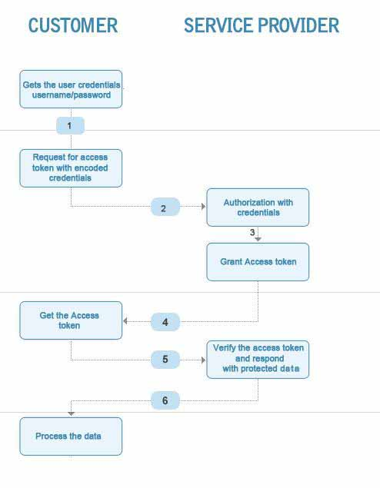
FIG 1.1 Credentials based authentication
OAuth Authentication

PROCEDURE FOLLOWED:

- Consumer Application registers with the MLS to get the consumer token and consumer secret key

- Consumer Request the request token with the consumer token and consumer secret key service provider will respond with oauth_key.

- User is directed to MLS for authorizing with oauth key with the call back url

- User submits credentials after the authorization the user is redirected to the customer application by passing oauth verifier

- Consumer application requests for the access token with the request token and oauth verifier

- Service Provider responds with the access token

- Consumer access the protected resources with the access token

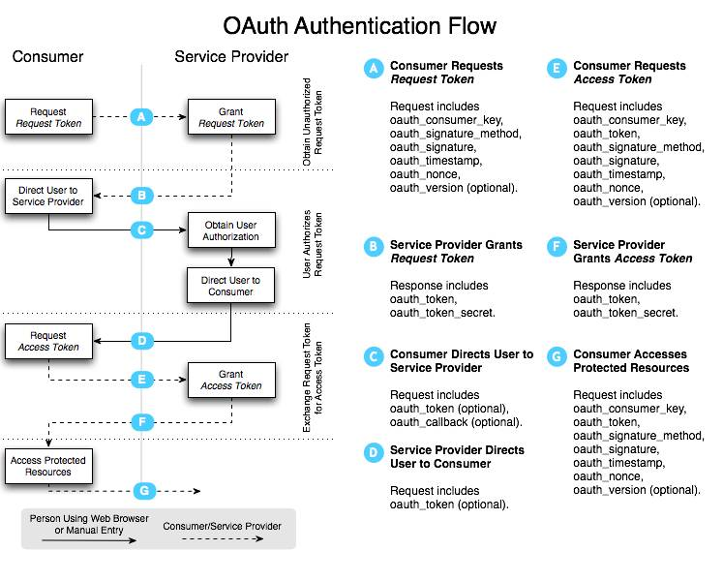
FIG 1.2 OAuth based authentication
OAuth Process flow – sample request and response

ClientApp

consumer/clientapp/register
Register an consumer application
URI | consumer/register
VERB | POST
Request | Consumer_id: Login id of the consumer.  client_app_name: This is a mandatory parameter specifying the client application name.  http://api.meetlinkshare.com/v1/consumer/register
Response | consumer_id: Consumer’s unique id (to be used only for the runtime traffic).  Name: This the client application name.  Status: This is the status of the client application.  Customer Key: This is the key associated with the client application.  Secret key: This is the secret associated with the key.  Success 2xx with proper response  <clientapp>  <consumer>  <customer_key> unique key with random 32 characters </customer_key>  <secret> unique key with random 16 characters </secret>  <loginid>consumer</loginid>  <clientapplicationname>clientapp_name</clientapplicationname>  <status>true</status>  <created_at>2010-02-02 09:18:16 UTC</created_at>  </consumer>  </clientapp>  <clientapp>  Failure 5xx with proper error message  <error>  <message>Couldn't create Client Application. Invalid api group name or loginid</message>  </error>  </clientapp>

consumer/clientapp/delete
Deletes a client application for specified customer
URI | /consumer/delete
VERB | GET
Request | Consumer_id: Login id of the consumer (to be used for portal access).This is a mandatory parameter.  Client_app_name: Specifying the client app name  http://api.meetlinkshare.com/v1/consumer/delete?client_app_name=clientapp_name&consumerid=consumer
Response | Success 2xx with proper response  Failure 5xx with proper error message  <consumer><error>  <message>Consumer or Client Application doesn't exists</message>  </error>  </consumer>

Key

consumer/key/generate
Generate a consumer key and secret for the specified Client
URI | /consumer/key/generate
VERB | GET
Request | consumerid: Login id of the consumer  Client_app_name: The client application name  http://api.meetlinkshare.com/v1/consumer/key/generate?client_app_name=clientapp_name&consumerid=consumer
Response | Key: This is the key generated.  Secret: This is the secret associated with the key.  application_name This is the client application name associated with the key.  Status: This is the status of the key.(true/false)  Success 2xx with proper response  <consumer>  <key> unique key with random 32 characters </key>  <secret> unique key with random 16 characters </secret>  <clientapplicationname>clientapplication_name</clientapplicationname>  <status>true</status>  <created_at/>  </consumer>  Failure 5xx with proper error message  <consumer>  <error>  <message>Key Not approved</message>  </error>  </consumer>

consumer/key/validate
Validate the key and return the attributes of the Key
URI | /consumer/key/validate
VERB | GET
Request | Key: This is a mandatory parameter.  http://api.meetlinkshare.com/v1/consumer/key/validate?key=66181434f9f8dba51d34a8d052f7676b
Response | Key: This is the key generated.  Secret: This is the secret associated with the key.  Client_app_name:This is the client application name associated with the key.  Status: This is the status of the key.(true/false)  Success 2xx with proper response  <consumer>  <key> unique key with random 32 characters </key>  <secret> unique key with random 16 characters </secret>  <clientapplicationname>clientapp_name</clientapplicationname>  <status>true</status>  <created_at/>  </consumer>  Failure 5xx with proper error message  <consumer>  <error>  <message>Key doesn’t Exists</message>  </error>  </consumer>
Failure Scenarios | If key is invalid.

consumer/key/revoke
Revokes the Key
URI | /consumer/key/revoke
VERB | GET
Request | Key: This is a mandatory parameter.  http://api.meetlinkshare.com/v1/consumer/clientapp/key/revoke?key=66181434f9f8dba51d34a8d052f7676b
Response | Status: This is the status of the key.(Revoked)  Success 2xx with proper response  <key>  <status>Revoked</status>  </key >  Failure 5xx with proper error message  <consumer>  <error>  <message>Key doesn’t Exists</message>  </error>  </consumer>

consumer/key/approve
Approves the Key
URI | /consumer/key/approve
VERB | GET
Request | Key: This is a mandatory parameter.  http://api.meetlinkshare.com/v1/consumer/clientapp/key/approve?key=66181434f9f8dba51d34a8d052f7676b
Response | Status: This is the status of the key.(Approved)  Success 2xx with proper response  <key>  <status>Approved</status>  </key >  Failure 5xx with proper error message  <consumer>  <error>  <message>Key doesn’t Exists</message>  </error>  </consumer>

OAuth

Request_token/generate
Generates the request_token for specified consumer key
URI | /request_token/generate
VERB | GET
Request | Key: This is a mandatory parameter.  http://api.meetlinkshare.com/v1/requesttoken/generate?key=7b814aef20b0a93f289f926c469ca1c8
Response | Success 2xx with proper response  <request_token>  <token> unique key with random 32 characters </token>  <secret> unique key with random 16 characters </secret>  </request_token>  Failure 5xx with proper error message  <request_token>  <error><message>Key is not valid</message>  </error>  </request_token>

Request_token/validate
Validates the request token
URI | /request_token/validate
VERB | GET
Request | request_token: This is a mandatory parameter.  http://api.meetlinkshare.com/v1/requesttoken/validate?request_token=fd11dc3e39c5b8959cb3e23d7965dee8
Response | Success 2xx with proper response  <request_token>  <token> unique token with random 32 characters </token>  <token_secret> unique token_secret with random 16 characters </token_secret>  <key> unique key with random 32 characters </key>  <clientapp_name>app2</clientapp_name>  </request_token>  Failure 5xx with proper error message  <request_token>  <error><message>Request token is not valid  </message>  </error>  </request_token>
Failing Scenarios | If request_token is invalid.

Request_token/revoke
Request token is revoked and status becomes inactive
URI | /request_token/revoke
VERB | GET
Request | Request_token: This is a mandatory parameter.  http://api.meetlinkshare.com/v1/requesttoken/revoke?request_token=cf0701c7a47ad33869f1b09ccefbf95f
Response | Success 2xx with proper response  n/a  Failure 5xx with proper error message  <request_token>  <error>  <message>Request token is not valid</message>  </error>  </request_token>
Remarks | Update the status of request token as “disabled”.

Request_token/approve
Request token is approved and status becomes active
URI | /request_token/approve
VERB | GET
Request | Request_token: This is a mandatory parameter.  http://api.meetlinkshare.com/v1/requesttoken/approve?request_token=cf0701c7a47ad33869f1b09ccefbf95f
Response | Success 2xx with proper response  n/a  Failure 5xx with proper error message  <request_token>  <error>  <message>Request token is not valid</message>  </error>  </request_token>
Remarks | Update the status of request token as “enabled”.

Oauth_verifier/create
creates the verifier
URI | /verifier/create
VERB | GET
Request | Verifier: This is a mandatory parameter.  userid: This is a mandatory parameter.  The optional parameters are user_attribute1,user_attribute2  http://api.meetlinkshare.com/v1/verifier/create?verifier=verifier&userid=user_id&attribute1=attr1&user_attribute2=attr2  \
Response | Success 2xx with proper response  n/a  Failure 5xx with proper error message  <oauth_verifier>  <error><message>Unable to create Oauth Verifier</message>  </error>  </oauth_verifier >

Oauth_verifier/delete
Purge the verifier
URI | /oauth/verifier/delete
VERB | GET
Request | Verifier: This is a mandatory parameter.  http://api.meetlinkshare.com/v1/verifier/delete?verifier=verifier
Response | Success 2xx with proper response  n/a  Failure 5xx with proper error message  <oauth_verifier >  <error>  <message>Unable to delete Oauth Verifier</message>  </error>  </oauth_verifier >

Access_token/generate
Generates the accesstoken
URI | /accesstoken/generate
VERB | GET
Request | Oauth_Verifier: This is a mandatory parameter.  Request_token: This is a mandatory parameter.  http://api.meetlinkshare.com/v1/accesstoken/generate?request_token= requesttoken&verifier=verifier&key=342b0efe3a491fc575e63d57da97a74b
Response | Token: This is the access token generated.  Secret: This is the secret generated for the particular access token.  Key: This the key associated with the particular access token.  Status: This specifies the status of the particular access  token(true/false)  Success 2xx with proper response  <accesstoken>  <token> unique token with random 32 characters </token>  <secret> unique secret with random 16 characters </secret>  <key> unique key with random 32 characters </key>  </accesstoken>  Failure 5xx with proper error message  <accesstoken>  <error>  <message>Key is not valid</message>  </error>  </accesstoken>

Access_token/validate
Return the attributes of the access token
URI | /access_token/validate
VERB | GET
Request | Access_token: This is a mandatory parameter.  key: This is an mandatory parameter.  http://api.meetlinkshare.com/v1/accesstoken/validate?access_token=cc198acddc70d308bf4900ec0cce0b7c&key=66181434f9f8dba51d34a8d052f7676b
Response | Accesstoken: This is the access token generated.  Secret:  This is the secret generated for the particular access token.  Success 2xx with proper response  < accesstoken >  <token> unique token with random 32 characters </token>  <token_secret> unique secret with random 16 characters </token_secret>  <key> unique key with random 32 characters </key>  <issuedtimestamp>2011-07-25 04:59:53 UTC</issuedtimestamp>  </accesstoken>  Failure 5xx with proper error message  <accesstoken>  <error>  <message>Access token is not valid</message>  </error>  </accesstoken>
Failing Scenarios | If access_token is invalid.

Accesstoken /revoke
Access token is revoked and status becomes inactive
URI | /accesstoken/revoke
VERB | GET
Request | Access_token: This is a mandatory parameter.  http://api.meetlinkshare.com/v1/accesstoken/revoke?access_token=accesstoken
Response | Success 2xx with proper response  n/a  Failure 5xx with proper error message  <accesstoken>  <error>  <message>Access token is not valid</message>  </error>  </accesstoken>
Remarks | Update the status of access token as “disabled”.

Accesstoken /approve
Access token is approved and status becomes active
URI | /accesstoken/approve
VERB | GET
Request | Access_token: This is a mandatory parameter.  http://Api.meetlinkshare.com/v1/accesstoken/approve?access_token=accesstoken
Response | Success 2xx with proper response  n/a  Failure 5xx with proper error message  <accesstoken>  <error>  <message>Access token is not valid</message>  </error>  </accesstoken>
Remarks | Update the status of access token as “enabled”.

Access_token/update
General purpose update method
URI | /access_token/update
VERB | GET
Request | Access_token: This is a mandatory parameter.  User_id : This is a mandatory parameter.  The optional parameters are user_attribute1,user_attribute2,user_attribute3,status  http://api.meetlinkshare.com/v1/accesstoken/update?access_token=accesstoken &userid=user_id&status=true
Response | Success 2xx with proper response  n/a  Failure 5xx with proper error message  <accesstoken>  <error>  <message>Access token is not valid</message>  </error>  </accesstoken>

