Software Architecture and Design Specification
Project: Railway Ticket Reservation System
Version: 1.0
Authors: Mini Project Team
Date: 30-09-2026
Status: Draft for Mini Project Submission

Revision History
Version | Date | Author | Change Summary
1.0 | 30-09-2026 | Project Team | Complete architecture and component design aligned with SRS v1.0

Approvals
Role | Name | Signature / Date
Project Mentor | Rajeshwari Adarakatti | ________________
Team Leader | Deeptanshu Kumar | ________________
Product Owner | Aryaprasad | ________________

1. Introduction

1.1 Purpose
This document specifies the software architecture and component-level design of the Railway Ticket Reservation System (RTRS). It translates the requirements in the SRS into a modular web-application design covering components, interfaces, data stores, interactions, security controls and design decisions.

1.2 Scope
The architecture covers passenger registration/authentication, train search, route and schedule display, seat availability, ticket booking, unique booking/PNR generation, booking history, ticket viewing, cancellation, refund-status recording, seat restoration, administrator management of train/schedule/fare/availability information, and audit/troubleshooting records. Physical railway operations and real railway backend integration are outside the mini-project scope.

1.3 Audience
Student development team, tester/QA, project lead, product owner, mentor, evaluator and future maintainers.

1.4 Definitions
RTRS - Railway Ticket Reservation System; PNR - Passenger Name Record; API - Application Programming Interface; JWT - JSON Web Token; RBAC - Role-Based Access Control; UI - User Interface; DBMS - Database Management System; RTM - Requirements Traceability Matrix.

2. Document Overview

2.1 How to use this document
Use this document as the design baseline for implementation and testing. It should be read together with the SRS, UML use-case diagrams, database design, REST API specification and Software Test Plan.

2.2 Related Documents
Railway Ticket Reservation System SRS v1.0, Software Test Plan v1.0, UML use-case diagrams, database schema, API specification and GitHub mini-project repository.

3. Architecture

3.1 Goals & Constraints
Goal / Constraint | Description
Separation of concerns | Presentation, business logic and persistence are separated into distinct layers.
Data consistency | Seat allocation must not permit two successful allocations for the same seat under concurrent requests.
Security | Accounts and booking information must be protected through hashing, authorization, validation, secure transport where deployed and safe logging.
Maintainability | Components have focused responsibilities and communicate through clear interfaces.
Academic scope | The prototype does not control physical railway operations or integrate with a real railway operational backend.

3.2 Stakeholders & Concerns
Stakeholder | Concerns
Passenger | Simple search, accurate availability, secure booking, ticket view, cancellation and clear messages.
Administrator | Train, route, schedule, fare and availability maintenance; auditability.
Product Owner - Aryaprasad | Requirements, priorities, acceptance and sign-off.
Developer / Project Lead - Deeptanshu Kumar | Implementation, technical feasibility, integration and defect resolution.
Tester / QA Lead - Amar | Test planning, execution, verification and defect reporting.
Project Mentor - Rajeshwari Adarakatti | Architecture/design review, guidance and approval.

3.3 Component (UML) Diagram
Figure 1 shows the main software components and their dependencies. React provides the presentation layer; the Express REST API coordinates application services; the relational database provides persistence. Mock payment is optional, consistent with the SRS.
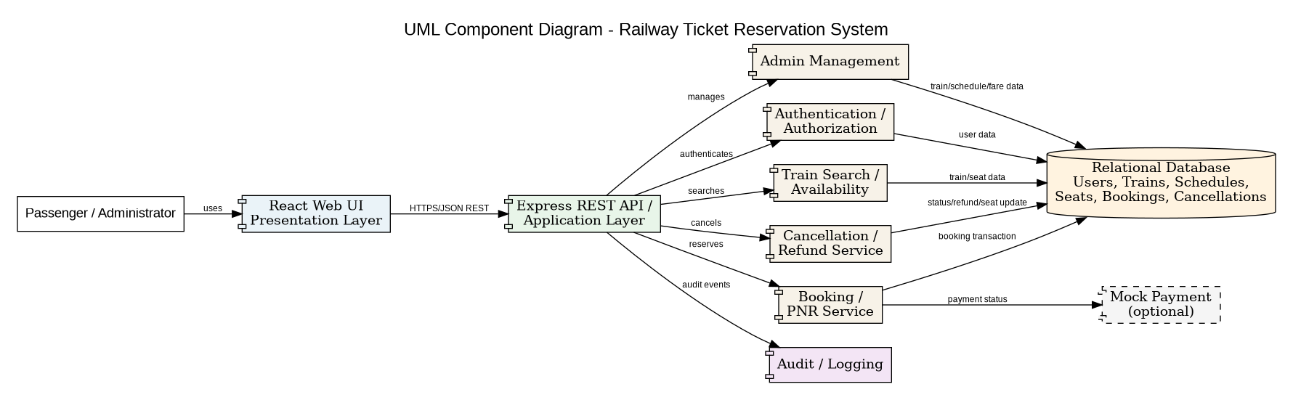
Figure 1. UML Component Diagram - Railway Ticket Reservation System

3.4 Component Descriptions
Component | Responsibility | SRS Traceability
React Web UI | Search, result display, availability, passenger form, ticket, history, cancellation and admin screens. | RTS-F-003..F-017; RTS-NF-003, 007
Authentication / Authorization | Registration, login, hashing, JWT/session handling, role and ownership checks. | RTS-F-001, F-002, F-016; RTS-NF-005, 006; RTS-SR-001, 002
Train Search | Search by source, destination and date; return train details, timings and fare. | RTS-F-003, F-004
Availability / Inventory | Read current seat inventory and perform atomic allocation/restoration. | RTS-F-005, F-008, F-010, F-015; RTS-NF-002
Booking / PNR | Validate passenger details, create reservation, generate unique PNR and ticket data. | RTS-F-006..F-012
Cancellation / Refund | Check ownership/cutoff, calculate refund, change status and restore seats. | RTS-F-013..F-016
Admin Management | Add/update/deactivate train and schedule records and maintain fare/availability information. | RTS-F-017
Audit / Logging | Record booking/cancellation events with timestamps and identifiers without sensitive authentication data. | RTS-F-018; RTS-NF-008; RTS-SR-005
REST API Layer | HTTP/HTTPS JSON interface, validation, status codes and service coordination. | RTS-NF-001, 003, 004; RTS-SR-003, 004
Relational Database | Persistent users, trains, schedules, seats, bookings, cancellations and audit records. | All persistence-related requirements

3.5 Chosen Architecture Pattern and Rationale
A three-tier layered architecture is selected: Presentation Layer (React UI), Application Layer (Node.js/Express REST API and business services) and Data Layer (relational SQL database). This matches the SRS product perspective, which specifies a browser UI communicating with backend services and a relational database. Separation of concerns reduces coupling and simplifies unit, integration and system testing. A full microservices architecture is not used because the academic project has a limited scope and benefits from simpler deployment and debugging.

3.6 Technology Stack & Data Stores
Layer | Technology / Store | Purpose
Presentation | React; CSS/Tailwind as applicable | Responsive browser UI
Application | Node.js + Express.js | REST APIs and business/service logic
Authentication | JWT and secure one-way password hashing | Authentication and role-based access
Persistence | Relational SQL DBMS (e.g., MySQL) | Users, trains, schedules, seats, bookings, cancellations, audit records
Testing/Tools | Postman, Git/GitHub, VS Code | API testing, version control and development

3.7 Risks & Mitigations
Risk | Mitigation
Double booking | Re-check availability before confirmation and use transactional/atomic seat allocation.
Stale availability | Treat displayed availability as provisional and perform a final backend check.
Unauthorized access | Use authenticated sessions/tokens plus role and ownership authorization.
Injection / malformed input | Validate/sanitize inputs and use parameterized/prepared database access.
Partial state after failure | Use transaction boundaries so booking, seat and audit updates remain consistent.
Sensitive data leakage | Never log passwords/tokens; keep sensitive authentication data out of URLs and error responses.

3.8 Traceability to Requirements
Req ID | Requirement | Design Module | Test Case Ref
RTS-F-001 | Registration | Authentication / User Module | TC-REG-01, TC-REG-02
RTS-F-002 | Login | Authentication / User Module | TC-AUTH-01, TC-AUTH-02
RTS-F-003 | Train search | Search Module | TC-SEARCH-01, TC-SEARCH-03
RTS-F-004 | Train details | Search Module | TC-SEARCH-02
RTS-F-005 | Seat availability | Availability Module | TC-AVAIL-01, TC-AVAIL-02
RTS-F-006 | Booking form | Booking Module | TC-BOOK-01
RTS-F-007 | Passenger validation | Booking Module | TC-BOOK-02
RTS-F-008 | Availability check | Booking / Inventory Module | TC-BOOK-03
RTS-F-009 | PNR creation | Booking Module | TC-BOOK-04
RTS-F-010 | Seat decrement | Booking / Inventory Module | TC-BOOK-05
RTS-F-011 | Ticket confirmation | Ticket Module | TC-TICKET-01
RTS-F-012 | Booking history | Booking Module | TC-HISTORY-01
RTS-F-013 | Cancellation | Cancellation Module | TC-CANCEL-01
RTS-F-014 | Refund calculation | Cancellation Module | TC-CANCEL-02
RTS-F-015 | Seat restoration | Cancellation / Inventory Module | TC-CANCEL-03
RTS-F-016 | Ownership authorization | Authorization Module | TC-SEC-03
RTS-F-017 | Admin management | Admin Module | TC-ADMIN-01, TC-ADMIN-02
RTS-F-018 | Audit events | Audit / Logging Module | TC-AUDIT-01
RTS-NF-001 | Response time | Application / API | TC-PERF-01
RTS-NF-002 | Concurrent seat consistency | Booking / Inventory Module | TC-CONC-01
RTS-NF-005 | Password hashing | Authentication Module | TC-SEC-01
RTS-NF-006 | Role-based access | Authorization Module | TC-SEC-02
RTS-SR-001 | Secure password storage | Authentication Module | TC-SEC-01
RTS-SR-002 | Authorization | Authorization Module | TC-SEC-02, TC-SEC-03
RTS-SR-003 | TLS | Deployment / API Layer | TC-SEC-04
RTS-SR-004 | Input validation | Validation / API Layer | TC-SEC-05
RTS-SR-005 | Sensitive-data logging | Logging Module | TC-SEC-06

3.9 Security Architecture
The design implements the two SRS security objectives: protect passenger accounts and booking information from unauthorized access, modification or disclosure; and preserve reservation-data integrity so bookings, cancellations and seat availability remain trustworthy.
Security Requirement | Design Control | Verification
RTS-SR-001 | Secure one-way password hashing; no plaintext password persistence. | TC-SEC-01
RTS-SR-002 | Authentication + role/ownership authorization middleware. | TC-SEC-02, TC-SEC-03
RTS-SR-003 | HTTPS/TLS in supported deployment configurations. | TC-SEC-04
RTS-SR-004 | Server-side validation/sanitization and parameterized SQL access. | TC-SEC-05
RTS-SR-005 | Sensitive authentication data excluded from logs, URLs and error messages. | TC-SEC-06

4. Design

4.1 Design Overview
Requests originate at the React UI and are sent to REST endpoints. The backend validates inputs and authorization before applying business logic. Services read or update the SQL database. Booking and cancellation paths are consistency-sensitive operations. The client receives structured results or safe error messages.

4.2 UML Sequence Diagrams
The booking sequence corresponds to RTS-F-003 to RTS-F-011 and shows search, availability verification, passenger data entry, atomic reservation, PNR creation and confirmation.
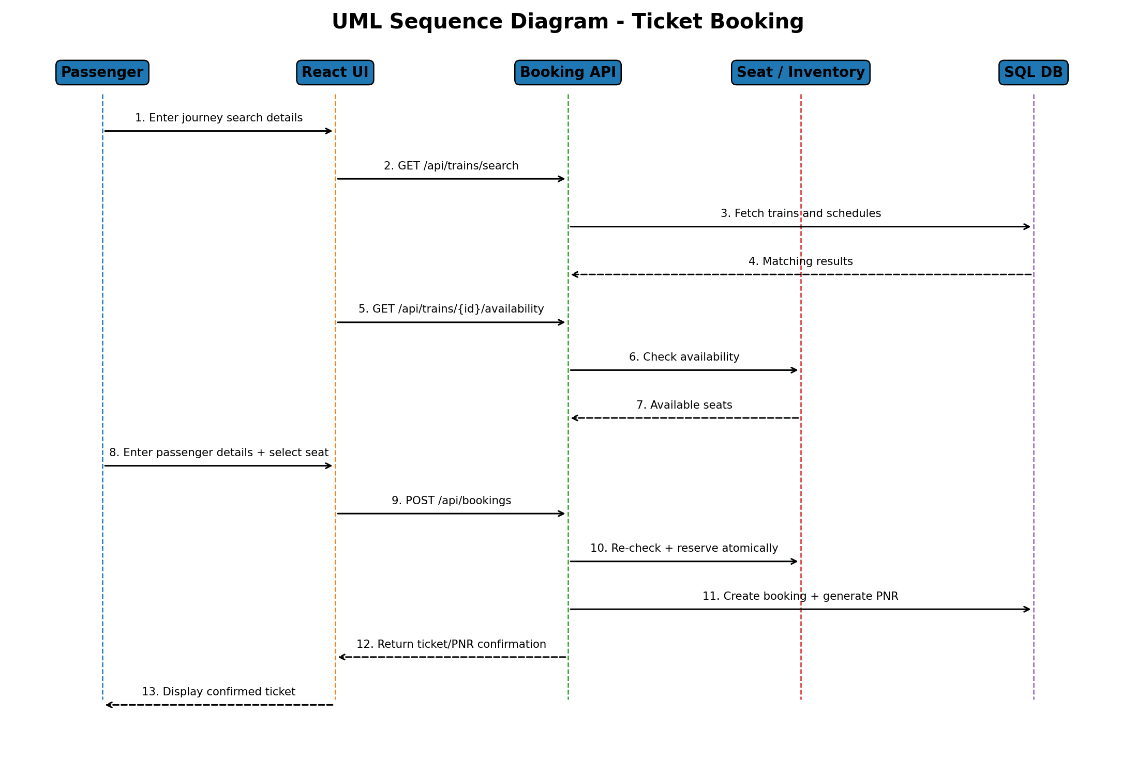
Figure 2. UML Sequence Diagram - Ticket Booking
The cancellation sequence corresponds to RTS-F-013 to RTS-F-016 and shows ownership/eligibility verification, refund calculation, booking status update, seat restoration and audit recording.
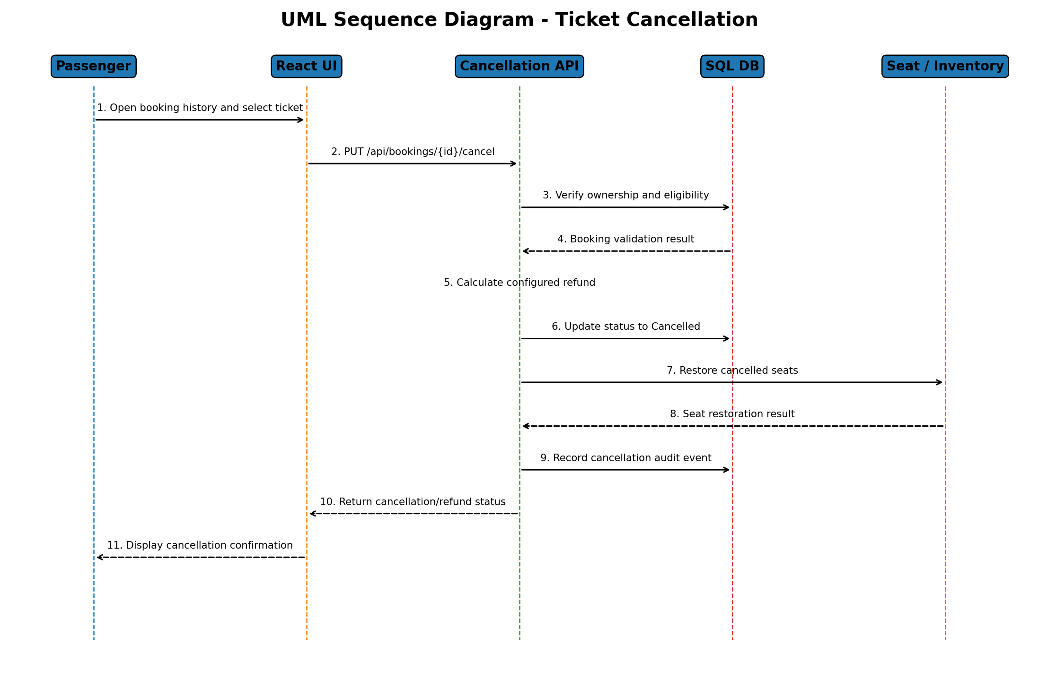
Figure 3. UML Sequence Diagram - Ticket Cancellation

4.3 API Design
API | Method / Endpoint | Request / Parameters | Response / Result | Access
Registration | POST /api/auth/register | Name, email/username, password | Registration status / validation error | Public
Login | POST /api/auth/login | Email/username, password | JWT/session information + role | Public
Train Search | GET /api/trains/search | Source, destination, journeyDate | Matching trains + schedule/fare | Public
Availability | GET /api/trains/:id/availability | Train ID, journeyDate, class | Current seat availability | Public
Create Booking | POST /api/bookings | Train, journey, passenger details, seat/class | Booking ID, PNR and ticket data | Authenticated
Booking History | GET /api/bookings | Authenticated user context | Own active/previous bookings | Authenticated
Cancel Booking | PUT /api/bookings/:id/cancel | Booking ID | Cancelled status + refund amount | Owner
Admin Train/Schedule | POST/PUT /api/admin/trains | Train/schedule/fare fields | Created/updated record | Admin only

4.4 Error Handling, Logging & Monitoring
Condition | HTTP Status | User Response | Logging
Invalid input | 400 | Clear validation message | Non-sensitive validation event
Unauthenticated | 401 | Login/session message | Endpoint/status
Unauthorized role/ownership | 403 | Access denied | Security/audit event
Missing record | 404 | Resource not found | Endpoint/status
Seat conflict | 409 | Seat unavailable; reselect/refresh | Conflict event
Unexpected server/DB failure | 500 | Generic retry/error message | Internal diagnostic without credentials

4.5 UX Design
Passenger journey: Register/Login -> Search Train -> Review Results -> Check Availability -> Enter Passenger Details -> Confirm Booking -> View Ticket/PNR -> Optional Cancellation. Search results show train number/name, route, departure, arrival, duration, fare and seat availability. Required fields are validated before submission. Confirmation and cancellation messages clearly indicate the outcome. The interface is designed for common desktop and mobile viewport sizes.

4.6 Open Issues & Next Steps
- Finalize the exact relational schema and database constraints used in implementation.
- Finalize the configured cancellation/refund policy.
- Use a simulated/mock payment flow if live payment is not integrated.
- Complete API integration between React frontend, Express backend and SQL database.
- Prepare seeded test data and execute the Software Test Plan and RTM.
- Add deployment/monitoring details if the prototype is hosted.

5. Appendices

5.1 Glossary
Term | Meaning
PNR | Unique booking reference for retrieving a reservation.
JWT | JSON Web Token used for authenticated session claims.
RBAC | Role-Based Access Control restricting operations by role.
REST API | HTTP-based interface used by frontend and backend.
RTM | Matrix connecting requirements to design modules and tests.

5.2 References
Railway Ticket Reservation System SRS v1.0 dated 06-09-2026; Software Test Plan v1.0; project UML use-case diagrams; database and API design artifacts.

5.3 Tools
React, Node.js, Express.js, relational SQL DBMS, Git/GitHub, Postman, VS Code and UML modelling tools.

