PL/SQL programming

Exercise 1: Control Structures

Scenario 1: The bank wants to apply a discount to loan interest rates for customers above 60 years old.

**Code:**

DECLARE

CURSOR senior_customers IS

SELECT c.CustomerID, l.LoanID, l.InterestRate

FROM Customers c

JOIN Loans l ON c.CustomerID = l.CustomerID

WHERE MONTHS_BETWEEN(SYSDATE, c.DOB) / 12 > 60;

BEGIN

FOR cust IN senior_customers LOOP

UPDATE Loans

SET InterestRate = InterestRate - 1

WHERE LoanID = cust.LoanID;

END LOOP;

COMMIT;

DBMS_OUTPUT.PUT_LINE('1% discount applied to loan interest rates for customers above 60.');

END;

/

**Output:**

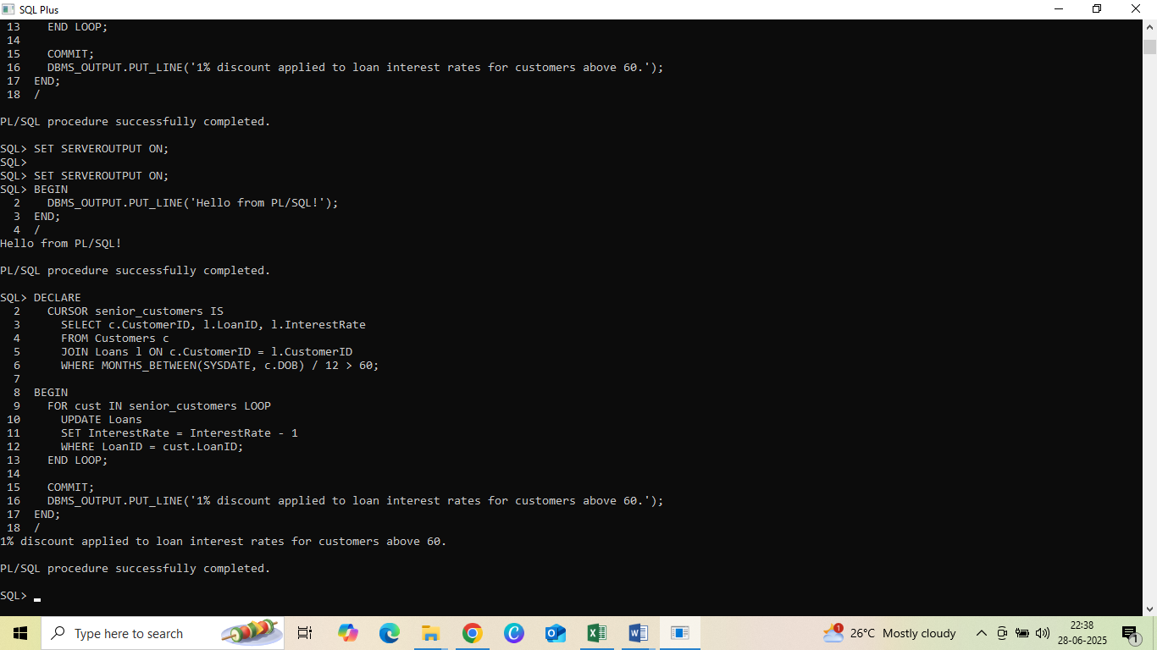

Scenario 2: A customer can be promoted to VIP status based on their balance.

**Code:**

ALTER TABLE Customers ADD IsVIP VARCHAR2(5);

DECLARE

CURSOR vip_cursor IS

SELECT CustomerID FROM Customers WHERE Balance > 10000;

BEGIN

FOR cust IN vip_cursor LOOP

UPDATE Customers

SET IsVIP = 'TRUE'

WHERE CustomerID = cust.CustomerID;

END LOOP;

COMMIT;

DBMS_OUTPUT.PUT_LINE('VIP status updated for customers with balance > $10,000.');

END;

/

**Output:**

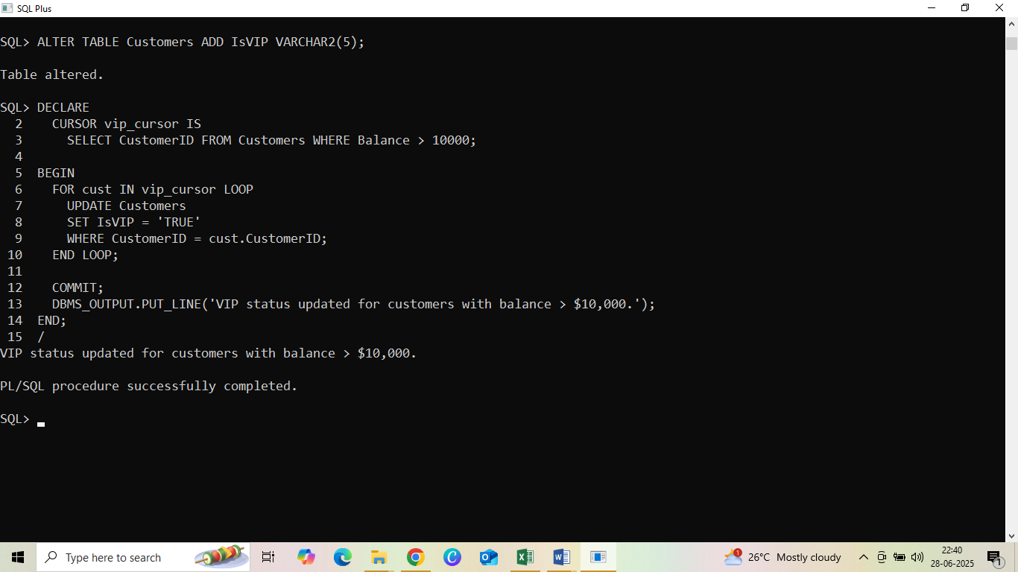

Scenario 3: The bank wants to send reminders to customers whose loans are due within the next 30 days.

**Code:**

BEGIN

FOR loan_rec IN (

SELECT l.LoanID, l.CustomerID, c.Name, l.EndDate

FROM Loans l

JOIN Customers c ON l.CustomerID = c.CustomerID

WHERE l.EndDate BETWEEN SYSDATE AND SYSDATE + 30

) LOOP

DBMS_OUTPUT.PUT_LINE('Reminder: ' || loan_rec.Name ||

', your loan (ID: ' || loan_rec.LoanID ||

') is due on ' || TO_CHAR(loan_rec.EndDate, 'DD-MON-YYYY') || '.');

END LOOP;

END;

/

**Output:**

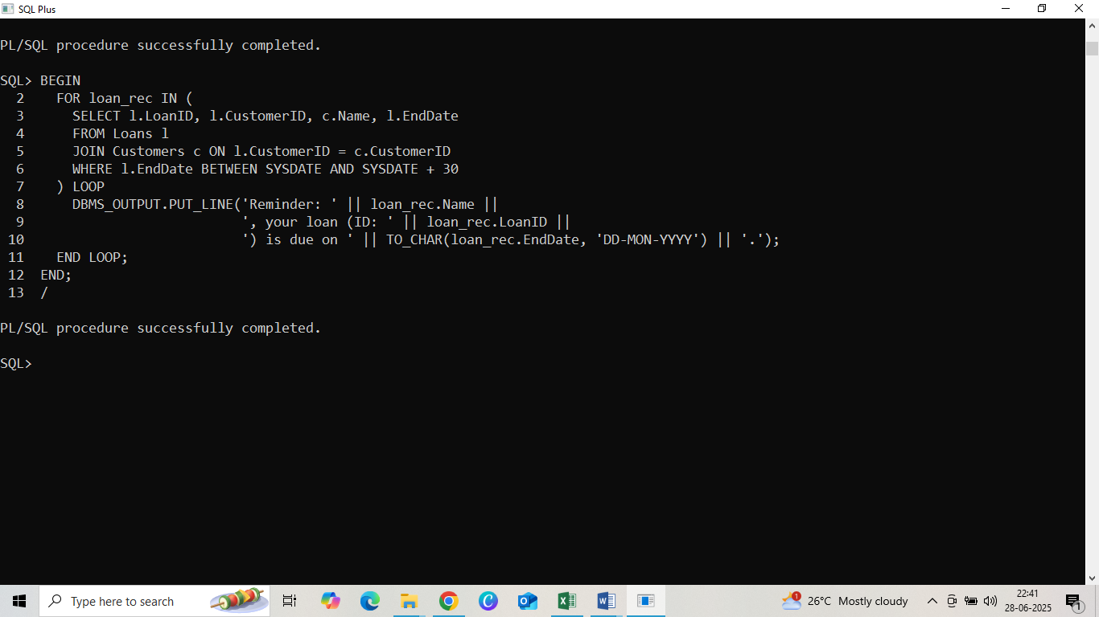

Exercise 3: Stored Procedures

Scenario 1: The bank needs to process monthly interest for all savings accounts.

**Code:**

CREATE OR REPLACE PROCEDURE ProcessMonthlyInterest IS

BEGIN

UPDATE Accounts

SET Balance = Balance + (Balance * 0.01)

WHERE AccountType = 'Savings';

DBMS_OUTPUT.PUT_LINE('Monthly interest applied to all savings accounts.');

END;

/

**Output:**

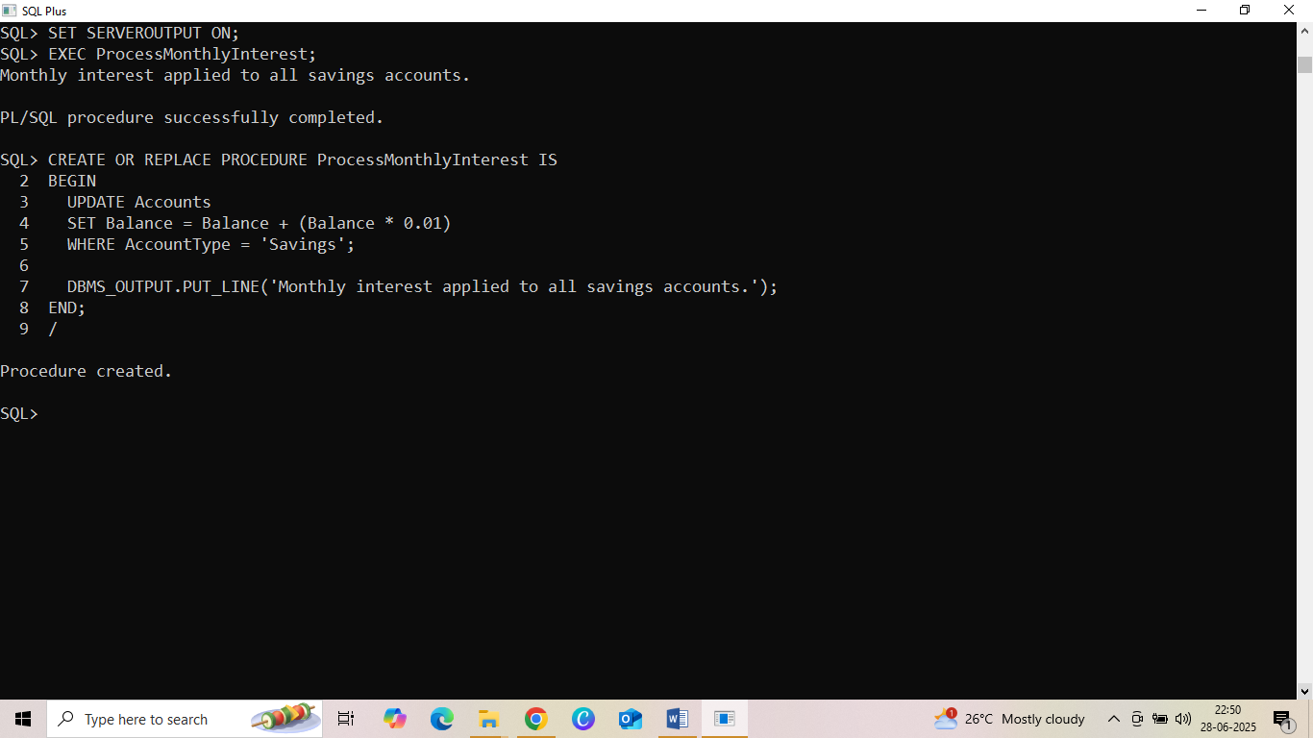

Scenario 2: The bank wants to implement a bonus scheme for employees based on their performance.

**Code:**

CREATE OR REPLACE PROCEDURE UpdateEmployeeBonus (

p_dept IN VARCHAR2,

p_bonus_percent IN NUMBER

) IS

BEGIN

UPDATE Employees

SET Salary = Salary + (Salary * (p_bonus_percent / 100))

WHERE Department = p_dept;

DBMS_OUTPUT.PUT_LINE('Bonus of ' || p_bonus_percent || '% applied to department ' || p_dept);

END;

/

**Output:**

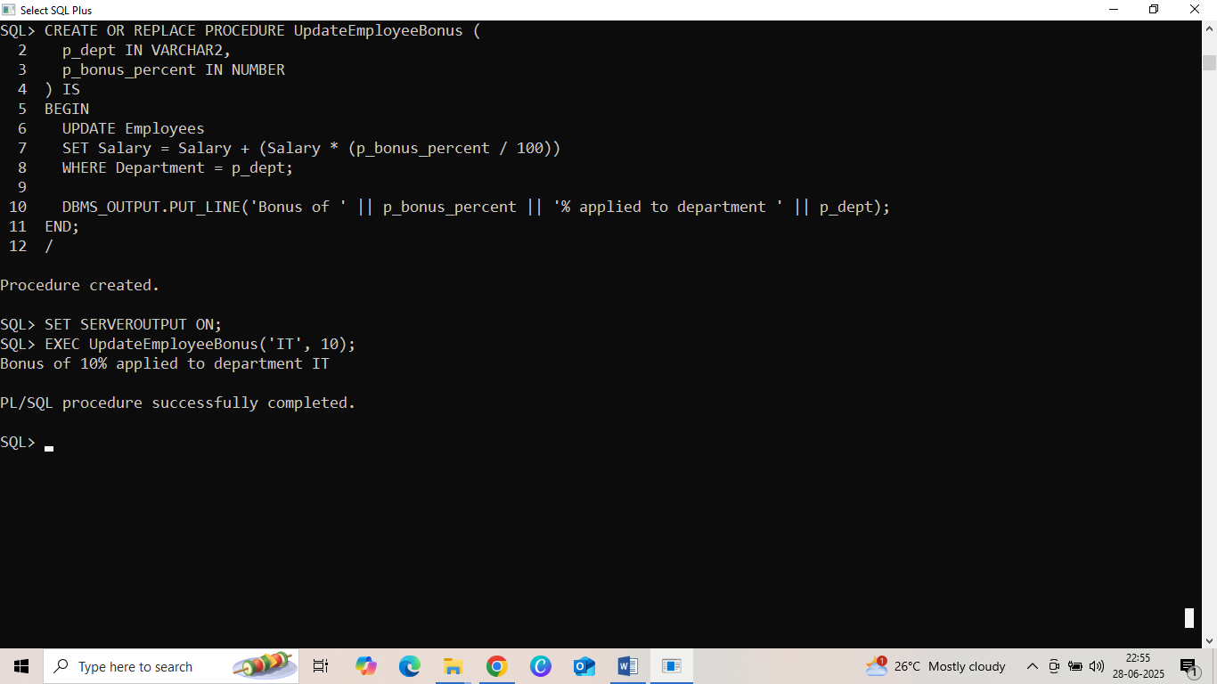

Scenario 3: Customers should be able to transfer funds between their accounts.

**Code:**

CREATE OR REPLACE PROCEDURE TransferFunds (

p_from_acc IN NUMBER,

p_to_acc IN NUMBER,

p_amount IN NUMBER

) IS

v_balance NUMBER;

BEGIN

-- Get current balance of source account

SELECT Balance INTO v_balance

FROM Accounts

WHERE AccountID = p_from_acc;

-- Check for sufficient balance

IF v_balance >= p_amount THEN

-- Deduct from source

UPDATE Accounts

SET Balance = Balance - p_amount

WHERE AccountID = p_from_acc;

-- Add to destination

UPDATE Accounts

SET Balance = Balance + p_amount

WHERE AccountID = p_to_acc;

DBMS_OUTPUT.PUT_LINE('₹' || p_amount || ' transferred from Account ' || p_from_acc || ' to Account ' || p_to_acc);

ELSE

DBMS_OUTPUT.PUT_LINE('Transfer failed: Insufficient balance in Account ' || p_from_acc);

END IF;

EXCEPTION

WHEN NO_DATA_FOUND THEN

DBMS_OUTPUT.PUT_LINE('One of the accounts does not exist.');

END;

/

**Output:**

