Create a React App named “bloggerapp” in with 3 components.

1. Book Details

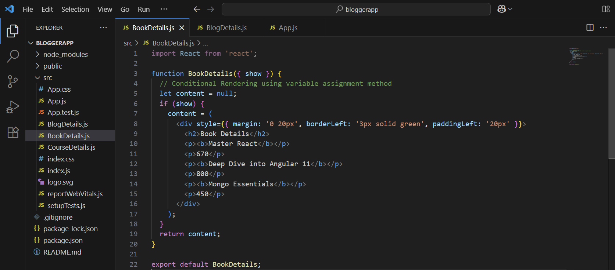

1. Blog Details

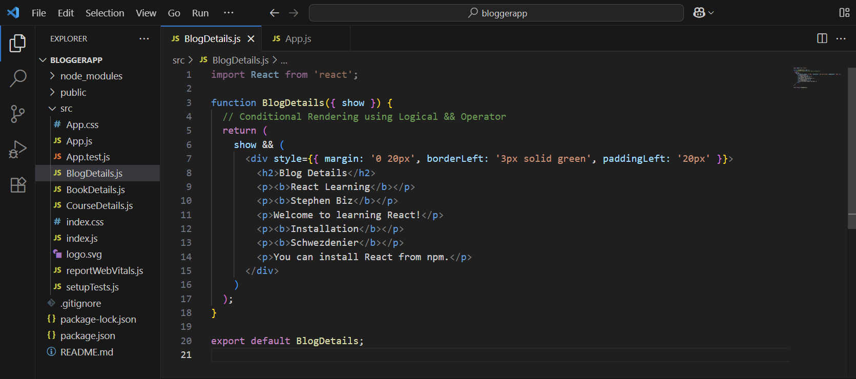

1. Course Details

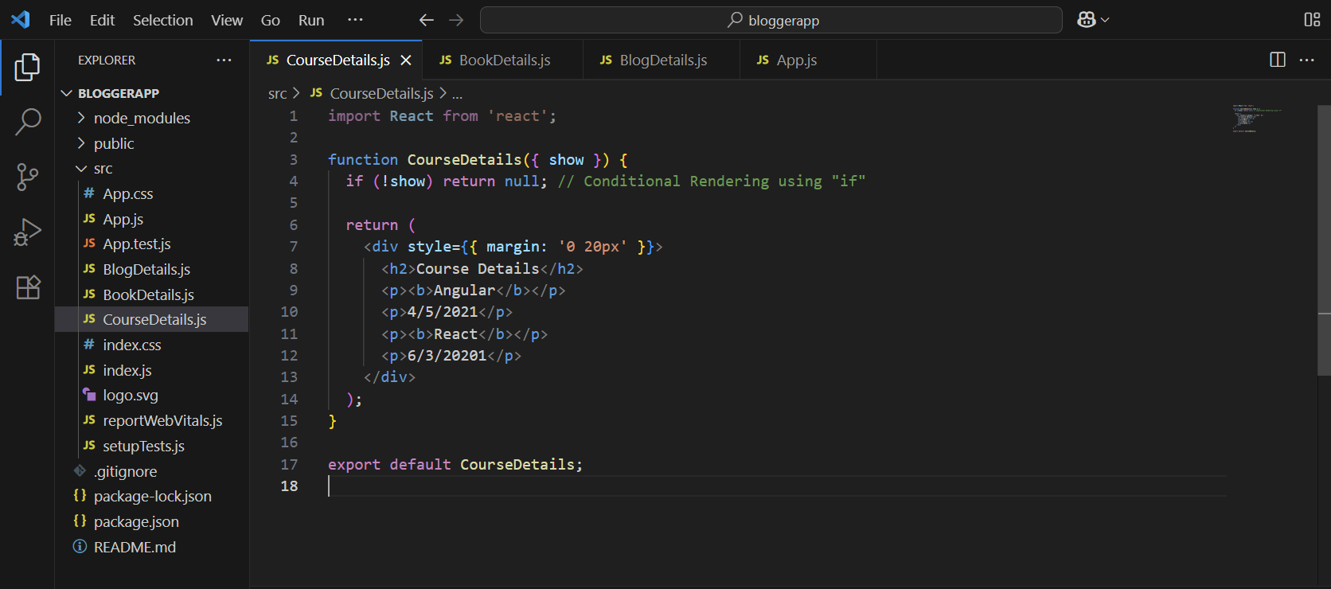

Implement this with as many ways possible of Conditional Rendering.

