• Explain branching and merging   
A branch is a separate line of development in your repository.

* + Think of it as a copy of your code where you can make changes without affecting the main branch (master or main).
  + Work on new features without disturbing stable code.
  + Fix bugs in isolation.
  + Collaborate with others without overwriting each other’s work.
* **Default branch**: When you create a new repo, the default is usually master or main.

**Key Commands:**

bash

CopyEdit

git branch <branch-name> # create a branch

git checkout <branch-name> # switch to a branch

git branch # list branches

Merging is the process of combining changes from one branch into another.

* **Types of merges:**
  + **Fast-forward merge**: Simple merge when there are no conflicting changes.
  + **Three-way merge**: Happens when both branches have new commits — may cause conflicts.

**Key Commands:**

bash

CopyEdit

git checkout master # switch to the branch you want to merge into

git merge <branch-name> # merge the branch into current branch

• Explain about creating a branch request in GitLab

Also called **creating a branch** in GitLab’s UI.

* Steps:
  1. Open your GitLab repository in a browser.
  2. Go to **Repository → Branches**.
  3. Click **New branch**.
  4. Enter branch name (e.g., feature-login) and choose which branch to base it on (usually master).
  5. Click **Create branch**.
  6. You can now pull this branch locally and work on it:

bash

CopyEdit

git fetch origin

git checkout feature-login

• Explain about creating a merge request in GitLab

A merge request (MR) in GitLab is like a pull request (PR) in GitHub — it’s how you ask to merge your branch into another.

Steps:

Push your branch to GitLab:

bash

Copy

Edit

git push -u origin feature-login

In GitLab, click Merge requests → New merge request.

Select:

Source branch = your branch (feature-login)

Target branch = where you want to merge (master)

Review changes, add title and description.

Click Create merge request.

Team members can review, comment, and approve before merging.

Branch Request

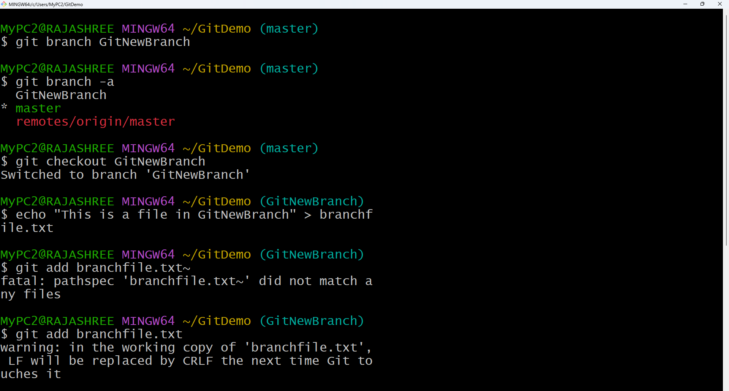

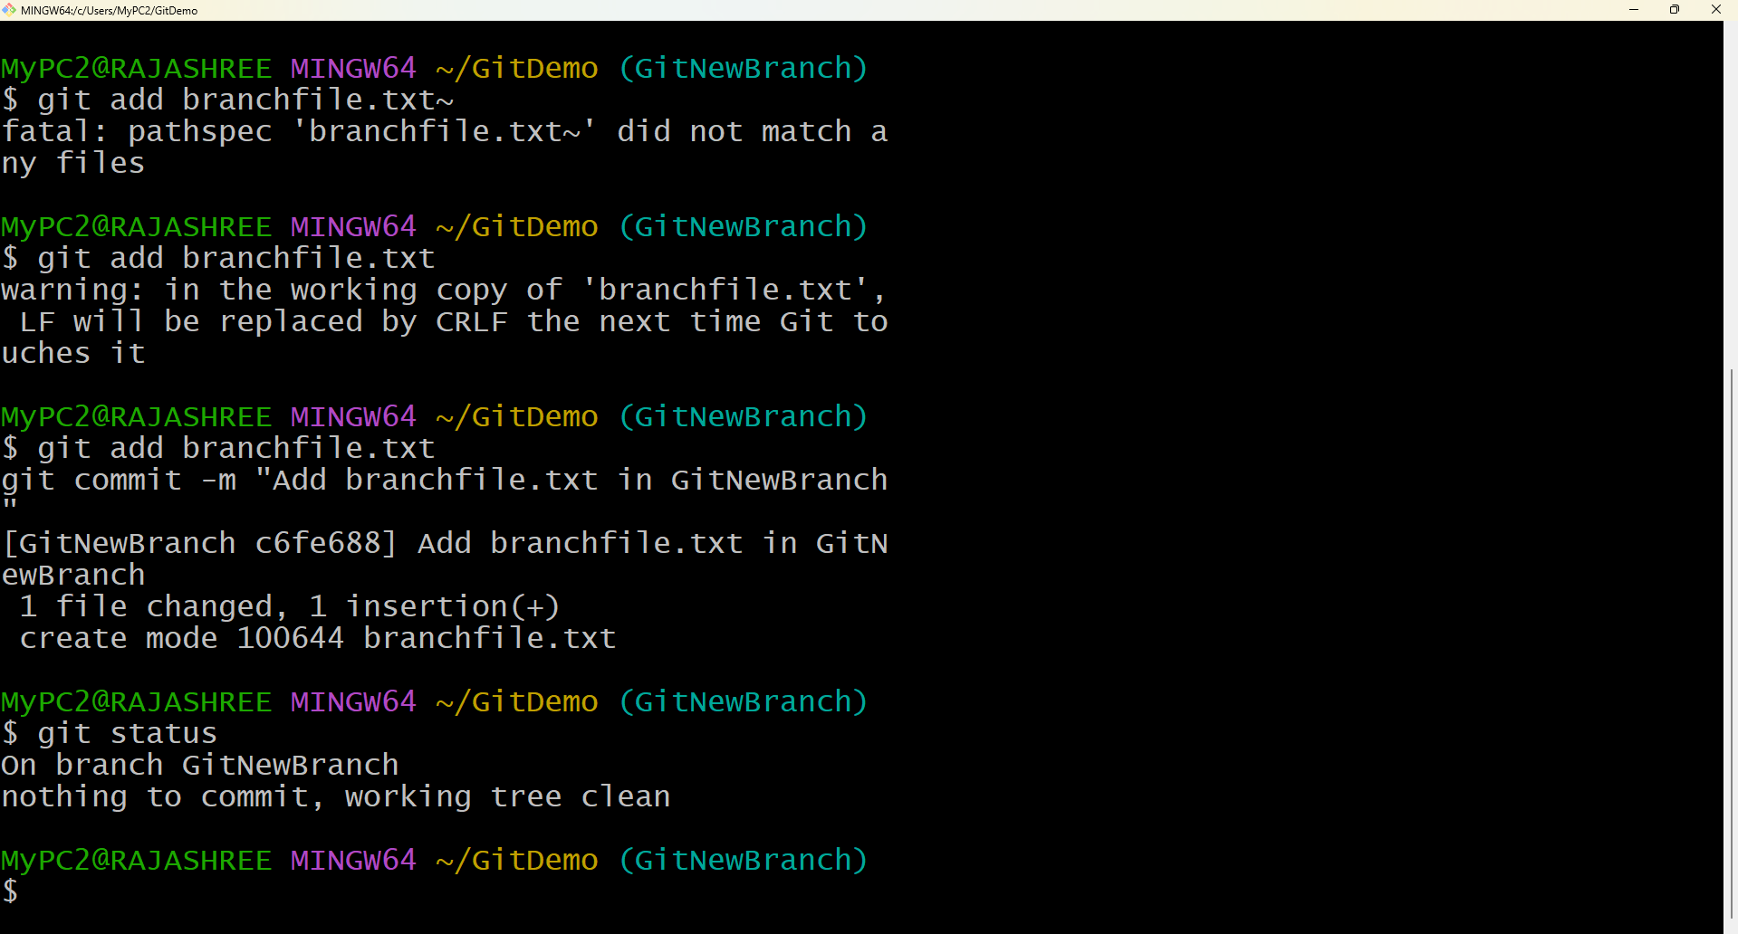

Merge Request

