TEAM SOFTWARE DEVELOPMENT PROJECT

STUDENT NAME-

STUDENT ID-

Contents

Abstract 3

Introduction 3

My character and input 4

Collecting the requirements 4

Building user stories 4

Stating outcomes, and design expectations 5

Prototyping, and testing along with the developer 5

Examining the project risk 5

Evolution of the application 6

Iteration walkthrough 7

Challenges 8

Features of application and targets 8

Self-reflection 10

RAD methodology critique 11

Conclusion 12

References 14

# Abstract

In the medical industry on daily basis, various types of diseases and depressions affect the livelihood of various patients and also the families of the patient. Postnatal depression is a very happening problem that occurs in women during, or after pregnancy. Though being a common disease, it can be dangerous to the mother and her child. The concerned depression affects women mentally and makes them feel anxious, tearful, constant mood swings, and bad mood mostly.

The study of the issue is based on a direct system that is available as a mobile application. This application helps the victims of this problem seek support, and help to recover from it. this mobile app is very much capable of providing all the related information to the concerned women consisting including proper precautions, medication, and vast information related to the concerned issue. The best thing about the app is that it is highly user-friendly and the users can use this app easily without any pre-training. The models that were used while the development with the help of the RAD model which is related to the software development life cycle model (Papandreou, and et.al, 2023).

# Introduction

The concerned report is based on providing information about the development of the concerned application. It can be easily identified that the objective behind the development of the concerned mobile application is to help women that are suffering from Postnatal depression. The major victims of the concerned health issue are mothers who just gave birth to a baby. It is a common disease that affects around 20% of mothers after having a child. It can be identified that there are various symptoms that are related to the above health issue such as a sense of sadness, tearfulness, loss of energy, the feeling of guilt, hopelessness, self-arming thoughts, loss of focus, and various other symptoms are there that are the indicators of the above-mentioned health condition.

Several variables, including variations in the hormones, stress, a history of depression, sleep deprivation, and traumatic life events, might contribute to postnatal depression. Therapy for postpartum depression frequently combines various forms of treatment, drugs, yoga, and dietary adjustments. It is crucial for new mothers to seek assistance if they are exhibiting postnatal depression symptoms because prompt therapy can significantly enhance outcomes for both the mother and the child (Ashraf, and et.al, 2023).

To assist the patients with this problem an application is created with the help of a rapid application development model. The concerned model approach is employed to examine the development of applications. This comprises the needs, planning, and development. The planning and requirements of the application are automatically included in RAD models (Beck, 2023).

The task of the model is to collect all the information that is required by the application such as the information of the patient and the requirement of the customers. take a trial of all the prototypes that are used by the patient and then reuse those prototypes. This combined will interacts and then deliver effectively.

# My character and input

In the development process of the concerned application, my responsibility was to act as a user representative. My task was to make sure that all the requirements that are required by the developers of the app development are properly held.

## Collecting the requirements

The needs of women who utilize this program are given the most attention. According to their needs throughout pregnancy, such as material on psychological issues, their symptoms, and how to manage them, and personal details for the medical staff, their family, and their friends so that they can readily access and contact them when needed. Their medical histories, consultations with notices from doctors, and even information about how they perceive medications are all used to ensure that they never neglect to take their medications on time (Singh, and et.al, 2022).

## Building user stories

I would like to be able to communicate with other ladies going through similar challenges as a new mother experiencing postnatal depression so that I don't feel alone and can get support and guidance. In order to get the care, I want without having to leave my job, I want to be able to access support at any time, even after usual business hours, as a working woman facing postnatal depression. Being a mother of 2 children experiencing specific depression, I want to have access to childcare services while I am attending the support group to treat my condition. My goal is to prioritize the development of my mental health without sacrificing the growth, and care of my children. In order to get the care, I need without going into debt or adding to my already high level of financial stress, I need to be able to access inexpensive or free mental health services as a woman with little financial resources who is suffering from postnatal depression. I wish to be capable of contacting a support structure that is non-judgmental, culturally responsive, and respects my privacy as a mother who is reluctant to seek care for postnatal depression because of social or cultural stigma so that I feel safe and comfortable asking for help.

## Stating outcomes, and design expectations

Due to the program's evolution, problems, risk, and other criteria. I anticipate a fantastic outcome and system design. This can aid a woman with postpartum depression. After system construction, this system ought to produce favorable results. I believe that the existing tools and models should be supported by new innovations in technology and in design demands. As discussed under the system's progress and performance, the system is functioning as intended.

## Prototyping, and testing along with the developer

The participant of the dev team makes the decisions regarding the prototypes that are required for this application's development. The tools, methods, and prototypes utilized in this software are chosen and improved by them. The user information and details must be stored in a database so that they can be used in the future to improve the application's results. The software advancement cycle's fast application development approach is applied in the creation of this application. This approach suggests innovation and prototypes for the creation of software applications after automatically analyzing the produced requirements. As per the American group interview with some young mothers, it has been identified that the majority of the people like the idea of text message alerts. That’s why the application will have a highly responsive text message system.

## Examining the project risk

A few of the most crucial aspects of app development are risk assessments. Our analysis, which is based on the RAD model, indicates that postnatal depression multimedia applications face numerous production risks. The following are the included risk factors.

Investigating and regrouping the depression indications, supporting multiple relevant technologies on the mobile application, database for the storage of the results of the analysis, finance-related problems, less strong social support, reconsidering multiple health issues during pregnancy, lack of joy in life, and various other issues are there.

Pregnant women experience greater issues at that time. They are harmed in many ways. It is possible for postnatal depression to develop before or after pregnancy. One year after having birth, it may occur. In addition to seriously affecting the mother, postnatal depression also has an adverse effect on the father and kid. Parents who have a young kid and have experienced postpartum depression may take into account feelings and circumstances that may be connected to the woman's emotional or physical health and might additionally have an impact on the child (Parracha, and et.al, 2023).

Using the Pitt inventory, postnatal depression is evaluated when the newborn is 6 months old. We analyze risk assessments and rank risks based on many risk interfaces, such as a bad user interface, regulatory issues, inadequate human resources, and project stalling. This risk-control process determines the risk analysis ranking based on probability and seriousness.

|  |  |  |  |  |
| --- | --- | --- | --- | --- |
| Hazard | Control procedure | Likelihood (a) | Severity (b) | Risk Ranking (=axb) |
| weak user interface | Ensure we use proper tools | 3 | 3 | 9 |
| Stalling of project | Ensure you have sufficient supply of funds for this type of project | 3 | 2 | 6 |
| weak human resources | Making sure you hire highly technical candidates for the team | 2 | 4 | 8 |
| Regulatory concerns | Adherence to standard operational protocols in the health-related sector | 2 | 3 | 6 |

# Evolution of the application

This application was created with women in mind. The issues that arise following pregnancies are the main focus. After giving birth, many women experience postnatal depression issues. A mobile application is being developed to aid with and solve this issue. It aids postpartum depressed women by reminding them of their medications, scheduled appointments, and contacts with friends, family, and medical professionals, as well as by keeping a record of the patient's information. This app offers all the observations and helps women with their depressive therapies, everyday medical issues, and pregnancy concerns.

## Iteration walkthrough

This application was created as part of a significant, high-quality WPI project. This application was developed collaboratively. It is collaborative research and design at a professional level. In this application, the user interaction application is used for the project design portion. where information is stored and displayed on various screens using various screens, analytics, and storage. The structure of this application can be done with the help of the minimum number of prototypes. The characteristics of the patient's disease and potential treatments are analyzed in this application using a variety of algorithms and sensors. This application offers beneficial values, outcomes, and design. Based on an examination of the previous dataset, this program generates patient information and identity data. Deep learning and AI that is based on machine learning can make this task viable. which uses learned data to change the outcomes.

There are multiple features that are there in an electronic device such as a mobile. It consists of facilities such as monitoring the patient, remote screening, and analyzing the medical problems of the concerned patient. The concerned prototype system is used to examine both the health and behavior of the concerned patient. The application generates and shares insights about health checkups in form of a text message to the mobile phone of the concerned person.

Wellness sensors are also used in this application to monitor hormone levels, weight, mood changes, nutrition, and pregnancy-related illnesses. Text message-based technology, identity systems, and qualitative analysis are some of the innovations used in this smartphone app.

## Challenges

The application that was being developed or was developed faced multiple challenges that made the task a bit more complex. One stakeholder represented the User in the application design, which also included friends, family, a medical team, the application, and numerous additional entities. Therefore, the following are the challenges that were faced by the teams while the development of the application was in place:

* Requirements for the app- the very initial challenge was to collect all the relevant and required data, tools, methods, information, and various other inputs that will be helping the teams to develop an application that can successfully operate (MUGHNI, 2021).
* Operating of the system- a second very evident problem that the team creating the application can face is related to the prototypes that are going to be used for the operations of the application. The concerned problem is usually faced while the development of the application. It is also concerned with the nature of stakeholders that are concerned with the development of the application.

## Features of application and targets

The purpose of this web application is to offer a platform through which expectant mothers may quickly and automatically identify, track, and monitor their well-being. As we all know, women experience a variety of health obstacles and issues during pregnancy, including mood changes, feeling depressed, anxiety, emotional ups and downs, high blood pressure, physical illnesses, and stress. With the use of this program, ladies may identify all these different types of issues for themselves. And they can call medical professionals and doctors if they experience any problems. They are also reminded about their medications and viewpoints by this application (Morales-Munoz, and et.al, 2023). It uses the text message approach to send a text message to the smartphone if it discovers any issues.

A recognition and result interpretation system and technique are very much required by this application. The feature will allow the application to analyze, and track the mood of the patient and send them a text message accordingly. The risk monitoring feature of the app can study the changes in the behavior and then generate further actions as per that. The application just removes the stress over the patent and they can receive continuous alerts through the application (Hamidia, and et.al, 2023).

The concerned application identifies the problems related to the mental status of the patient and then delivers the generated information to the healthcare workers. Through the mobile application, all the essential contact of the families, health experts, and doctors can easily examine the patient. Telehealth also does the same work including physical and mental health issues and problems. Through this application, women can monitor their health like blood pressure, manage stress levels, sugar levels, etc.

Stats-based problem identification techniques that can analyze and forecast the accurate health status of the patient are required by the concerned application. There are various statistical techniques that are provided with the help of machine learning. Big data collection can be used to analyze the outcomes of machine learning, which can quickly identify postpartum depression. On the basis of previously learned data, machine learning creates additional data and predicts the outcome. This information is more precise and detects and predicts the outcome more quickly (Mukherjee, and et.al, 2020).

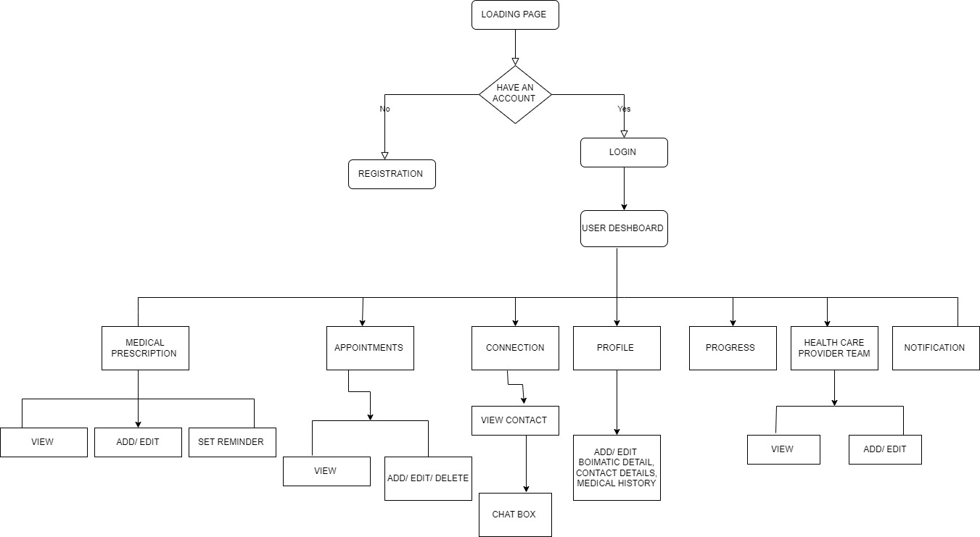

Figure 1 figure of application functionalities, and requirements.

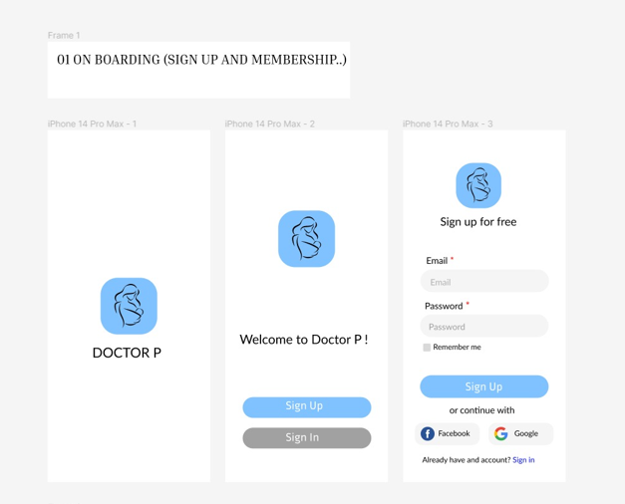

Figure 2 system homepage view

# Self-reflection

As per my experience. The application that is developed is a form of a mobile application to increase the simplicity of its usage. It is very compatible with any smartphone. The objective behind the application is to assist pregnant women who are suffering from Postnatal depression health issues. The women that are using this app are regularly updated about their behavior, illness, and well-being changes with the help of the concerned mobile application (Lobo, 2023). These women are notified about each and every piece of information through text messages. In my opinion, it is very helpful because the app is highly user-friendly and is developed while considering the interests of the users that are going to use the app. Since the behavior of postpartum depressive women also affects their loved one’s members, this application also aids their partner in easing this issue. Therefore, helping those women can benefit greatly from this smartphone app (Federica, and et.al, 2023).

# RAD methodology critique

We employ the RAD software development approach in the creation of this system. , which is a component of the agile approach, instantly plans and creates the technical specifications when any application is being developed. For system design inside a team, a fast application programming paradigm is utilized. It takes a release iterative, frequent prototype, and continuous deployment approach to the SDLC. In the world of software development, RAD has grown to be a crucial method. The rapid application creation model looks at app development strategies and techniques. Fast application progressions can be delivered through it. The main perk of the concerned RAD model is that it is very effective in designing methodologies, it is a very quick technology, it is also one of the most flexible channels, and therefore due to all the features it reduces the development time by a lot of margins and does ensure high efficiency, and effectiveness standards. It is a highly customer-oriented model as it operates on the basis of the feedback and inputs provided by the user to its system.

Upsides, and down-sides

*Upsides*

There are various perks that are associated with the concerned model. Therefore, the following are all the perks that are related to the concerned model:

The model can effectively improve the reusability of the components that are part of the entire system. Risk management of the end product is enhanced. This methodology integrates from the very beginning. Due to the model, the overall performance of the entire system becomes much more efficient, and thus the utility of it increases (Swami, 2023).

*downsides*

the following are the negatives that are related to the concerned system

the system is very much dependent upon the architect of the system, its performance is very much influenced by a strong team, and the system also might fail to manage many stakeholders at a time.

evolution methodologies

the evolution methodology of the application development is a five-stage process. The following are the five stages that are evolution stages of the concerned model.

* Highlight requirements- Every stakeholder finalizes all necessary application details because we need to know the requirements of any application before we can begin to develop it. Everything is reorganized, including deadlines, project objectives, and financial requirements.
* Construct prototype- once tall the requirements have been derived the task of the team is to create prototypes that will further help in the development of further systems (Davenport, and Swami, 2023).
* Gather feedback from users- one of the best ways to know the exact positioning of the entire application is by gathering relevant feedback for the product. This will help the team to know the limitations, as well as the advantages that are related to the product. The team will then work on them to build the application more effectively.
* Software testing- The most crucial phase of software design is testing. It examines how well the application functions. The application has to be rewritten if it doesn't function properly. The software cannot be uploaded without being tested.
* Launching of the product- once all the above steps are conducted properly the task of the team of the application is to launch the app successfully for its users.

The associated case tools

The phrase "CASE tools" stands for computer-aided computer programming. It makes use of numerous software automated tools for the establishment and promotion of the system software. This equipment is used by the system project manager, system developer, and system manager. This tool includes many different kinds of auxiliary tools, such as those for developing web applications, programming, and prototypes. It consists of four different types of components, including an integrated case tool, an upper CASE, a lower CASE, and a central repository. The system's strategy, assessment, planning, execution, validation, and management are all handled by these four basic tools (Boutros, and et.al, 2023).

# Conclusion

The above report highlights the system, and nature of Postnatal depression and its effect on patients. It has been identified that pregnant women are highly affected by the concerned depression. The above report elaborates on my role in performing various tasks for the formation of the application. The report contains a brief analysis of the mobile application that is developed with the help of the RAD development model. The report also highlights the evolution of the application. The report further has also highlighted a critique related to the RAD methodology. Along with various negatives, and positives related to it.

# References

Ashraf, S., Shah, K., Vadukapuram, R., Shah, B., Jaiswal, S., Mansuri, Z. and Jain, S., 2023. Impact of Paternal Depression on Child Neurodevelopmental Outcomes and Disorders. The Primary Care Companion for CNS Disorders, 25(1), p.45432.

Beck, C.T., 2023. Experiences of Postpartum Depression in Women of Color. MCN: The American Journal of Maternal/Child Nursing, 48(2), pp.88-95.

Boutros, A., Nurvitadhi, E. and Betz, V., 2023. RAD-Sim: Rapid architecture exploration for novel reconfigurable acceleration devices. arXiv preprint arXiv:2301.04767.

Davenport, C.J. and Swami, V., 2023. Getting help as a depressed dad: A lived experience narrative of paternal postnatal depression, with considerations for healthcare practice. Journal of psychiatric and mental health nursing, 30(1), pp.1-7.

Davenport, C.J. and Swami, V., 2023. Identifying and supporting men who experience paternal postnatal depression. Mental Health Practice, 26(2).

Federica, G., Renata, T. and Marzilli, E., 2023. Parental Postnatal Depression in the Time of the COVID-19 Pandemic: A Systematic Review of Its Effects on the Parent–Child Relationship and the Child’s Developmental Outcomes. International journal of environmental research and public health, 20(3), p.2018.

Hamidia, A., Kheirkhah, F., Basirat, Z., Ghadimi, R., Chehrazi, M., Barat, S., Cuijpers, P., O'Connor, E., Mirtabar, S.M. and Faramarzi, M., 2023. A Psychosocial Risk Assessment Tool to Predict Postnatal Depression in Women with Complicated Pregnancy. Current Psychiatry Research and Reviews Formerly: Current Psychiatry Reviews, 19(1), pp.28-39.

Lobo, M.D., 2023. Artificial Intelligence in Teleradiology: A Rapid Review of Educational and Professional Contributions. Handbook of Research on Instructional Technologies in Health Education and Allied Disciplines, pp.80-104.

Morales-Munoz, I., Ashdown-Doel, B., Beazley, E., Carr, C., Preece, C. and Marwaha, S., 2023. Maternal postnatal depression and anxiety and the risk for mental health disorders in adolescent offspring: Findings from the Avon Longitudinal Study of Parents and Children cohort. Australian & New Zealand Journal of Psychiatry, 57(1), pp.82-92.

Papandreou, P., Amerikanou, C., Vezou, C., Gioxari, A., Kaliora, A.C. and Skouroliakou, M., 2023. Improving Adherence to the Mediterranean Diet in Early Pregnancy Using a Clinical Decision Support System; A Randomised Controlled Clinical Trial. Nutrients, 15(2), p.432.

Parracha, E.R., Advinha, A.M., Lopes, M.J. and Oliveira‐Martins, S., 2023. Mobile apps for quick adverse drug reaction report: a scoping review. Pharmacoepidemiology and Drug Safety.

Singh, J., Patel, C. and Chaudhary, N.K., 2022. Design Considerations and Architecture for a Resilient Risk based Adaptive Authentication and Authorization (RAD-AA) Framework. arXiv preprint arXiv:2208.02592.

Mukherjee, J., Baluta, A., Litoiu, M. and Krishnamurthy, D., 2020, October. Rad: Detecting performance anomalies in cloud-based web services. In 2020 IEEE 13th International Conference on Cloud Computing (CLOUD) (pp. 493-501). IEEE. Mirzaei, A., Shafiee Rad, H. and Rahimi, E., 2022. Integrating ARCS motivational model and flipped teaching in L2 classrooms: A case of EFL expository writing. Computer Assisted Language Learning, pp.1-30.

MUGHNI, A.R., 2021. SISTEM INFORMASI AKUNTANSI KEUANGAN TERINTEGRASI POIN PELANGGAN BERBASIS WEB DENGAN MODEL RAD (RAPID APPLICATION DEVELOPMENT) STUDI KASUS CV COMPTECH PANGKALPINANG (Doctoral dissertation, ISB ATMA LUHUR).