1. **Setup and Installation**

In order to set up the code in your local machine, make sure you have Node JS and angular cli installed.

The ShopBridge application code is available at <https://github.com/rainalopes/shopbridge_frontend>

and can be cloned using the following URL <https://github.com/rainalopes/shopbridge_frontend.git>

Once the repository is cloned open the project folder(The folder inside which the entire angular project structure is visible) in Visual Studio code terminal or your command line terminal. Then run the following command: “npm i” in order to install the dependency packages.

Once the installation is completed, run the angular project using the command, “ng serve”

Then open the browser and hit <http://localhost:4200>

The angular application will be loaded as follows,

1. **Product Flow**
2. To Add new Product click on the New Button

1. To Update click on the pencil icon in front of specific product

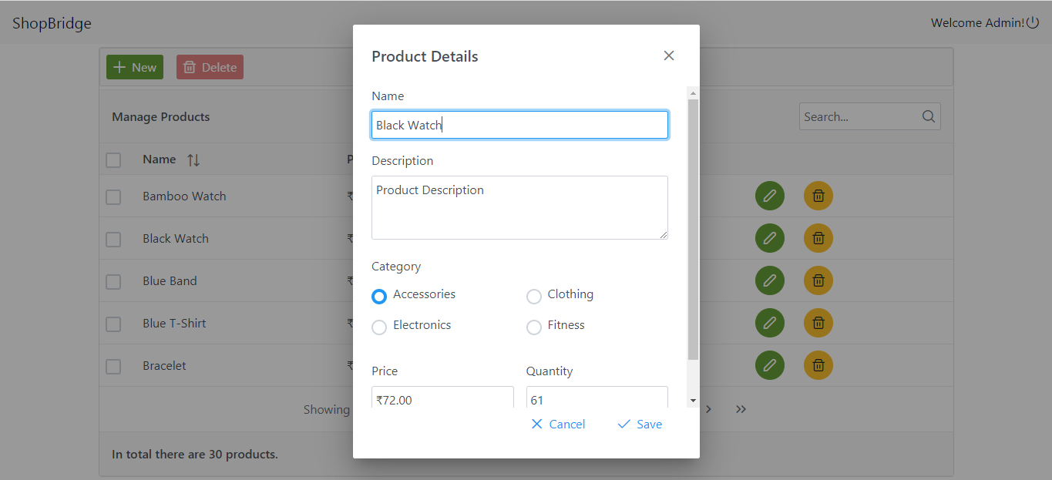

1. To Delete a product you can either select multiple products using check boxes and delete multiple products by clicking delete button in table header(This button gets enabled only if any product is selected) or you can delete single product using the delete button in front of specific product.

You can also search for products using the global search input in the top right.

To sort the data click on the sort icon below each table header.

**3. Time Tracking**

1. Frontend functionality -1 hr

2. Frontend presentational aspects (styling, DOM, etc) – 30 mins

3. Required Validations – 10 mins

4. Unit Test Coverage- 15 mins