**MINOR PROJECT REPORT**

**ON**

**HOTEL MANAGEMENT SYSTEM**



**BACHELOR OF ENGINEERING**

**In**

**Computer Science and Engineering**

**SUBMITTED BY**

**Group no.- 2(G6)**

HIMANSHI TICKOO (2021A1L009)

SIMRAN RAINA (2021A1L013)

NEHARIKA GOSWAMI (2021A1L001)

AGRIMA SHARMA (114-CSE-17)

**Model Institute of Engineering and Technology**

**Kot Bhalwal, Jammu - 181122**

**www.mietjammu.in**

**Contents**

|  |  |
| --- | --- |
| S.NO. | TOPICS |
| 1. | What is Hotel Management System |
| 2. | Features of Hotel Management System |
| 3. | Steps to create a Hotel Management System |
| 4. | Source Code |
| 5. | References |

**What is Hotel Management System Project in Python?**



## What is hotel management?

Hotel management is an area of the hospitality industry that involves overseeing the operations of a hotel location. When working as a hotel manager, you may manage the operations of a motel, resort or another similar establishment that provides lodging and other services for guests.

The title, "hotel manager" often refers to a hotel's general manager, who serves as the head executive at a specific property. The duties assigned to the manager depend on the size of the hotel, as well as its purpose and the expectations of its owners. A general manager at a hotel receives support from department heads, who oversee their own employees and report on the key functions.

The **Hotel Management System Project in Python** is a general software developed (using Python) to simplify hotel operations by automating them.

## **Features of Hotel Proect**

## **Features of Hotel Management Python Project**

A **Hotel Management Python Project** It covers major aspects of hotel management; it could perform the following operations. **Hotel Booking**, Provide you with **Hotel Rooms Info**, **Room Service**, **Billing and Record-Keeping**.

### **1. Hotel Booking**

Function to book a room in a hotel by entering information about the user or customer.

### **2. Room Management**

* These features manage all the information of the rooms in the hotel.

### **3. Room Services**

* Function that user has to select and give **users** and **customers information** about **hotel rooms** (i.e., about room amenities).

### **4. Billing and Record-Keeping**

* At check-out, there is a function that lets you pay for your hotel room and calculate restaurant bill.
* Use this function to keep track of who has stayed at the hotel and calculating room rent.

**Hotel Management System Project in Python with Source Code**

* **Step 1: Create a Project Name.**

First step opens the **PyCharm IDE** and click “**File**” and select “**New** **Project**” and then create a **project name** after that click the “**create**” button.

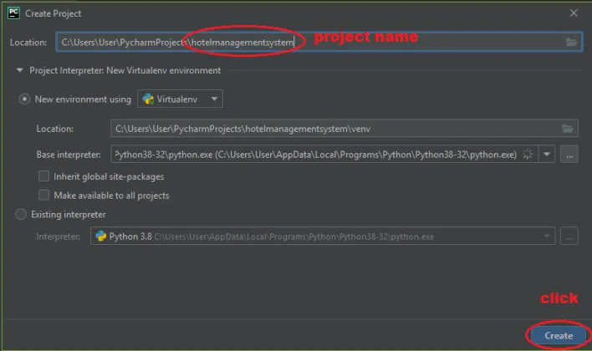

* **Step 2: Create a Python File.**

Second step after creating a project name, “**right**” click the project name and the click “**New”** after that choose “**Python File** “.” after that choose “**Python File** “.” after that choose “**Python File** “.

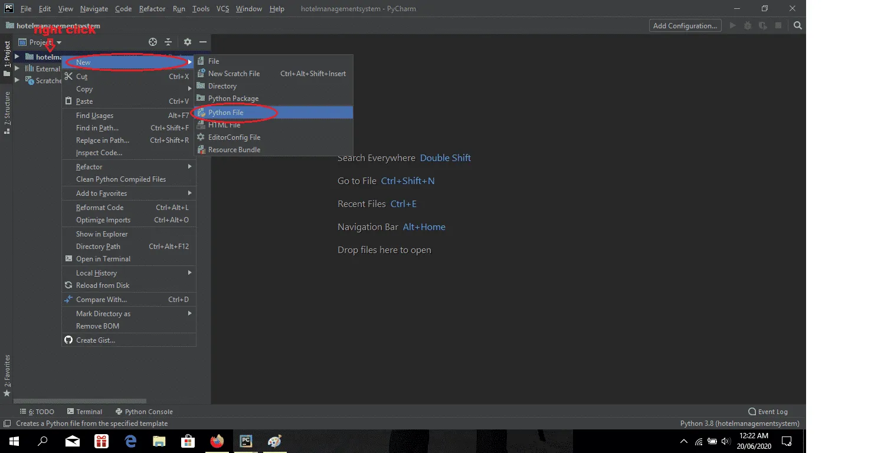

* **Step 3: Name the Python File.**

Third step after choose **Python File** name the file “**Hotel Management System**” and then click “**Enter** “.

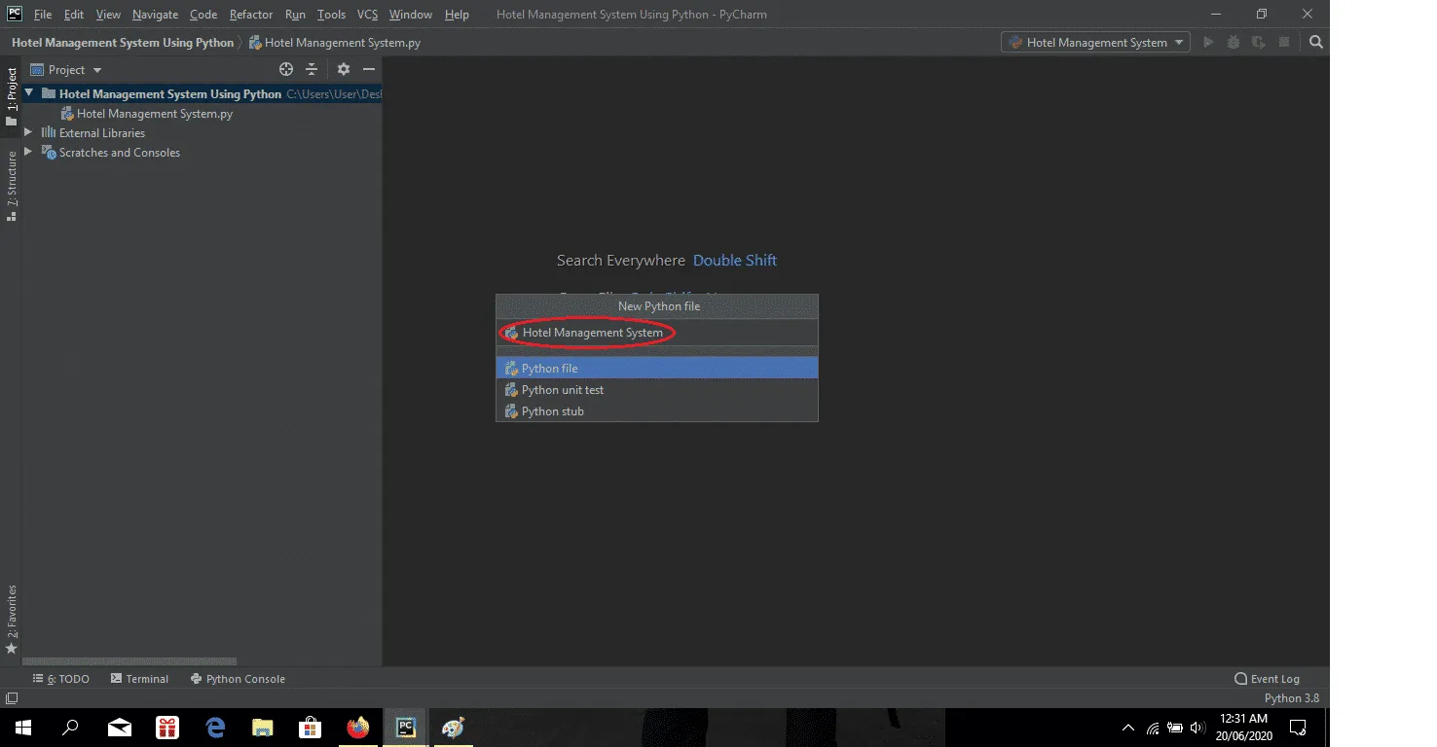

## 

## **Hotel Management Python Code**

class hotelfarecal:

def __init__(self,rt='',s=0,p=0,r=0,t=0,a=1800,name='',address='',cindate='',coutdate='',rno=101):

print ("\n\n*****WELCOME TO HEWING HOTEL*****\n")

self.rt=rt

self.r=r

self.t=t

self.p=p

self.s=s

self.a=a

self.name=name

self.address=address

self.cindate=cindate

self.coutdate=coutdate

self.rno=rno

def inputdata(self):

self.name=input("\nEnter your name:")

self.address=input("\nEnter your address:")

self.cindate=input("\nEnter your check in date:")

self.coutdate=input("\nEnter your checkout date:")

print("Your room no.:",self.rno,"\n")

def roomrent(self):#sel1353

print ("We have the following rooms for you:-")

print ("1.  type A---->rs 6000 PN\-")

print ("2.  type B---->rs 5000 PN\-")

print ("3.  type C---->rs 4000 PN\-")

print ("4.  type D---->rs 3000 PN\-")

x=int(input("Enter Your Choice Please->"))

n=int(input("For How Many Nights Did You Stay:"))

if(x==1):

print ("you have opted room type A")

self.s=6000*n

elif (x==2):

print ("you have opted room type B")

self.s=5000*n

elif (x==3):

print ("you have opted room type C")

self.s=4000*n

elif (x==4):

print ("you have opted room type D")

self.s=3000*n

else:

print ("please choose a room")

print ("your room rent is =",self.s,"\n")

def restaurentbill(self):

print("*****RESTAURANT MENU*****")

print("1.water----->Rs20","2.tea----->Rs10","3.breakfast combo--->Rs90","4.lunch---->Rs110","5.dinner--->Rs150","6.Exit")

while (1):

c=int(input("Enter your choice:"))

if (c==1):

d=int(input("Enter the quantity:"))

self.r=self.r+20*d

elif (c==2):

d=int(input("Enter the quantity:"))

self.r=self.r+10*d

elif (c==3):

d=int(input("Enter the quantity:"))

self.r=self.r+90*d

elif (c==4):

d=int(input("Enter the quantity:"))

self.r=self.r+110*d

elif (c==5):

d=int(input("Enter the quantity:"))

self.r=self.r+150*d

elif (c==6):

break;

else:

print("Invalid option")

print ("Total food Cost=Rs",self.r,"\n")

def laundrybill(self):

print ("******LAUNDRY MENU*******")

print ("1.Shorts----->Rs3","2.Trousers----->Rs4","3.Shirt--->Rs5","4.Jeans---->Rs6","5.Girlsuit--->Rs8","6.Exit")

while (1):

#brought to you by code-projects.org

e=int(input("Enter your choice:"))

if (e==1):

f=int(input("Enter the quantity:"))

self.t=self.t+3*f

elif (e==2):

f=int(input("Enter the quantity:"))

self.t=self.t+4*f

elif (e==3):

f=int(input("Enter the quantity:"))

self.t=self.t+5*f

elif (e==4):

f=int(input("Enter the quantity:"))

self.t=self.t+6*f

elif (e==5):

f=int(input("Enter the quantity:"))

self.t=self.t+8*f

elif (e==6):

break;

else:

print ("Invalid option")

print ("Total Laundary Cost=Rs",self.t,"\n")

def gamebill(self):

print ("******GAME MENU*******")

print ("1.Table tennis----->Rs60","2.Bowling----->Rs80","3.Snooker--->Rs70","4.Video games---->Rs90","5.Pool--->Rs50==6","6.Exit")

while (1):

g=int(input("Enter your choice:"))

if (g==1):

h=int(input("No. of hours:"))

self.p=self.p+60*h

elif (g==2):

h=int(input("No. of hours:"))

self.p=self.p+80*h

elif (g==3):

h=int(input("No. of hours:"))

self.p=self.p+70*h

elif (g==4):

h=int(input("No. of hours:"))

self.p=self.p+90*h

elif (g==5):

h=int(input("No. of hours:"))

self.p=self.p+50*h

elif (g==6):

break;

else:

print ("Invalid option")

print ("Total Game Bill=Rs",self.p,"\n")

def display(self):

print ("******HOTEL BILL******")

print ("Customer details:")

print ("Customer name:",self.name)

print ("Customer address:",self.address)

print ("Check in date:",self.cindate)

print ("Check out date",self.coutdate)

print ("Room no.",self.rno)

print ("Your Room rent is:",self.s)

print ("Your Food bill is:",self.r)

print ("Your laundary bill is:",self.t)

print ("Your Game bill is:",self.p)

self.rt=self.s+self.t+self.p+self.r

print ("Your sub total bill is:",self.rt)

print ("Additional Service Charges is",self.a)

print ("Your grandtotal bill is:",self.rt+self.a,"\n")

self.rno+=1

def main():

a=hotelfarecal()

while (1):

print("1.Enter Customer Data")

print("2.Calculate rommrent")

print("3.Calculate restaurant bill")

print("4.Calculate laundry bill")

print("5.Calculate gamebill")

print("6.Show total cost")

print("7.EXIT")

b=int(input("\nEnter your choice:"))

if (b==1):

a.inputdata()

if (b==2):

a.roomrent()

if (b==3):

a.restaurentbill()

if (b==4):

a.laundrybill()

if (b==5):

a.gamebill()

if (b==6):

a.display()

if (b==7):

quit()

main()

**REFRENCES**

* [Hotel Management System Project In Python With Source Code (itsourcecode.com)](https://itsourcecode.com/free-projects/python-projects/hotel-management-system-project-in-python/#:~:text=Steps%20on%20how%20to%20create%20a%20Hotel%20Management,...%204%20Step%204%3A%20The%20actual%20code.%20)
* [What Is Hotel Management? Definition and Duties | Indeed.com](https://www.indeed.com/career-advice/finding-a-job/hotel-management)