**MINOR PROJECT REPORT**

**ON**

**NETWORK TOPOLOGIES USING SWITCHES AND ROUTERS**



**BACHELOR OF ENGINEERING**

**In**

**Computer Science and Engineering**

**SUBMITTED BY**

**Group no.- 9(G6)**

HIMANSHI TICKOO (2021A1L009)

SIMRAN RAINA (2021A1L013)

NEHARIKA GOSWAMI (2021A1L001)

AGRIMA SHARMA (114-CSE-17)

**Model Institute of Engineering and Technology**

**Kot Bhalwal, Jammu - 181122**

**www.mietjammu.in**

**Contents**

|  |  |
| --- | --- |
| **S.NO.** | **Topics** |
| **1.** | **Introduction** |
| **2.** | **Advantages and Disadvantages** |
| **3.** | **Topology and Its Types** |
| **4.** | **Devices and machine used for design** |
| **5.** | **Steps to configure Hybrid topology using cisco packet tracer** |
| **6.** | **Conclusion** |
| **7.** | **References** |

**INTRODUCTION**

This topological technology is the combination of all the various types of topologies. It is used when the nodes are free to take any form. It means these can be individuals such as Ring or Star topology or can be a combination of various types of topologies. Each individual topology uses the protocol.

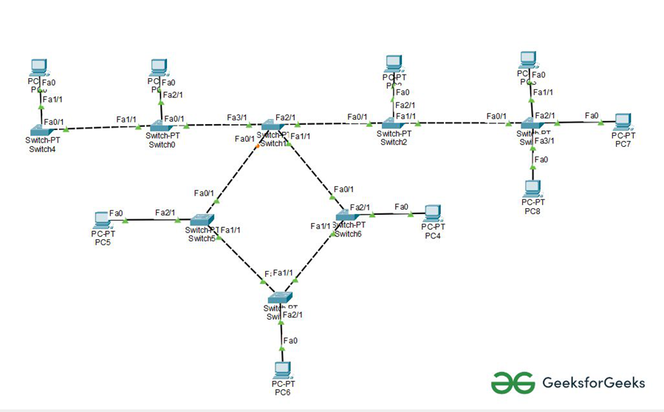

**Fig 1.1 Hybrid Topology**

The structure of hybrid topology that contains more than one topology.

E.g., for instance, if in an office in one of the department’s ring topologies is employed and another star, topology is employed, connecting these topologies will end in Hybrid Topology (ring topology and star topology).

**Advantages of Hybrid Topology:**

* This type of topology combines the benefits of different types of topologies in one topology.
* Can be modified as per requirement.
* It is extremely flexible.
* It is very reliable.
* It is easily scalable as Hybrid networks are built in a fashion which enables easy integration of new hardware components.
* Error detecting and troubleshooting are easy.
* Handles a large volume of traffic.
* It is used to create large networks.
* The speed of the topology becomes fast when two topologies are put together.

**Disadvantages of Hybrid Topology:**

* It is a type of network expensive.
* The design of a hybrid network is very complex.
* There is a change in the hardware to connect one topology with another topology.
* Usually, hybrid architectures are larger in scale so they require a lot of cables in the installation process.
* Hubs which are used to connect two distinct networks are very costly. And hubs are different from usual hubs as they need to be intelligent enough to work with different architectures.
* Installation is a difficult process.

**TOPOLOGY AND ITS TYPES:**

The arrangement of a network that comprises nodes and connecting lines via sender and receiver is referred to as network topology. The various network topologies are:

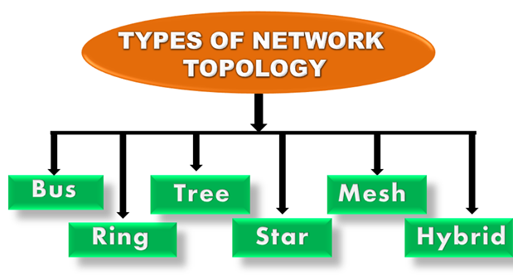

**Fig 1.2 Network Topologies**

**Mesh Topology:** In a mesh topology, every device is connected to another device via a particular channel. In Mesh Topology, the protocols used are AHCP (Ad Hoc Configuration Protocols), DHCP (Dynamic Host Configuration Protocol), etc.

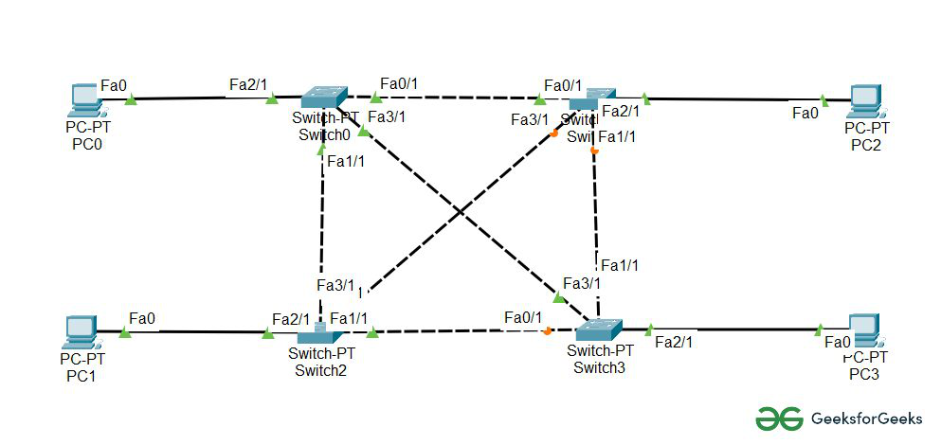

**Fig 1.3 Mesh Topology**

Every device is connected to another via dedicated channels. These channels are known as links.

**Star Topology:** In star topology, all the devices are connected to a single hub through a cable. This hub is the central node and all other nodes are connected to the central node. The hub can be passive in nature i.e., not an intelligent hub such as broadcasting devices, at the same time the hub can be intelligent known as an active hub. Active hubs have repeaters in them. Coaxial cables or RJ-45 cables are used to connect the computers. In Star Topology, many popular Ethernet LAN protocols are used as CD (Collision Detection), CSMA (Carrier Sense Multiple Access), etc.

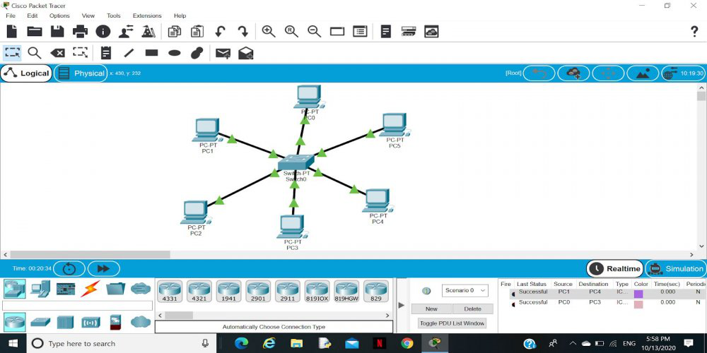

**Fig 1.4 Star Topology**

A star topology having four systems connected to a single point of connection i.e., hub.

**Bus Topology:** Bus topology is a network type in which every computer and network device is connected to a single cable. It is bi-directional. It is a multi-point connection and a non-robust topology because if the backbone fails the topology crashes. In Bus Topology, various MAC (Media Access Control) protocols are followed by LAN ethernet connections like TDMA, Pure Aloha, CDMA, Slotted Aloha, etc.

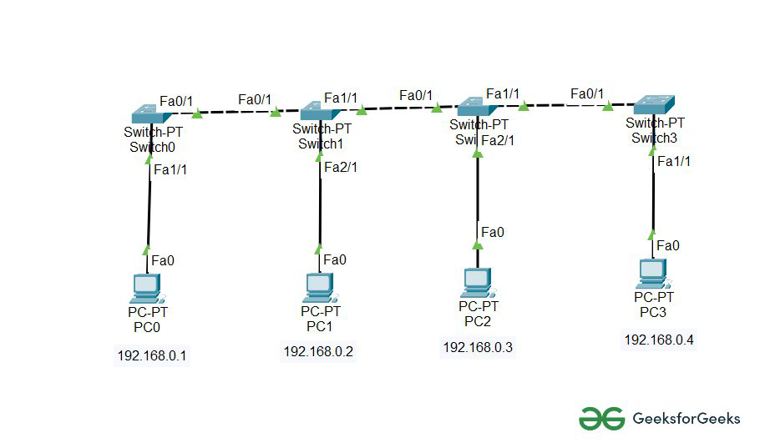**Fig 1.5 Bus Topology**

A bus topology with shared backbone cable. The nodes are connected to the channel via drop lines.

**Ring Topology:** In this topology, it forms a ring connecting devices with exactly two neighbouring devices.

A number of repeaters are used for Ring topology with a large number of nodes, because if someone wants to send some data to the last node in the ring topology with 100 nodes, then the data will have to pass through 99 nodes to reach the 100th node. Hence to prevent data loss repeaters are used in the network.

The data flows in one direction, i.e.., it is unidirectional, but it can be made bidirectional by having 2 connections between each Network Node, it is called Dual Ring Topology. In-Ring Topology, the Token Ring Passing protocol is used by the workstations to transmit the data.



**Fig 1.6 Ring Topology**A ring topology comprises 4 stations connected with each forming a ring.

The most common access method of ring topology is token passing.

* Token passing: It is a network access method in which a token is passed from one node to another node.
* Token: It is a frame that circulates around the network.

**Tree Topology:** This topology is the variation of the Star topology. This topology has a hierarchical flow of data. In Tree Topology, protocols like DHCP and SAC (Standard Automatic Configuration) are used.

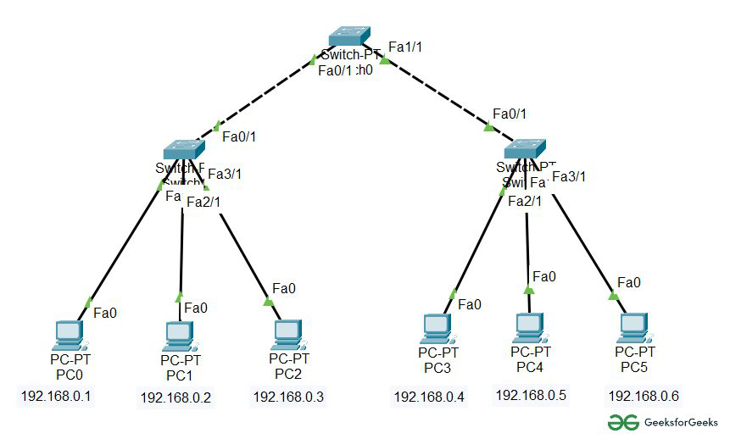

**Fig 1.7 Tree Topology**In this, the various secondary hubs are connected to the central hub which contains the repeater. This data flow from top to bottom i.e., from the central hub to the secondary and then to the devices or from bottom to top i.e., devices to the secondary hub and then to the central hub. It is a multi-point connection and a non-robust topology because if the backbone fails the topology crashes.

**TABLE 1: DEVICES AND MACHINES USED FOR DESIGN**

|  |  |  |
| --- | --- | --- |
| **S.NO.** | **Device or Function Machine** | **Function** |
| **1.** | **Cross-Over Cable** | The internal wiring of Ethernet crossover cables reverses the transmit and receive signals. It is most often used to connect two devices of the same type: e.g., two computers (via network interface controller) or two switches to each other. |
| **2.** | **Router** | A primary function of a router is to forward packets toward their destination. This is accomplished by using a switching function, which is the process used by a router to accept a packet on one interface and forward it out of another interface. |
| **3.** | **Switches** | An Ethernet/Network Switch operates at the data link layer (layer 2) of the OSI model. Unlike a hub, a switch forwards a message to a specific host. |
| **4.** | **PCs** | Device that Sends and receive messages from different topologies e.g.; Pcs, smartphone, laptop etc. |

E.g., for instance, if in an office in one of the department’s ring topologies

is employed and another star, topology is employed, connecting these topologies

will end in Hybrid Topology (ring topology and star topology).

E.g., for instance, if in an office in one of the department’s ring topologies

is employed and another star, topology is employed, connecting these topologies

will end in Hybrid Topology (ring topology and star topology).Advantages of Hybrid Topology:

This type of topology combines the benefits of different types of

topologies in one topology.

• Can be modified as per requirement.

• It is extremely flexible.

• It is very reliable.

• It is easily scalable as Hybrid networks are built in a fashion which

enables easy integration of new hardware components.

• Error detecting and troubleshooting are easy.

• Handles a large volume of traffic.

• It is used to create large networks.

• The speed of the topology becomes fast when two topologies are put

Toget

This type of topology combines the benefits of different types of topologies in one topology.

**Steps to configure Hybrid Topology Using Cisco Packet Tracer:**

**Step 1:** The Network Topology is established between router, switches and further with PCs.

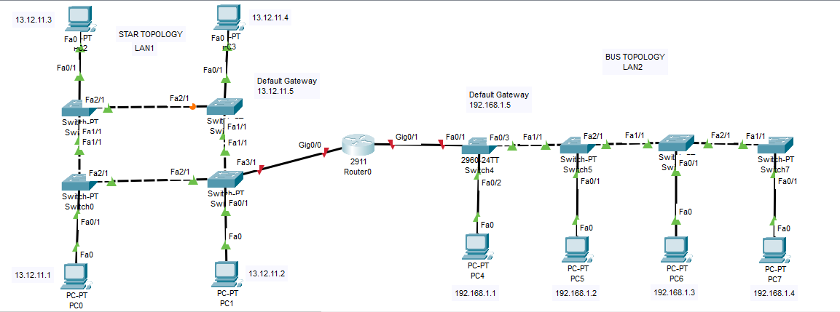

**Step 2:** Configure the PCs (hosts) with IPv4 address, Subnet Mask, and Default gateway according to the IP addressing. Repeat the same Procedure with PCs of LAN2 to configure them.

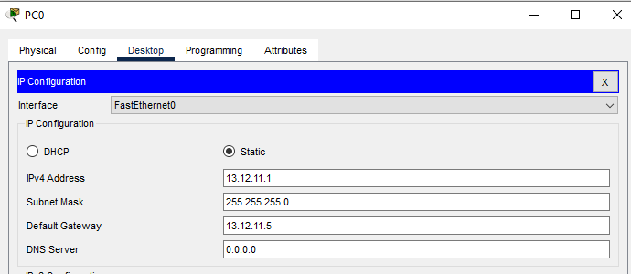

**step 3:** Assigning IP address using the ipconfig command. Repeat the same procedure with other PCs of Both LANs to configure them thoroughly.

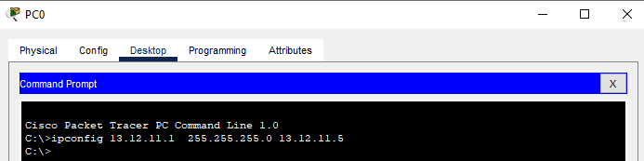

**Step 4:** Configure router with IP address and subnet mask.

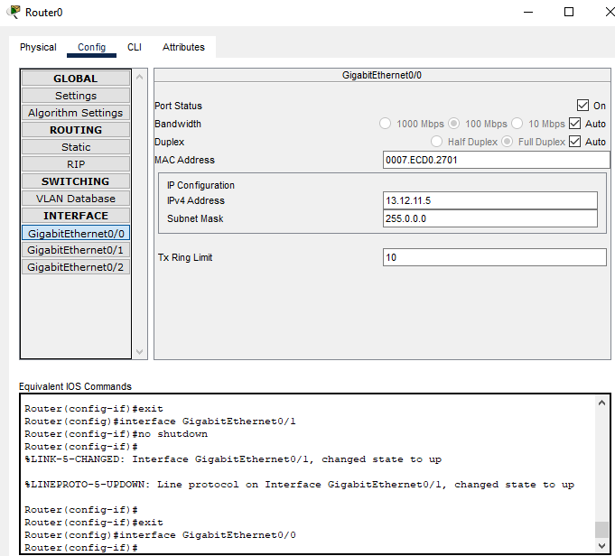

**Step 5:** Verifying the network by pinging the IP address of any PC. We will use the ping command to do so.

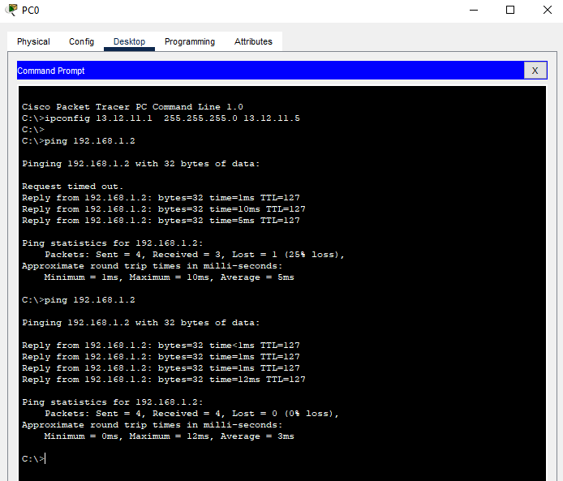

**Step 6:** In simulation, the cables are connecting the devices with others and we are getting replies which means the connection is working properly.

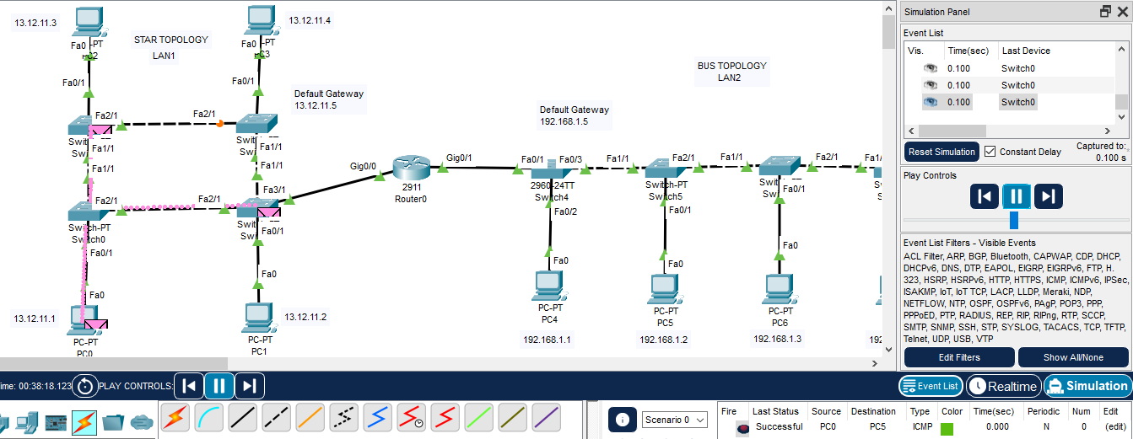

**Conclusion**

It proves to be more flexible, reliable, effective and scalable than other networking topologies

but at the same time difficult to manage and costly also. Although its complex structure can

create hazards due to its robust and effective features gained a lot of popularity. The Network

of topology differs from place to place. If the server problem occurs server gets down, Then

topology faces its failure.

**References**

* https://www.geeksforgeeks.org/connection-between-ring-and-bus-topology-in-cisco/?ref=rp
* https://www.geeksforgeeks.org/types-of-network-topology/
* https://www.javatpoint.com/computer-network-topologies