|  |  |  |  |  |  |  |  |  |  |  |  |  |  |  |  |  |
| --- | --- | --- | --- | --- | --- | --- | --- | --- | --- | --- | --- | --- | --- | --- | --- | --- |
| |  | | --- | |  | |  |  |  | |  | | --- | |  | |  |  |  |  | **مدارس قوس قزح العالمية**  المنهج / بريطاني  ترخيص رقم . 4340140079  **تحت اشراف وزارة التربية والتعليم**  **الإدارة العامة للتربية والتعليم بمنطقة الرياض**  **إدارة التعليم الأجنبي والأهلي** |  |  |  |  |  |
|  |  |  |  |  |  |  |  |  |  |  |  |  |  |  |
|  |  |  |  |  |  |  |  |  |  |  |  |  |  |  |
|  |  |  |  |  |  |  |  |  |  |  |  |  |  |  |
|  |  |  |  |  |  |  |  |  |  |  |  |  |  |  |

Rainbow International School

Curriculum/ British

License NO.4340140079

Ministry of Education

General Directorate of Education/ Riyadh

Private and Foreign Education

**Term 1, Academic Year 2021 - 2022**

**VIRTUAL LESSONS**

**WEEK 6 (03-10-21 – 07-10-21)**

**Grade 6**

|  |  |  |
| --- | --- | --- |
|  | **TASKS** | **RESOURCES & HW** |
| **Maths** | Unit 1B – Measure • Learner’s Book pp.20-23,  Telling the time and the time table + time intervals  • Learner’s Book pp.24-27 ,  Area and perimeter (1)  • Learner’s Book pp.28-29 , | Complete learners book activity  Complete learners book activity  Complete learners book activity |
| **Writing** | Day 1:  Continuation of module 1   * Exercises J,K,L (page 6,7) * Writing the first draft (exercise M), page 8     Day 2:  Module 2: Write about an unusual place to live   * Useful words (table of contents) * Prefixes: ir- and -il (table of contents) * Chapter intro * Table of contents, page 4 | Day 1:   * Edit first draft for errors         Day 2:   * Write 1 paragraph (notebook) using the new words. * Practice reading the text: Life on the Edge (page 10)      * Revise module 1 for evaluation test |
| **Grammar** | **Day 1: Unit 3: Unit 3: After an Earthquake TB, pp. 22-23**    **Day 2: Unit 3: Unit 3: After an Earthquake TB, pp. 24-25** | **Day 1: ONLINE WORKSHEET 3**  **& Link**  **Day 2:  Letter G on p. 25**  **Write the answer in your notebook** |
| **Listening and**  **Speaking** | **Day 1**  **Wrap up**  **Unit 1 and  2- SB, pp.24-25**  **Introduction of Unit 3**  **Why do people move to new places?**  **SB pp. 26-29**    **Day 2**  **Continuation of Unit 3**  **+**  **Assessment Test Unit 1 and 2** | **Day 1**    **WB, pp. 20-21**  **+**  **Revise for Assessment Unit 1 and 2**            **Day 2**    **WB, pp. 22-23** |
| **R.C.V.** | **DAY 1:**  Chapter 7: **THE COUNT IN PARIS.**  Pages: 40 - 45  **DAY  2:**  Chapter 8: **LOVE AND MONEY**  Pages: 48 – 53 | **DAY 1:**  Page 46 - 47  Worksheet  **DAY 2:**  Page 54 – 55  Write a summary (Unit 7-8) |
| **Social Studies** | **Day 1: Booklet pg 3, 4**  **Day 2: quiz** | **------------------** |
| **Science** | **Day1 ..2.3 ..T.B Pgs.26-27**    **Day2..2.4.. T.B Pgs.28-29**  **Day4..2.5..T.Bp Pgs.30-31** | **Day1.T.B questions .pg.27**  **A.B ex.2.3**  **Day 2.T.Bquestions.pg.29**  **A.B ex.2.4**  **Day.3.T.B questions.pg.31**  **A.B.ex.2.5** |
| **Arabic** | ١-الظاهرة الإملائية  ٢-الوظيفة النحوية  ٣-تابع الأفعال الناسخة (كان وأخواتها) | اليوم الأول:  الواجب :ص٦٣ |
| **Islamic** | اليوم الأول:  التوحيد: أنواع الشرك الأكبر  اليوم الثاني:  الحديث: من فضائل صلة الرحم  اليوم الثالث:  الفقه والسلوك: صلاة العيدين  التقويم | اليوم الأول:  الواجب: التقويم صفحة ٣١  اليوم الثاني:  لواجب: التقويم صفحة ٧٦ |
| **Computer** | **Chapter 1 Evaluation Test** |  |
| **French** | **Le livre : La page 8**  **+Wb :La page 4** | **Écris sur ton cahier :**  **Des mots qui contiennent**  **Le son( ion)**  **Et des mots qui contiennent le son (oin)** |
| **SAUDI HISTORY** | **اليوم الأول / الدرس السابع** | **الواجب/ نشاط (٣) ص ٦٢** |

**Please make note of the quiz this week.**

|  |  |  |
| --- | --- | --- |
| **SUBJECT** | **6A** | **6B** |
| Social studies | **7th Oct,2021** | **7th Oct,2021** |
| L & S | **7th Oct,2021** | **7th Oct,2021** |
| Computer | **Monday** | **Tuesday** |

**IMPORTANT ANNOUNCEMENT:**

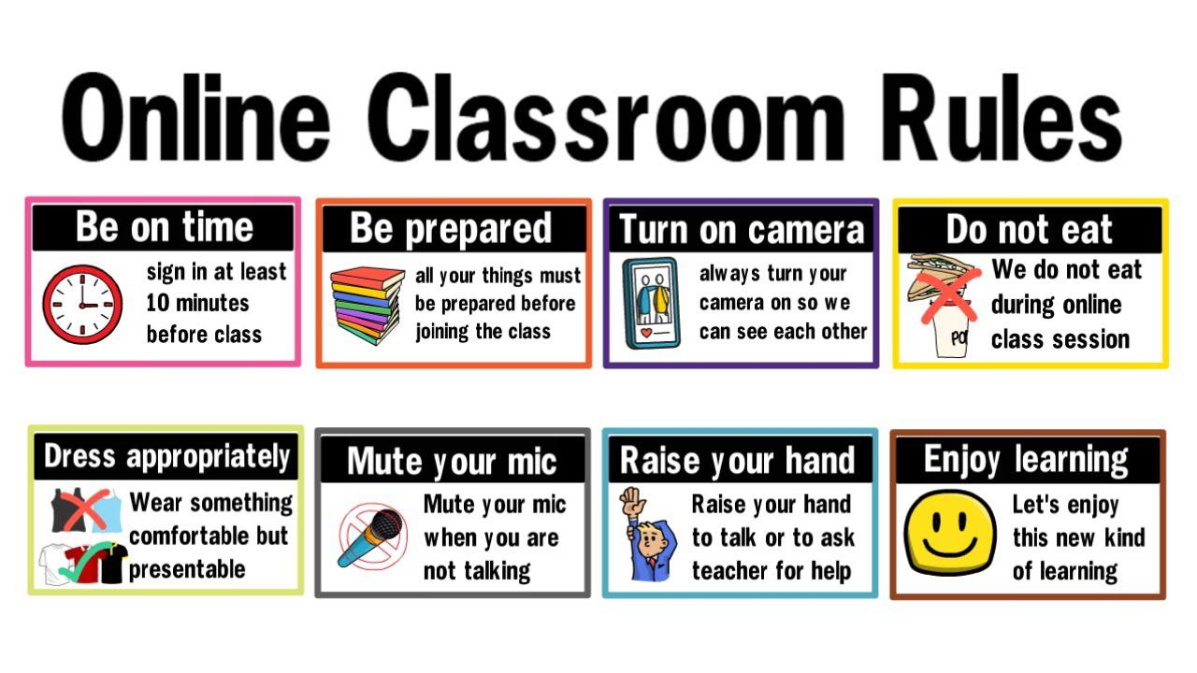**Please rename your zoom profile to your full name and switch on the camera for attendance and security reasons.**