Vasicek Model Calibration and Validation

R Markdown
This is an R Markdown document. Markdown is a simple formatting syntax for authoring HTML, PDF, and MS Word documents. For more details on using R Markdown see http://rmarkdown.rstudio.com.
When you click the Knit button a document will be generated that includes both content as well as the output of any embedded R code chunks within the document. You can embed an R code chunk like this:
summary(cars)
## speed dist
## Min. : 4.0 Min. : 2.00
## 1st Qu.:12.0 1st Qu.: 26.00
## Median :15.0 Median : 36.00
## Mean :15.4 Mean : 42.98
## 3rd Qu.:19.0 3rd Qu.: 56.00
## Max. :25.0 Max. :120.00

Including Plots
You can also embed plots, for example:
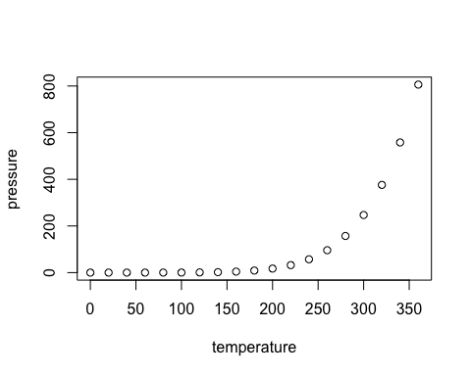
Note that the echo = FALSE parameter was added to the code chunk to prevent printing of the R code that generated the plot.
Vasicek Model Calibration and Validation in R
This script: 1. Simulates historical portfolio default data under a Vasicek one-factor credit risk model 2. Calibrates model parameters (PD and asset correlation) using maximum likelihood estimation 3. Performs parameter stability analysis 4. Performs sensitivity testing 5. Simulates correlated defaults and portfolio loss dynamics 6. Documents model assumptions and limitations
rm(list = ls())
set.seed(123)
1. Helper functions
# Conditional default probability under Vasicek one-factor model
# p(z) = Phi((Phi^{-1}(pd) - sqrt(rho)*z) / sqrt(1-rho))
conditional_pd <- function(z, pd, rho) {
q <- qnorm(pd)
pnorm((q - sqrt(rho) * z) / sqrt(1 - rho))
}
# Simulate default counts across multiple periods
simulate_default_history <- function(T_periods, n_obligors, pd, rho) {
Z <- rnorm(T_periods) # systematic factor for each period
default_counts <- numeric(T_periods)
default_rates <- numeric(T_periods)
for (t in 1:T_periods) {
p_t <- conditional_pd(Z[t], pd, rho)
defaults_t <- rbinom(1, size = n_obligors, prob = p_t)
default_counts[t] <- defaults_t
default_rates[t] <- defaults_t / n_obligors
}
data.frame(
period = 1:T_periods,
Z = Z,
default_count = default_counts,
default_rate = default_rates
)
}
# Negative log-likelihood for observed default counts
# We integrate over the latent systematic factor Z ~ N(0,1)
negloglik_vasicek <- function(param, default_counts, n_obligors) {
pd <- param[1]
rho <- param[2]
# parameter constraints
if (pd <= 0.0001 || pd >= 0.30 || rho <= 0.0001 || rho >= 0.999) {
return(1e10)
}
# marginal likelihood for each period:
# L_t = integral Binomial(k_t | n, p(z)) * phi(z) dz
# approximate with numerical integration
ll_vec <- numeric(length(default_counts))
for (t in seq_along(default_counts)) {
k_t <- default_counts[t]
integrand <- function(z) {
p_t <- conditional_pd(z, pd, rho)
dbinom(k_t, size = n_obligors, prob = p_t) * dnorm(z)
}
val <- try(
integrate(integrand, lower = -8, upper = 8, subdivisions = 1000L)$value,
silent = TRUE
)
if (inherits(val, "try-error") || is.na(val) || val <= 0) {
return(1e10)
}
ll_vec[t] <- log(val)
}
return(-sum(ll_vec))
}
# Calibrate PD and rho by MLE
fit_vasicek_mle <- function(default_counts, n_obligors,
init_pd = 0.03, init_rho = 0.10) {
fit <- optim(
par = c(init_pd, init_rho),
fn = negloglik_vasicek,
default_counts = default_counts,
n_obligors = n_obligors,
method = "L-BFGS-B",
lower = c(0.0001, 0.0001),
upper = c(0.30, 0.999)
)
list(
fit = fit,
pd_hat = fit$par[1],
rho_hat = fit$par[2],
negloglik = fit$value,
convergence = fit$convergence
)
}
# Simulate portfolio-level correlated defaults using estimated parameters
simulate_portfolio_loss <- function(n_scenarios, n_obligors, pd, rho,
ead = 100, lgd = 0.45) {
default_threshold <- qnorm(pd)
default_matrix <- matrix(0, nrow = n_scenarios, ncol = n_obligors)
Z <- rnorm(n_scenarios)
for (s in 1:n_scenarios) {
epsilon <- rnorm(n_obligors)
asset_return <- sqrt(rho) * Z[s] + sqrt(1 - rho) * epsilon
default_matrix[s, ] <- ifelse(asset_return < default_threshold, 1, 0)
}
portfolio_default_rate <- rowMeans(default_matrix)
portfolio_loss <- rowSums(default_matrix * ead * lgd)
list(
default_matrix = default_matrix,
portfolio_default_rate = portfolio_default_rate,
portfolio_loss = portfolio_loss
)
}
2. Simulate “historical” default data
# True model parameters
pd_true <- 0.03
rho_true <- 0.15
# Historical panel setup
T_periods <- 40 # e.g., 40 quarterly observations
n_obligors <- 500 # portfolio size per period
history_data <- simulate_default_history(
T_periods = T_periods,
n_obligors = n_obligors,
pd = pd_true,
rho = rho_true
)
cat("==== Simulated Historical Default Data (first 10 rows) ====\n")
## ==== Simulated Historical Default Data (first 10 rows) ====
print(head(history_data, 10))
## period Z default_count default_rate
## 1 1 -0.56047565 15 0.030
## 2 2 -0.23017749 14 0.028
## 3 3 1.55870831 1 0.002
## 4 4 0.07050839 12 0.024
## 5 5 0.12928774 5 0.010
## 6 6 1.71506499 1 0.002
## 7 7 0.46091621 12 0.024
## 8 8 -1.26506123 40 0.080
## 9 9 -0.68685285 16 0.032
## 10 10 -0.44566197 12 0.024
3. Maximum likelihood calibration
mle_result <- fit_vasicek_mle(
default_counts = history_data$default_count,
n_obligors = n_obligors,
init_pd = 0.02,
init_rho = 0.10
)
cat("\n==== MLE Calibration Results ====\n")
##
## ==== MLE Calibration Results ====
cat("Convergence code:", mle_result$convergence, "\n")
## Convergence code: 0
cat("Estimated PD :", round(mle_result$pd_hat, 6), "\n")
## Estimated PD : 0.026393
cat("Estimated rho:", round(mle_result$rho_hat, 6), "\n")
## Estimated rho: 0.11318
cat("Negative log-likelihood:", round(mle_result$negloglik, 4), "\n")
## Negative log-likelihood: 142.4943
comparison_table <- data.frame(
Parameter = c("PD", "rho"),
True = c(pd_true, rho_true),
Estimated = c(mle_result$pd_hat, mle_result$rho_hat),
Error = c(mle_result$pd_hat - pd_true, mle_result$rho_hat - rho_true)
)
cat("\n==== Parameter Recovery Check ====\n")
##
## ==== Parameter Recovery Check ====
print(comparison_table)
## Parameter True Estimated Error
## 1 PD 0.03 0.02639284 -0.003607155
## 2 rho 0.15 0.11318037 -0.036819630
4. Parameter stability analysis
# Split the time series into two subsamples
split_point <- floor(T_periods / 2)
hist_1 <- history_data$default_count[1:split_point]
hist_2 <- history_data$default_count[(split_point + 1):T_periods]
mle_1 <- fit_vasicek_mle(hist_1, n_obligors, init_pd = 0.02, init_rho = 0.10)
mle_2 <- fit_vasicek_mle(hist_2, n_obligors, init_pd = 0.02, init_rho = 0.10)
stability_table <- data.frame(
Parameter = c("PD", "rho"),
Full_Sample = c(mle_result$pd_hat, mle_result$rho_hat),
First_Half = c(mle_1$pd_hat, mle_1$rho_hat),
Second_Half = c(mle_2$pd_hat, mle_2$rho_hat)
)
cat("\n==== Parameter Stability Analysis ====\n")
##
## ==== Parameter Stability Analysis ====
print(stability_table)
## Parameter Full_Sample First_Half Second_Half
## 1 PD 0.02639284 0.02360773 0.02916311
## 2 rho 0.11318037 0.11701003 0.10599580
5. Sensitivity testing
# Sensitivity of log-likelihood to rho around calibrated estimate
rho_grid <- seq(max(0.01, mle_result$rho_hat - 0.08),
min(0.50, mle_result$rho_hat + 0.08),
by = 0.02)
sensitivity_results <- data.frame(
rho = rho_grid,
NegLogLik = NA_real_
)
for (i in seq_along(rho_grid)) {
test_param <- c(mle_result$pd_hat, rho_grid[i])
sensitivity_results$NegLogLik[i] <- negloglik_vasicek(
test_param,
default_counts = history_data$default_count,
n_obligors = n_obligors
)
}
cat("\n==== Sensitivity Testing (rho) ====\n")
##
## ==== Sensitivity Testing (rho) ====
print(sensitivity_results)
## rho NegLogLik
## 1 0.03318037 157.6948
## 2 0.05318037 148.3389
## 3 0.07318037 144.4568
## 4 0.09318037 142.8869
## 5 0.11318037 142.4943
## 6 0.13318037 142.7733
## 7 0.15318037 143.4663
## 8 0.17318037 144.4303
## 9 0.19318037 145.5803
6. Simulate correlated default structures
portfolio_sim <- simulate_portfolio_loss(
n_scenarios = 5000,
n_obligors = 1000,
pd = mle_result$pd_hat,
rho = mle_result$rho_hat,
ead = 100,
lgd = 0.45
)
cat("\n==== Portfolio Default Rate Summary ====\n")
##
## ==== Portfolio Default Rate Summary ====
print(summary(portfolio_sim$portfolio_default_rate))
## Min. 1st Qu. Median Mean 3rd Qu. Max.
## 0.00000 0.01100 0.02000 0.02649 0.03400 0.25800
cat("\n==== Portfolio Loss Summary ====\n")
##
## ==== Portfolio Loss Summary ====
print(summary(portfolio_sim$portfolio_loss))
## Min. 1st Qu. Median Mean 3rd Qu. Max.
## 0 495 900 1192 1530 11610
# Approximate pairwise default correlation
sample_cols <- 1:20
corr_mat <- cor(portfolio_sim$default_matrix[, sample_cols])
pairwise_corr <- corr_mat[upper.tri(corr_mat)]
cat("\n==== Approximate Pairwise Default Correlation ====\n")
##
## ==== Approximate Pairwise Default Correlation ====
print(mean(pairwise_corr, na.rm = TRUE))
## [1] 0.01875563
7. Stress / scenario analysis
stress_Z <- c(-2, -1, 0, 1, 2)
stress_table <- data.frame(
Systematic_Factor = stress_Z,
Conditional_PD = NA_real_
)
for (i in seq_along(stress_Z)) {
stress_table$Conditional_PD[i] <- conditional_pd(
z = stress_Z[i],
pd = mle_result$pd_hat,
rho = mle_result$rho_hat
)
}
cat("\n==== Conditional PD under Stress Scenarios ====\n")
##
## ==== Conditional PD under Stress Scenarios ====
print(stress_table)
## Systematic_Factor Conditional_PD
## 1 -2 0.089789724
## 2 -1 0.044631574
## 3 0 0.019865059
## 4 1 0.007893772
## 5 2 0.002793906
8. Basic risk metrics
loss_var_95 <- quantile(portfolio_sim$portfolio_loss, 0.95)
loss_var_99 <- quantile(portfolio_sim$portfolio_loss, 0.99)
cat("\n==== Portfolio Loss Risk Metrics ====\n")
##
## ==== Portfolio Loss Risk Metrics ====
cat("VaR 95%:", round(loss_var_95, 2), "\n")
## VaR 95%: 3287.25
cat("VaR 99%:", round(loss_var_99, 2), "\n")
## VaR 99%: 5175
9.Plots
plot(
history_data$period, history_data$default_rate,
type = "b",
main = "Historical Default Rates",
xlab = "Period",
ylab = "Default Rate"
)
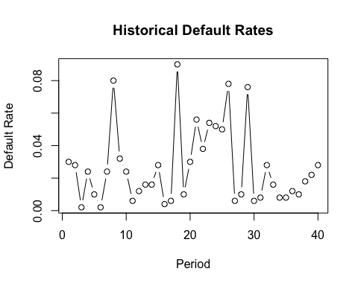
plot(
sensitivity_results$rho, sensitivity_results$NegLogLik,
type = "b",
main = "Sensitivity of NegLogLik to rho",
xlab = "rho",
ylab = "Negative Log-Likelihood"
)
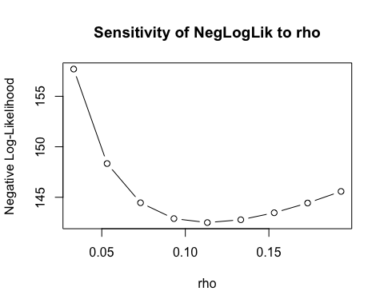
hist(
portfolio_sim$portfolio_default_rate,
breaks = 40,
main = "Portfolio Default Rate Distribution",
xlab = "Default Rate"
)
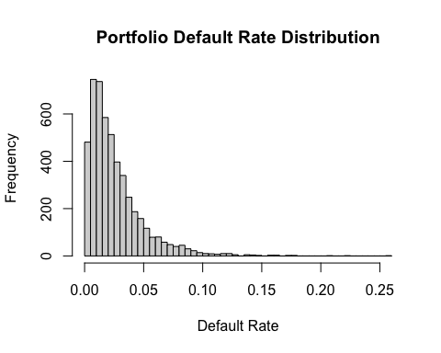
hist(
portfolio_sim$portfolio_loss,
breaks = 40,
main = "Portfolio Loss Distribution",
xlab = "Portfolio Loss"
)
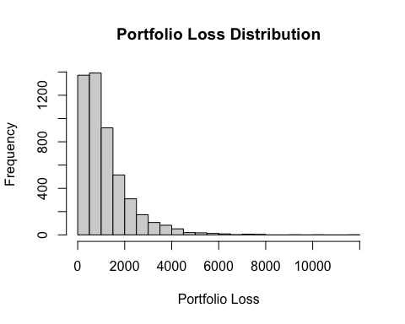
10. Assumptions and limitations
cat("\n==== Model Assumptions and Limitations ====\n")
##
## ==== Model Assumptions and Limitations ====
cat("Assumptions:\n")
## Assumptions:
cat("- Homogeneous portfolio: same PD, same EAD, same LGD, same correlation.\n")
## - Homogeneous portfolio: same PD, same EAD, same LGD, same correlation.
cat("- One-factor dependence structure through a single systematic risk factor.\n")
## - One-factor dependence structure through a single systematic risk factor.
cat("- Conditional defaults are independent given the systematic factor.\n")
## - Conditional defaults are independent given the systematic factor.
cat("- Historical periods are treated as independent draws of the systematic factor.\n\n")
## - Historical periods are treated as independent draws of the systematic factor.
cat("Limitations:\n")
## Limitations:
cat("- This is a simplified portfolio credit model and does not include rating migration.\n")
## - This is a simplified portfolio credit model and does not include rating migration.
cat("- LGD and EAD are assumed fixed rather than stochastic.\n")
## - LGD and EAD are assumed fixed rather than stochastic.
cat("- The model does not include macroeconomic covariates or IFRS 9 lifetime ECL framework.\n")
## - The model does not include macroeconomic covariates or IFRS 9 lifetime ECL framework.
cat("- Numerical integration is used for MLE and may be computationally expensive for larger datasets.\n")
## - Numerical integration is used for MLE and may be computationally expensive for larger datasets.

