Array Sum
 | Sequential | 1 thread | 2 threads | 5 threads | 7 threads | 9 threads
Time | 1.066
Pthread |  | 1.354 | 0.997 | 0.982 | 0.873 | 0.835
OpenMP |  | 0.704 | 0.581 | 0.500 | 0.536 | 0.507

Matrix Multiplication
 | Sequential | 1 thread | 2 threads | 5 threads | 7 threads | 9 threads
Time | 5.181
Pthread |  | 2.606 | 1.713 | 0.952 | 0.769 | 0.801
OpenMP |  | 4.735 | 3.640 | 2.269 | 2.094 | 2.145

Trapezoidal Rule Integration
 | Sequential | 1 thread | 2 threads | 5 threads | 7 threads | 9 threads
Time | 2.781
Pthread |  | 2.534 | 1.654 | 0.960 | 0.792 | 0.828
OpenMP |  | 2.726 | 1.823 | 1.057 | 0.922 | 0.945

N Queens
 | Sequential | 1 thread | 2 threads | 5 threads | 7 threads | 9 threads
Time | 2m15.690
Pthread |  | 48.580 | 31.661 | 15.069 | 13.172 | 13.312
OpenMP |  | 50.524 | 31.670 | 19.314 | 15.970 | 13.060

Array Sum
Sequential
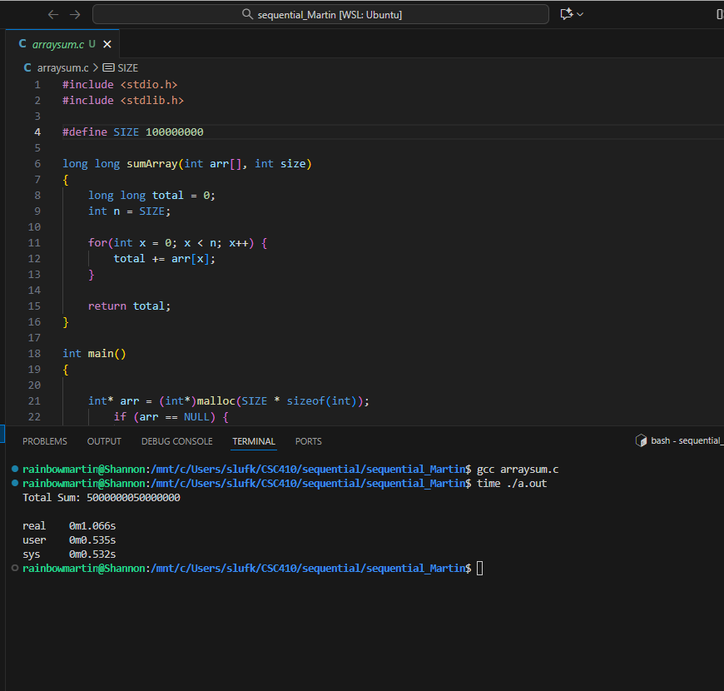

Pthread – 1 thread
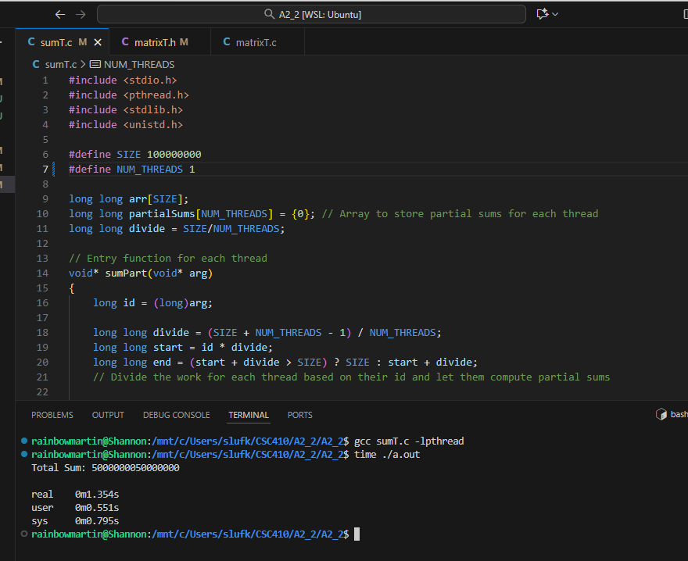

Pthread – 2 threads
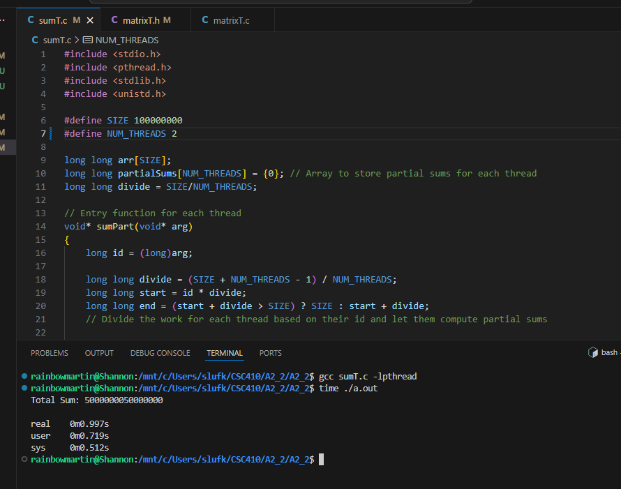

Pthread – 5 threads
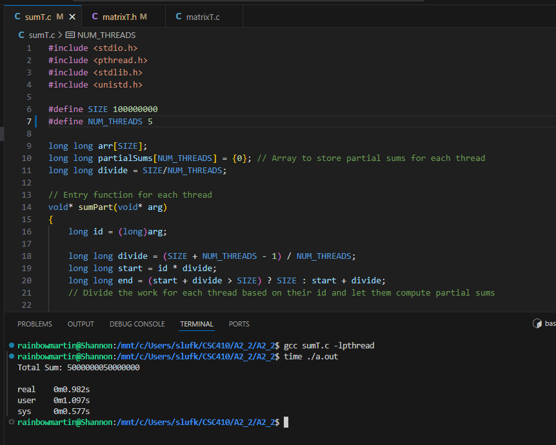

Pthread – 7 threads
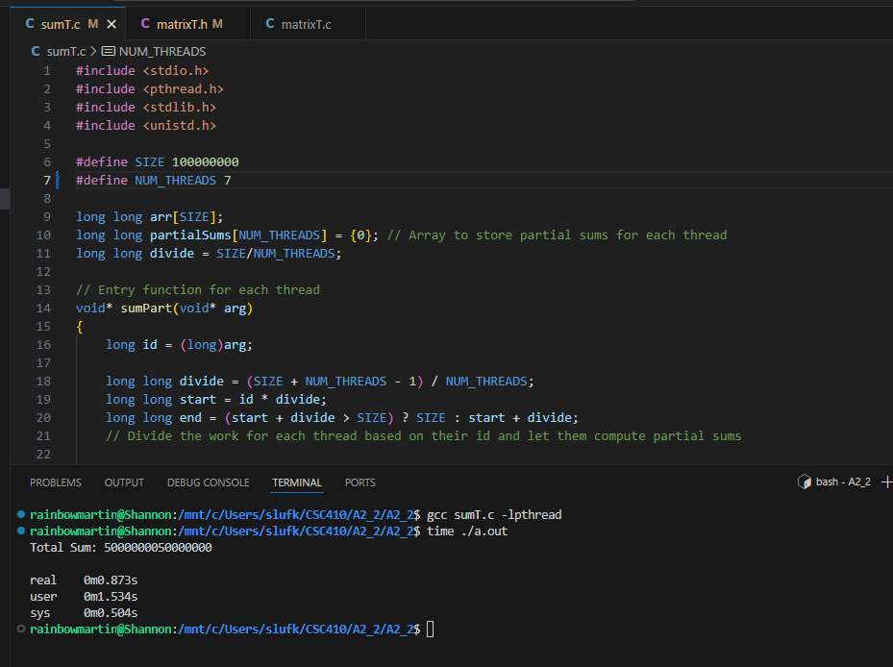

Pthread – 9 threads
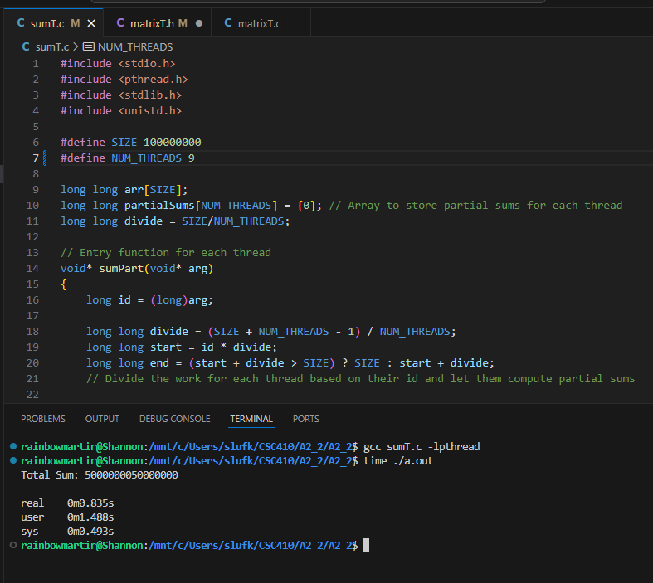

Omp – 1 thread
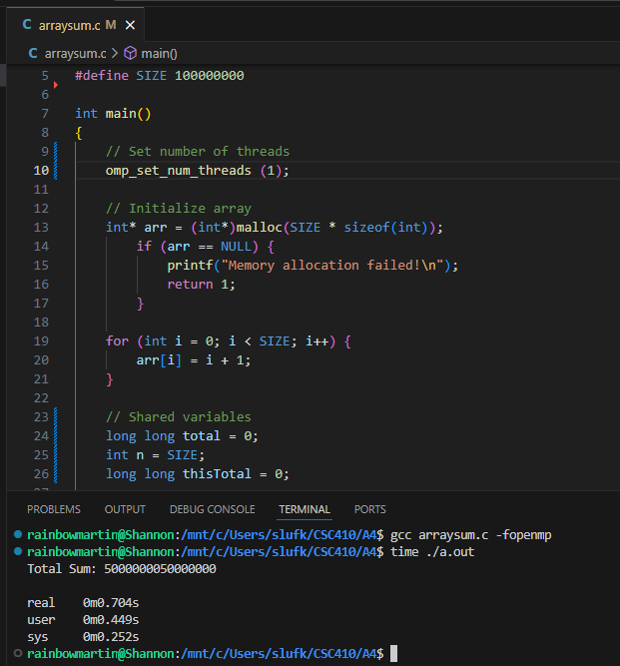

Omp – 2 threads
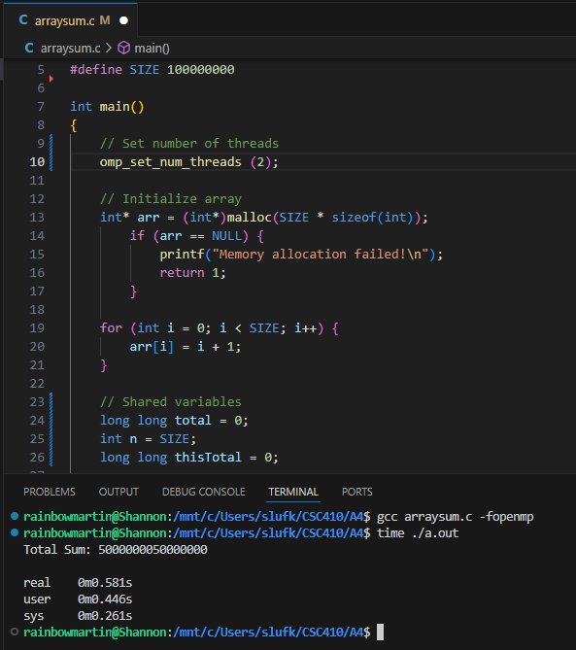

Omp – 5 threads
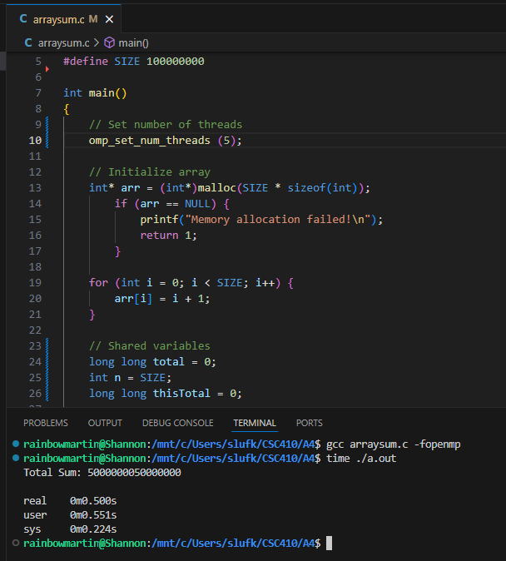

Omp – 7 threads
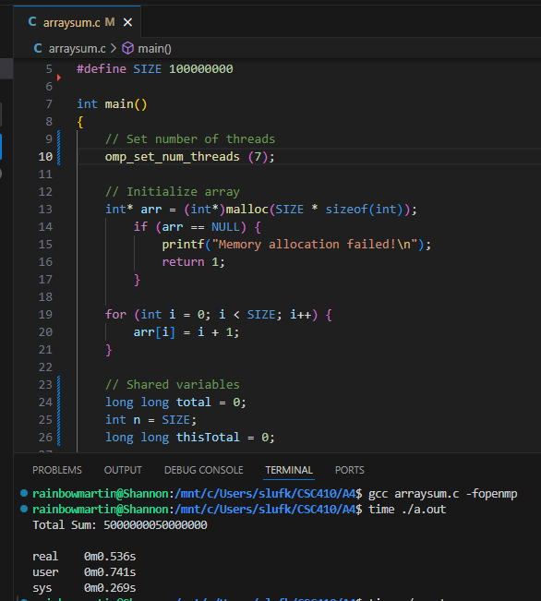

Omp – 9 threads
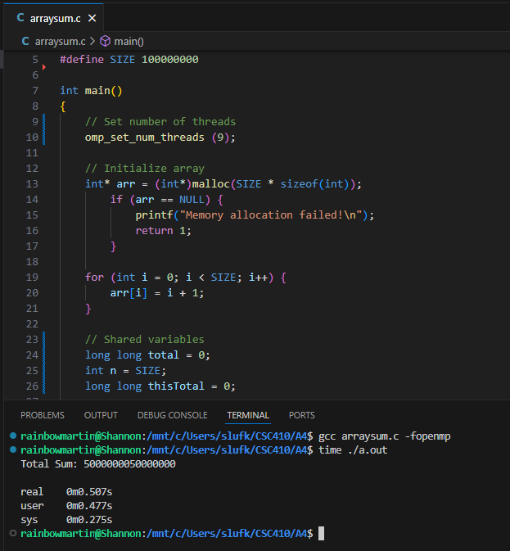

Matrix Multiplication
Sequential
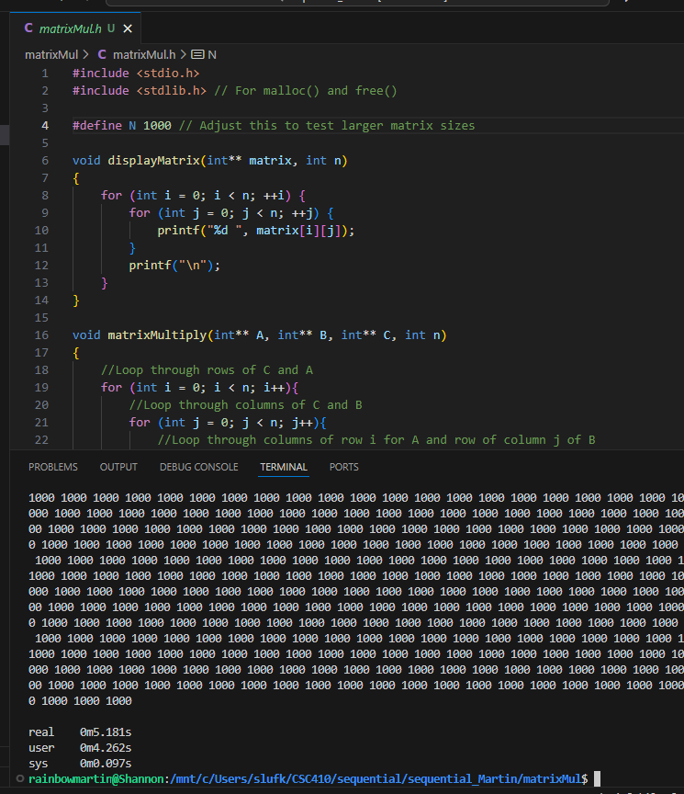
Pthread – 1 thread
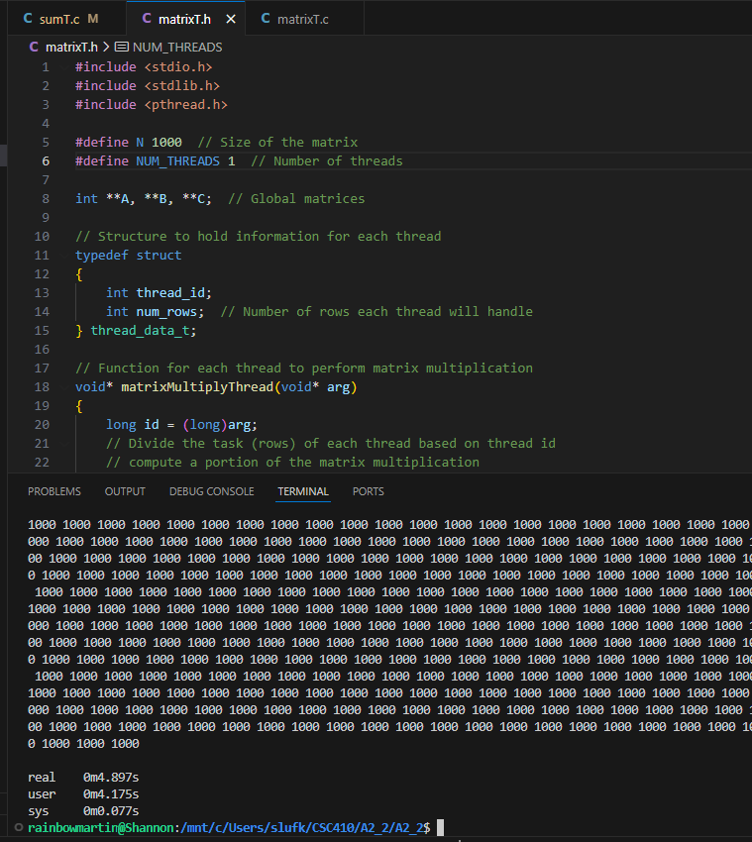

Pthread – 2 threads
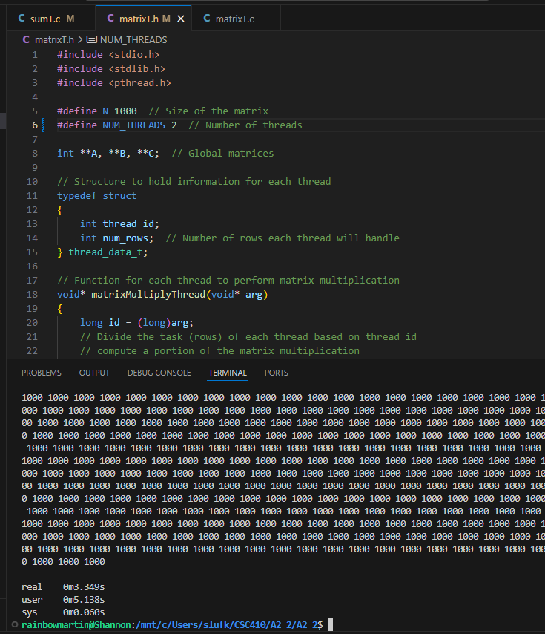

Pthread – 5 threads
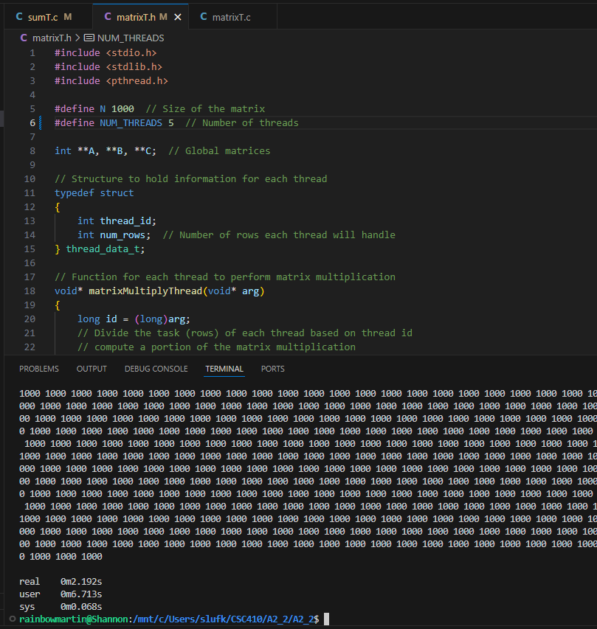

Pthread – 7 threads
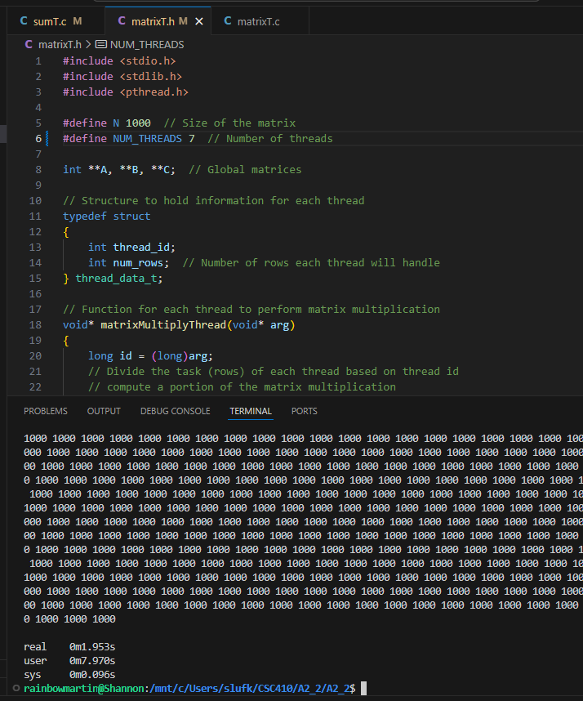

Pthread – 9 threads
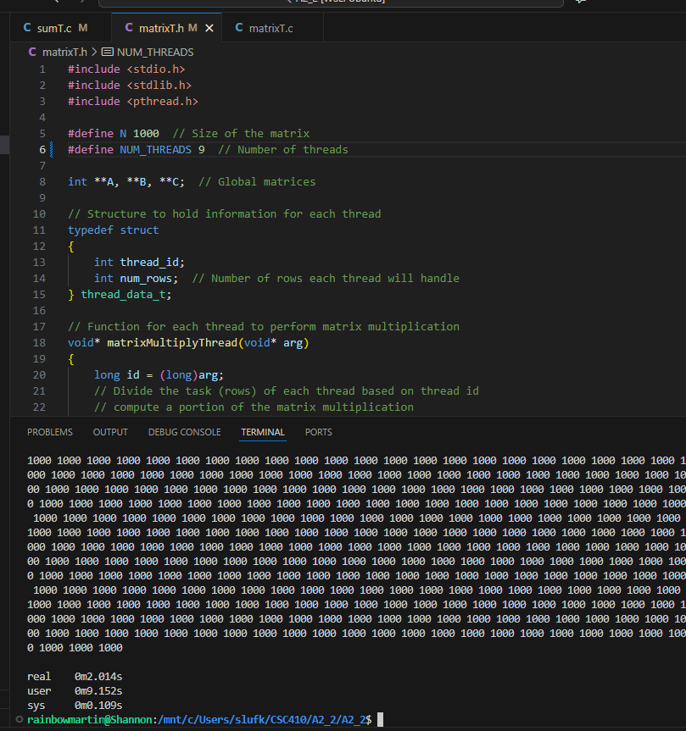

Omp – 1 thread
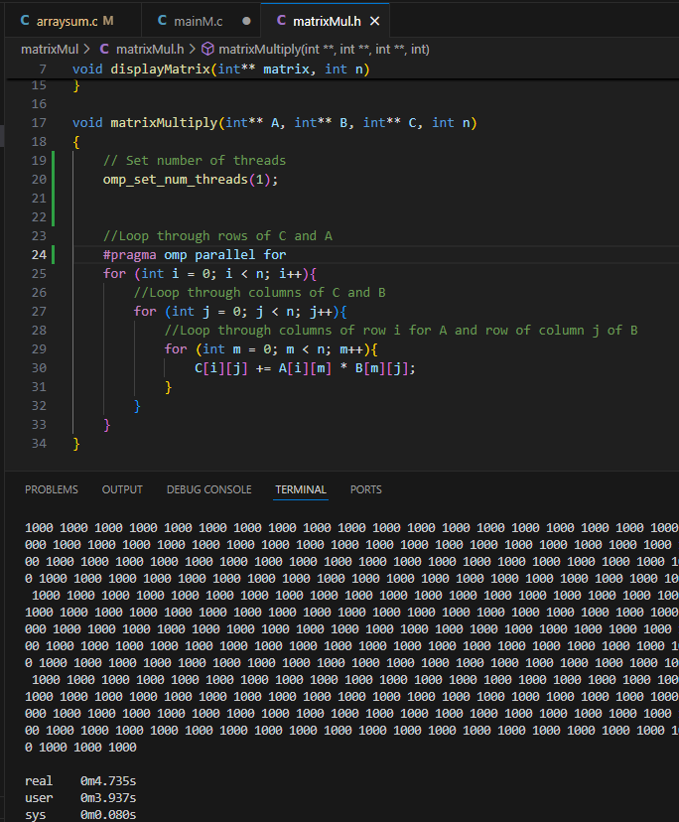

Omp – 2 threads
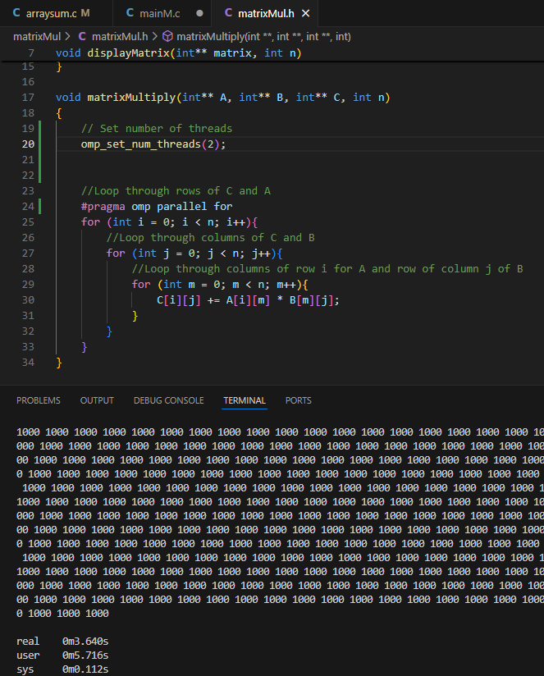

Omp – 5 threads
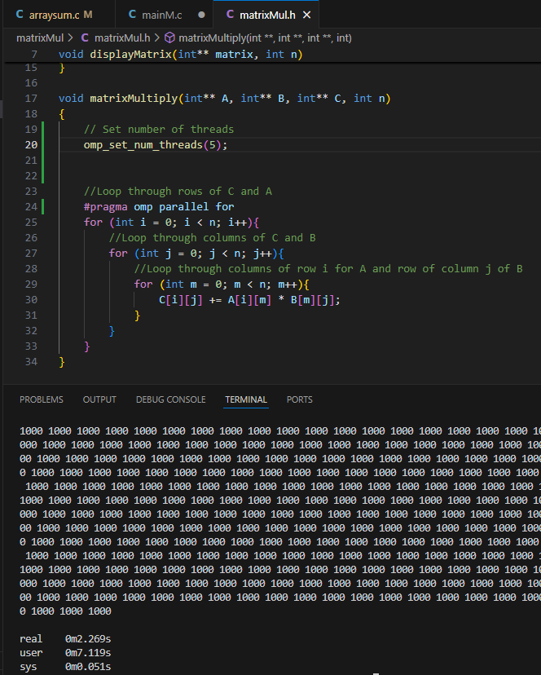

Omp – 7 threads
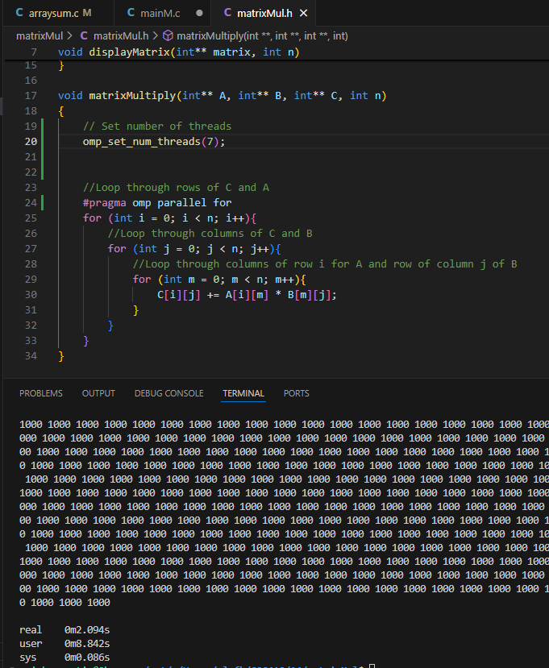

Omp – 9 threads
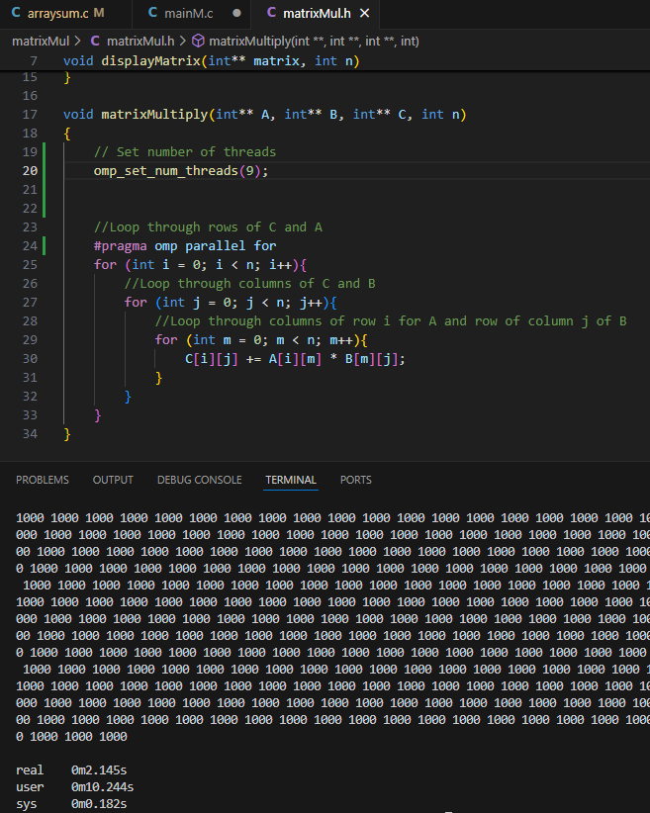
Trapezoidal Rule Integration
Sequential
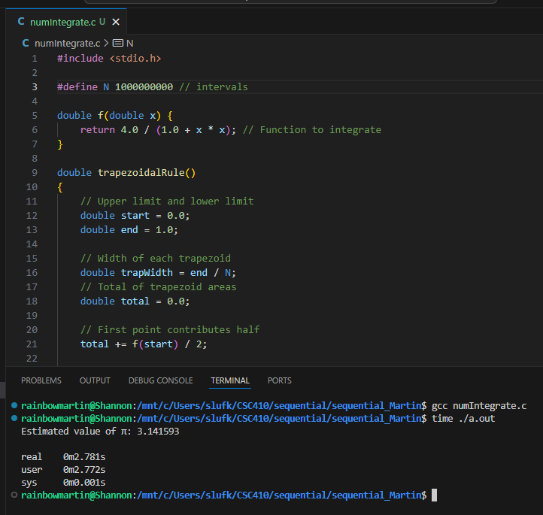
Pthread – 1 thread
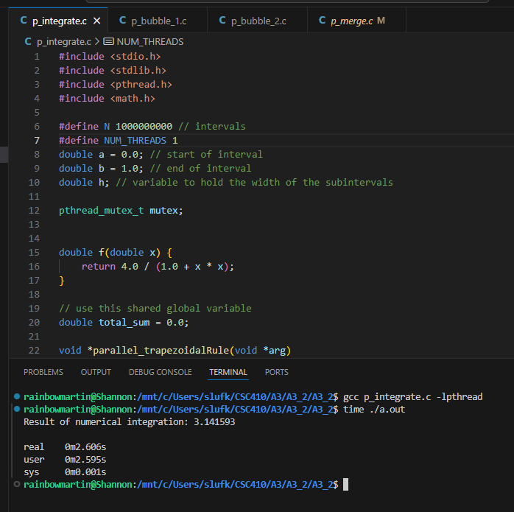

Pthread – 2 threads
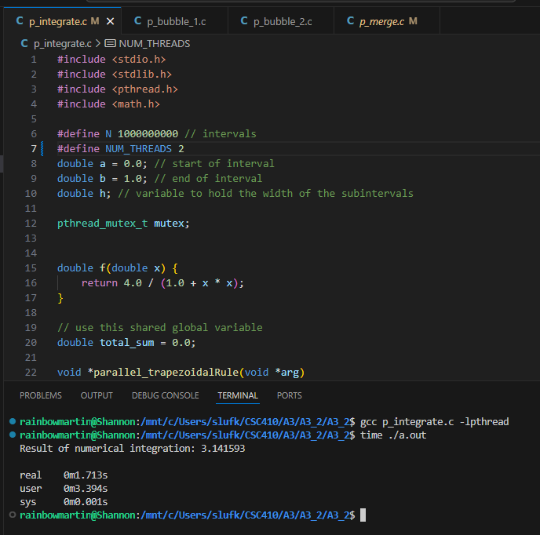

Pthread – 5 threads
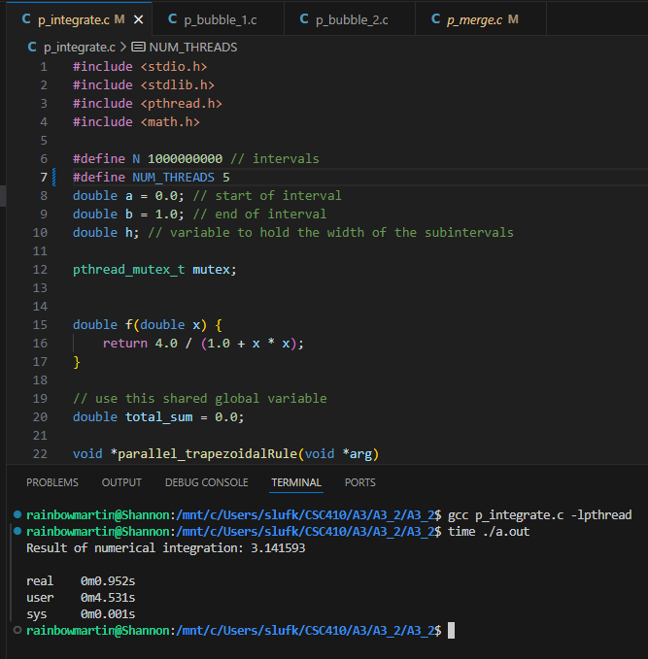

Pthread - 7 threads
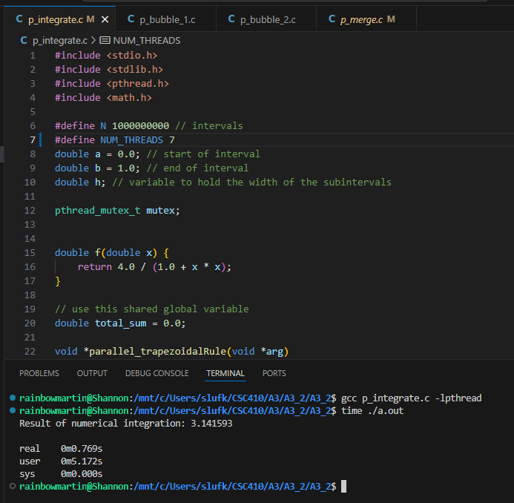

Pthread - 9 threads
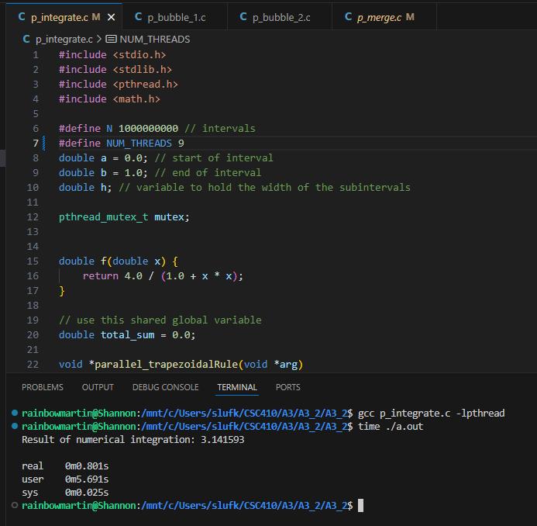

Omp – 1 thread
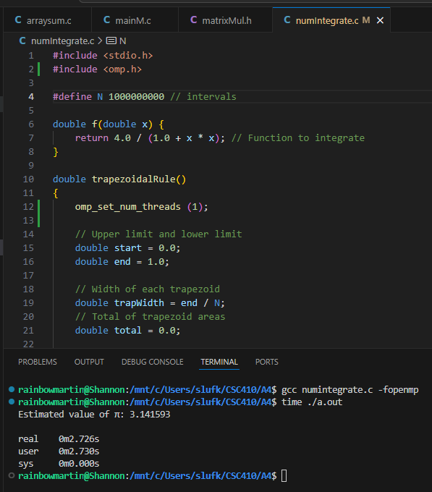

Omp – 2 threads
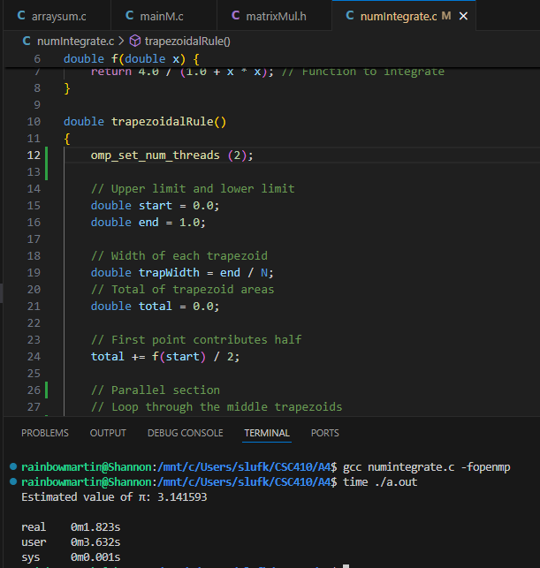

Omp – 5 threads
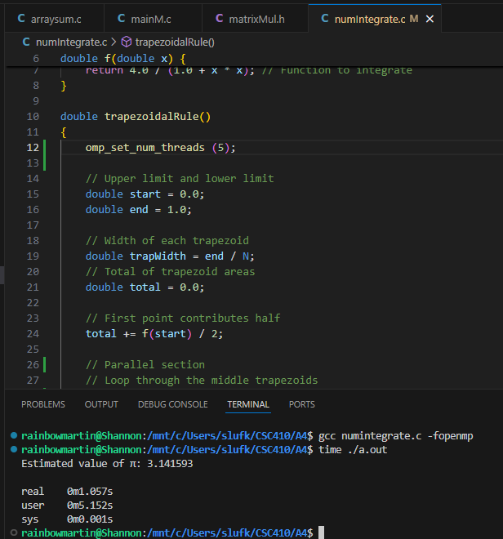

Omp – 7 threads
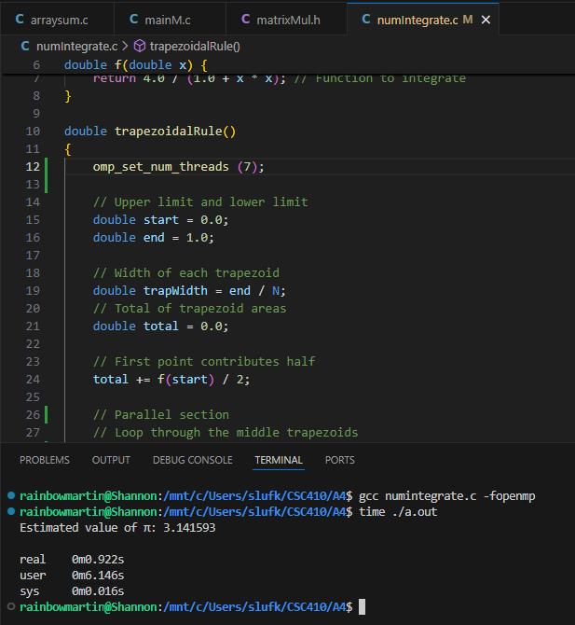

Omp – 9 threads
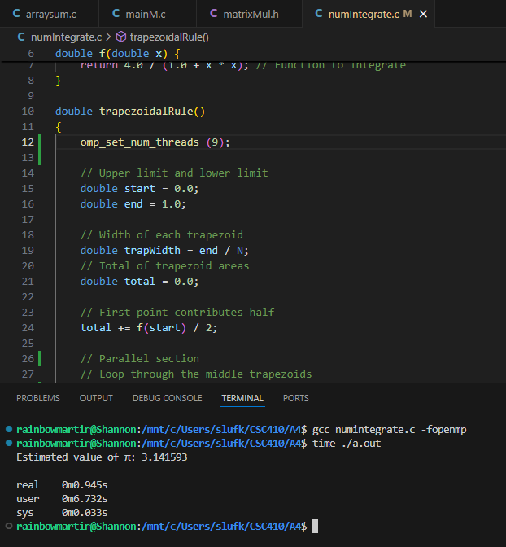

N Queens
Sequential
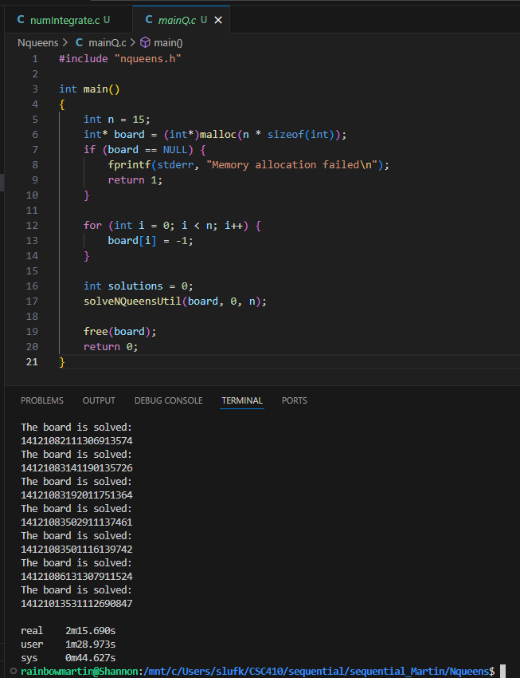
Pthread – 1 thread
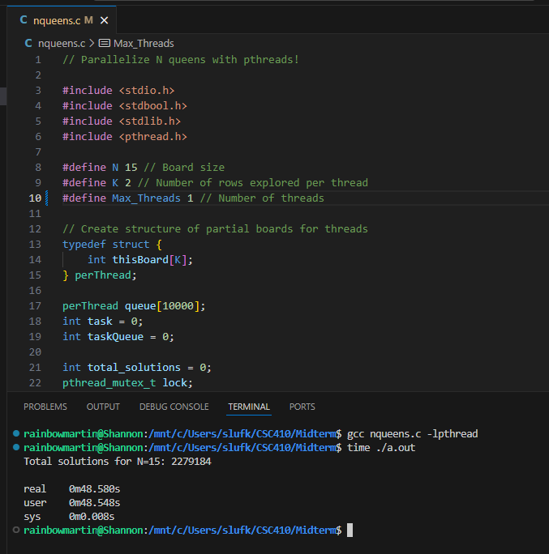

Pthread – 2 threads
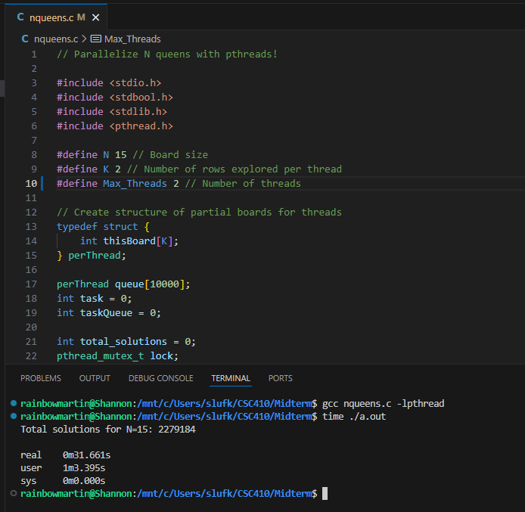

pthread – 5 threads
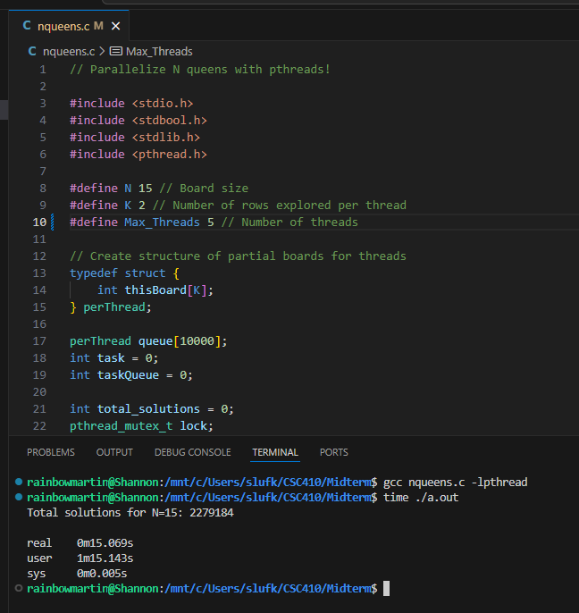

Pthread - 7 threads
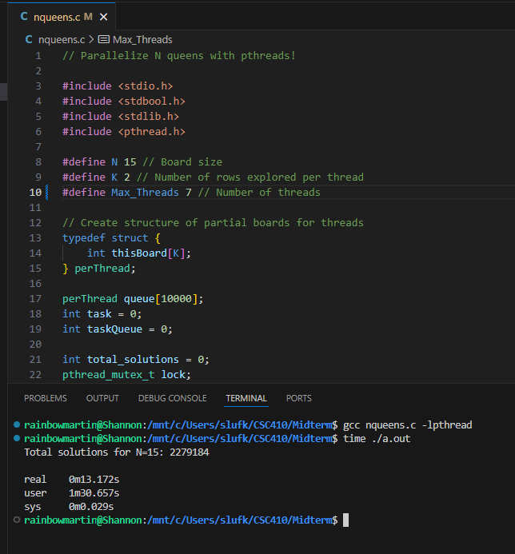

Pthread - 9 threads
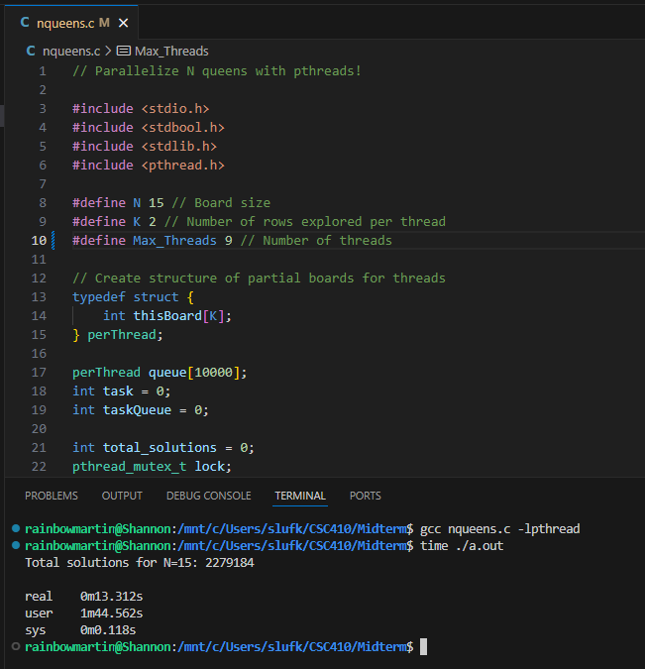

Omp – 1 thread
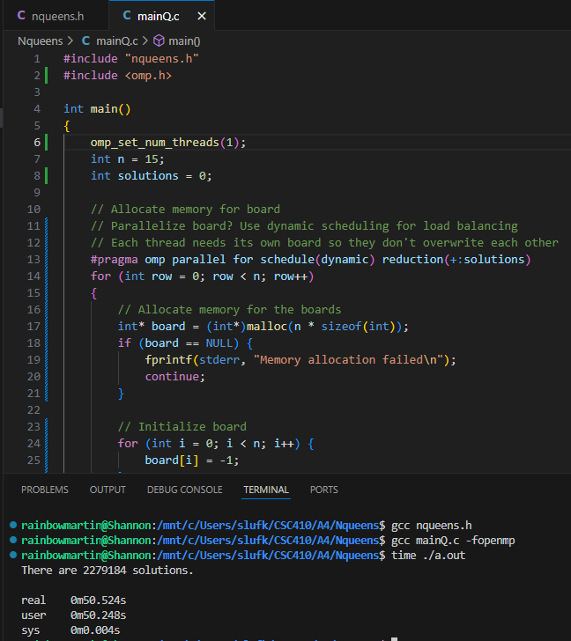

Omp – 2 threads
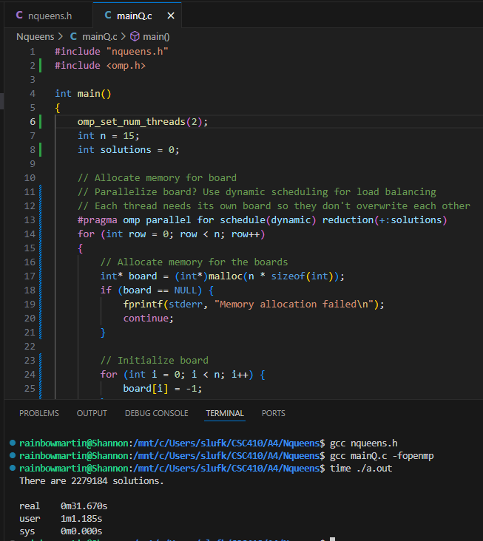

Omp – 5 threads
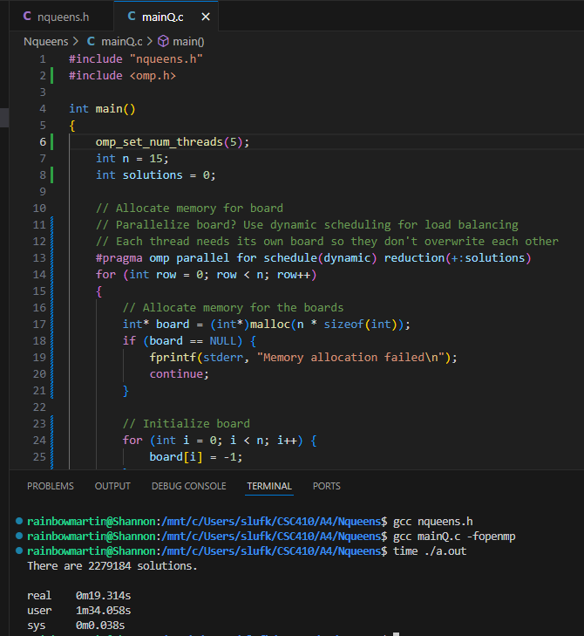

Omp – 7 threads
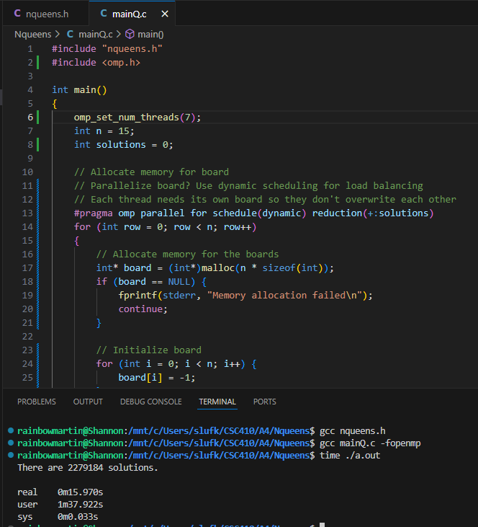
Omp – 9 threads
