Project 1
Section 1.3 – Sorting Algorithms
Rainbow Martin
Hardware Specs:
- CPU: 11th Gen Intel(R) Core(TM i7-1195G7 @2.90GHz, 4 cores
- 8 GB of RAM
- 475GB of Storage
- GPU Intel(R) Iris(R) Xe Graphics, 128 MB
- OS: Windows 11
n | Time taken by Selection sort  (in seconds) | Time taken by Counting sort  (in seconds)
10² | 0.000000 | 0.000000
10³ | 0.002000 | 0.000000
10⁴ | 0.280000 | 0.001000
10⁵ | 31.705000 | 0.001000
10⁶ | 2293.487000 | 0.016000
10⁷ | * | 0.145000
10⁸ | * | 2.004000
10⁹ | * | 73.729000
* Algorithm time growth is exponential – will take days to run

Selection Sort and Count Sort running on 10^5 size input
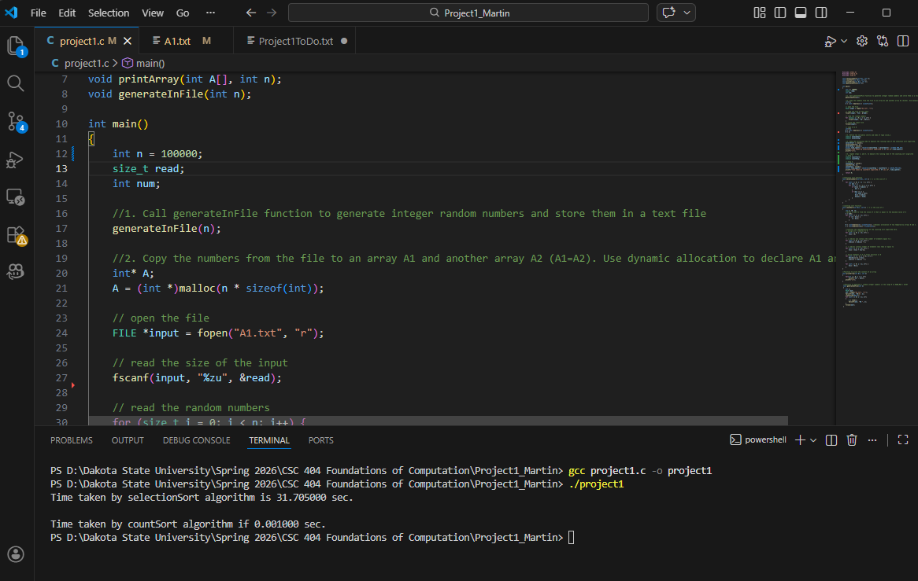
Selection Sort and Count Sort running on
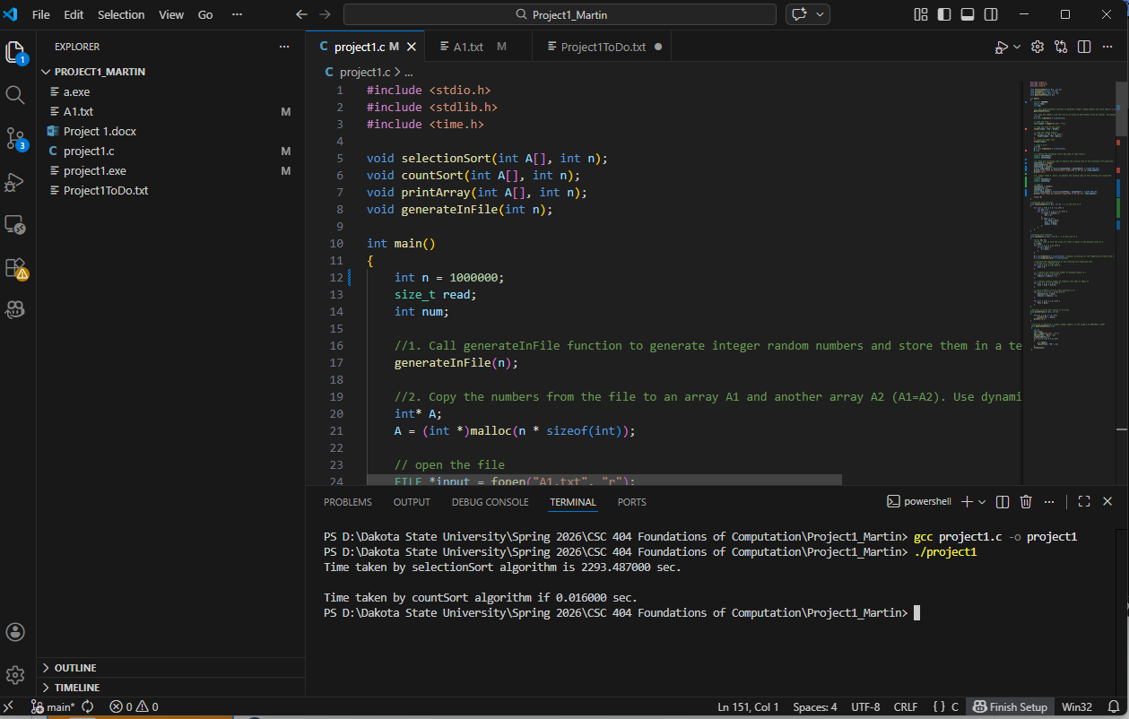
Count Sort running on 10^9 size input
