GOOGLE ADS API BASIC ACCESS APPLICATION
OpenSEO Google Ads Keyword Planner
Tool Design and Compliance Documentation
Keyword research and historical metrics only
Applicant / tool | OpenSEO - self-hosted SEO research workspace
Primary website | https://openseo.mostee.com
Google Cloud project | 321604194945
Manager account (MCC) | 604-324-3227
API contact | rainco2026@gmail.com
Document date | 16 August 2026

Prepared for Google Ads API Basic Access review

SECTION 1

Product overview
Purpose, business model, audience, and API scope
OpenSEO is an open-source and self-hostable SEO research and workflow platform. It combines keyword research, rank tracking, competitor analysis, backlink analysis, site auditing, Google Search Console data, and AI-assisted SEO workflows in one project workspace. The software is free and open source; deployments may use third-party data services that are billed separately.
The Google Ads Keyword Planner is a personal extension within OpenSEO. It uses the Google Ads API only to obtain keyword ideas and historical keyword metrics for manual SEO research. It does not create, edit, pause, or delete campaigns, ads, ad groups, budgets, billing arrangements, users, audiences, conversions, or remarketing data.
Permissible use requested: Researching keywords and recommendations. The tool requires KeywordPlanIdeaService access, which is restricted at Explorer Access and available after Basic Access approval.

Intended audience
- The current production deployment is privately controlled and protected by access controls.
- Access is limited to the owner and explicitly authorized team members who perform SEO and content research.
- The developer token in this application is not distributed with the open-source code and is not shared with unrelated self-hosted deployments.
- Each independent self-hosted deployment must configure and secure its own Google credentials and comply with Google Ads API requirements.

Business model
OpenSEO is positioned as an open-source alternative to commercial SEO suites. The application supports a hosted website and self-hosted deployments. The Google Ads integration described here is not sold as an advertising-management service and does not allow customers to supply or reuse this developer token.

SECTION 2

User interface and workflow
A user-initiated, read-only keyword research flow
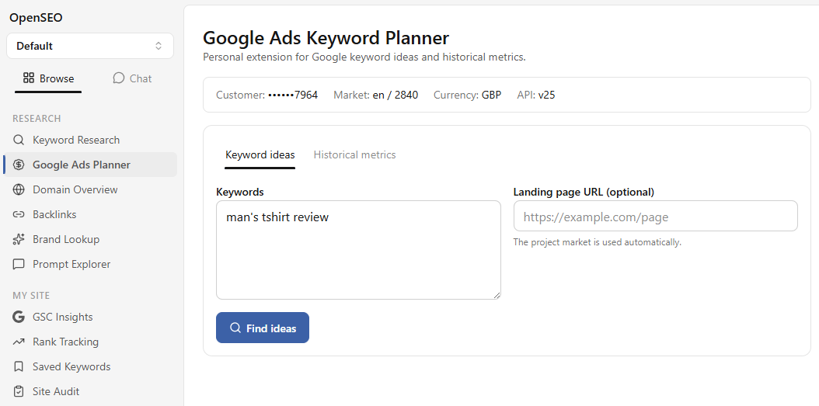
Figure 1. OpenSEO Google Ads Keyword Planner - Keyword Ideas input screen. The customer identifier is masked in the user interface.

Keyword Ideas workflow
- An authorized user opens a project and selects Google Ads Planner.
- The page displays the configured customer in masked form, plus the project-derived language, geographic market, currency, and API version.
- The user enters up to ten seed keywords, an optional HTTPS landing page URL, or both.
- The user clicks Find ideas. The browser sends the validated request to an authenticated OpenSEO server function.
- The Worker exchanges the stored OAuth refresh token for a short-lived access token and calls the Google Ads API from the server.
- OpenSEO normalizes the response and displays keyword ideas and metrics. The user manually reviews the results and may explicitly save selected keywords to the project.

SECTION 3

Functional design
Supported operations, validation, and returned data
User function | Google Ads API method | Inputs | Purpose
Keyword ideas | KeywordPlanIdeaService.GenerateKeywordIdeas | Seed keywords and/or HTTPS URL; project language and geo target | Generate related keyword suggestions and planning metrics
Historical metrics | KeywordPlanIdeaService.GenerateKeywordHistoricalMetrics | One or more explicit keywords; project language and geo target | Retrieve monthly search history and aggregate planning metrics

Inputs and safeguards
- Keyword inputs are trimmed, length-limited, deduplicated, and validated at the server trust boundary.
- Landing page input, when provided, must be an HTTPS URL.
- Adult keyword inclusion is disabled.
- The project market determines the Google Ads language and geographic targeting constants automatically.
- Requests use GOOGLE_SEARCH as the keyword plan network.
- The application applies timeouts, limited retries for transient failures, and rate-limit handling.

Data returned to the user
Field | Use in OpenSEO | Storage behavior
Keyword and close variants | Display and keyword selection | Saved only when the user explicitly saves selected rows
Average monthly searches | Search-demand assessment | Mapped to a normalized project keyword record when saved
Monthly search volumes | Trend and seasonality review | Returned for display; retained only through explicit project actions
Competition and index | Relative advertising competition signal | Displayed as planning context
Average CPC and bid ranges | Commercial-intent context | Converted from micros to the configured currency

SECTION 4

System architecture and account model
Server-side OAuth, explicit account relationships, and least exposure

Request path
- Authorized browser session - the user submits a keyword research request inside an OpenSEO project.
- OpenSEO server function - authenticates the session, validates inputs, and resolves project market settings.
- Keyword Planner service - prepares the permitted read-only planning request.
- OAuth token exchange - the Cloudflare Worker obtains a short-lived access token from Google's OAuth service.
- Google Ads API - the Worker sends the OAuth bearer token, developer token, login customer ID, and target customer ID.
- Normalized response - only fields used by the product are returned to the interface; credentials never enter the browser response.

Account relationship
OAuth user | A Google user authorized for the manager/client hierarchy
Manager account | 604-324-3227 - supplied as login-customer-id
Target customer | 920-177-7964 - supplied as the customer resource in requests
Google Cloud project | 321604194945 - owns the OAuth client and has Google Ads API enabled
Developer token | Issued from the manager account API Center; requested access level: Basic

Credential boundary: OAuth client secret, refresh token, and developer token are Worker secrets. They are never rendered in HTML, sent to the browser, included in exported keyword data, or committed to the source repository.

SECTION 5

Data handling and security controls
How credentials, requests, responses, and logs are protected
Control area | Implementation
Authentication | The deployed application is protected by access controls. Server functions require an authenticated application session and project context.
Secret storage | OAuth client secret, refresh token, and developer token are stored as Cloudflare Worker secrets and read only at runtime.
Transport | Browser-to-Worker, OAuth token exchange, and Google Ads API requests use HTTPS.
Token handling | The refresh token remains server-side. Short-lived access tokens are obtained only as needed and are not persisted in browser storage.
Input validation | Runtime schemas validate keywords, URLs, identifiers, currency codes, configuration shape, and Google response fields.
Response minimization | The application maps only the keyword planning fields required by the user interface rather than exposing the full upstream response.
Logging | Structured error logs retain status, safe error classification, message, and request ID. Authorization headers and credential values are excluded.
User-visible identifiers | The target customer ID is masked in the interface; only the last four digits are shown.

Retention and user control
Keyword ideas and metrics are displayed in response to a user request. OpenSEO does not automatically create permanent records for every API result. A user must select rows and invoke the save action before normalized keyword records are stored in the project database. Project data remains under the control of the deployment owner and authorized users.
No advertising mutations: The integration contains no workflow or API call for campaign management, account creation, user management, billing, payment, conversion tracking, Customer Match, audience creation, or remarketing.

SECTION 6

Policy boundaries and operational controls
Designed for transparent, user-directed keyword research

Permitted behavior
- Every Google Ads API request is initiated by an authorized user action.
- The purpose is limited to keyword research, recommendations, and historical planning metrics.
- Results support manual SEO and content-planning decisions; they are not used to impersonate Google or claim guaranteed advertising outcomes.
- Google Ads data is labeled by source and presented with the configured market and currency context.
- The application respects Google API errors, quota responses, token revocation, and access-level restrictions.

Explicitly out of scope
- Automated campaign, ad, budget, bidding, billing, or account changes
- User invitations or Google Ads account access management
- App conversion tracking, offline conversions, Customer Match, or remarketing
- Resale, sublicensing, publication, or distribution of the developer token
- Providing unrelated third parties with direct or indirect credential access
- Bulk scraping or unattended harvesting of Google Ads data

Monitoring and incident response
The deployment owner monitors structured Worker logs and Google Ads API responses. If a credential is suspected to be exposed, it is rotated or revoked and the Worker secret is updated. Authentication failures, expired grants, quota limits, permission errors, malformed responses, and upstream availability failures are handled as explicit error categories.
Access request: Basic Access is requested because KeywordPlanIdeaService planning methods are restricted under Explorer Access. The requested scope does not require unlimited Standard Access operations.

APPENDIX

Technical inventory and reviewer references
Endpoints, configuration categories, and official documentation

External endpoints used
Endpoint / service | Method | Purpose
https://oauth2.googleapis.com/token | POST | Exchange the server-held refresh token for a short-lived OAuth access token
googleads.googleapis.com/v25/...:generateKeywordIdeas | POST | Retrieve keyword ideas and associated planning metrics
googleads.googleapis.com/v25/...:generateKeywordHistoricalMetrics | POST | Retrieve historical search metrics for supplied keywords

Configuration categories
Category | Examples | Location
OAuth application | Client ID and client secret | Server runtime; secret value stored in Worker secrets
Google Ads authorization | Refresh token and developer token | Worker secrets only
Account routing | Target customer ID and login customer ID | Validated server configuration
Presentation | API version and currency code | Validated server configuration and masked UI metadata

Official reviewer references
- Google Ads API developer token: https://developers.google.com/google-ads/api/docs/api-policy/developer-token
- Access levels and permissible use: https://developers.google.com/google-ads/api/docs/api-policy/access-levels
- OAuth and REST authorization headers: https://developers.google.com/google-ads/api/rest/auth
- Google Ads API call structure: https://developers.google.com/google-ads/api/docs/concepts/call-structure

Application contact
Contact email | rainco2026@gmail.com
Product website | https://openseo.mostee.com
Production deployment | https://openseo.steer.workers.dev
Requested access | Google Ads API Basic Access - Researching keywords and recommendations

End of document

