|  |
| --- |
| SavgunKo GAmes |
| Game Design Document |
| **Flatland-Radness Game**  https://scontent-yyz1-1.xx.fbcdn.net/hphotos-xfl1/v/wl/t34.0-12/12825097_10207542846902595_425257518_n.jpg?oh=d491141292f44f35af175ba6308f6930&oe=56E59997 |
| Version #01  All work Copyright © 2012 by SavgunKo Games.  All rights reserved. |
| **George Savchenko & Jason Gunter** |
|  |

|  |
| --- |
| March 31, 2016 |

**Table of Contents**

Contents

**I.** **Game Overview** 5

**II.** **Game Play Mechanics** 5

**III.** **Camera** 5

**IV.** **Controls** 5

**V.** **Menu and Screen Descriptions** 5

**VI.** **Game World** 6

**VII.** **Levels** 6

**VIII.** **Game Progression** 6

**IX.** **Items** 6

**X.** **Scoring** 6

**XI.** **Bonuses** 6

**XII.** **Cheat Codes** 6

**XIII.** **Sound Index** 6

**XIV.** **Art / Multimedia Index** 7

**XV.** **Future Features** 7

**Version History**

<https://github.com/gsavchenko/Flatland-Radness>

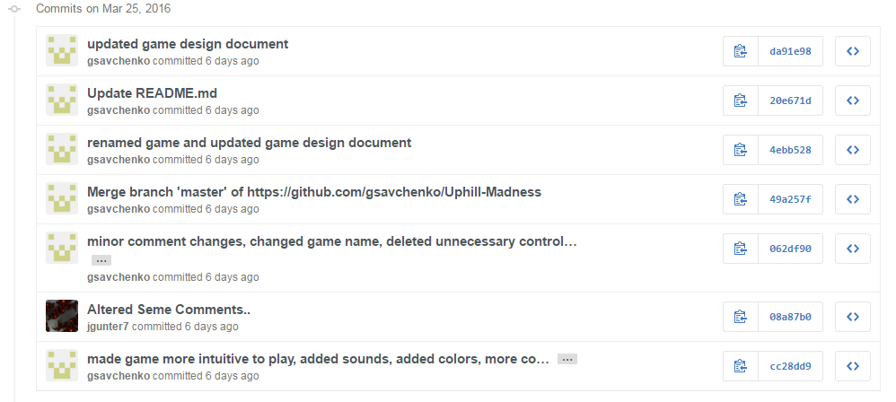

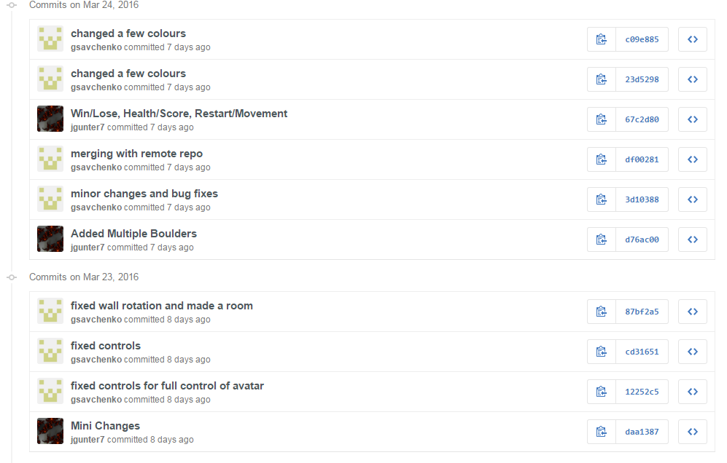

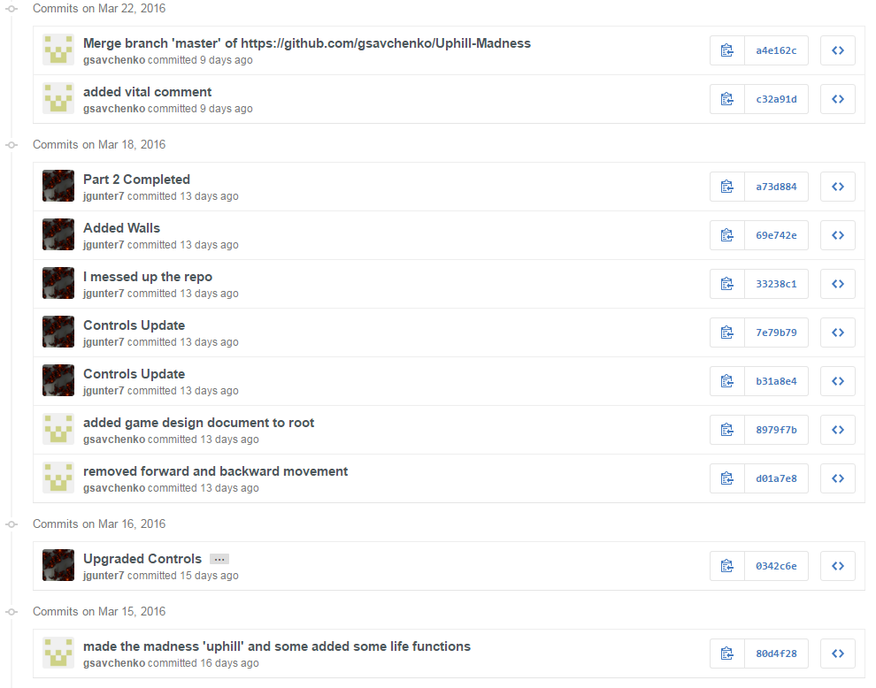

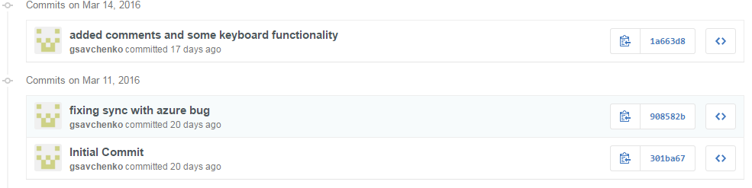

1. **Game Overview**

The player must avoid boulders that they encounter in the game. They must collect coins to increase their score and proceed to new levels. The player can move side-to-side and jump over the boulders to avoid them. The player can also collect special coins that will provide different power ups or changes to the game. Lastly, the player can collect coins to get a high score in the game.

1. **Game Play Mechanics**

The player will collect coins and use the arrow keys and keyboard to move their player to the goal.

1. **Camera**

A first person camera will be used, as it is a requirement for this assignment.

1. **Controls**

The user will be able to use the up, down, left and right arrow keys to move the player forwards, backwards, left and right. In addition to this, the user can use the space bar to jump.

1. **Menu and Screen Descriptions**

**Menu:**

The menu will allow the user to start the game, read through the instruction screens, or view previous high scores.

**Instructions:**

The instructions screen will allow the user to navigate the instruction pages with “Next” and “Back”, and will include a “Play” and “Menu” button for easy navigation for the user.

**Play:**

This option will play the main game.

**Game Over:**

This will be the game over screen, which will allow the player to go back to the main menu, or restart the game.

1. **Game World**

The player is in a square arena; the boulders will move throughout the arena for the player to avoid. Coins will also spawn to provide score and game changes to the player. Additional levels will increase difficulty and bring different power ups or changes to the game play. Collecting a certain number of coins will progress the player to the next levels.

1. **Levels**

As mentioned above, each level will show different obstacles and power ups. This will be defined later as part 2 and 3 of this project.

1. **Game Progression**

The player will collect a certain amount of coins to proceed to the next level. Level 1 is for coins < 20, level 2 is for coins > 20 but < 40, and level three will be for any player that has more than 60 coins collected.

1. **Items**

**Boulder Object:**

This object is spherical in shape, and will roll around the arena area. If it collides with the player, it will make a sound, and decrease the player health for the period of contact.

**Coins:**

This item will increase the player score and will respawn when the player collides with it. Different colour coins will provide different power ups or game play changes.

1. **Scoring**

The player score will be tracked by the net number of coins the player has lost or gained during game play.

1. **Bonuses**

Bonuses have not yet been determined.

1. **Cheat Codes**

Some cheats will be available from the console in the browser. This may be defined during the final stages of the project.

1. **Sound Index**
   1. Background Music (background.wav)
   2. Collision (collide.wav)
   3. Coin Collection (coin.wav)
2. **Art / Multimedia Index**
   1. Sphere textures (textures.png)
   2. Plane texture (ground.png)
   3. Side-Hill texture (hill.png)
   4. Coin texture (coin.png)
3. **Future Features**

These will be updated once further progress has been made on the game.