INSERT Paper title Here (no more than 80 CHARACTERS)
Insert Author’s Name, Company or Affiliation, City, State (if not USA include Country)
Insert Co-Author’s Name, Company or Affiliation, City, State (if not USA include Country)
(If you have multiple authors from the same company, list authors' names first, followed by company or affiliation, city and state. Do NOT include email addresses here.)

Abstract [Heading 1]
The first heading of your paper should be the abstract using the Heading 1 style and Body Text style for the text. It is not necessary that this abstract be the same as the abstract you previously submitted. This abstract should be a synopsis of your paper. It will generally not be longer than the first column of your paper.

Do This First! [Heading 1]
Before you do anything else, please print a copy of this file! It contains instructions for producing your paper for the 2019 ICNS Conference. This file is also a template for creating your paper; you can delete or type over these instructions to help you get started. Finally, the printed version of these instructions will serve as a visual reference of how your finished paper should look.
Next, save this file on your hard drive, but with a different name. Use the “File – Save As” command and give it a different name. Now you’re ready to read the rest of the instructions and start your paper.
If you have questions about anything in these instructions, please contact:
Tony Rossetti
407-896-6355
publications.chair@i-cns.org

Using Styles [Heading 1]
The elements that you will need for your paper have been formatted for you through the use of the “styles” capability of the software. Styles are selected from the box on the far left of the toolbar. Note: if you position your cursor anywhere in this paragraph, the “styles” box will say “Body Text”; we’ve also noted different styles in brackets following some of the elements on this page of instructions (Title, Author, Heading 1, Heading 2, etc.).
To use styles, you can either select the style you wish to apply and start typing, or select the text to which you wish to apply a style; then, using the mouse, point to the style box on the toolbar. Click once on the down arrow on the right, and select the appropriate style.

2019 ICNS Conference Styles [Heading 2]
Please use the following styles in your paper:
- Title (Title of Paper)
- Author (Author Name and Information/Conference Name and Date)
- Heading 1 (First-level Section Headings)
- Heading 2 (Subsection Headings)
- Heading 3 (Sub-Subsection Headings)
- Body Text or Normal Text (Normal Paragraph Text)
- List Bullet (Bulleted List Items)
- Caption (For Figure and Table Captions)
- Table Text (For Table Entries)
- Footnote Reference (Superscript)
- Footnote Text (Place footnotes at bottom of page where referenced)
- References (For list of references at the end of the paper)
- Hyperlinks (For hyperlinks and email addresses)
- (Note 1: Do not use Heading styles 4, 5, or 6 in your paper. Note 2: Capitalize the first letter of each word in all Headings, Tables, and Figures. For example, Format/Change Case/Title Case.)

Why Bother? [Heading 2]
Styles are easy to use. They do all of the formatting work for you, and they help maintain a consistent look across all of the papers in the Proceedings. Consistent use of styles also ensures accurate, automated processing of your paper for the Proceedings on CD-ROM. The Proceedings use the heading styles as bookmarks to allow the reader easier navigation through your paper.

Transfer to PDF Bookmarks [Heading 3]
If you need to use a heading below Heading 2 you can use Heading 3. All three headings will translate to PDF bookmarks for easy navigation on the Proceedings CD.

Title
The title of your paper should not exceed 80 characters in length, including spaces. If your title exceeds the 80 character limit, the title will be truncated in signage at the Conference.

References
References, if any, should be included as the first heading after the body of your paper using the Heading 1 style. Number references consecutively throughout your document. If you cite a reference more than once, use the same reference number each time. Enclose the number in brackets and inside the closing punctuation. For example: The results of the testing promoted closure of the investigation [1].
Include the reference information in the following order:
- Author or editor, last name first (Do not put last name first for subsequent authors in a multi-author publication.)
- Publication date
- Title
- Edition, document, or volume number, if applicable
- Place of publication
- Publisher
- Pages or chapters
- Internet links, if applicable.
Also, use the Reference style as shown below:
[1] Jones, Mary, John Smith, 2002, Good Writing, Washington, DC, Printing Company, pp. 22-44.

Acknowledgements
If an acknowledgement is necessary, include it under the heading Acknowledgements using the Heading 1 style. Use the Body Text style and include the acknowledgements immediately after the references.

Disclaimer
If a disclaimer is necessary, include it under the heading Disclaimer using the Heading 1 style. Use the Body Text/Normal Text style and include the disclaimer immediately after the acknowledgements.

Email Addresses
If email addresses for the authors are desired, include them under the heading Email Addresses using the Heading 1 style. Use the Hyperlink Text style and include the email addresses immediately after the disclaimer.

Appendices
For papers typically 8-15 pages in length, appendices are not required. However, if appendices are used, include them under the heading Appendix I (II, III, etc.) using the Heading 1 style. Use the Body Text style and include the appendices immediately after the email addresses.

Conference Identification
In order to identify at which ICNS Conference the paper was published and presented; please add the following lines at the end of the paper using the Author text style:

2019 Integrated Communications Navigation and Surveillance (ICNS) Conference
April 9-11, 2019

Other Things You Need To Know About Formatting Your Paper
This section outlines other formatting actions required for 2019 ICNS Conference publications.

Length
Papers should be 8 to 15 pages in length.

Margins
Left, right, and top margins are 0.8. Bottom margin is 1.25 in.

Columns
Columns should be equal widths of 3.3 in. with a spacing of 0.3 in.

Font
The font selected for this publication is Times New Roman. Body text is 11 point.

IMPORTANT! – To ensure that your paper is in compliance with ICNS requirements, margins, font size, and heading styles must be strictly followed. Not following these instructions can result in exclusion from the Proceedings and/or disqualification for Best Paper awards. (We reserve the right to reformat your paper to meet these requirements.)

Tables
Always use a table editor or tabs to create tables. Do NOT use spaces to align columns in your tables, and do NOT use the “columns” feature to create tables. Center the table in the column. Use the “Caption” style to identify each table with a bold sequential numeric reference, centered at the top of your table as shown below (see Table 1). Table titles should be less than 40 characters with more detailed explanations in the text with a specific reference to the appropriate table. Use the ‘Table Text Bold’ style for headings in your table and the ‘Table Text’ style for entries in your table.
Table 1. Sample Table and Table Caption
Sample Description | X | Y | Z
Sample Test 1 | 1 | 2 | 3
Sample Test 2 | 6 | 2 | 2
Totals | 7 | 4 | 5

Graphics
Please include graphics with ‘Inline with text’ wrapping. Use the “Caption” style to include a centered caption for the graphic no longer than 40 characters, and place it at the bottom of the graphic, as indicated below with a specific reference to the figure (Figure 1). To ensure the best quality printing of the graphic, adjust the contrast and brightness (select graphic, then select Format Picture/Picture). Figure captions should use ‘Title Case’. Be sure to include/embed Figures and Captions in the body of your paper.
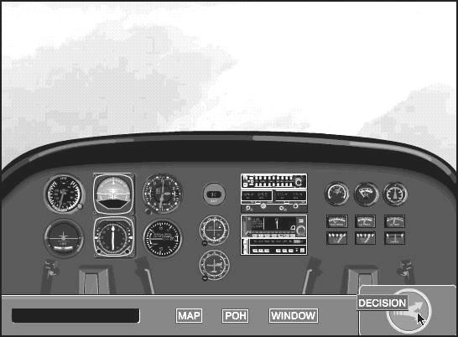
Figure 1. Example of a Figure and Caption
Be sure to include/embed Figures and Captions in the body of your paper. If the graphic is too large to fit in a single column:
- Insert a Continuous Section Break (Insert/Break/Section Breaks/Continuous)
- Format for single column (Format/Columns/One/OK)
- Insert the graphic and figure caption
- Insert another Continuous Section Break (Insert/Break/Section Breaks/Continuous)
- Format for two columns (Format/Columns/Two/OK)

See example in Figure 2:

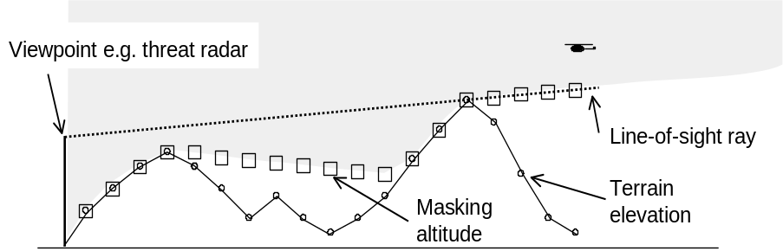
Figure 2. Umbra Intervisibility Ray

Hyperlinks and Email Addresses
To ensure that the CD-ROM version of your paper contains currently active links and email addresses, check them prior to submitting your paper. Use the Insert/Hyperlink function and the hyperlink style to insert a hyperlink (e.g., www.i-cns.org) or an email address (e.g., pub.editor@icnsonline.org).

Properties
Insert your paper’s title and author(s) in the file properties dialog box (File/Properties/ Insert Authors Here). The subject (2019 Integrated Communications Navigation and Surveillance Conference) should already be there.

Submitting Your Final Paper for Review and Approval
As soon as you have completed the final version of your paper, submit it electronically at: icnsonline.org. This must be done no later than March 1, 2019 to ensure adequate time for review and publication.
Name the file using your abstract number and up to the first five (5) letters of your last name (i.e., for abstract number 115, author Michael L. Johnson would save his file as: 115johns.doc, where .doc is the default three letter extension applied by Microsoft® Word.) Omit any spaces in your last name when naming your file (i.e., for abstract number 122, author Tom de Jong would save his file as: 122dejon.doc).
If you cannot submit the paper via icnsonline.org, or your paper is more than 35MB, two additional options are available:
- Email (if less than 35 MB in size); or
- Send a CD, or DVD by postal service to the Publications Editor at the address below, under heading “Additional Documentation Requirements”
Please indicate your use of Mac or PC, your full name, address, and phone number, “2019 ICNS,” and the file name of your paper.
The point of this conference is to foster a healthy information exchange among government and industry representatives. If you upload a paper for publication, then at least one of the authors listed on the paper is expected to attend and present that paper. IEEE reserves the right to exclude a paper from distribution after the conference (e.g., removal from IEEE Xplore) if the paper is not presented at the conference. Please register for the conference at icnsonline.org.

IEEE Copyright Form
All ICNS Conference papers are published through IEEE. Download the 2019 ICNS Conference official IEEE Copyright Form from icnsonline.org. Complete, and sign the form. Submit the form to the Publications Editor, via one of the following options:
- Scan to pdf or graphic file (jpg, gif, png, tif) and email
- Fax
- Postal service (Please note: Overnight delivery service is recommended; in case their tracking service is required for lost documents).
To:
Tony Rossetti
ALR International
3311 Dupree Avenue
Orlando, FL 32806-3411
pub.editor@icnsonline.org
Fax: 888-338-3537 (toll free)
Papers must be received no later than March 1, 2019 to ensure adequate time for review and publication. Presentations and IEEE Copyright Forms must be received no later than April 5, 2019
Please be aware of any additional release requirements that you may have above and beyond the ones imposed by this conference. Of particular interest are project sponsor and customer releases. Many companies also have their own publication release processes that must be satisfied prior to submitting the paper to the 2019 ICNS Conference. Remember that it becomes public domain once you upload it.

Get Started!
You’ve made it through all the instructions, and you’re ready to write your paper. So, what’s next?
There are several ways to get started, depending on your familiarity with Microsoft® Word.

Novice ICNS Authors
Use these instructions as a baseline for your paper, which allows you to “write over” the current text.
- First, save this file under a new name, as 115johns.doc (File, Save As, “new name”).
- Delete the first line of the existing title.
- Use your mouse to highlight the second line of the title, and then type the title of your paper in its place.
- Do the same for the “author” lines (note, hitting “return” at the end of an author line will automatically open up another author line).
- Delete the third line that contains information about multiple authors from the same company.
- Replace the abstract title with your abstract title and replace the abstract text with your abstract text.
- Continue replacing parts until you’re comfortable with how things work, then start adding your own elements by using the “Styles” box on the left side of the Formatting Toolbar.

Intermediate ICNS Authors
Use this file as a template.
- Save this file under a new name (e.g., 115johns.doc)
- Delete all of the text (Edit/Select All, Edit/Clear).
- Save the (empty) file again, and start writing. All of the necessary styles will be available to you via the Styles box on the Formatting toolbar.

Expert ICNS Authors
If you know about templates, and how to use them, you can extract the template from this file, and use it to build your paper. Hint: remove all of the text from this file (Edit/Select All, Edit/Clear), then save as a template (File/Save as, select Document Type – “Document Template (*.dot,*.dotx),” name your template (e.g. 2019ICNS.dot(x)), and Save.

2019 Integrated Communications Navigation and Surveillance (ICNS) Conference
April 9-11, 2019

Footnote 1 [Footnote Text]
Footnote 2

