Assessing the Global COVID-19 Impact on Air Transport with Open Data

Rainer Koelle  
Performance Review Unit  
EUROCONTROLBrussels, Belgium  
rainer.koelle@eurocontrol.int

Fabio Lourenco Carneiro Barbosa  
Subdepartment of Operations  
DECEARio de Janeiro, Brazil  
barbosaflcb@fab.mil.br

*Abstract*—<!—teaser & motivation -->This paper approaches the impact of the COVID-19 pandemic as a massive service disruption of the pre-pandemic global connectivity and regional air transport networks.

<!-- short background - why important -->   
In particular, the project aims to provide data analytical evidence for policy success and transformation of the air transportation system. As an aspirational goal, the industry aims to recover in a “greener” manner. The project builds on openly available data sets. The paper will be produced in a reproducible manner making the data, code, and its processing available to interested researchers and practitioners. The open assessment will provide policy makers with a tool to assess the reaction to local or regional measures.

<!-- approach chosen / research method -->This paper applies a data driven approach. In particular it builds on open data to assess the impact of COVID-19.

<!-- experimental work -->

<!-- results obtained -->This paper documents the analytical results for the period 2020 and the first half of 2021. The year 2019 is used for reference purposes.

<!-- conclusions / key take-away --> The analysis of the developments in Brazil, Europe, and the United States showed similarities but also stark differences in terms of the response to curb the spread of COVID-19 and associated travel policies. The results obtained demonstrate the feasibility to address global air transport problems with open and crowd sourced data. Future work to harmonise the open data collection and utility can provide a basis for a more open and transparent management of air transportation. The initial approach to address resilience can further inform the on-going work of the ICAO performance expert group under the Global Air Navigation Plan.

Keywords—COVID-19, disruption, resilience, air navigation system, XXX

# Introduction

For several years, many concerns of the global air traffic management community has been directed to the evident problem of imbalances between capacity and demand. The pressing, increasing demand for air transport registered in the last decade not only has already produced challenging delay management practices, but also fostered projections of even worse scenarios. EUROCONTROL [1], for example, argued that delays in Europe could reach up to 20 minutes per flight in 2040, in stark contrast to the 12 minutes per flight, as registered in 2016. The main driver for such developments were linked to the growth of air transportation.

In the above scenario, many disturbances on the air navigation system could represent a real threat to multiple stakeholders. Events such as extreme bad weather, unexpected interruptions of air navigation services, changes to the regulatory framework and others: all of those inputs could promote even more delay and its propagation effects. That is why the concept of resilience in ATM system became similarly relevant in the agenda during the same period. Arguably, a resilient ATM system could mitigate the negative effects of excessive demands on insufficient capacity and their respective constraints and bottlenecks.

On March 11, 2020, the World Health Organisation has declared the novel coronavirus (COVID-19) outbreak a global pandemic [2]. The COVID-19 crisis posed a completely different, unexpected, and inverted challenge. Communicable disease control resulted in massive restriction]s on international and regional air traffic and passenger travel. In many places, demand for air transport dropped as low as 90% of the previous "normal". Where the lack of capacity was previously the issue, now the lack of demand threatened the ATM system stability. In the financial perspective, airlines and airports had to deal with an unprecedented decrease in revenues while facing requirements to open and operate services and assets/infrastructure. As a result, air navigation providers collected less fees for their services, due to significantly fewer flights. In the operational perspective, pilots and air traffic controllers practiced less. The problems and obstacles cascaded into many other dimensions.

The unprecedented decline in air traffic demand resulted in severe financial strains on the air transport industry. The financial support or lack thereof for airlines and airports has been widely covered in the media. A variety of studies showed the interplay or consequences of the travel constraints. To date, lower attention was given to the inherent change in terms of air transport services. Hence, the current scenario is a proper moment to further investigate the concept of resilience.

This paper approaches the impact of the pandemic as a massive service disruption of the pre-pandemic global connectivity and regional air transport networks. In particular, the project aims to provide data analytical evidence for policy success and transformation of the air transportation system. As an aspirational goal, the industry aims to recover in a “greener” manner. To date, no assessment of this transformational aspects has been conducted.

data-analytical approach - using open data / freely available (tbd: validated against organisational data)

This paper utilises a data-driven approach. Despite the fact that aviation is a data rich environment, operational data on the previous and current traffic levels is not consistently available. The global traffic evaluation will be based on data from a community fed sensor network, Opensky-Network [3]. The operational flight data will be enriched with other publicly available dataset supporting the description of the level of the COVID pandemic and national/regional responses to the pandemic.

The contributions of this paper are

* conceptualisation of the COVID-19 impact on air transportation as a resilience problem;
* assessing the impact on the basis of open data
* novel methodology to describe disruption, transformation, and recovery phenomena of the air transport network
* identification of patterns and/or measures to describe and quantify/evaluate the level of recovery (or disruption)

# Background

## COVID-19 and Air Transportation

On 11. March 2020, the World Health Organisation reacted to the steadily increasing of infections and global spread of a newly detected Corona-Virus by declaring a pandemic [2]. As an immediate response, many governments reacted by imposing controls to curb the further spread of communicable disease. Next to social distancing and recommended hygiene measures, this resulted in massive restrictions on international and regional air traffic and passenger travel.

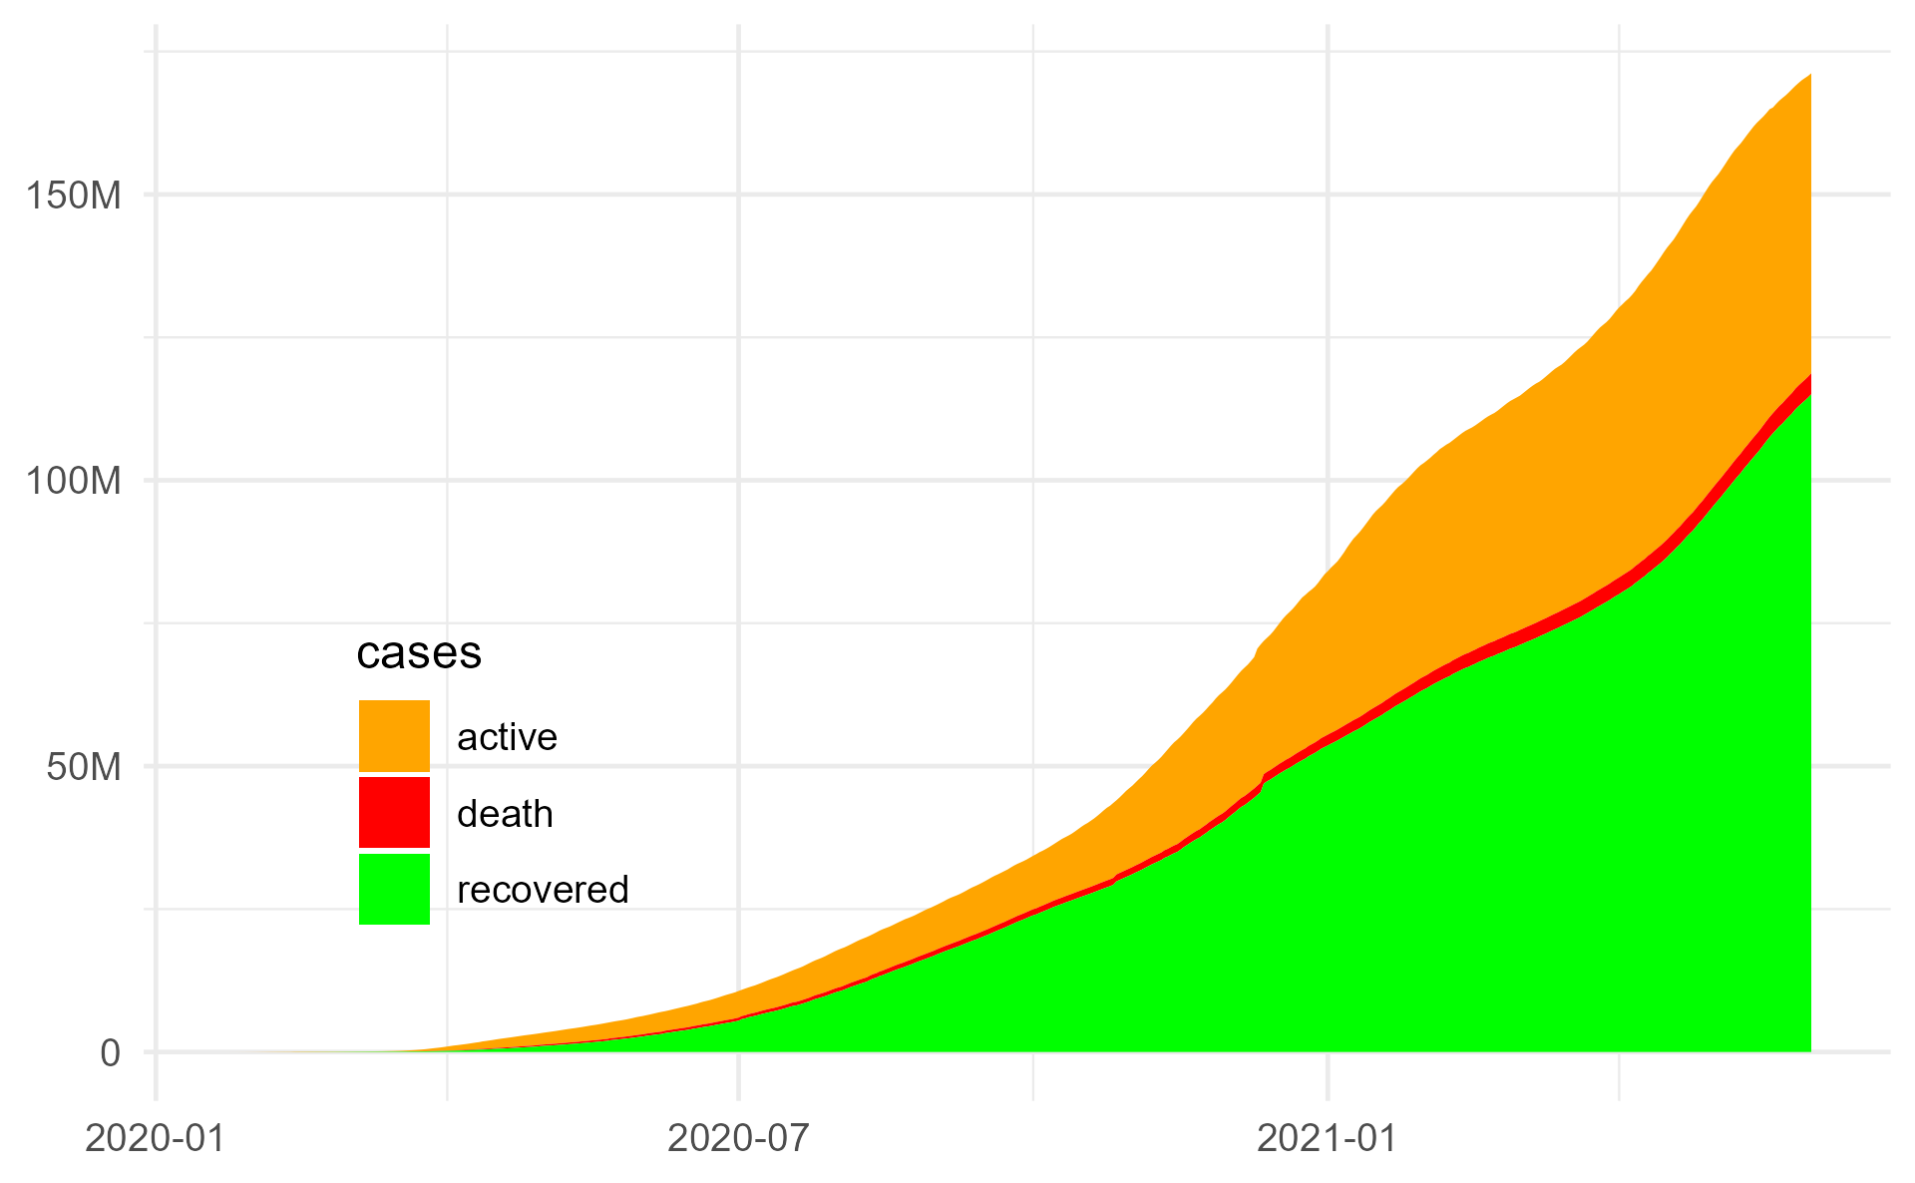

1. Reported number of cases (22. Jan 2020 through 27. May 2021)[4] based on data from John Hopkins University [5].

For example, in March 12, 2020, the United States established the suspension of most travels from the European Schengen area [6]. A few days later, European Comission President Ursula von der Leyen announced a similar measure, proposing for EU Member States to apply restrictions on non-essential travel. By that time, several countries, such as Austria, Germany, and Poland had already implemented border check controls, while Portugal, Italy, and Spain have imposed lockdowns [7] (Nielsen, 2020). At the same time, Australia imposed a severe arrival block on all non-citizens and non-residents at its airports [8]. In South America, Brazil, Chile, Argentina and other countries also followed the trend and closed their borders, totally or partially [9]. As a result, an unparalleled air traffic decline was seen worldwide [10].



1. Evolution of World Passenger Traffic 1945-2020, PRU analysis based on data from ICAO [10][11].

## Resilience

Resilience is a well-researched topic. The term is used by a diverse set of domains, communities, and research areas. In consequence there exists an abundance of theoretical definitions in the literature and numerous concepts that emerge from theses definitions and expert domains.

The term originates from physics and is nowadays used with reference to safety, security, environment and ecological systems, mental health/psychology, biological system, and others. Despite the varying contexts, across all of these disciplines the concept of resilience is closely related with the capability and ability of the focus of concern - typically the system or agent - to return to a stable state after a disruption impacted the original state.

Recently, the term is also used frequently on the political and strategic level. Policymakers, operational experts, and academics concur that the concept of resilience plays a major role when addressing and assessing the extent to which organisations and systems are prepared and capable to respond to and recover from disruptions.

Within air navigation, the term ‘resilience’ has been picked up by several communities, both operational and scientific. The concept first appeared in this context as a definition proposed by EUROCONTROL: “Resilience is the intrinsic ability of a system to adjust its functioning prior to, during, or following changes and disturbances, so that it can sustain required operations under both expected and unexpected conditions.”[12] Later, Gluchshenko (2012) proposed a widened view, including definitions for resilience, robustness, disturbance, stress, and perturbation [13]. In addition, the work marks the first proposition for a framework of different levels of stress and perturbations, as well as a proposition of potential metrics for resilience (both quantitative and qualitative). On a later work, Gluchshenko (2013) repeats the previous ideas and adds a performance-based approach as well as an algorithm to investigate resilience [14].

Those were the basic concepts that supported further works regarding resilience within the air navigation context. For example, the Project Resilience 2050 addressed the previous definitions and other technical tasks. The project ran from June 2012 and lasted 43 months, evolving the way to measure resilience. For the project, not only the time of deviation and time of recovery is considered. Instead, it measures resilience as the relative difference of rate of delays correlation, or R = (ax1 – dx1)/dx1. As a difference between two pearson correlations, it has no unit adopted. Finally, Koelle (2015) proposed to address resilience as a situation management and state-oriented problem [15]. Through two case studies, the author argued that “there is a lack of fit of the current operational ANS performance indicators to address impact of disruptions as they are primarily based on actual timestamps or transition times.”

The unprecedented decline in air transportation since March 2020 has triggered an increased interest in the topic. For example under the umbrella of the ICAO Global Air Navigation Plan Study Group, an expert team is currently working on refining the performance framework with a view to resilience. With a view to COVID, there is a dual interest in understanding resilience in air navigation/transportation:

• political level: The continuity and sustainability of a stable air traffic system supports and affects other dimensions of political interest, such as commercial relations, tourism industry, public health policies, among others. As a result, at a political level, it is of the utmost importance that the air navigation system remains functional. In that understanding, political acts were necessary in face of the pandemic crisis effects on aviation. For example, many governments injected financial support in the airline sector in order to help them survive the worst periods. In addition, measures such as tax deferrals to air navigation services providers were also adopted. Therefore, understanding how the air navigation system can exist in a more resilient manner is certainly beneficial for many political agents.

• operational level: While efficiency, delay management, and capacity constraints were previously the main problems affecting resilience, now the concept must be broadened to an inverted scenario. Airlines, ANSPs, airports, and other stakeholders in the industry must remain and manage resilience not only in order to recover from disruptions caused by excessive demand, but also from insufficient demand. If delays are no longer the main threat, others arise, such as insufficient funding, lack of training, and traffic unpredictability.

This paper addresses the operational dimension. Being able to characterise resilience within the operational domain will enable to address the more strategic and political decision-making.

# Method and Materials

## Research Approach and Toolset

Headings This work follows a data-driven approach and is based on the reproducibility paradigm. By design open data sources/sets have been identified and used. The associated data analysis is conducted using the open-source software and toolkit R, RStudio, and various packages of the R-ecosystem. The paper and its supporting datasets or code to retrieve the data have been published and are freely available.

Figure 3.1 shows the overall approach workflow for this paper. The primary open data source for air traffic data is the global daily flight data set (Olive, Strohmeier, and Lübbe 2021).

<<VERBATIM – NEED TO REPHRASE THIS>>———– This work builds on the RStudio (RStudio Team 2021) tools for the R language (R Core Team 2020) including Git (and the web-based repository managersGitHub and GitLab) as underlying version control system.The R language was originally developed within the statisticalcommunity supporting the task of statistical reporting by pro-viding routines for the statistical computing and visualisation.Being open source, the R community is actively engagingand sharing related software packages to enhance the corefunctionality. Without limiting the impact of other packages,the development of knitr [14] and RMarkdown [15], ggplot[16] for visualisation, and the so-called tidyverse packagesand RStudio IDE [17] represent an open source ecosystemfor data analysis. A key feature for the implementation of thereproducibility paradigm is the fact that RMarkdown supportsthe combination of text, analytical code, and visualisations ina single document. <<END VERBATIM COPY ————————————–>>

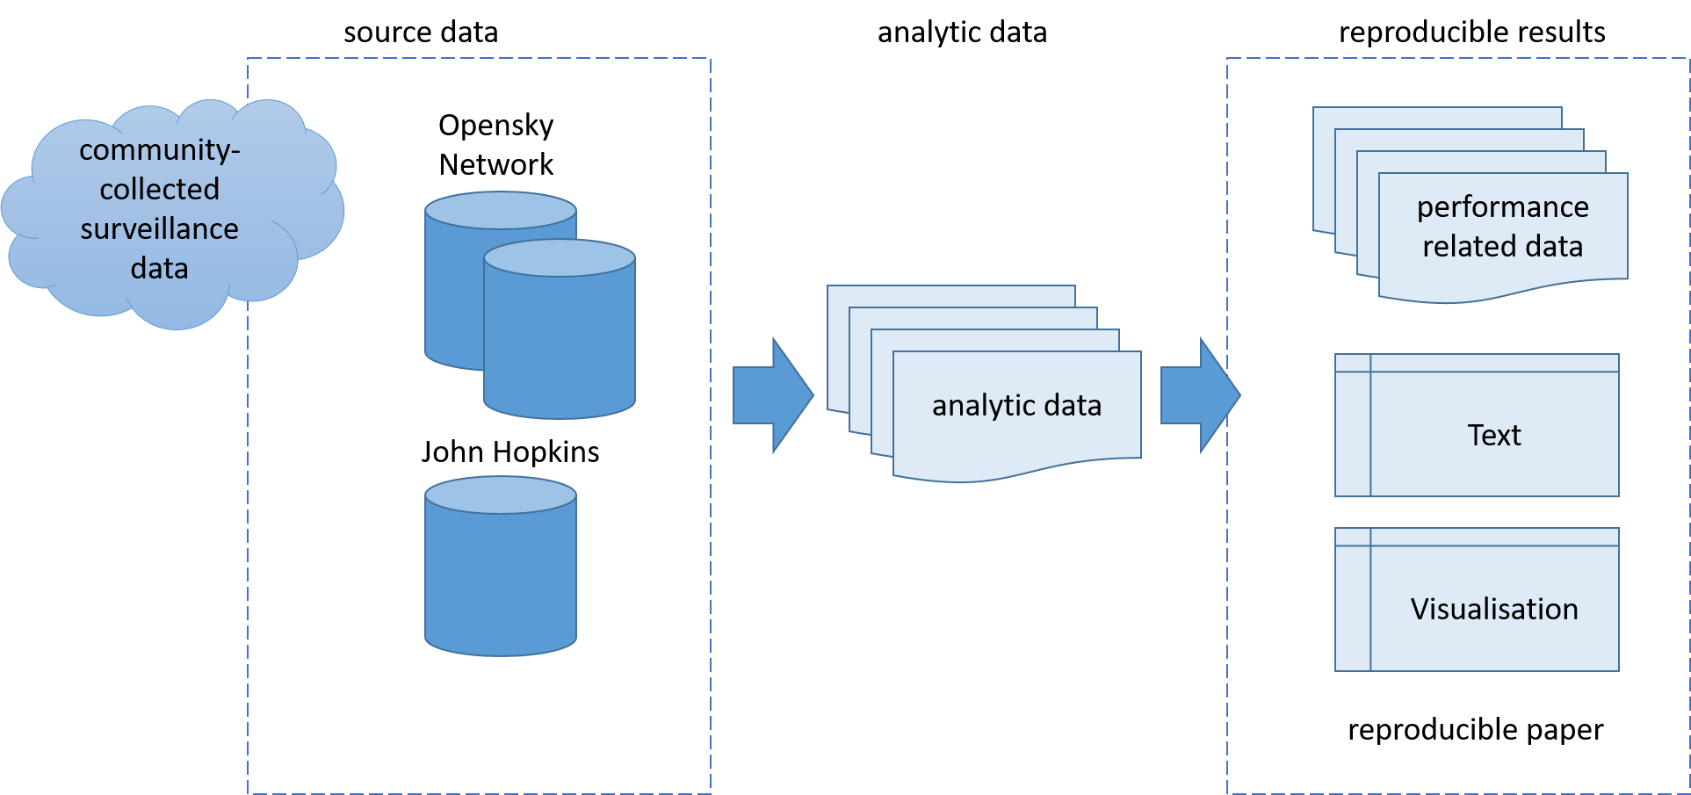

1. Reproducible Research Approach

## Open Source Data

This study builds on publicly available data. Opensky Network collects crowdsourced air traffic data from more than 2500 feeders (sensor stations). To support the process of illustrating and studying the impact of the COVID pandemic on air traffic demand, a flight-by-flight dataset is provided on a monthly basis (Olive, Strohmeier, and Lübbe 2021). The data spans the period since 1. January 2019. Fig. 3.2 shows the number of daily flights tracked by Opensky Network globally. The observed continual increase throughout the first six months in 2019 is driven by the increasing rate of ADSB equipage. Particularly, air transport operators in the United States or operating to the United States established compliance with the ADSB mandate applicable as of 1. January 2020. In 2019, the peak daily number of tracked flights ranges just under 104000. The negative spike observed on 2019-09-22 is linked to a data outage. Throughout the second half of 2019 the median number of flights ranged just under 88000.

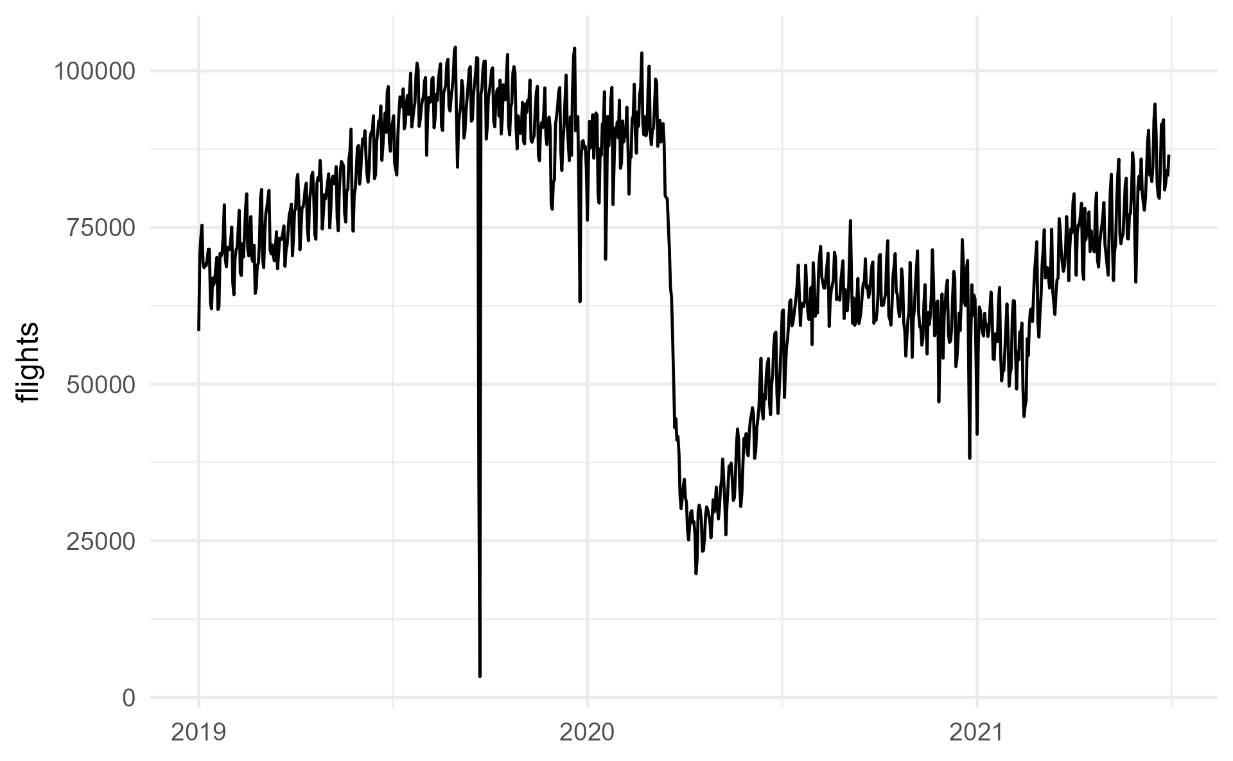

1. Daily flights tracked by Opensky Network.

The global daily flight dataset by Opensky Network identifies a flight based on a series of received messages of 15 minutes or more (Strohmeier et al. 2021). As the sensor network does not cover the whole globe/airspace, a consistency check is made for flights leaving the coverage area and entering again (e.g. oceanic area). A heuristic algorithm for the identification of destination airports is applied for descending trajectories. While there are uncertainties in the data based on these heuristics, the dataset ensures detection of flights within certain geographic regions even without a positive departure and/or destination aerodrome identification.

TODO: develop table with months - file size - number of flights

1. Opensky-Network Data Global Flight Data Set

| Table Head | Table Column Head | | |
| --- | --- | --- | --- |
| Table column subhead | Subhead | Subhead |
| copy | More table copya |  |  |

1. Sample of a Table footnote. (*Table footnote*)

## Measuring Resilience

The concept of resilience (and robustness) is intimately linked with the construct of disruptions. Any given disturbance forces a disruption in the level of service. Following Gluchshenko’s work (2012), the longer the system takes to recover to a previously unperturbed state, the less resilient the system is. In complement, from Koelle’s work (2015), the deeper the level of disruption, also less resilient the system is. As a result, a possible interpretation for resilience metrics is found considering both the duration of the disrupted service performance, and its disruption level - or how much a system level of service is affected.

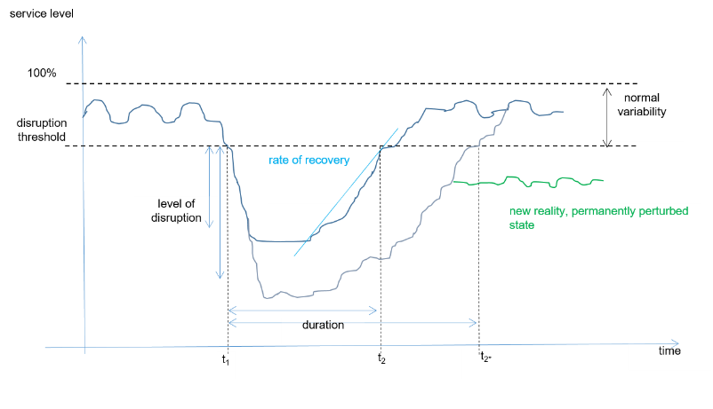

1. Resilience as a function of disturbance impact

Consequently, resilience R can be conceptually measured as the observed loss in quality of service (performance) over the time to recovery, t1-t2, for a certain level of disruption. Thus, mathematically, this represents the area covered by



as presented in Fig. 5 (LOS: loss of service / performance, THR: associated threshold).

Use “(1)”, not “Eq. (1)” or “equation (1)”, except at the beginning of a sentence: “Equation (1) is . . .”

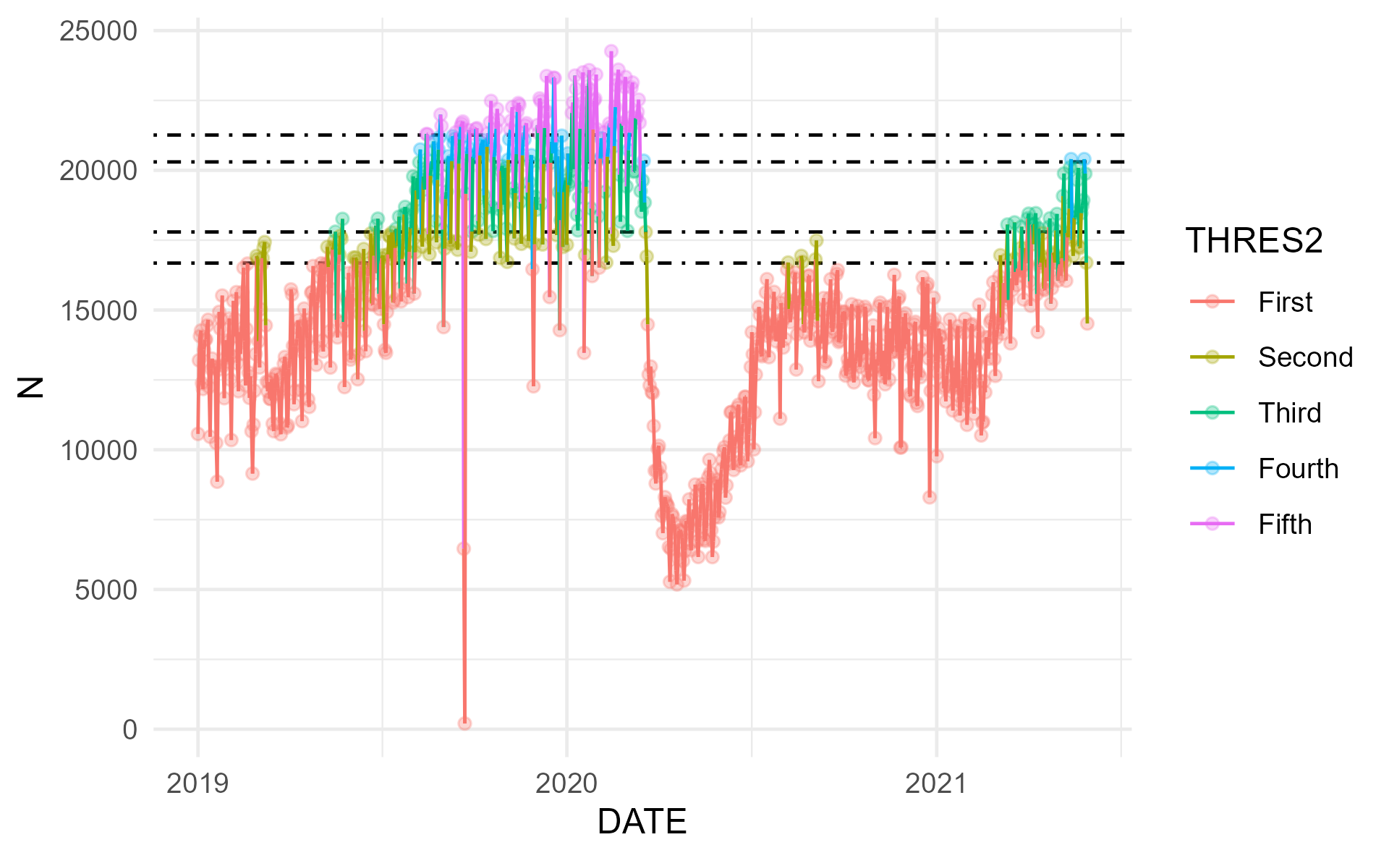

Figure 3.4: Resilience concept applied to observed US air traffic development

However, an evident question arises from this approach: what is the proper threshold for the service to be considered disrupted? Certain that, for some indicators, this could be a fixed value, this paper proposes an alternative method. The disruption threshold can be viewed as an adaptive function of the recent traffic levels. As a result, the disruption threshold level would not be a fixed value, but a variable one, taking into account the recent trends to define a normal band based on moving windows. The example below shows this potential approach.

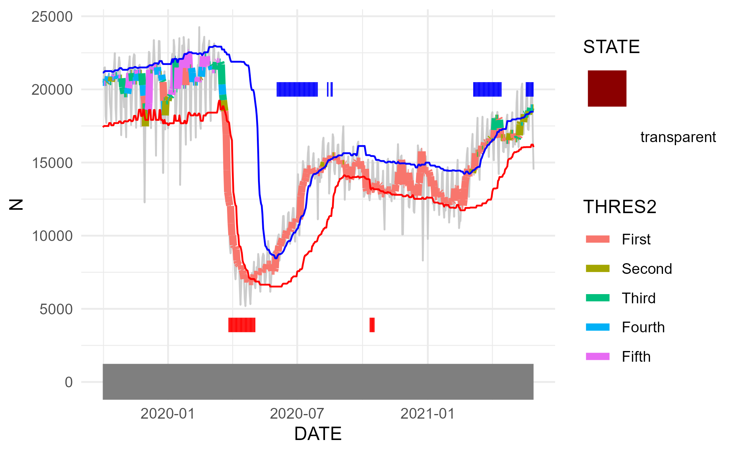

1. Sliding Window Approach with Upper and Lower Bounds

Instead of a horizontal line (fixed value), the disruption threshold adapts according to the recent trends in traffic. In the figure above, the red line is the disruption threshold, defined as the 20th percentile of the daily traffic, considered the previous 60 days. Naturally, those are empirically suggested values that could be adapted according to any particular needs. In addition, the blue line is set to be a potential indicator of disruptions in the opposite direction, i.e. a positive disruption, caused by an abnormal excessive demand.

# Results and Discussion

## Network Level Assessment for Brazil, Europe, and the United States

Based on the study dataset Fig. 3.2 provides an appreciation of the global developments. This paper zooms in on comparing the situation in Brazil, Europe, and the United States. Figure 4.1 shows the different network level responses to the regional/local air traffic constraints.

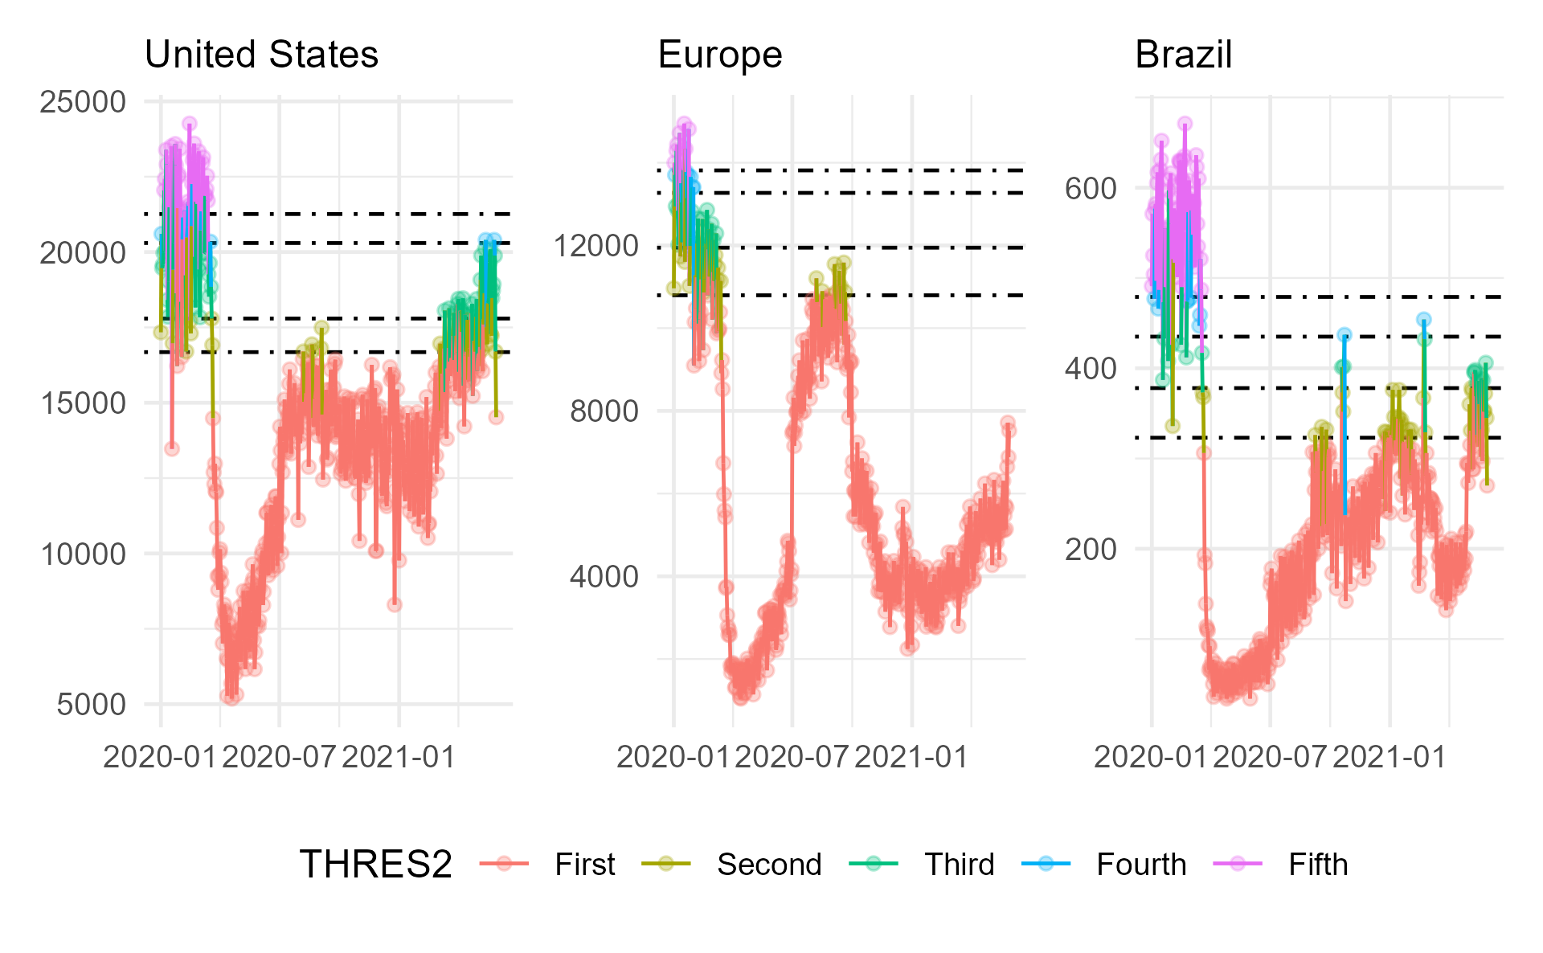

1. Flight Demand Timeline for the United States, Europe, and Brazil.

The United States have recovered.

Europe has seen an initial recovery in summer 2020 with a decline towards the holiday season 2020/2021. With April/May 2021 traffic increases again in Europe.

Brazil also experienced the sharp decline in traffic in March 2020. Similar to the US, traffic in Brazil showed an initial continual increase. Traffic show an alternating pattern.

## Traffic Development – Connectivity

Think about this - expand / develop / clean

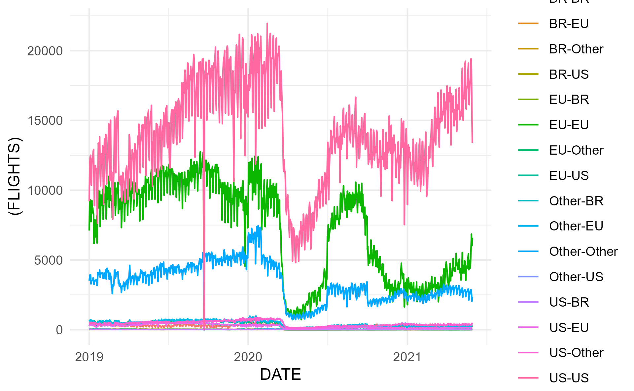

# Conclusions and Future Work

The unprecedented decline in air traffic due to the global response to restricting the spread of COVID-19 impacted air transportation stakeholders across the globe. Local and regional response measures and the impact varied. However, the drop in air transport demand challenged the sustainability of operating the air transport system. Restrictions were more commonly lifted with the second quarter of 2021. However, the success of increasing vaccination rates and local/regional travel policies is still uncertain. The first signs of recovery need to be balanced against the overall system efficiency and performance. This is particularly relevant as higher levels of efficiency will support the political ambition to address the contribution of aviation to the environmental sustainability discussion.

To augment the current performance measurement toolset, this paper took an initial look at describing the impact of COVID-19 as a large-scale air transportation system disruption. This paper addressed the identification and description of disruptions, associated transformation, and recovery phenomena of the air transport network. The methodology will be useful to support the monitoring of the recovery levels across the globe. It complements the toolbox for policy makers and strategic planers to determine priority measures in support of the anticipated air travel demand recovery with the roll-out and increasing levels of vaccination.

The regional comparison of Brazil, Europe, and the United States revealed differences.

Add a few major findings here

A key aspect of the work presented is the use of open data as no public global data set on air traffic exists. While there is sometimes criticism about crowd sourced data, the comparison with respective formal monitoring data available to the authors showed a good match. However, the results need to be interpreted on the basis of the made assumptions. Future publications of assessments based on authority approved data may differ. The combination of different open source data sets identified a need for a wider community discussion on data formats and storage standards. The flight association used in this paper is based on the operational experience of the authors. The use of pattern recognition or clustering techniques may help to augment the association of tracked flights.

The study built on open air transport data and applied a reproducible research approach. Interested practitioners and researchers are able to access the underlying data and validate the results of this paper via the source code hosted on github (c.f. acknowledgement below). As part of this project, the requirements for an open data based flight table for the evaluation of the global air transportation network are refined. The results and insights of this work will be shared with the wider effort of the ICAO GANP expert group on performance.

##### Acknowledgment

This paper builds on open data and the crowd-sourcing community supporting the data collection, processing and preparation, and distribution. The authors would like to thank all contributors and individuals supporting the effort of building an open data environment for air transportation and air navigation related research at ouraiports.com and Opensky-Network.

Details on the access to the underlying data, its processing, and the analytical modelling can be accessed via <https://github.com/rainer-rq-koelle/paper-2021-DASC-COVID19>.

##### References

1. EUROCONTROL Statistics and Forecast Servi. 2018. “European Aviation in 2040, Challenges of Growth.” Edition 2., Brussels, Belgium: EUROCONTROL.
2. World Health Organisation, Director-General. 2020. “WHO Director-General’s Opening Remarks at the Media Briefing on COVID-19 - 11 March 2020.
3. Strohmeier, Martin, Xavier Olive, Jannis Lübbe, Matthias Schäfer, and Vincent Lenders. 2021. “Crowdsourced Air Traffic Data from OpenSky Network 2019-2020.” Earth Systems Science Data 13: 357–66. <https://doi.org/10.5194/essd-13-357-2021>.
4. Krispin, Rami, and Jarrett Byrnes. 2021. “Coronavirus: The 2019 Novel Coronavirus COVID-19 (2019-nCoV) Dataset.”
5. Dong, Ensheng, Hongru Du, and Lauren Gardner. 2020. “An Interactive Web-Based Dashboard to Track COVID-19 in Real Time.” The Lancet Infectious Diseases 20 (5): 533–34. <https://doi.org/10.1016/s1473-3099(20)30120-1>.
6. BBC. 2020. “Coronavirus.” Coronavirus: Trump Suspends Travel from Europe to US, 12. March 2020.
7. Nielsen, 2020
8. Worthington, Brett, and Jack Snape. 2020. “Australia Blocks Arrival of All Non-Citizens, Non-Residents in Expanded Coronavirus Travel Ban.” ABC News.
9. France24. 2020. “Coronavirus Notice, Americas.” Latin American Countries Step up Coronavirus Restrictions as Cases Spread.
10. International Civil Aviation Organization. 2021. “ICAO Economic Impact Analyses of COVID-19 on Civil Aviation.” <https://www.icao.int/sustainability/Pages/Economic-Impacts-of-COVID-19.aspx>.
11. EUROCONTROL, PRU. 2021. “Performance Review Report, An Assessment of Air Traffic Management in Europe During the Calendar Year 2020.” <https://www.eurocontrol.int/publication/performance-review-report-prr-2020>.
12. EUROCONTROL. 2009. “White Paper on Resilience Engineering for ATM.”
13. Gluchshenko, Olga. 2012. “Definitions of Disturbance, Resilience and Robustness in ATM Context.”
14. Gluchshenko, Olga, and Peter Foerster. 2013. “D1. 3 Setting the Basis, Defining Resilience in the Organization of ATM.”
15. Koelle, Rainer. 2015. “Operational Resilience Performance of European Airports.” In proceedings of the Integrated Communications, Navigation and Surveillance Conference (ICNS), pp. 1-19, doi: 10.1109/ICNSURV.2015.7121296.

Dong, Ensheng, Hongru Du, and Lauren Gardner. 2020. “An Interactive Web-Based Dashboard to Track COVID-19 in Real Time.” *The Lancet Infectious Diseases* 20 (5): 533–34. <https://doi.org/10.1016/s1473-3099(20)30120-1>.

EUROCONTROL Statistics and Forecast Servi. 2018. “European Aviation in 2040, Challenges of Growth.” Edition 2. Brussels, Belgium: EUROCONTROL.

Krispin, Rami, and Jarrett Byrnes. 2021. “Coronavirus: The 2019 Novel Coronavirus COVID-19 (2019-nCoV) Dataset.”

Olive, Xavier, Martin Strohmeier, and Jannis Lübbe. 2021. “Crowdsourced Air Traffic Data from The OpenSky Network 2019-2021.” Zenodo. <https://doi.org/10.5281/zenodo.4893103>.

R Core Team. 2020. *R: A Language and Environment for Statistical Computing*. Manual. Vienna, Austria: R Foundation for Statistical Computing.

RStudio Team. 2021. *RStudio: Integrated Development Environment for r*. Manual. Boston, MA: RStudio, PBC.

Strohmeier, Martin, Xavier Olive, Jannis Lübbe, Matthias Schäfer, and Vincent Lenders. 2021. “Crowdsourced Air Traffic Data from OpenSky Network 2019-2020.” *Earth Systems Science Data* 13: 357–66. <https://doi.org/10.5194/essd-13-357-2021>.