Assessing the Global COVID19 Impact on Air Transport with Open Data

22 July 2021

This paper approaches the impact of the pandemic as a massive service disruption of the pre-pandemic global connectivity and regional air transport networks. In particular, the project aims to provide data analytical evidence for policy success and transformation of the air transportation system. As an aspirational goal, the industry aims to recover in a “greener” manner. The project builds on openly available data sets. The paper will be produced in a reproducible manner making the data, code, and its processing available to interested reseachers and practitioners. The open assessment will provide policy makers with a tool to assess the reaction to local or regional measures.

# 1 Introduction

For many years, many concerns of the global air traffic management community has been directed to the evident problem of imbalances between capacity and demand. The pressing, increasing demand for air transport registered in the last decade not only has already produced challenging delay management practices, but also fostered projections of even worse scenarios. EUROCONTROL (EUROCONTROL Statistics and Forecast Servi 2018), for example, argued that delays in Europe could reach up to 20 minutes per flight in 2040, in stark contrast to the 12 minutes per flight, as registered in 2016.

In the above scenario, many disturbances on the air navigation system could represent a real threat to multiple stakeholders. Events such as extreme bad weather, unexpected interruptions of air navigation services, changes in regulatory framework and others: all of those inputs could promote even more delay and its propagation effects. That is why the concept of resilience in ATM system became similarly relevant in the agenda during the same period. Arguably, a resilient ATM system could mitigate the negative effects of excessive demands on insufficient capacity and their respective constraints and bottlenecks.

On March 11, 2020, the World Health Organisation has declared the novel coronavirus (COVID-19) outbreak a global pandemic. The COVID-19 crisis posed a completely different, unexpected, and inverted challenge. Communicable disease control resulted in massive restrictions on international and regional air traffic and passenger travel. Demand for air transport dropped as low as 90% of the previous “normal” in many places. Where the lack of capacity was previously the issue, now the lack of demand threatened the ATM system stability. In the financial perspective, airlines and airports had to deal with an unprecedented decrease in incomes. As a result, air navigation providers collected less fees for their services, due to significantly fewer flights. In the operational perspective, pilots and air traffic controllers practiced less. The problems and obstacles developed into many other dimensions.

The unprecedented decline in air traffic demand resulted in severe financial strains on the air transport industry. The financial support or lack thereof for airlines and airports has been widely covered in the media. A variety of studies showed the interplay or consequences of the travel constraints. To date, lower attention was given to the inherent change in terms of air transport services Hence, the current scenario is a proper moment to further investigate the concept of resilience.

This paper approaches the impact of the pandemic as a massive service disruption of the pre-pandemic global connectivity and regional air transport networks. In particular, the project aims to provide data analytical evidence for policy success and transformation of the air transportation system. As an aspirational goal, the industry aims to recover in a “greener” manner. To date, no assessment of this transformational aspects has been conducted.

data-analytical approach - using open data / freely available (tbd: validated against organisational data)

This paper utilises a data-driven approach. Despite the fact that aviation is a data rich environment, operational data on the previous and current traffic levels is not consistently available. The global traffic evaluation will be based on data from a community fed sensor network, Opensky-Network. <> The operational flight data will be enriched with other publicly available dataset supporting the description of the level of the COVID pandemic and national/regional responses to the pandemic.

The contribution of this paper are

* conceptualisation of the COVID-19 impact on air transportation as a resilience problem;
* assessing the impact on the basis of open data
* novel methodology to describe disruption, transformation, and recovery phenomena of the air transport network <>
* identification of patterns and/or measures to describe and quantify/evaluate the level of recovery (or disruption)

# 2 Background

## 2.1 COVID-19 & Air Transportation

On 11. March 2020, the World Health Organisation reacted to the steadily increasing of infections and global spread of a newly detected Corona-Virus by declaring a pandemic. As an immediate response, many governments reacted by imposing controls to curb the further spread of communicable disease. Next to social distancing and recommended hygiene measures, this resulted in massive restrictions on international and regional air traffic and passenger travel.

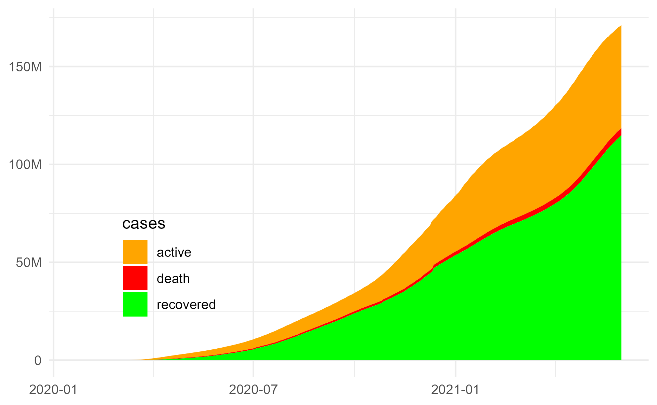

Figure 2.1: Reported number of cases (22. Jan 2020 through 27. May 2021) (Krispin and Byrnes 2021) based on data from John Hopkins University (Dong, Du, and Gardner 2020)

TODO

* provide some descriptive text about COVID and government reactions
* any more key milestones relevant for this study, e.g. US/EU stop, Lufthansa/BA/KLM/Air France stopping to operate to China as of late January

## 2.2 Resilience

Resilience is a well-researched topic. The term is used by a diverse set of domains, communities, and research areas. In consequence there exists an abundance of theoretical definitions in the literature and numerous concepts that emerge from theses definitions and expert domains.

The term originates from physics and is nowadays used with reference to safety, security, environment and ecological systems, mental health/psychology, biological system, and others. Despite the varying contexts, across all of these disciplines the concept of resilience is closely related with the capability and ability of the focus of concern - typically the system or agent - to return to a stable state after a disruption impacted the original state.

Recently, the term is also used frequently on the political and strategic level. Policymakers, operational experts, and academes concur that the concept of resilience plays a major role when addressing and assessing the extent to which organisations and systems are prepared and capable to respond to and recover from disruptions.

Within air navigation, the term ‘resilience’ has been picked up by several communities, both operational and scientific.

EUROCONTROL (2009): first definition of resilience in ATM context – “Resilience is the intrinsic ability of a system to adjust its functioning prior to, during, or following changes and disturbances, so that it can sustain required operations under both expected and unexpected conditions.”

Gluchshenko (2012):

Definitions for Resilience, robustness, disturbance, stress, and perturbation Proposition for a framework of different levels of stress/perturbations Proposition of metrics for resilience (both quantitative and qualitative)

Gluchshenko (2013): repeats the previous ideas and adds a performance-based approach as well as an algorithm to investigate resilience

Project Resilience 2050 (Jun/2012 + 43 months) – includes the previous definitions and other technical tasks. However, it evolves the way to measure resilience. Now, not only the time of deviation and time of recovery is considered. The project measures it as the relative difference of rate of delays correlation, or R = (ax1 – dx1)/dx1 – it has no unit, it’s the difference between two pearson correlations.

Koelle (2015): proposes to address resilience as a situation management and state-oriented problem. Through two case studies, argued that “there is a lack of fit of the current operational ANS performance indicators to address impact of disruptions as they are primarily based on actual timestamps or transition times.”

The unprecedented decline in air transportation since March 2020 has triggered an increased interest in the topic. For example under the umbrella of the ICAO Global Air Navigation Plan Study Group, an expert team is currently working on refining the performance framework with a view to resilience. With a view to COVID, there is a dual interest in understanding resilience in air navigation/transportation:

* political level: ADD SOME DESCRIPTION
* operational level: ADD SOME DESCRIPTION

This paper addresses the operational dimension. Being able to characterise resilience within the operational domain will enable to address the more strategic and political decision-making.

## 2.3 <if we need to fill space> Crowd-Sourced Data Collection

# 3 Method/Materials

## 3.1 Research Approach and Toolset

This work follows a data-driven approach and is based on the reproducibility paradigm. By design open data sources/sets have been identified and used. The associated data analysis is conducted using the open-source software and toolkit R, RStudio, and various packages of the R-ecosystem. The paper and its supporting datasets or code to retrieve the data have been published and are freely available.

Figure 3.1 shows the overall approach workflow for this paper. The primary open data source for air traffic data is the global daily flight data set (Olive, Strohmeier, and Lübbe 2021).

<<VERBATIM – NEED TO REPHRASE THIS>>———– This work builds on the RStudio (RStudio Team 2021) tools for the R language (R Core Team 2020) including Git (and the web-based repository managersGitHub and GitLab) as underlying version control system.The R language was originally developed within the statisticalcommunity supporting the task of statistical reporting by pro-viding routines for the statistical computing and visualisation.Being open source, the R community is actively engagingand sharing related software packages to enhance the corefunctionality. Without limiting the impact of other packages,the development of knitr [14] and RMarkdown [15], ggplot[16] for visualisation, and the so-called tidyverse packagesand RStudio IDE [17] represent an open source ecosystemfor data analysis. A key feature for the implementation of thereproducibility paradigm is the fact that RMarkdown supportsthe combination of text, analytical code, and visualisations ina single document. <<END VERBATIM COPY ————————————–>>

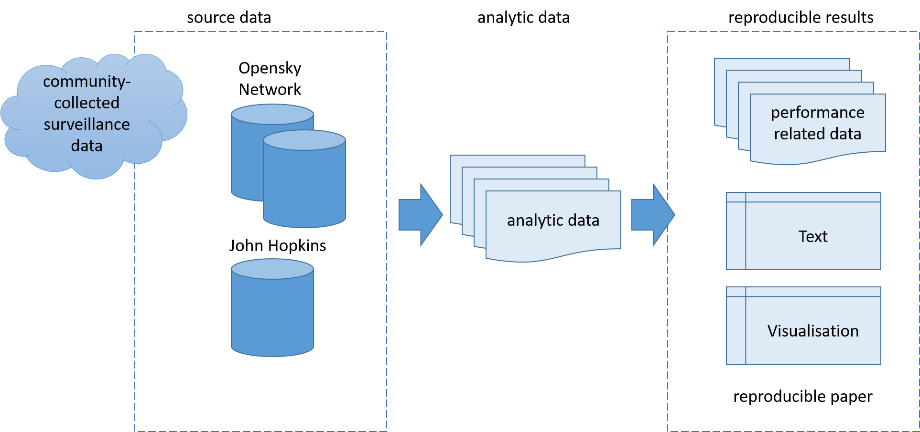

Figure 3.1: Reproducible Research Approach

## 3.2 Open-source Data

This study builds on publicly available data. Opensky Network collects crowdsourced air traffic data from more than 2500 feeders (sensor stations). To support the process of illustrating and studying the impact of the COVID pandemic on air traffic demand, a flight-by-flight dataset is provided on a monthly basis (Olive, Strohmeier, and Lübbe 2021). The data spans the period since 1. January 2019. Fig. 3.2 shows the number of daily flights tracked by Opensky Network globally. The observed continual increase throughout the first six months in 2019 is driven by the increasing rate of ADSB equipage. Particularly, air transport operators in the United States or operating to the United States established compliance with the ADSB mandate applicable as of 1. January 2020. In 2019, the peak daily number of tracked flights ranges just under 104000. The negative spike observed on 2019-09-22 is linked to a data outage. Throughout the second half of 2019 the median number of flights ranged just under 88000.

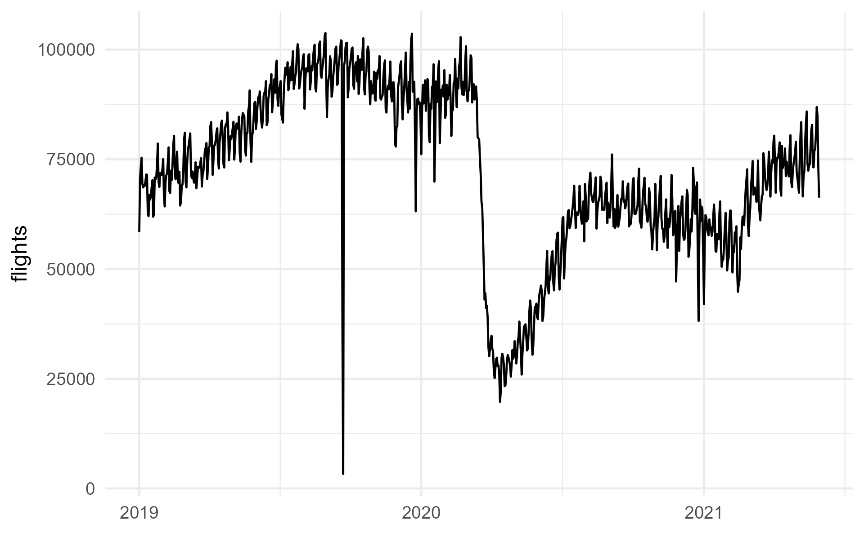

Figure 3.2: Daily flights tracked by Opensky Network

The global daily flight dataset by Opensky Network identifies a flight based on a series of received messages of 15 minutes or more (Strohmeier et al. 2021). As the sensor network does not cover the whole globe/airspace, a consistency check is made for flights leaving the coverage area and entering again (e.g. oceanic area). A heuristic algorithm for the identification of destination airports is applied for descending trajectories. While there are uncertainties in the data based on these heuristics, the dataset ensures detection of flights within certain geographic regions even without a positive departure and/or destination aerodrome identification.

TODO: develop table with months - file size - number of flights

## 3.3 Measuring Resilience

The concept of resilience (and robustness) is intimately linked with the construct of disruptions.

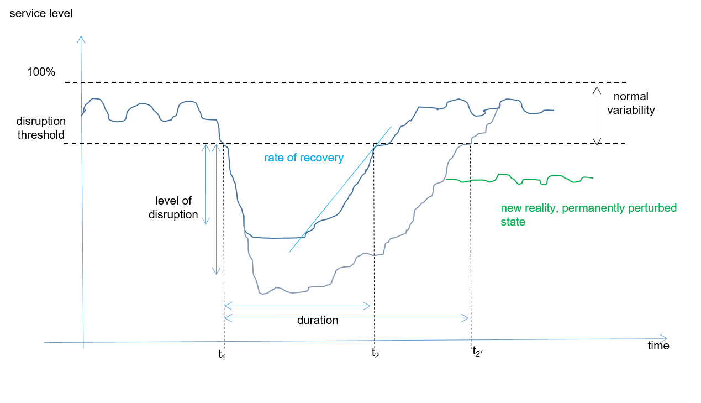

Figure 3.3: Resilience as a function of disturbance impact

Conceptually, resilience R can be measured as the observed loss in quality of service (performance) over the time to recovery, t1-t2, for a certain level of disruption. Thus, mathematically, this represents the area covered by

$$\int_{a}^{b}{[}THR−LOS(t)]dt$$

as presented in Fig. 3.3 (LOS: loss of service / performance, THR: associated threshold).

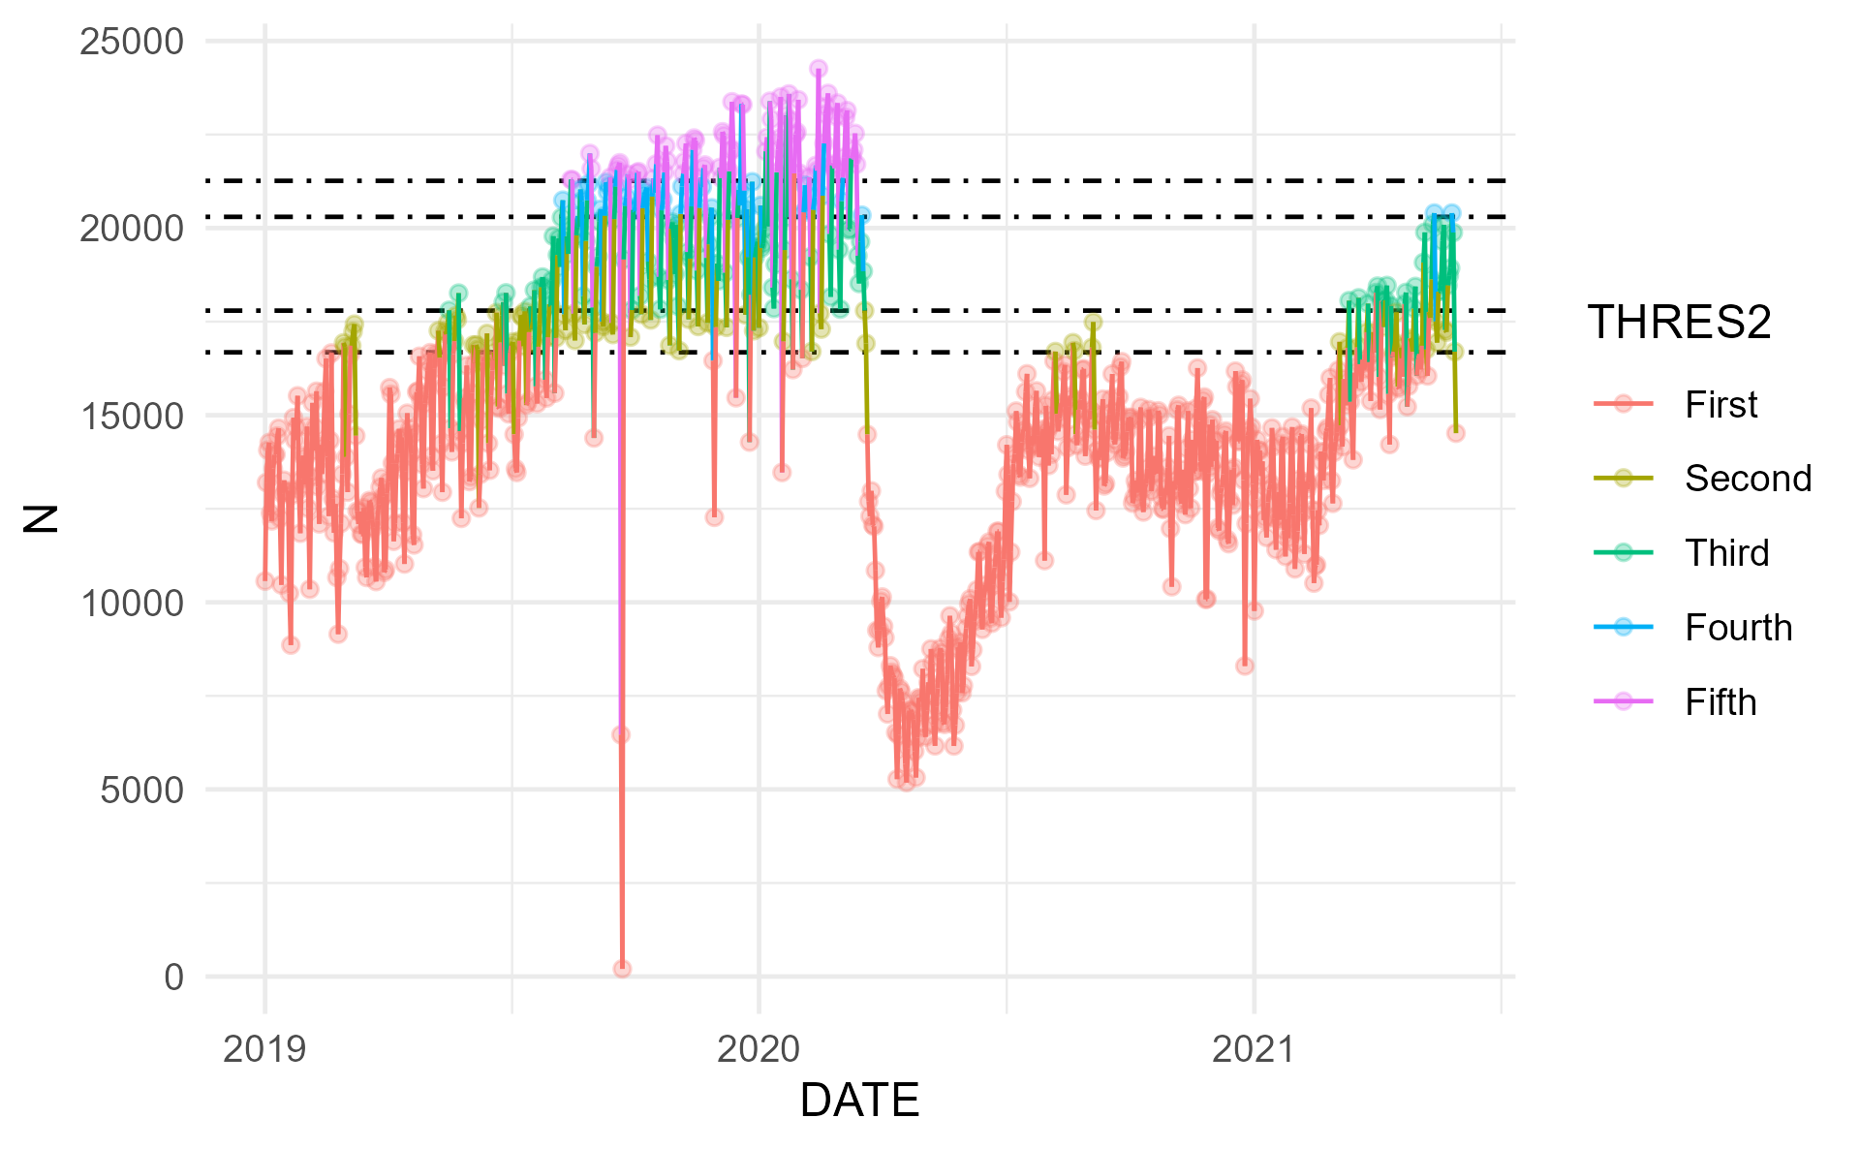

Figure 3.4: Resilience concept applied to observed US air traffic development

TODO - further develop & include sliding window approach proposed by Fabio

# 4 Results/Discussion

## 4.1 Network Level Assessment for Brazil, Europe, and the United States

Based on the study dataset Fig. 3.2 provides an appreciation of the global developments. This paper zooms in on comparing the situation in Brazil, Europe, and the United States. Figure 4.1 shows the different network level responses to the regional/local air traffic constraints.

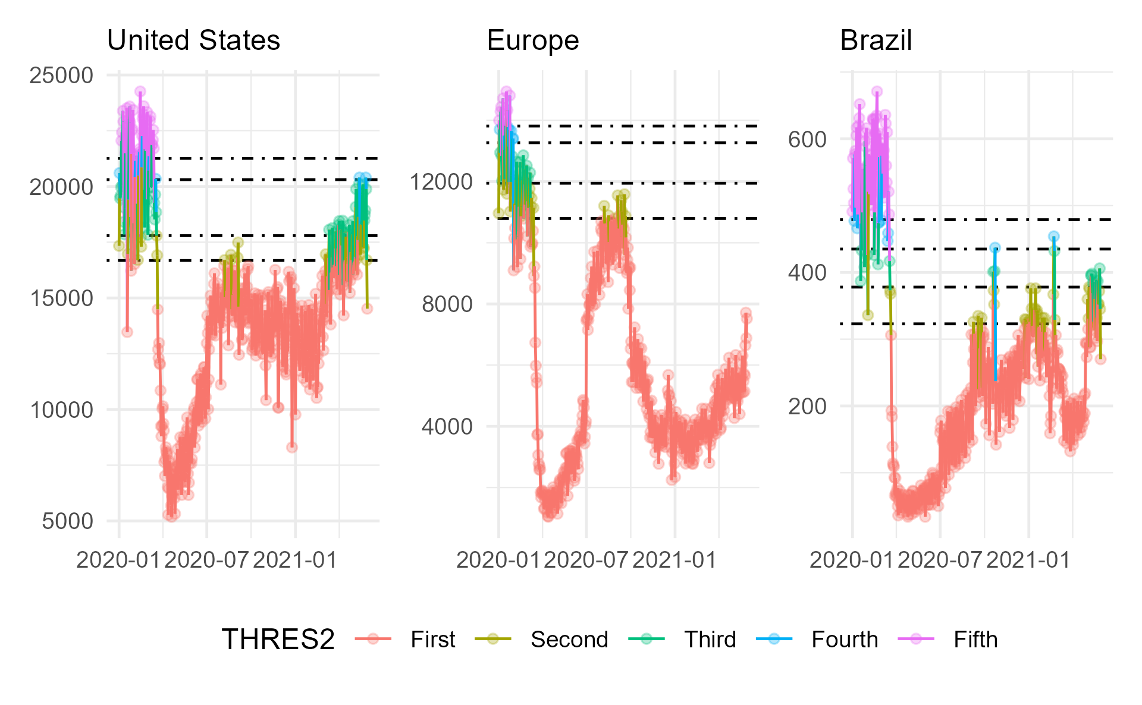

Figure 4.1: Timeline for United States, Europe, and Brazil

The United States have recovered.

Europe has seen an initial recovery in summer 2020 with a decline towards the holiday season 2020/2021. With April/May 2021 traffic increases again in Europe.

Brazil also experienced the sharp decline in traffic in March 2020. Similar to the US, traffic in Brazil showed an initial continual increase. Traffic show an alternating pattern.

TODO: provide some more commentary

## 4.2 Traffic Development - Connectivity

1. Resilience can be measured as a function of time - the smaller the relationship between time of stress and the time of recovery, more resilient a system is.

1.2 how to use open data to “see” resilience?

1.2.1 Gather and prepare data

## # A tibble: 6 x 9  
## ADEP ADEP_CTRY ADEP_REG ADES ADES_CTRY ADES_REG TYPE DATE CALL   
## <chr> <chr> <chr> <chr> <chr> <chr> <chr> <date> <chr>   
## 1 YSSY AU Other EDDF DE EU A332 2019-01-01 CES219  
## 2 LEMD ES EU LEMD ES EU A332 2019-01-01 AEA040  
## 3 YSSY AU Other LFPG FR EU B788 2019-01-01 CXA825  
## 4 UUEE RU EU EDDF DE EU B744 2019-01-01 CLU211  
## 5 KLDJ US US LFPG FR EU B788 2019-01-01 ETH704  
## 6 WIII ID Other RPLL PH Other B77W 2019-01-01 SVA872

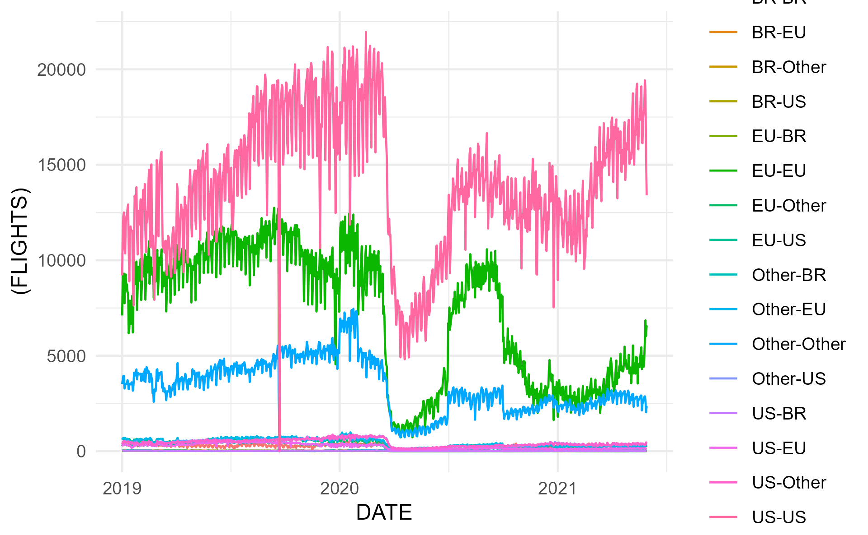

Figure 4.2: test

# 5 Conclusion

This paper addressed the identification and description of disruptions, associated transformation, and recovery phenomena of the air transport network. The methodology will be useful to support the monitoring of the recovery levels across the globe. It complements the toolbox for policy makers and strategic planers to determine priority measures in support of the anticipated air travel demand recovery with the roll-out and increasing levels of vaccination.

As part of this project, the requirements for an open data based flight table for the evaluation of the global air transportation network are refined. The results and insights of this work will be shared with the wider effort of the ICAO GANP expert group on performance.

# Acknowledgment

# References

Dong, Ensheng, Hongru Du, and Lauren Gardner. 2020. “An Interactive Web-Based Dashboard to Track COVID-19 in Real Time.” *The Lancet Infectious Diseases* 20 (5): 533–34. <https://doi.org/10.1016/s1473-3099(20)30120-1>.

EUROCONTROL Statistics and Forecast Servi. 2018. “European Aviation in 2040, Challenges of Growth.” Edition 2. Brussels, Belgium: EUROCONTROL.

Krispin, Rami, and Jarrett Byrnes. 2021. “Coronavirus: The 2019 Novel Coronavirus COVID-19 (2019-nCoV) Dataset.”

Olive, Xavier, Martin Strohmeier, and Jannis Lübbe. 2021. “Crowdsourced Air Traffic Data from The OpenSky Network 2019-2021.” Zenodo. <https://doi.org/10.5281/zenodo.4893103>.

R Core Team. 2020. *R: A Language and Environment for Statistical Computing*. Manual. Vienna, Austria: R Foundation for Statistical Computing.

RStudio Team. 2021. *RStudio: Integrated Development Environment for r*. Manual. Boston, MA: RStudio, PBC.

Strohmeier, Martin, Xavier Olive, Jannis Lübbe, Matthias Schäfer, and Vincent Lenders. 2021. “Crowdsourced Air Traffic Data from OpenSky Network 2019-2020.” *Earth Systems Science Data* 13: 357–66. <https://doi.org/10.5194/essd-13-357-2021>.