Building Back Better – Democratization of Performance Monitoring with Open Data

Rainer Koelle, Sam Peeters, and Enrico Spinielli   
Performance Review Unit  
EUROCONTROLBrussels, Belgium  
[rainer.koelle@eurocontrol.int](mailto:rainer.koelle@eurocontrol.int),   
[sam.peeters@eurocontrol.int](mailto:sam.peeters@eurocontrol.int),   
[enrico.spinielli@eurocontrol.int](mailto:enrico.spinielli@eurocontrol.int)

*Abstract*—The COVID-19 pandemic accelerated the use, sharing, and distribution of data on a global basis. Higher levels of transparency were achieved with continual updates of pandemic related information. The air transportation sector – while by definition an information rich industry – is a notable exception. While different organizations offered aggregated data on air traffic developments on national or airport level, complementary data on air traffic movements for further analysis are not available publicly. This creates a deadlock between addressing the societal needs of monitoring how aviation recovers from the COVID-19 pandemic and addresses the aspirational environmental goals. The advent of crowd collected open data has gained higher visibility to fill this vital gap. This paper investigates the feasibility of utilizing open data for the operational performance monitoring at airports. The work focusses on a subset of the indicators proposed under ICAO’s Global Air Navigation Plan and in use in Europe. From the existing framework indicators are chosen to assess the operational performance in the arrival phase. A novel approach to characterize and assess the arrival flow management and level of traffic synchronization is presented. This will allow to evaluate on-going air traffic recovery and identify operational inefficiencies or bottlenecks. The study is performed as a use-case analysis for three major European airports that operate different approach paradigms. The use-case analysis provides compares the observed performance in the months of March and May for the successive years 2019, 2020, and 2021. The results demonstrate the general feasibility and utility of open data for operational performance monitoring. A higher level of transparency can be achieved with providing the interested public, policy decision-makers and strategic planners with direct feedback on the recovery and actual operational performance. The suitability of the traffic synchronization measure and its parameterization requires further validation across a wider set of airports.

Keywords—operational performance, open data, arrival management, traffic synchronisation

# Introduction

The COVID19 pandemic shifted the focus and attention of political decision-makers and strategic planers over the past year. The unprecedented decline of regional and international air traffic poses challenges in terms of funding of the air transportation system in general and planned air traffic management modernization. While it is unclear how today’s travel constraints and the vaccine roll-out will play out, both airspace users and air traffic service providers are committed to “build back better.” This will include a higher emphasis on operational excellence. Higher levels of operational efficiency are considered to be enablers for reduced queueing, both in the airspace and on the ground, and lower associated fuel burn and emissions. It will be essential to ensure that with increasing traffic levels, inefficiencies are immediately tracked and remedied.

Air transportation services are by definition an information rich environment. However, today, the access and availability of open data for the monitoring and validation of air transport /air navigation system performance or related published results of studies and research exercises is limited [1][2]. Within this context, crowd collected open data gains a higher momentum and visibility. Opensky Network became a key resource for open air transport data during the COVID-19 pandemic [3]. Opensky Network provides a global flight-by-flight record of observed tracks on a monthly basis for interested researchers or practitioners [4]. For detailed studies, the associated trajectory data can be accessed via the Network resources. There is an active community establishing tools for the extraction and processing of the data. Demonstrating the feasibility and utility of using an existing open data source to assess the current air transportation system performance, and trace the development of the performance levels with returning traffic demand is vital.

The paper follows a data-driven exploratory approach. Based on the operational performance indicators promoted by ICAO, a performance monitoring toolchain is developed building on the open air transport data. The public availability of the data in a near real-time set-up ensures that independent validation of observed operational performance is available to policy makers, strategic planners, practitioners, and researchers. A novel traffic synchronization oriented performance metric is developed. The metric aims to isolate operational and airspace related dimensions or inefficiencies. The approach will be presented as use-case analysis of three European airports that show significant differences in traffic patterns and approach concepts. The analysis of the arrival management techniques will support the evaluation of the achieved performance levels in terms of ground-based or airspace holding/queueing and delay absorption.

# Reboot: from COVID-19 to Operational Efficiency

On March 11, 2020, the World Health Organization declared the novel coronavirus (COVID19) outbreak a global pandemic. Initial cases were reported in Wuhan, China, in December 2019, and spread rapidly around the world causing severe acute respiratory syndromes. Communicable disease control resulted in massive restrictions on international and regional air traffic and passenger travel. The unprecedented decline in air traffic demand resulted in severe financial strains on the air transport industry as revenue streams were disrupted. For example:

* Airlines reduced air transport services) to a minimum resulting in the grounding of substantial portions of the aircraft fleet due to the lack of passenger demand based on social distancing requirements, travel restrictions and bans [5][6];
* Airports had to reduce their operations, including closing down terminals and runways. The latter often to offer parking space to the grounded fleet [6][7].
* Air navigation service providers trimmed down staffing and operations in response to the decline in traffic
* Support industry (aircraft manufacturers, maintenance and servicing) had to reduce to minimum staffing or shut-down their production [9].

The financial support or lack thereof for airlines and airports has been widely covered in the media. The COVID-19 pandemic triggered the research interest by different disciplines or research directions. Sun et al. [10] identified a “*paper tsunami*” attempting to group related research in broad categories/application domains: (i) analysis of global air transportation system, including aviation as a transmission means, (ii) passenger facilitation and flight experience, (iii) long-term impacts regarding system financing, passenger demand, and associated challenges.

The study cuts transversal through the aforementioned domains. A variety of studies showed the interplay or consequences of the travel constraints, however, a link with the observed operational performance was not made. This is of particular interest as the crisis provides a “*[…] chance for rethinking global transportation and consider the opportunity of a reboot*.” [10] The inherent change in terms of air transport services and operational performance provides a bridge to the pre-pandemic priorities.

During 2018 and 2019 the focus was on solving the en-route crisis in Europe. This also sparked discussions about the environmental footprint of aviation and its impact on green-house gas emissions (e.g. CO2, NOx). Research showed that aviation is the fastest growing activity in terms of green-house gases. Dependent on the scope, the numbers differ and aviation accounts for approximately 2 to 3% of the current total global annual CO2 emissions [11] and under 5% of the man-made global warming effects [12]. As a result of the COVID-19 pandemic and the decline in air traffic, CO2 emissions from air transportation reduced significantly in 2020. In [13], PRU referenced a reduction of more than 50% compared to 2019 levels. This observation puts a strong emphasis for operational excellence throughout the anticipated COVID-19 recovery phase. Other measures such as new aircraft technology (engine, propulsion), increased global use of sustainable aviation fuel, and accompanying economic incentives (e.g. fees, taxation) will see a longer implementation time-frame.

With the higher visibility of Greta Thunberg’s “*Flygskam*” (flight shame) [14], national and international regulatory bodies started initiating policies and incentivized action by aviation stakeholders.

Green deal

The bulk of the money - €1.5tn - would be devoted to finance genuinely European projects, where there is an EU value added. We describe a series of flagship initiatives that the EU could launch in the fields of public health, transport infrastructure and energy/decarbonisation.

<<VERBATIM COPY>>More recently the greening of transport became a declared goal. Given that the transport sector accounts for roughly a quarter of total greenhouse gas emissions produced by human activity in the EU, the European Commission (2011) published the ‘Roadmap to a Single European Transport Area – Towards a competitive and resource efficient transport system’. This White Paper suggested to massively reduce Europe's dependence on oil and to cut carbon emissions in transport by 60% by 2050. The key measures to fulfil this goal were planned to be: i) No more conventionally-fuelled cars in cities; ii) 40% use of sustainable low carbon fuels in aviation and at least 40% cut in shipping emissions; iii) A 50% shift of medium distance intercity passenger and freight journeys from road to rail and waterborne transport.

# Material and Methods

## Operational Performance Monitoring

ICAO promotes a performance-based approach to encourage the promotion of best practices, excellence in operations, and an efficient and effective use of resources [18]. To support strategic and organizational decision-making, performance monitoring shall be data-driven and based on scientific practices. These principles are encoded in ICAO Performance Framework under the Global Air Navigation Plan (GANP). The most recent edition of the GANP comprises a set of operational key performance indicators (KPIs).

Within the European context, EUROCONTROL established an organization-wide performance review system and a performance review commission (PRC). The latter reviews annually the performance of the European air navigation system through its annual performance review report (PRR, [13]). The European Commission adopted the principles of a performance-based approach as part of its Single European Sky initiative. The associated performance scheme is now applied in its third reference period (2020 – 2024). The performance scheme builds on measures established under the EUROCONTROL performance review system.

Under the umbrella of the GANP, ICAO established a study group that is tasked to further harmonize the different efforts. Table I summarizes the current proposed KPIs. The KPIs 01-16 were complemented by 3 additional KPIs (17-19) with the recent GANP update (6th edition, 2019):

1. ICAO GANP KPIs

| KPI Overview | | | |
| --- | --- | --- | --- |
| KPI ID | KPI Title | Scope | Data Type |
| KPI01 | Departure Punctuality | Airport | Movement |
| KPI02 | Taxi-Out Additional Time | Airport | Movement |
| KPI03 | ATFM slot adherence | Airport/En-route | Flow management (en-route) |
| KPI04 | Filed flight plan en-route extension | En-route | Flight plan trajectory |
| KPI05 | Actual en-route extension | En-route | Actual trajectory |
| KPI06 | En-route airspace capacity | En-route | En-route capacity declaration |
| KPI07 | En-route ATFM delay | En-route | Flow management |
| KPI08 | Additional time in terminal airspace | Airport | Movement and trajectory crossing positions |
| KPI09 | Airport peak capacity | Airport | Airport capacity declaration |
| PI10 | Airport peak throughput | Airport | Movement |
| KPI11 | Airport throughput efficiency | Airport | Movement and (airport) capacity declaration |
| KPI12 | Airport/terminal ATFM delay | Airport | Flow management (airport/terminal) |
| KPI13 | Taxi-in additional time | Airport | Movement |
| KPI14 | Arrival punctuality | Airport | Movement |
| KPI15 | Flight time variability | Flight Phases | Movement |
| KPI16 | Additional fuel burn | Flight Phases | Movement, trajectory, and fuel born/CO2 |
| KPI17 | Level-off during climb | Airport (200NM) | Trajectory |
| KPI18 | Level capping during cruise | En-route | Trajectory |
| KPI19 | Level-off during descent | Airport (200NM) | Trajectory |

## Measuring Arrival Flow

The overarching objective of air navigation is the “safe, efficient, and orderly flow of air traffic” [19]. Airport operations on and within the vicinity of the airport pose a challenge. Arrival management aims at reducing the sequencing measures by air traffic controllers and reducing related procedural or tactical extension of the path. A reduction of such traffic sequencing operations leads to lower fuel consumption in unfavourable altitudes within the proximity of an aerodrome. Reduced fuel burn directly reduces emissions and contributes to lower noise. Streamlines arrival flows ensure further an increased usage of the available runway system capacity and airport operations.

With Table I there exists a good set of airport oriented operational performance measures. For historical reasons, these indicators are based on movement milestones. The key indicator for the assessment of the efficiency of the arrival flow is KPI08 additional time in terminal airspace. With the increasing interest in fuel efficiency, the update of the GANP KPIs included the inclusion of the vertical flight efficiency, i.e. level-off during the descent phase.

* The additional time is determined comparing the actual arrival travel time with an associated reference time. The arrival airspace is approximated by a cylinder of 40 or respectively 100NM. The reference time is determined for the subset of flights showing similar arrival characteristics in terms of arrival entry fix/area, landing runway, and aircraft weight turbulence category.
* Vertical flight efficiency is based on determining level segments during the last 200NM.

• arrival traffic flow characterisation, peak , “pressure” on runway system

• time vs distance flown.

## Analytical Approach and Data Requirements

describe trajectory basics, dedicated timestamps, and identification problems (e.g. runway)

develop analytical workflow/algorithm (cleaning & filtering >> segmentation >> rwy id >> …)

The access to historical ADS-B data was provided by Opensky Network (OSN) [20]. OSN is a collaborative crowdsourcing platform collecting ADS-B/Mode S messages shared by aviation enthusiasts around the world. OSN provides free access to its data for research purposes. For this study we collected trajectories for movements at 3 European airports, namely London Heathrow (IATA: LHR, ICAO: EGLL), Amsterdam Schiphol (IATA: AMS, ICAO: EHAM) and Zurich Airport (IATA: ZRH, ICAO: LSZH), for the months of March and May of 2019, 2020 and 2021.

For the collection of ADS-B data and the extraction of arrival runway (RWY) and landing time, we used the traffic Python library [21]. The traffic library converts the data from OSN to structures wrapping pandas data frames. For the processing of these data frames it provides specialised semantics for aircraft trajectories (e.g., intersection, re-sampling or filtering). Given an ICAO 24-bit identifier, it iterates over trajectories based on contiguous timestamps of data reports.

Fig. 1 shows the code to download one day of traffic departures from and arrivals to EGLL. It keeps only portions within 200 NM from the airport and resamples each trajectory at 1 second before storing in a file.

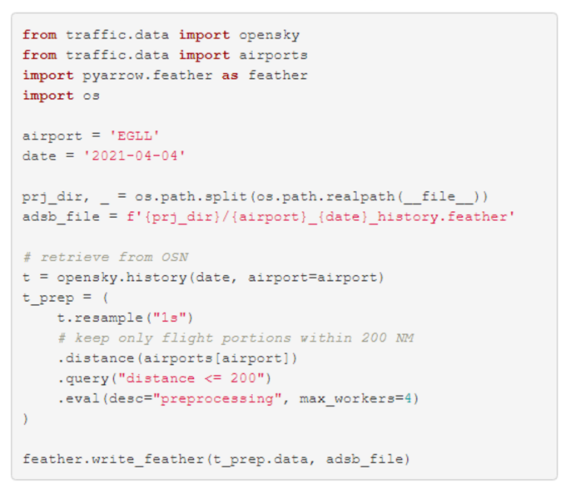

1. Example of extracting trajectory data from Opensky Network using the Python traffic library

To validate the runway association module developed for this study, we also extracted the landing runway and landing time with the help of the traffic library (c.f. Fig. 2). The traffic library implementation considers only arrival trajectories, i.e. landing_at_{airport}, and extract portions aligned with the different runways, i.e. aligned_on_{airport}. The runway association is based on meeting this condition the maximum number of times, i.e. ILS_max. Our goal was to reproduce the operational performance monitoring. The cut-off by the traffic library assigns the timestamp of the last-best position report. Our analysis showed that dependent on the coverage of the final segment better estimates for the landing time could be derived when interpolating the trajectory to the landing runway. Our implementation is based on an average observed groundspeed on final and determines the time over the threshold. We add 5 seconds to account for the average distance of 1000ft between the runway threshold and ground-point-of-intercept.

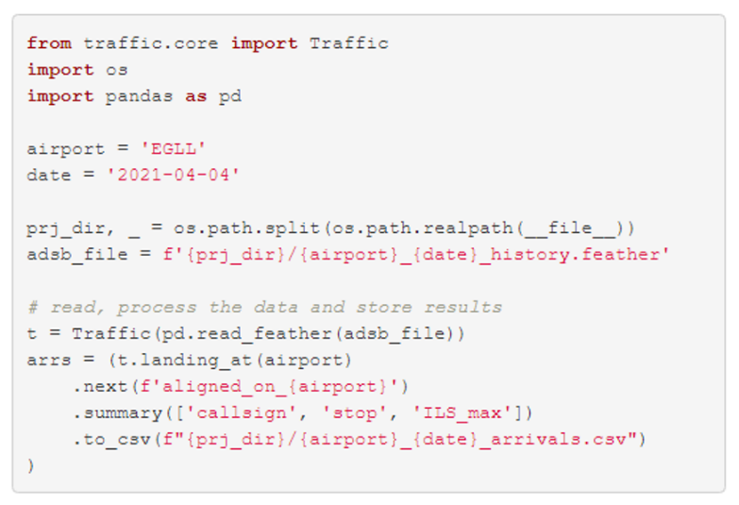

1. Example of extracting landing data from Opensky Network using the Python traffic library

Olive, Xavier, Martin Strohmeier, and Jannis Lübbe. 2021. “Crowdsourced Air Traffic Data from The OpenSky Network 2019-2021.” Zenodo. <https://doi.org/10.5281/zenodo.4893103>.

Strohmeier, Martin, Xavier Olive, Jannis Lübbe, Matthias Schäfer, and Vincent Lenders. 2021. “Crowdsourced Air Traffic Data from OpenSky Network 2019-2020.” *Earth Systems Science Data* 13: 357–66. <https://doi.org/10.5194/essd-13-357-2021>.

## 3.4 Study Data

This study builds on data collected by Opensky Network (<https://opensky-network.org/>). The Opensky Network community operates a sensor network of more than 3000 receivers across the globe (Strohmeier et al. 2021). The crowdsourced data collected by Opensky Network is available to research, non-profit and government organisations. To support the on-going efforts with a view to COVID-19, the network provides a preprocessed data set of flight data. This data can be downloaded from CERN’s Zenodo repository: <https://doi.org/10.5281/zenodo.3737101> (Olive, Strohmeier, and Lübbe 2021). It provides global flight data covering January 2019 through today. This data set is used in XXX and supports the analysis of air traffic development pre-COVID-19, during COVID, and the current recovery.

FIG X is build from this flight dataset. XXXXXXXXXXXXXXX

For this study the lower level trajectory data is used. The data was downloaded from Opensky Network making use of the *traffic library* (Olive 2019). The library supports the targeted extraction of trajectories landing and departing from the chosen airports. The respective trajectory data for March and May 2019, 2020, and 2021 was downloaded.

TODO - ADD TABLE WITH data size for MAR/MAY 2019, 2020, and 2020

The validity of the data was checked by comparing the extracted data with the airport operator flow (APDF) of EUROCONTROL’s Performance Review Unit. The APDF data [ref to data specs] is collected monthly in accordance with the associated data specification. The data is used for the regular performance monitoring under the EUROCONTROL Performance Review System and the European Sky Performance Scheme.

TODO - comparison of APDF with OSN data - number of flights / any specifics.

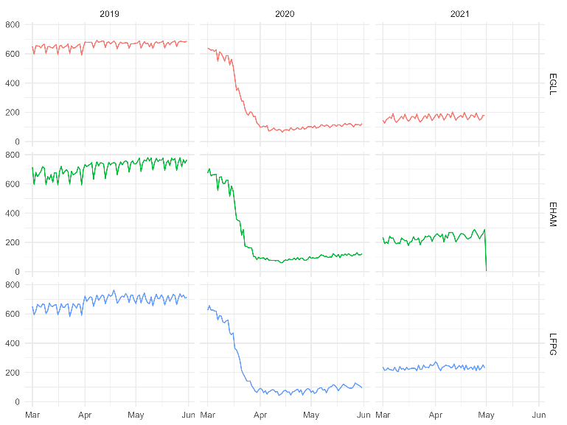

1. Comparison of APDF and Opensky Network timeline for arrivals at the study airports.

## Data

This study uses data from Opensky Network. The project downloaded the associated flight tables for 3 major airports in Europe and 2 months. With a view to the sharp decline in air traffic in March 2020 and an initial recovery in May, we chose these 2 months in 2019, 2020, and 2021. This provides characteristics and comparable months and supports the idea of taking snapshots pre-COVID, during the traffic decline, and a year after this initial disruption.

The study data accounted for xx GB

During an initial data validation step the downloaded data was compared to the monthly performance data collected from European airports by the Performance Review Unit of EUROCONTROL.

## Equations

*a*  *b*    

Use “(1)”, , except at the beginning of a sentence: “Equation (1) is . . .”

# Results and Discussion

## Overall Traffic / Demand Pattern

how far have we come, are we seeing traffic returning, expansion of runway system capacity (use of multiple runways. change of traffic pattern).

## Classical Performance Measure

* ASMA 100NM/40NM/50NM
* Vertical FE

## Sequencing – Arrival Management

The utilization of open data to assess operational efficiency in the arrival phase is a driver of this work.

Fig. 4 depicts the arrival trajectory of flight SIA322 at London Heathrow (EGLL) on 1. March 2019. The figure shows how the flight was prolonged by a continued North-westerly heading taking the flight to the north of the airport before turning it towards the arrival holding stack area. The heatmap coloring (blue ~ cold ~ little/no additional sequencing, red ~ hot ~ substantial sequencing) shows the flight entering a trombone pattern to absorb further flight time before being turned onto a baseleg to intercept the final approach. With joining the baseleg, the flight follows an efficient path to the landing runway.

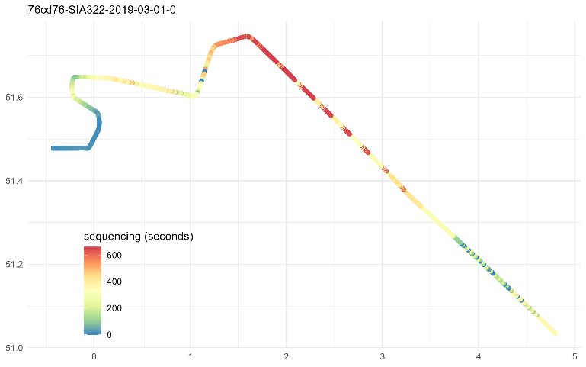

1. Example of the sequencing effort along the flown trajectory.

## Something Fancy and New?

make a scatter plot of aforementioned measures - something fancy?

# Conclusions and Future Work

There is a societal interest in higher level of transparency of the operational performance of the air transport system. The increased global vaccination rate resulted in the withdrawal of travel restrictions and the 2nd quarter of 2021 showed higher levels of air traffic in Europe. With the mental orientation towards a post-COVID-19 world, the public and political expectations on aviation to curb its environmental impact gain a higher priority again picking up on many initiatives launched before the pandemic.

Data availability is a key for developing an understanding of the dynamics of the COVID-19 recovery and operational performance. This also applies for the success of novel big data and artificial intelligence based methods. The results demonstrate the principal feasibility of a data-driven open data based approach for performance monitoring of air transport. This enables the day-to-day evaluation of operational excellence in an open and transparent manner. Operational excellence and the impact of varying operational concepts or benefit of technological enablers will become immediately visible. This will allow a closer evaluation of performance benefits, change implementation, and careful tracking of inefficiencies with the anticipated steadily increasing traffic levels in a post-COVID world.

This paper builds on the Opensky Network data. The collected ADS-B/Mode-S data support the development of a toolchain to monitor the operational performance. The feasibility study was performed for the airport context. A fundamental constraint is the coverage of the crowd collected data. By definition, community contributors place sensors on a best effort basis. Therefore coverage of ground movements is limited at the time being to a small number of airports. As a take-away from this work, the Performance Review Unit and Opensky Network look into orchestrating sensor placements at European airports.

A key aspect of this feasibility study was the development of an initial version of a toolchain. Based on the data exploration, open source software modules were developed. The use-case analysis of three airports proofed to provide sufficient operational variation to identify an initial set of assumptions and parameters. To mature the algorithms and introduce the modules to the day-to-day monitoring, future work requires a wider validation across a larger set of airports. The work presented in this paper was performed on standard office computers. The workflow of downloading the data and storing it for further processing, including saving out interim results consumes a considerable amount of resources and time. While this is acceptable on the basis of use-case analyses, an operational use will require the deployment of processing modules with the underlying data infrastructure or appropriate dimensioned and scalable cloud computing. As an initial step, the development of an open flight table comprising the identified key events and milestones for further performance analyses was initiated.

While similarities exists, the analysis revealed that there are differences in the arrival management concept at the studied airports. It will be interesting to follow the development of the novel performance measure during the COVID-19 recovery.

The results will be used to inform the work of ICAO’s global performance expert group with a view to help prioritizing concepts and capabilities of the airspace building blocks. This can form the basis for an extension of the currently proposed indicator set. It may serve as a basis to evaluate to what extent the industry meets the aspirational goals put forward and “builds back better!”

##### Acknowledgment

The authors thank the contributors of the Opensky Network community for the continued effort to collect, process, and provide open air transport data, Xavier Olive for his work on the traffic library, and the R/RStudio eco-system. Without these open source / open data contributions, this paper would not have been possible.

##### References

1. Bourgois, Marc, and Michael Sfyroeras. 2014. “Open Data for Air Transport Research: Dream or Reality?” In *Proceedings of the International Symposium on Open Collaboration*, 1–7.
2. Koelle, Rainer. 2017. “Open Source Software and Crowd Sourced Data for Operational Performance Analysis.” In *Twelfth USA/Europe Air Traffic Management Research and Development Seminar (Atm2017)*, edited by EUROCONTROL. Seattle, Washington, U.S.A.: EUROCONTROL & FAA.
3. Strohmeier, Martin, Xavier Olive, Jannis Lübbe, Matthias Schäfer, and Vincent Lenders. 2021. “Crowdsourced Air Traffic Data from OpenSky Network 2019-2020.” *Earth Systems Science Data* 13: 357–66. <https://doi.org/10.5194/essd-13-357-2021>.
4. Olive, Xavier, Martin Strohmeier, and Jannis Lübbe. 2021. “Crowdsourced Air Traffic Data from The OpenSky Network 2019-2021.” Zenodo. <https://doi.org/10.5281/zenodo.4893103>.
5. Sun, Xiaoqian, Sebastian Wandelt, and Anming Zhang. 2020. “How Did COVID-19 Impact Air Transportation? A First Peek Through the Lens of Complex Networks.” *Journal of Air Transport Management* 89: 101928.
6. Adrienne, Nena, Lucy Budd, and Stephen Ison. 2020. “Grounded Aircraft: An Airfield Operations Perspective of the Challenges of Resuming Flights Post COVID.” *Journal of Air Transport Management* 89: 101921.
7. EUROCONTROL (Performance Review Unit). “COVID-19 - Grounded Aircraft in the EUROCONTROL Area.” *ansperformance.eu*. <https://ansperformance.eu/covid/acft_ground/>.
8. Nhamo, Godwell, Kaitano Dube, and David Chikodzi. 2020. “Impact of COVID-19 on the Global Network of Airports.” In, 109133. Springer.
9. Truxal, Steven. 2020. “State Aid and Air Transport in the Shadow of COVID-19.” *Air and Space Law* 45 (Special issue).
10. Sun, Xiaoqian, Sebastian Wandelt, Changhong Zheng, and Anming Zhang. 2021. “COVID-19 Pandemic and Air Transportation: Successfully Navigating the Paper Hurricane.” Journal of Air Transport Management, 102062.
11. European Aviation Safety Agency (EASA). 2021. “Aviation Environmental Impacts.” *Environmental Impacts* <https://www.easa.europa.eu/eaer/climate-change/aviation-environmental-impacts>
12. Murphy, Andrew. 2021. “Flying and Climate Change.” *TE, Transport & Environment*. <https://www.transportenvironment.org/what-we-do/flying-and-climate-change>
13. EUROCONTROL, PRU. 2021. “Performance Review Report, an Assessment of Air Traffic Management in Europe During the Calendar Year 2020.” <https://www.eurocontrol.int/publication/performance-review-report-prr-2020>.
14. Asquith, James. 2020. “The Spread of Flight Shame in Europe - Is Greta Thunberg the Reason Why?” *Forbes*. <https://www.forbes.com/sites/jamesasquith/2020/01/13/the-spread-of-flight-shame-in-europe-is-greta-thunberg-the-reason-why/?sh=6b1ec58f69bd>
15. Placeholder
16. Placeholder
17. Placeholder
18. ICAO. 2016. *Doc 9750, Capacity & Efficiency, Global Air Navigation Plan 2016-2030*. Fifth Edition. Montreal, Canada: International Civil Aviation Organization. <https://www.icao.int/airnavigation/Documents/GANP-2016-interactive.pdf>.
19. ICAO. 2016. Procedures for Air Navigation Services - Air Traffic Management. Sixteenth Edition. Doc 4444 - PANS-ATM. Montreal, Canada: International Civil Aviation Organization.
20. Schäfer, Matthias, Martin Strohmeier, Vincent Linders, Ivan Martinovic, and Matthias Wilhelm. 2014. “Bringing Up OpenSky: A Large-Scale ADS-B Sensor Network for Research.” In *13th IEEE/ACM International Symposium on Information Processing in Sensor Networks (IPSN)*, 83–94.
21. Olive, Xavier. 2019. “Traffic, a Toolbox for Processing and Analysing Air Traffic Data.”
22. G. Eason, B. Noble, and I. N. Sneddon, “On certain integrals of Lipschitz-Hankel type involving products of Bessel functions,” Phil. Trans. Roy. Soc. London, vol. A247, pp. 529–551, April 1955.