How to measure resilience when there is no demand?

Rainer Koelle, EUROCONTROL, Brussels (Belgium) Fabio Barbosa, DECEA, Rio de Janeiro (Brazil)

# 1 Abstract

Resilience is important.

# 2 Introduction

# 3 Background

knitr::include_graphics("./figures/resilience-classical-description.png")

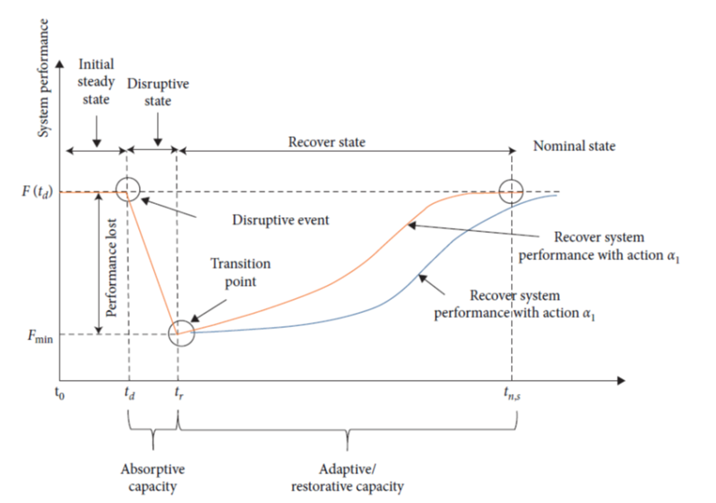

Figure 3.1: Conceptual depiction of time dependent system behaviour (c.f. Guo et al. (2021))

Several researchers have described the generic concept of disruption and recovery with respect to service provision, transportation infrastructures from a performance-based perspective, e.g. Vugrin, Turnquist, and Brown (2014), GLUCH, Koelle (2015). These approaches identify distinct phases. Fig. 3.1 depicts these phases.

proposed the generic concept of disruption and recovery underlying performance-based approaches, which is a time-dependent function F(t). Under noral operating conditions, the system performance measure F has a nominal value, until the system suffering a disruption at the time t0, as illustrated in Figure 1. (e resilience formulation is the ratio of recovery to loss:

$$R(t)=\frac{F(t)−F_{min}}{F_{0}−F_{min}}$$

## 3.1 heading 2

some cool text etc

* bullet
* more bullets
* one more bullet

### 3.1.1 heading 3

cool text and cool reference .

possibly some code chunks

# this could be code

# 4 Conclusions

# 5 Acknowledgements

If an acknowledgement is necessary, include it under the heading Acknowledgements using the Heading 1 style. Use the Body Text style and include the acknowledgements immediately after the references. # Disclaimer If a disclaimer is necessary, include it under the heading Disclaimer using the Heading 1 style. Use the Body Text/Normal Text style and include the disclaimer immediately after the acknowledgements. # Email Addresses

# 6 Conference Identification

2022 Integrated Communications Navigation and Surveillance (ICNS) Conference April 5-7, 2022

# References

Guo, Jiuxia, Xinping Zhu, Chenxi Liu, and ShuzhiSam Ge. 2021. “Resilience Modeling Method of Airport Network Affected by Global Public Health Events.” *Mathematical Problems in Engineering* 2021.

Koelle, Rainer. 2015. “Operational Resilience Performance of European Airports.” In *2015 Integrated Communication, Navigation and Surveillance Conference (ICNS)*, 1–19. IEEE.

Vugrin, Eric D, Mark A Turnquist, and Nathanael JK Brown. 2014. “Optimal Recovery Sequencing for Enhanced Resilience and Service Restoration in Transportation Networks.” *International Journal of Critical Infrastructures* 10 (3-4): 218–46.