
NVC CONNECT PLATFORM
User Manual
Administrator • Volunteer • Partner Organization
Formal operating guide with annotated web and mobile screens
Document note: This manual uses the attached sample only as a formatting reference. The procedures and images here describe the NVC volunteer-management system in this workspace.

Version 1.0 • Demonstration captures • 20 September 2026

Document control and conventions
Use this manual with the deployed NVC Connect web portal and Android/mobile interface. Menu names and approval rules can change as the system evolves; the screenshots are current demonstration captures, not production records.
Privacy: The screenshots use E2E demonstration accounts. Visible e-mail addresses and phone values are redacted where they appear. Never place a real password, OTP, token, or personal contact value in a screenshot or training copy.

How to read the annotated screens
- Red rectangle — the control, card, or information to use or check.
- Red arrow — the direction of the action or the related screen area.
- Numbered steps in the surrounding text — the sequence to follow in the live application.

Table of contents
Section | What it covers
1. Overall system process | The complete lifecycle from registration through reporting and impact review
2. Getting started | Sign-in, navigation, notifications, and privacy
3. Administrator web portal | Dashboard, programs, projects, volunteers, partners, reports, and map
4. Volunteer mobile app | Home, events, tasks, reports, messages, and profile
5. Partner mobile app | Partner space, projects, events, reports, messages, and profile
6. Detailed role hand-offs | Volunteer, partner, and administrator responsibilities across the lifecycle
7. Synchronization and troubleshooting | Web/mobile refresh behavior and common fixes
8. Quick reference | Navigation labels and support checklist

1. Overall NVC system process
NVC Connect is an approval-driven volunteer and partner-management system. The process starts with account onboarding, moves through program/project and event coordination, and ends with attendance, reports, outcomes, and impact review. Administrator access is provisioned separately; the lifecycle below focuses on volunteer and partner operations. The role-specific screens later in this manual explain how each participant performs their part of this lifecycle.

1.1 End-to-end lifecycle
- Account entry — a volunteer or partner chooses Sign up, completes the appropriate registration details and required documents, and verifies the account when requested.
- Approval gate — the account remains pending until an administrator reviews the profile or organization information and supporting documents. The administrator can approve, reject, or request changes.
- Program/project setup — the administrator can create and manage programs or projects. A partner can submit a project proposal; the administrator reviews the proposal and approves, rejects, or requests a revision.
- Event setup — the administrator or authorized partner creates project events and records the schedule, location, volunteer requirements, tasks, attachments, and other operating details.
- Volunteer matching — an approved volunteer browses programs/events, opens the details, and applies or requests to join. The administrator or partner reviews the request, then confirms participation or assignment.
- Activity delivery — the volunteer views assigned tasks and requirements, completes the activity, records attendance, and submits photos or field evidence when required. The partner or administrator coordinates and reviews the event record.
- Reporting and impact review — the volunteer or partner submits a report. The administrator reviews reports and outcomes, uses Analytics/Reports/Impact Map, and keeps the project/event record current.
- Shared synchronization — successful changes are stored in the shared backend and become available to the web portal and mobile/Android client after the receiving screen refreshes or reloads.
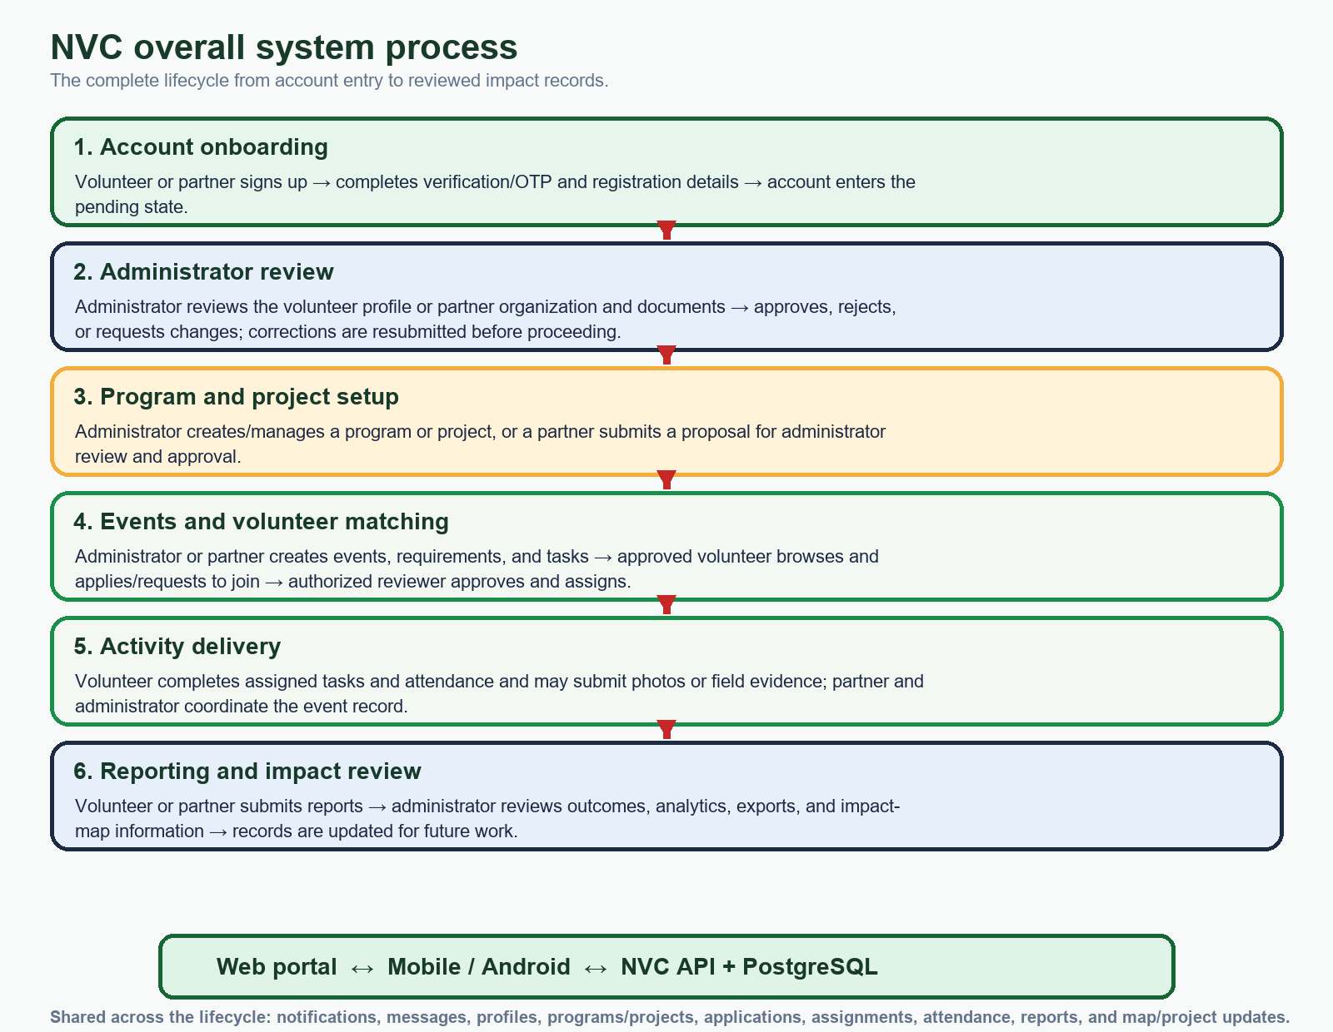
Figure 1. Overall NVC process. A rejected or incomplete account/proposal is corrected and resubmitted at the administrator review stage before the lifecycle continues.

1.2 Role hand-offs
Process stage | Volunteer | Partner organization | Administrator
Onboarding | Registers, verifies, and submits volunteer information/documents. | Registers, verifies, and submits organization information/documents. | Reviews the pending account and changes its approval status.
Program/project | Browses approved programs and project details. | Submits proposals and manages approved project workspaces. | Creates/manages programs or reviews partner proposals.
Events/tasks | Applies or requests to join and views assignments. | Creates/coordinates permitted events, requirements, and tasks. | Creates/coordinates events and assigns or reviews volunteers.
Delivery | Completes tasks, attendance, and required evidence. | Coordinates volunteers and event operations. | Monitors the operational record and attendance.
Reporting | Submits volunteer reports and field information. | Submits partner reports and project outcomes. | Reviews reports, analytics, exports, and impact information.

1.3 Roles and platforms
The web portal and Android/mobile client use the same backend and database. Menu availability depends on the authenticated role and the current account/project status.
Role | Primary responsibilities | Main interface
Administrator | Approve accounts and applications; create and monitor programs, projects, and events; assign volunteers; review reports and analytics. | Web portal
Volunteer | Maintain a volunteer profile; browse programs and events; join activities; complete tasks; record attendance and submit reports. | Mobile / Android app, with shared web access where enabled
Partner organization | Maintain the organization profile; propose and manage projects; create events; coordinate volunteers; submit reports and outcomes. | Mobile / Android app, with shared web access where enabled

1.4 Overall process photo guide
Use the following screens together with Figure 1. The arrows identify the navigation or record area used at each hand-off. The screen content can differ by account status, permissions, project assignments, and available data; an empty list does not change the process sequence.
PROCESS PHOTO • 1 — ADMINISTRATOR REVIEW AND DAILY COORDINATION
Administrator Dashboard
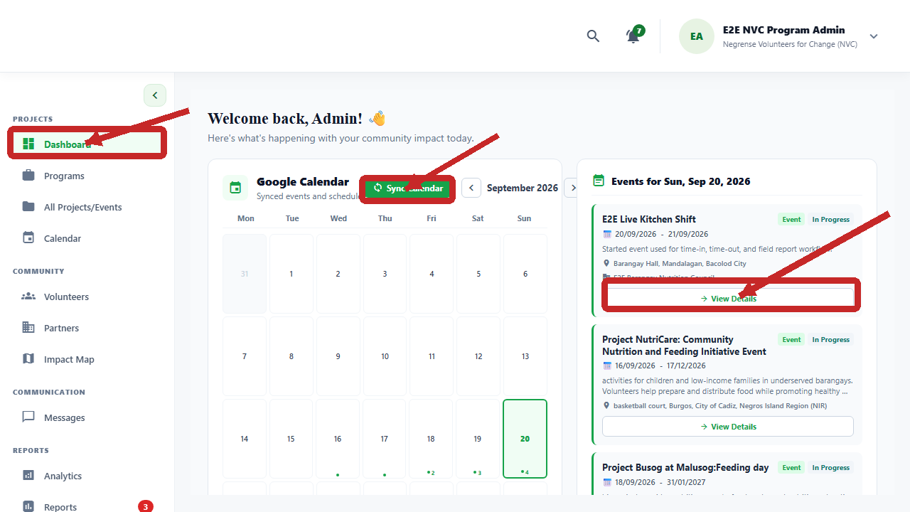
After sign-in, the administrator checks the calendar and event cards, then opens View Details for the record that needs action.
PROCESS PHOTO • 2 — ADMINISTRATOR PROGRAM SETUP
Programs and Add Program
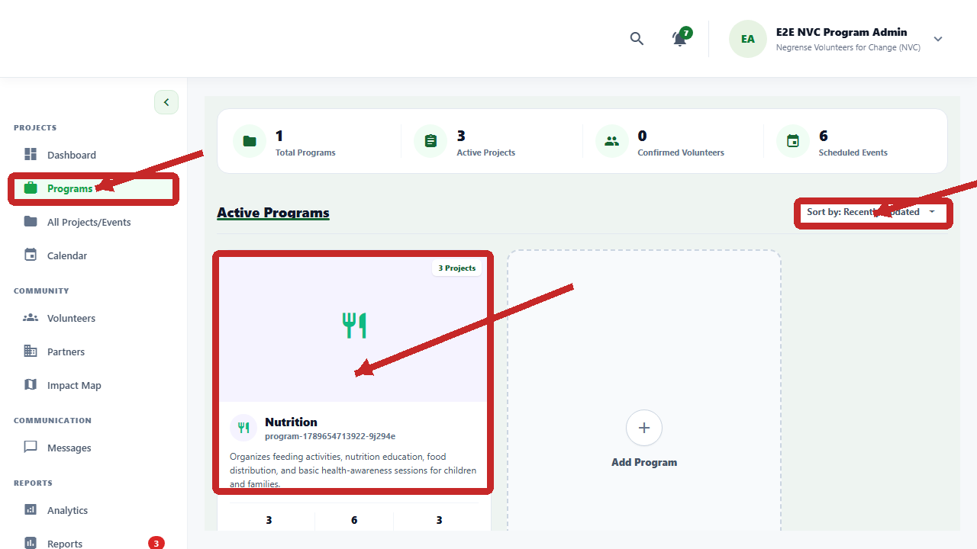
The administrator opens Programs, confirms the summary, and selects Add Program before creating or updating the program record.
PROCESS PHOTO • 2A — ADMINISTRATOR PROJECT AND EVENT MANAGEMENT
All Projects/Events
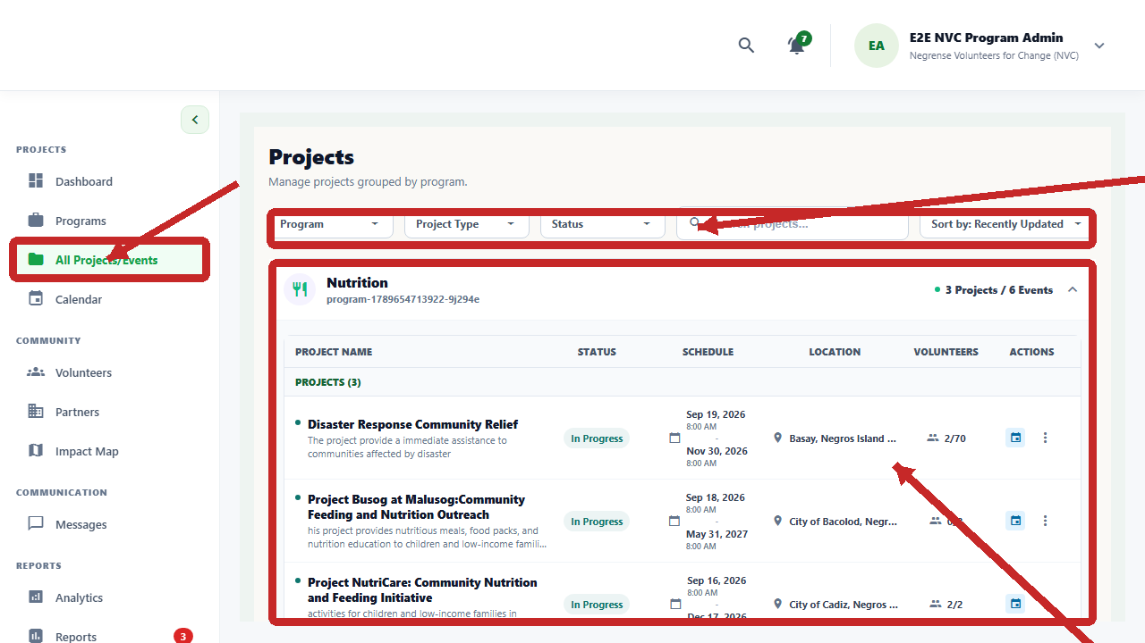
The administrator filters projects, checks status/schedule/location and volunteer counts, then opens the project or event action menu.
PROCESS PHOTO • 2B — ADMINISTRATOR SCHEDULE REVIEW
Admin Project Calendar
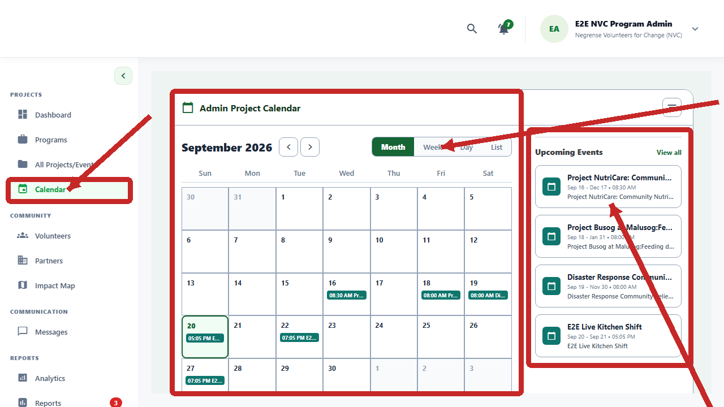
The administrator checks the month/week/day/list view and the Upcoming Events panel before coordinating the next activity.
PROCESS PHOTO • 3 — PARTNER PROJECT OPERATIONS
Partner Project Summary and Quick Actions
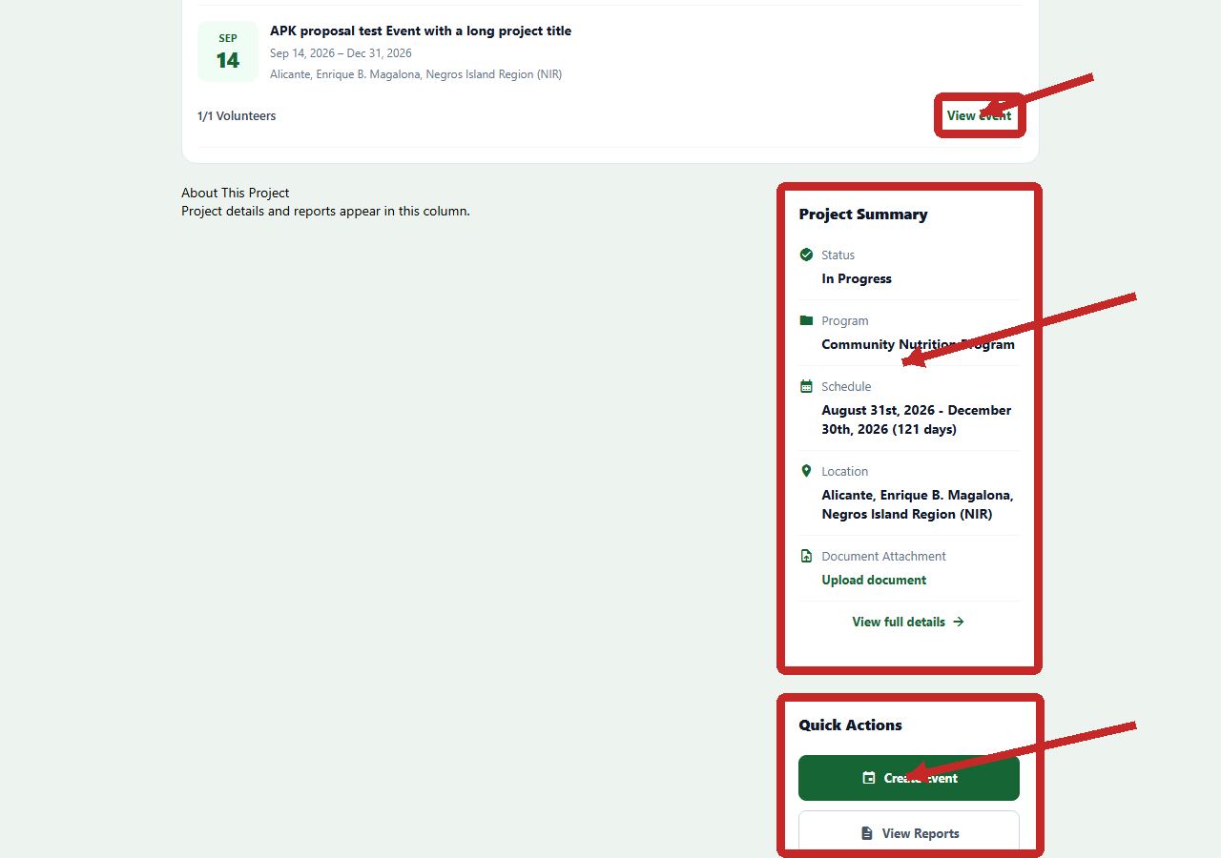
An approved partner opens the project workspace, checks status/schedule/location, then uses Create Event or View Reports as permitted.
PROCESS PHOTO • 3A - LOADED PARTNER WORKSPACE
Partner Dashboard with approved project records
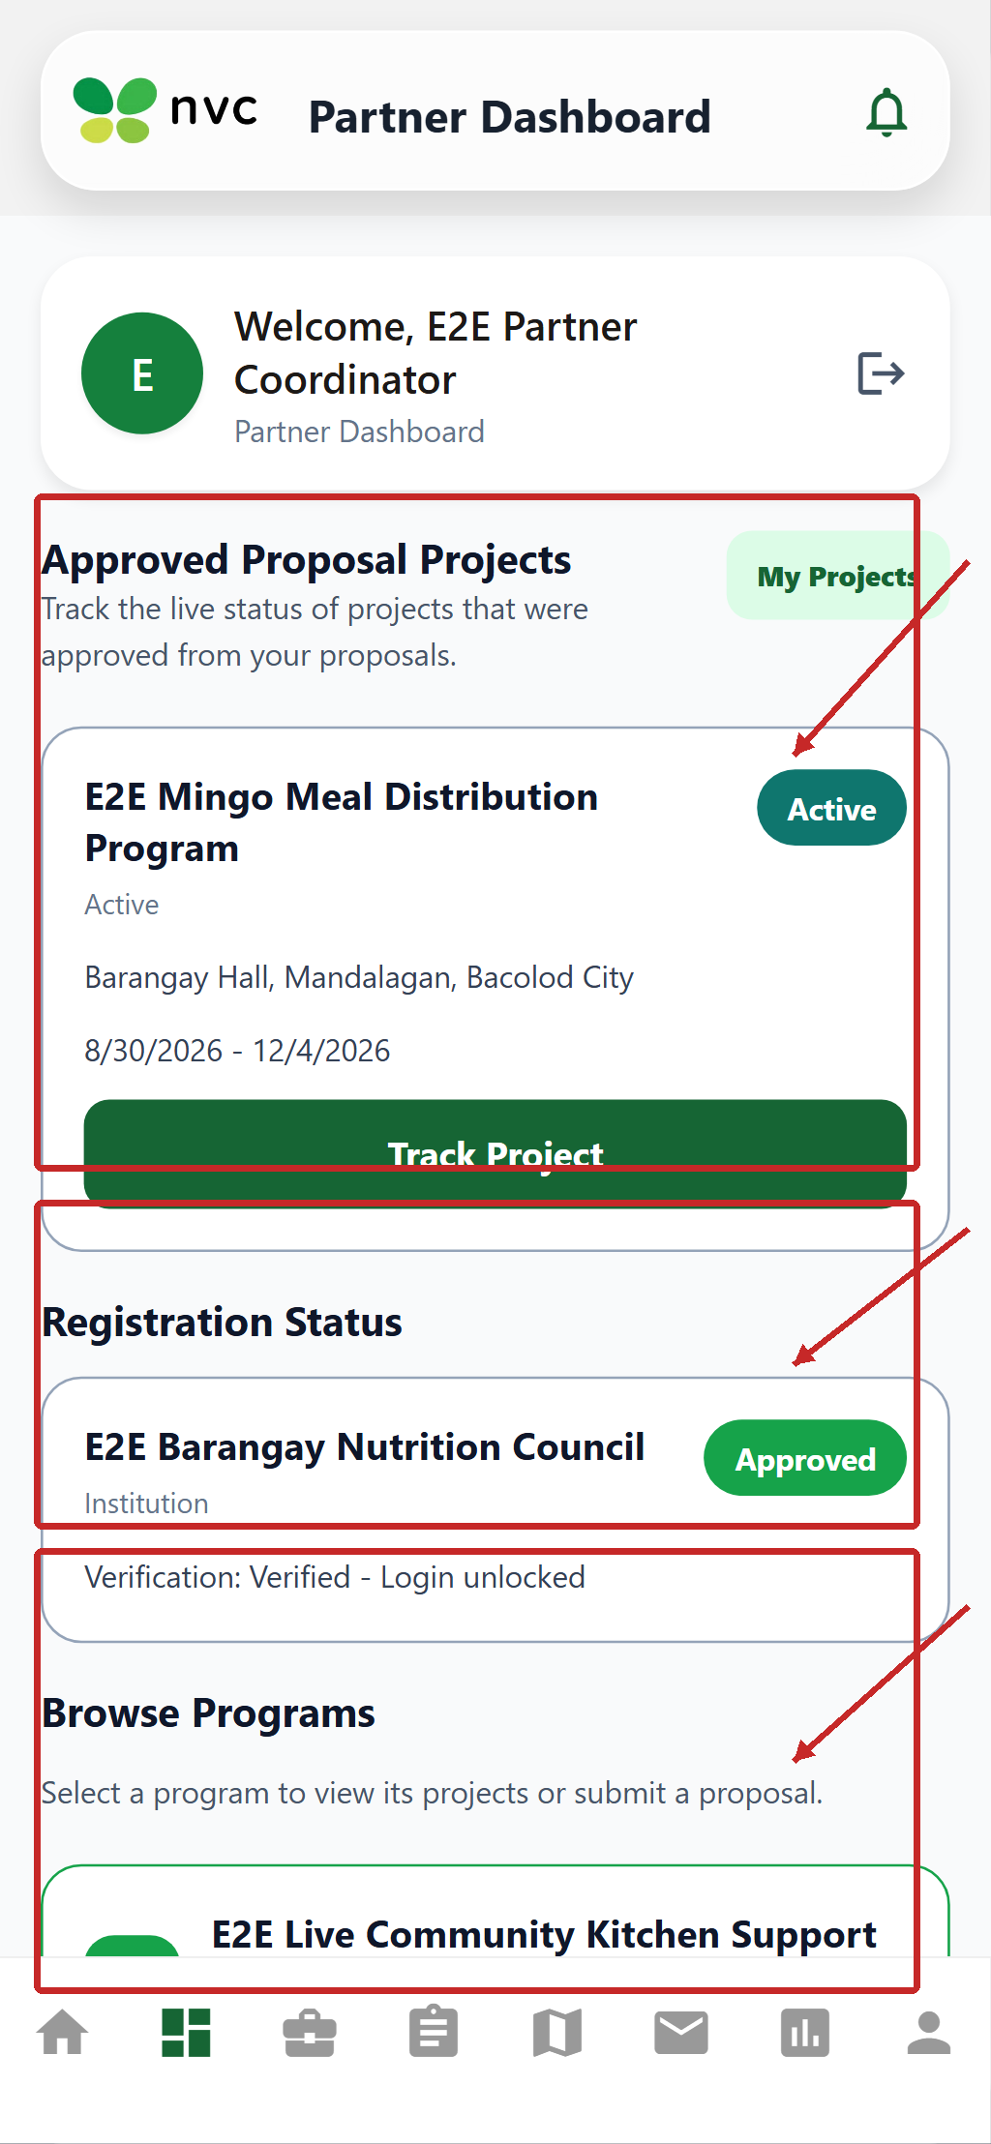
After the records load, the Partner Dashboard shows approved proposal projects, registration status, and the Browse Programs entry point.
PROCESS PHOTO • 3B - LOADED PROPOSAL ENTRY POINT
Partner Program Management with Submit Proposal
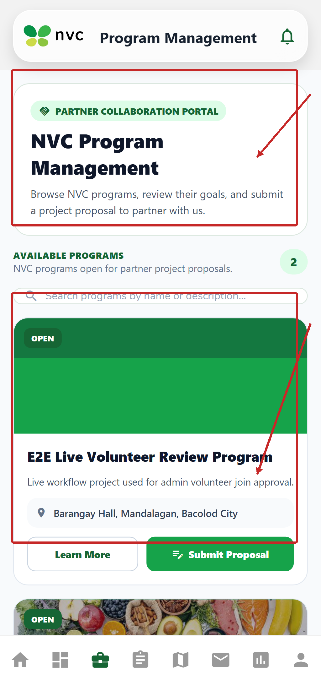
Open Program Management, review the available program, and select Submit Proposal on the program card to begin a project proposal.
PROCESS PHOTO • 4 — VOLUNTEER ENTRY TO ACTIVITIES
Volunteer Home and mobile navigation
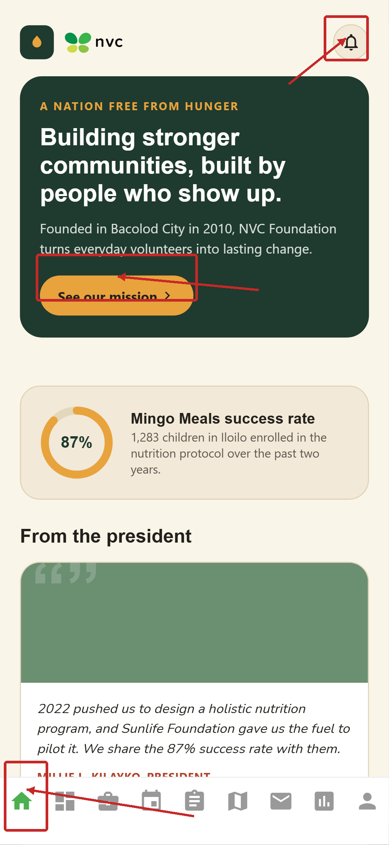
The volunteer starts at Home, checks notifications, and uses the bottom navigation to open Programs, Events, Tasks, Messages, Reports, or Profile.
PROCESS PHOTO • 5 — VOLUNTEER AND PARTNER COORDINATION
Volunteer Messages
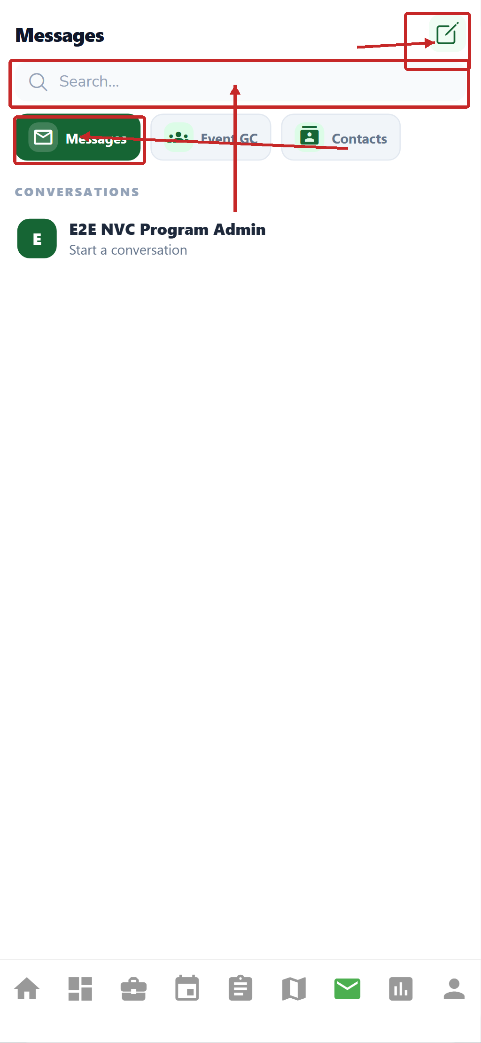
The volunteer uses Messages, Event GC, or Contacts to coordinate an approved activity; the same conversation can be viewed by authorized participants.
PROCESS PHOTO • 6 — VOLUNTEER ACCOUNT AND PARTICIPATION RECORD
Volunteer Profile
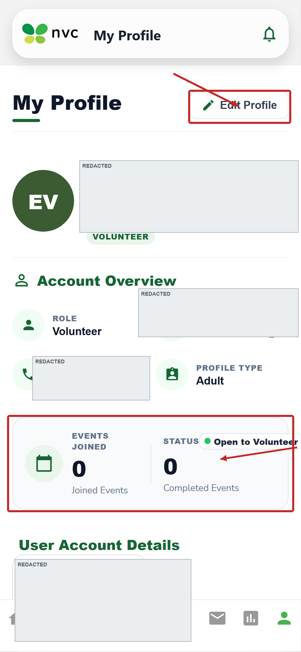
The volunteer verifies account status and registration information here; profile changes should be saved before applying or completing an activity.
PROCESS PHOTO • 7 — PARTNER APPROVAL STATUS
Partner Home
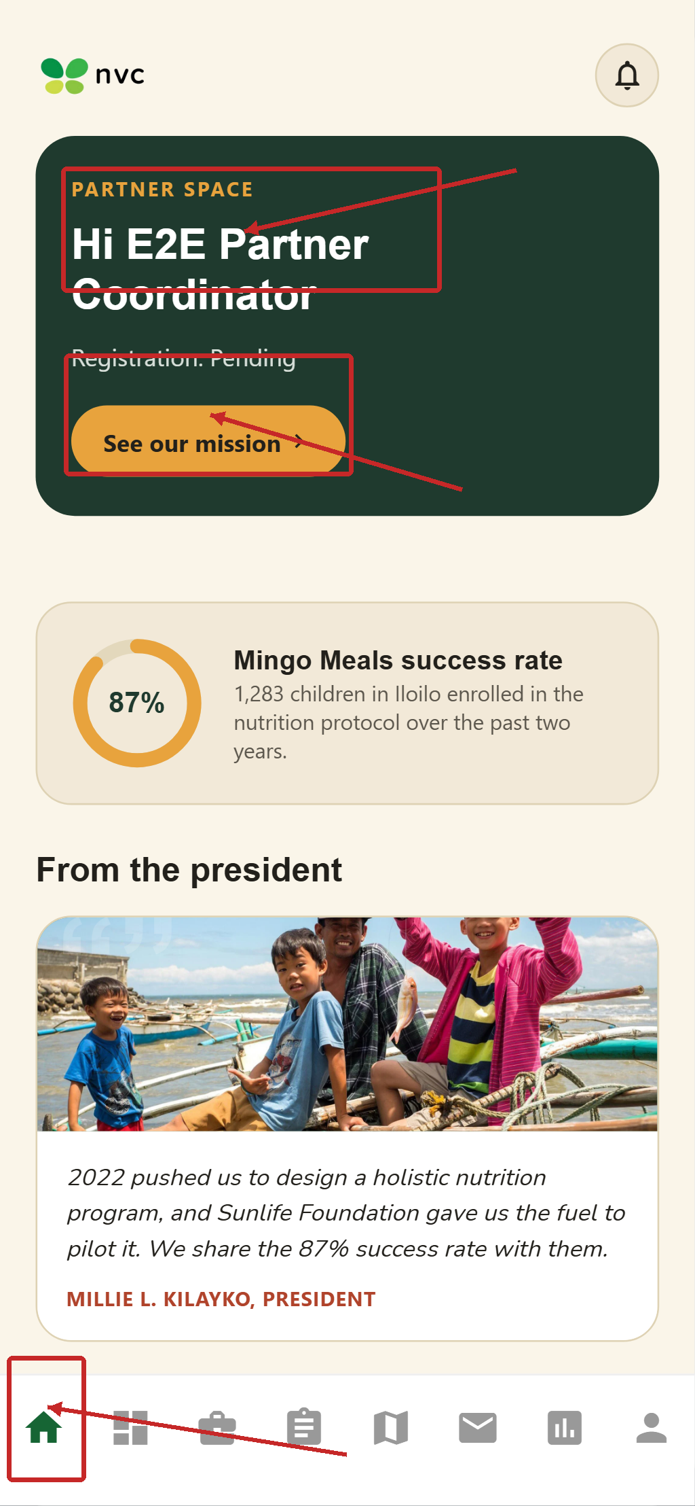
The partner checks the organization greeting and registration status; a pending account must wait for administrator review or respond to a requested change.
PROCESS PHOTO • 8 — PARTNER COORDINATION
Partner Messages
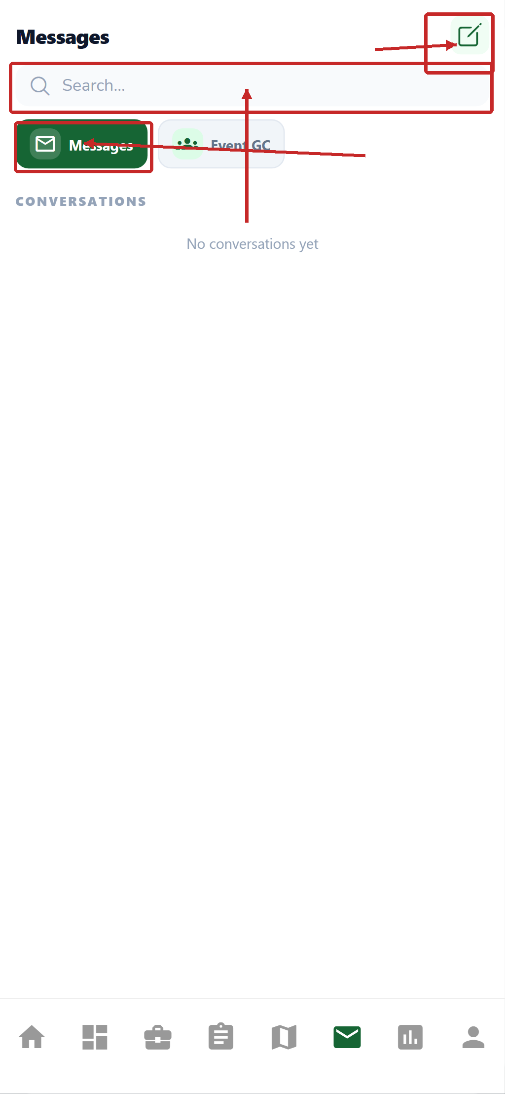
The partner uses Messages, Event GC, or Contacts to coordinate project delivery, volunteer questions, and administrator decisions.
PROCESS PHOTO • 9 — PARTNER ORGANIZATION RECORD
Partner Profile
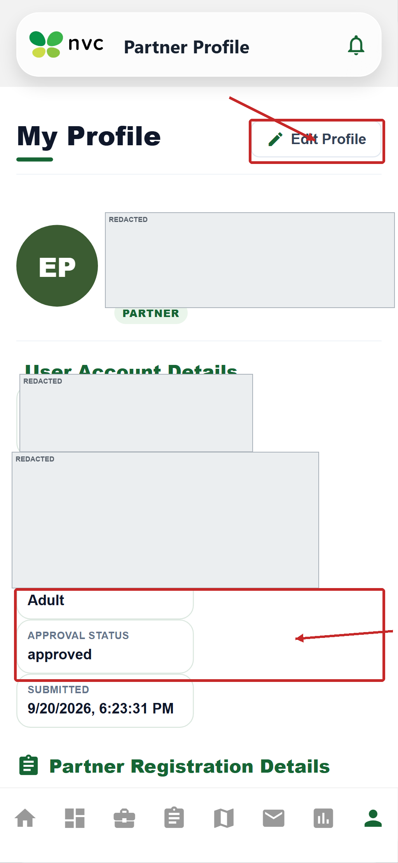
The partner checks organization details and approval information and updates permitted fields before proposing or managing project work.

1.5 Process coverage checklist and picture tutorials
This revision compares the requested process list with the manual content. The earlier role pages covered navigation and common screens; this section adds separate visual tutorials for the process steps that are not always visible in a seeded account, including registration, approval decisions, Partner proposal review, joining, attendance, report submission, Administrator monitoring, and synchronization.
Photo key: Screens labelled with a current UI name are real captured system screens with red boxes and arrows. Items labelled tutorial are process diagrams that explain the required hand-off when the live demo record is data-dependent; loading or empty placeholder screens are not presented as completed evidence.

Process | Roles involved | Tutorial image
1. Account registration | Volunteer / Partner | Registration screens + Process 1 card
2. Administrator account review | Administrator / Volunteer / Partner | Volunteer/Partner review screens + Process 2 card
3. Program and project management | Administrator / Partner | Projects screen
3A. Partner proposal and review | Partner / Administrator | Loaded proposal form + queue/action screens
4. Event setup | Administrator / Partner | Project Quick Actions, Calendar, and Events screen
5. Volunteer application and matching | Volunteer / Administrator / Partner | Programs/Events screens + Process 5 card
6. Activity and task completion | Volunteer / Administrator / Partner | Tasks screen + Process 6 card
7. Partner coordination | Partner / Volunteer / Administrator | Partner Project and Messages
8. Reports and documentation | Volunteer / Partner / Administrator | Volunteer Reports screen + Process 8 card
9. Administrator monitoring and impact review | Administrator | Dashboard, Partner/Volunteer review, and Analytics/Reports
10. Communication and notifications | All roles | Messages and notification areas
11. Web and mobile synchronization | All roles | Process 11 card and Figure 1

PROCESS PHOTO • PROCESS 1A — ROLE CHOICE
Mobile account type selection
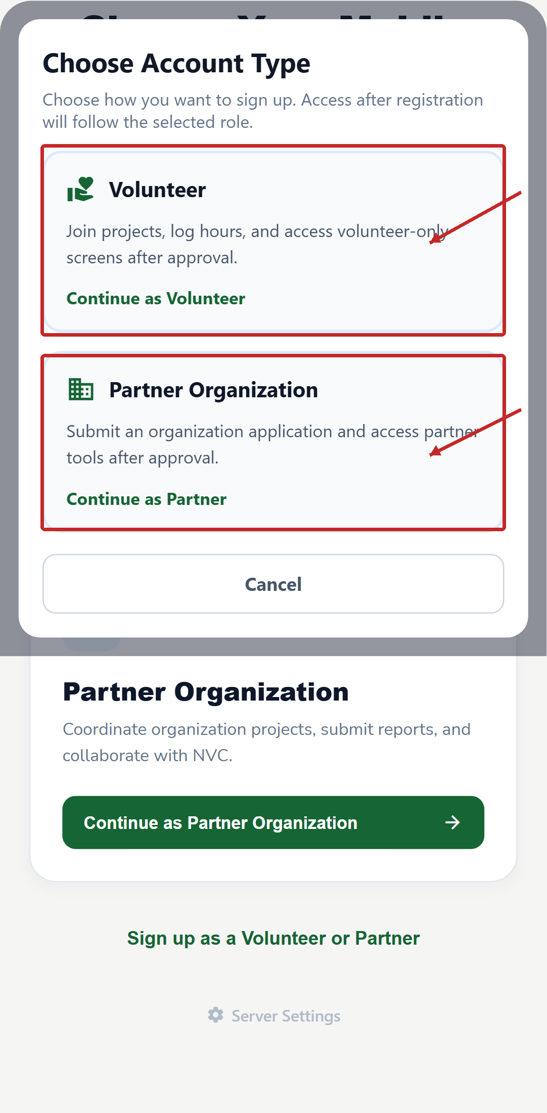
Select Continue as Volunteer or Continue as Partner Organization. The selected role determines the registration form and the portal available after approval.
PROCESS PHOTO • PROCESS 1B — VOLUNTEER REGISTRATION
Volunteer Registration form
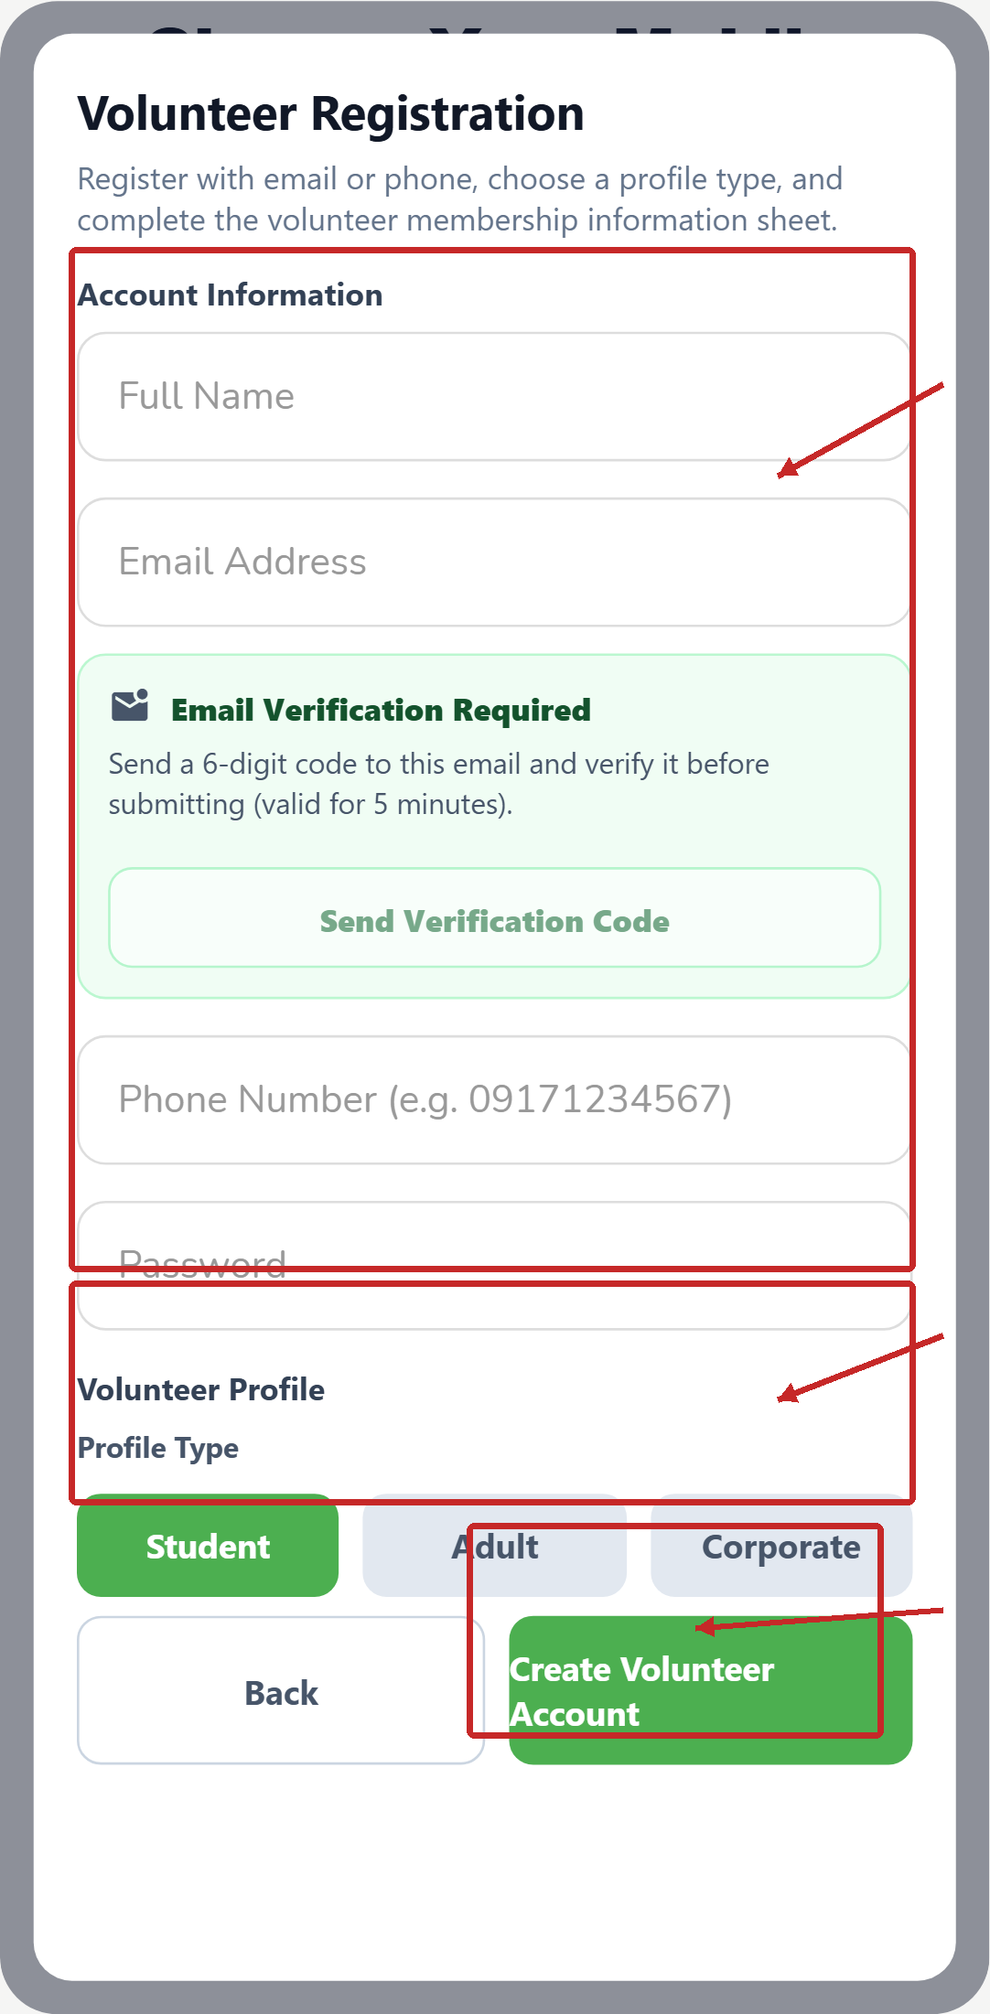
Complete the account fields, send and verify the e-mail code when requested, select the volunteer profile type, and select Create Volunteer Account.
PROCESS PHOTO • PROCESS 1C — PARTNER REGISTRATION
Partner Registration form
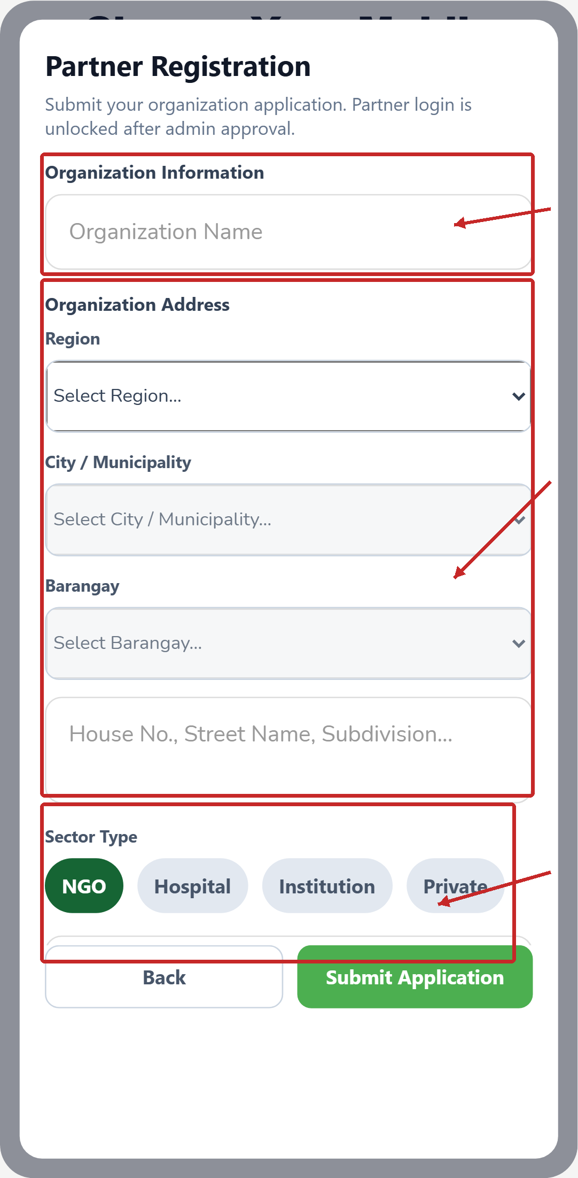
Complete organization and address information, choose the sector type, and select Submit Application. Partner login is unlocked after Administrator approval.
PROCESS PHOTO • PROCESS 1
Account registration tutorial
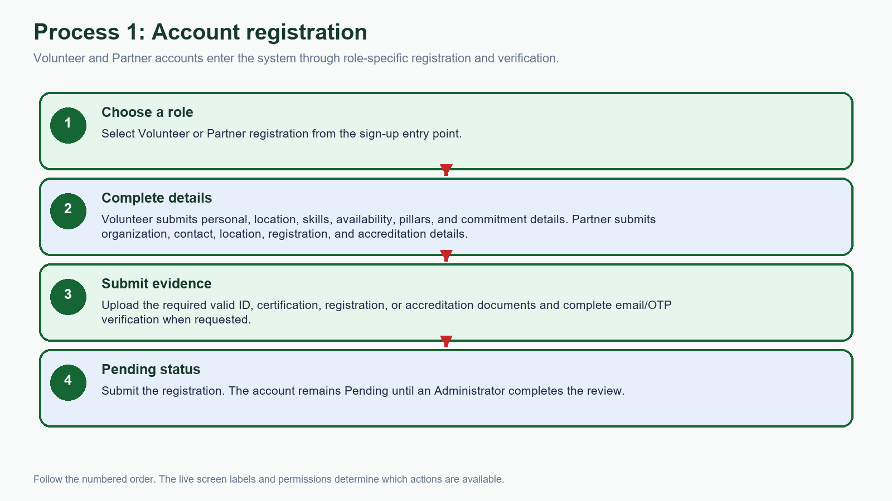
Use the role-specific registration form, submit the required information and documents, complete verification when requested, and confirm that the account is Pending.
PROCESS PHOTO • PROCESS 2A — VOLUNTEER REVIEW
Administrator Volunteer Management
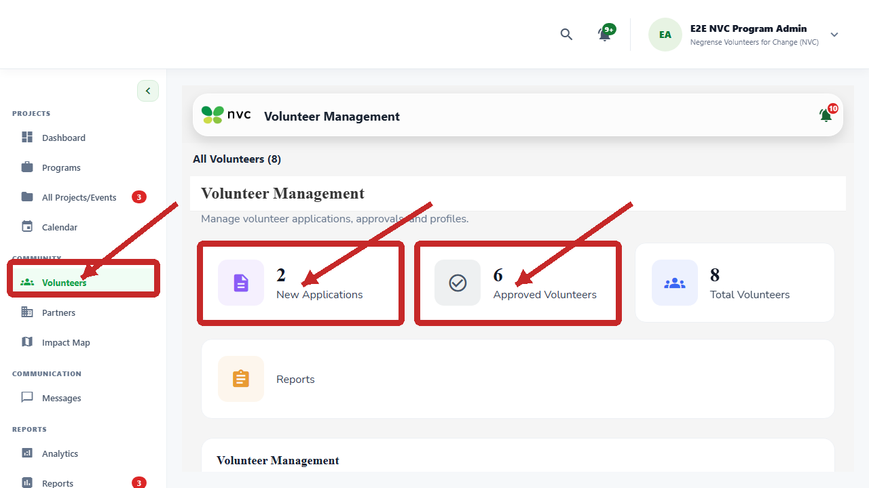
Open Volunteers from the web sidebar. The live screen shows New Applications, Approved Volunteers, and Total Volunteers for the review queue.
PROCESS PHOTO • PROCESS 2B — PARTNER REVIEW
Administrator Partner Management
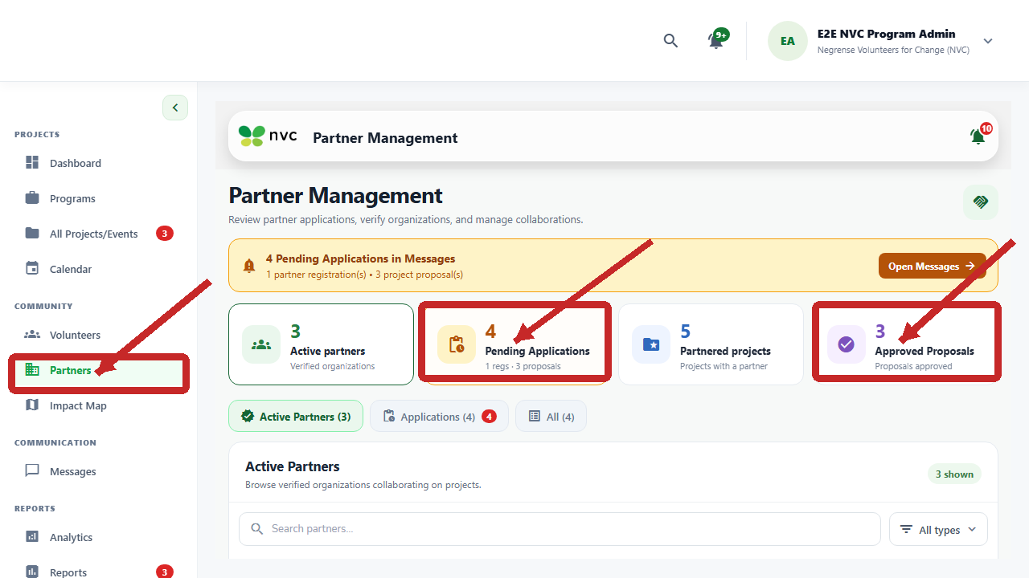
Open Partners to review pending applications, active partners, partnered projects, and approved proposals before making a decision.
PROCESS PHOTO • PROCESS 2
Administrator account review tutorial
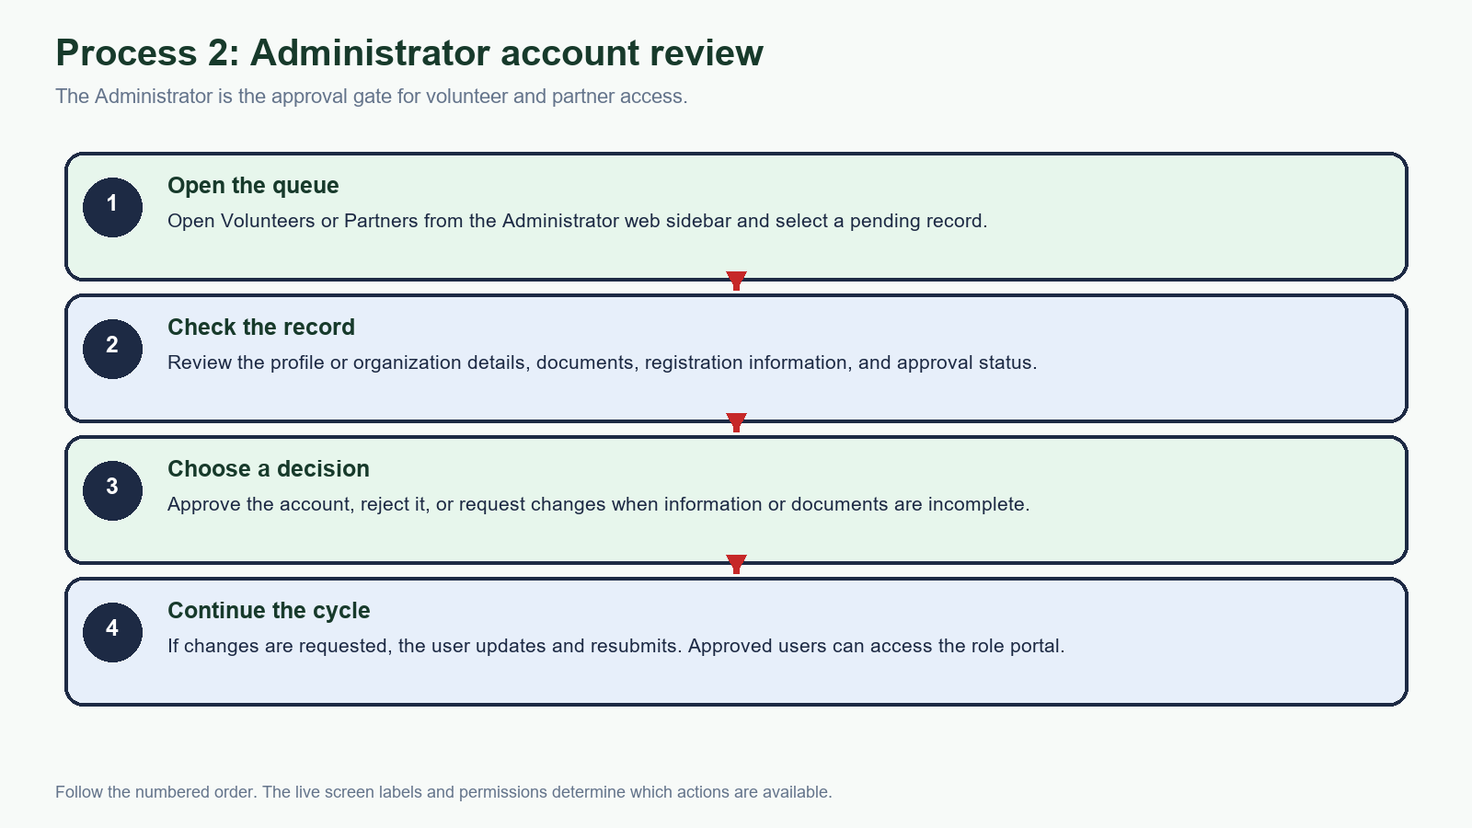
Administrator review is required before a volunteer or partner can proceed. A request for changes sends the record back for correction and resubmission.
PROCESS PHOTO • PROCESS 3
Program and project management
Use Programs to create or manage program records, then use All Projects/Events to filter projects and open the project/event actions.
PROCESS PHOTO • PROCESS 3A
Partner proposal queue
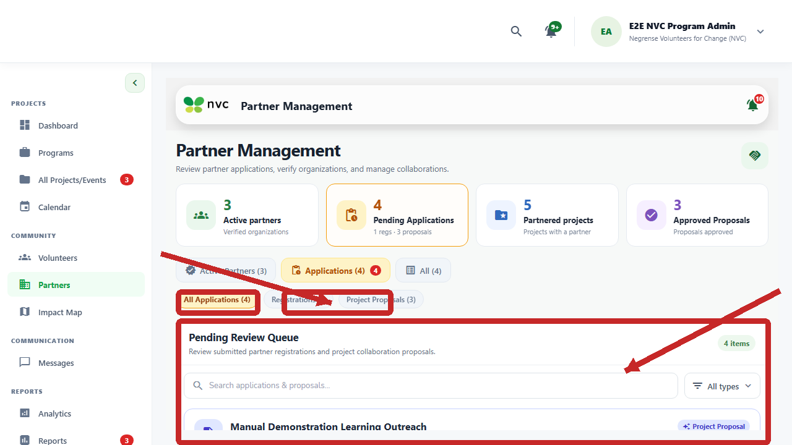
In Partner Management, select Applications and Project Proposals to open the Pending Review Queue for partner registrations and project collaboration proposals.
PROCESS PHOTO • PROCESS 3A - PROPOSAL FORM TOP
Partner New Project Proposal form
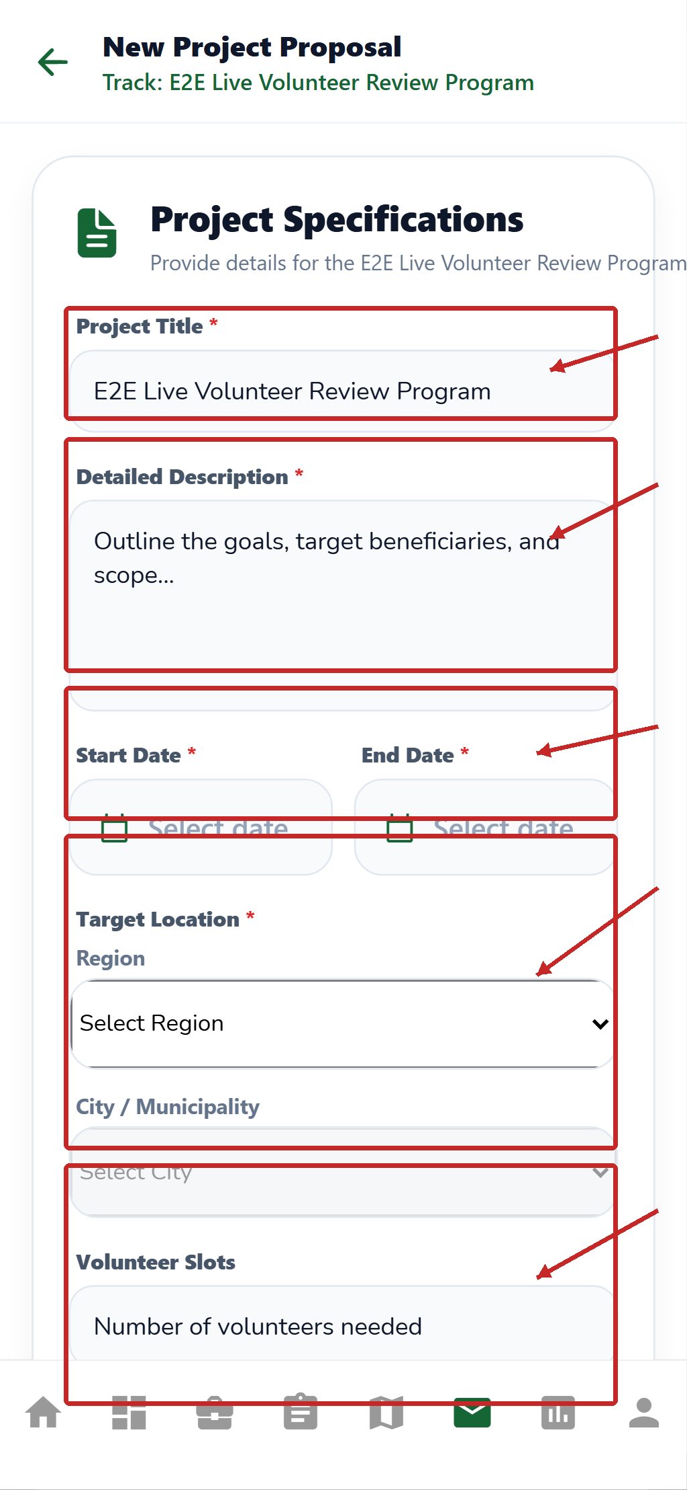
The Partner enters the project title, detailed description, start and end dates, target location, and volunteer slots before continuing down the proposal form.
PROCESS PHOTO • PROCESS 3A - PROPOSAL FORM LOWER FIELDS
Partner proposal evidence and submission controls
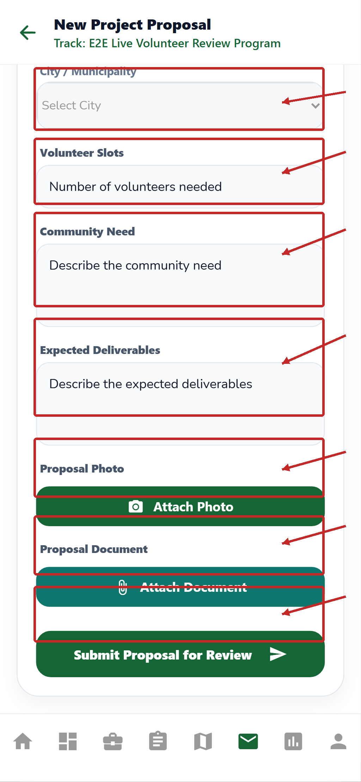
The Partner completes the community need and expected deliverables, attaches a proposal photo and document when available, and selects Submit Proposal for Review.
PROCESS PHOTO • PROCESS 3B
Partner proposal review actions
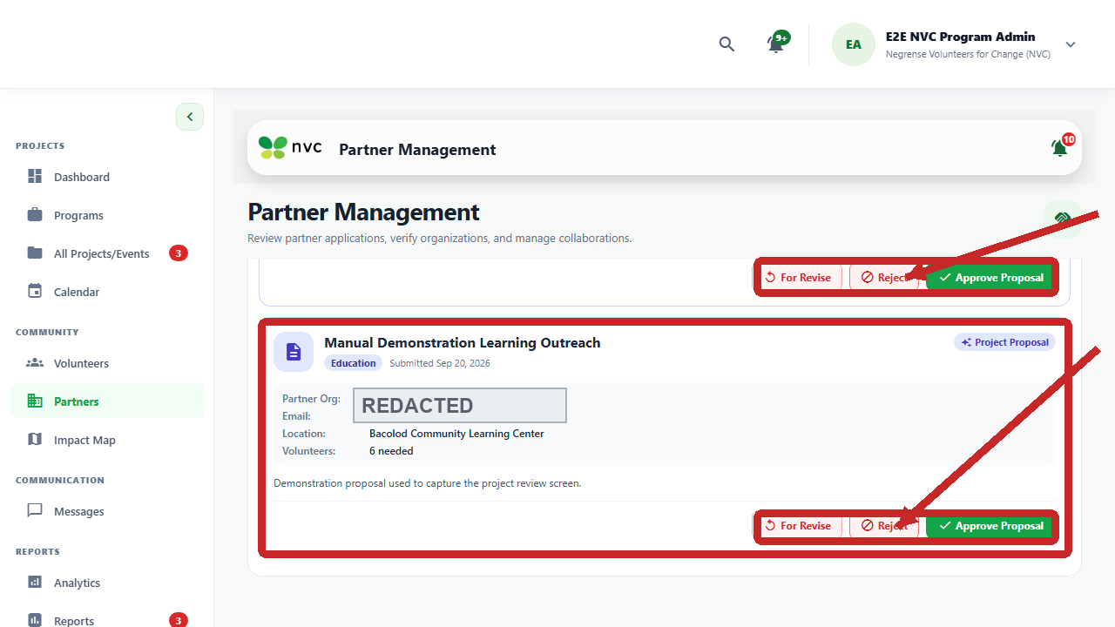
The proposal card provides the actual Administrator decisions: For Revise, Reject, and Approve Proposal. Use For Revise when the Partner must correct and resubmit information.
PROCESS PHOTO • PROCESS 3C
Partner proposal tutorial
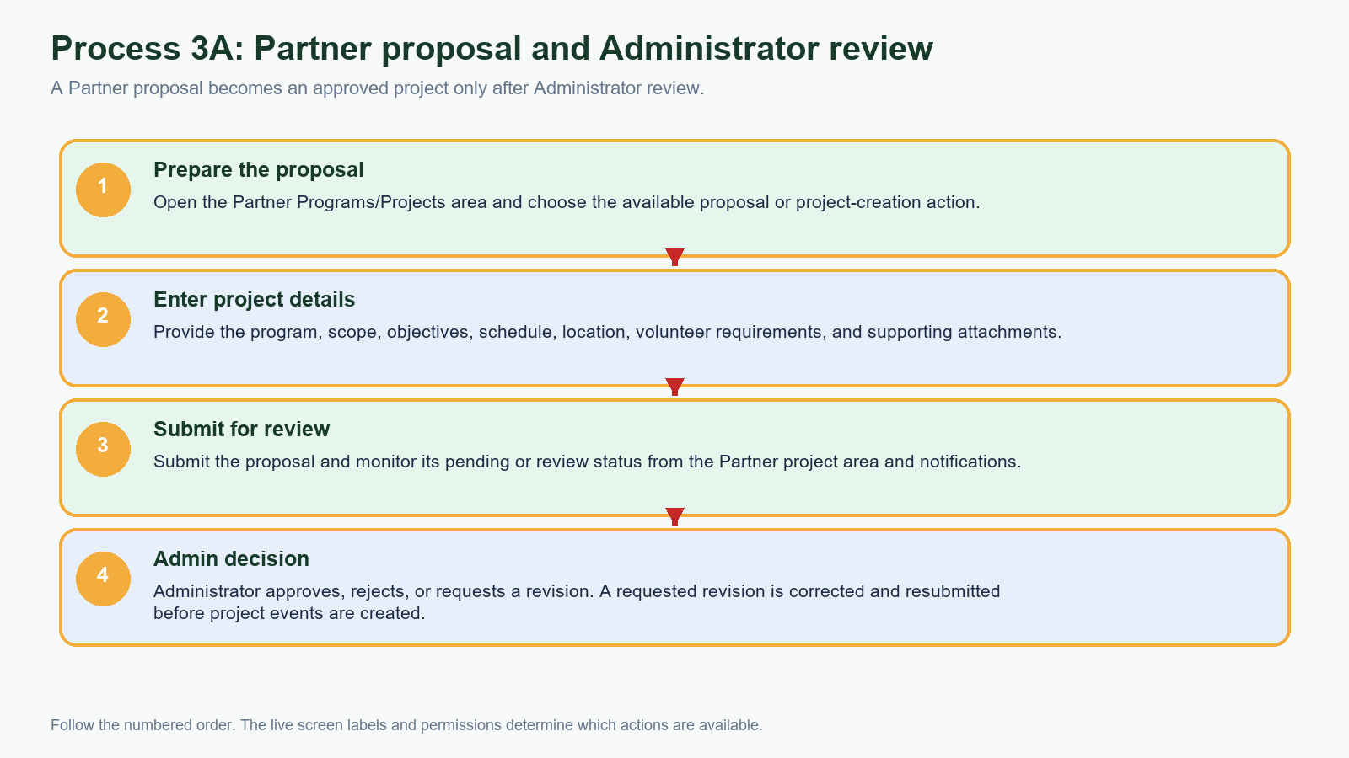
The Partner prepares and submits the proposal; the Administrator approves, rejects, or requests a revision before the project proceeds to event setup.
PROCESS PHOTO • PROCESS 4
Event setup and schedule tutorial
From an approved project, use Create Event to set up the activity; use the Admin Project Calendar to verify the date, schedule, and upcoming event list.
PROCESS PHOTO • PROCESS 4A — VOLUNTEER EVENTS
Volunteer Events screen
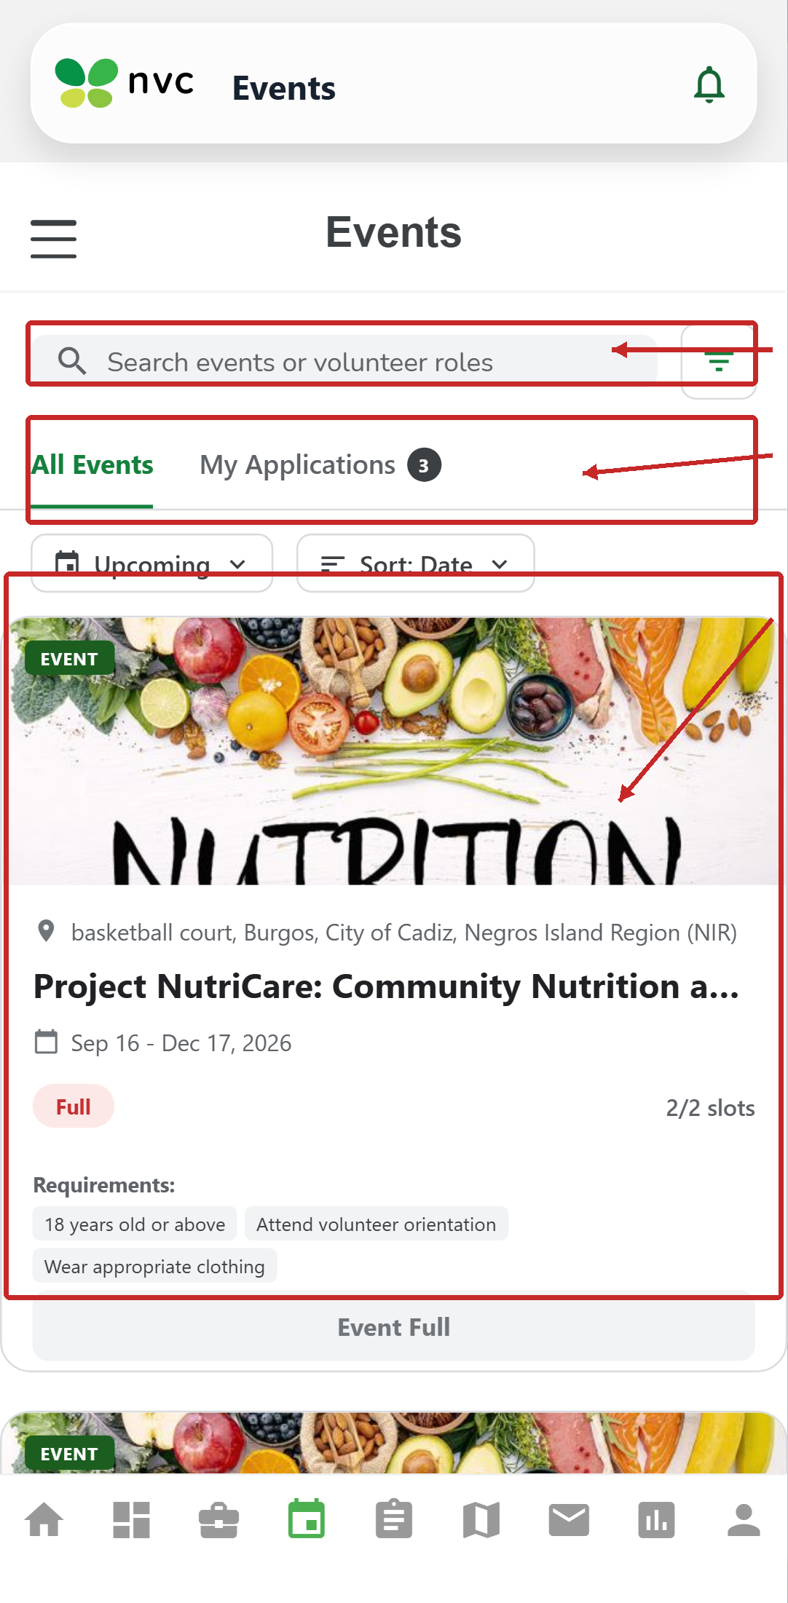
The volunteer uses the Events screen to search, switch between All Events and My Applications, filter upcoming activities, and review requirements/capacity before joining.
PROCESS PHOTO • PROCESS 4 — SCHEDULE REFERENCE
Admin Project Calendar
After creating or updating an event, confirm it appears in the correct calendar view and in Upcoming Events.
PROCESS PHOTO • PROCESS 5A — PROGRAMS
Volunteer Program Management screen
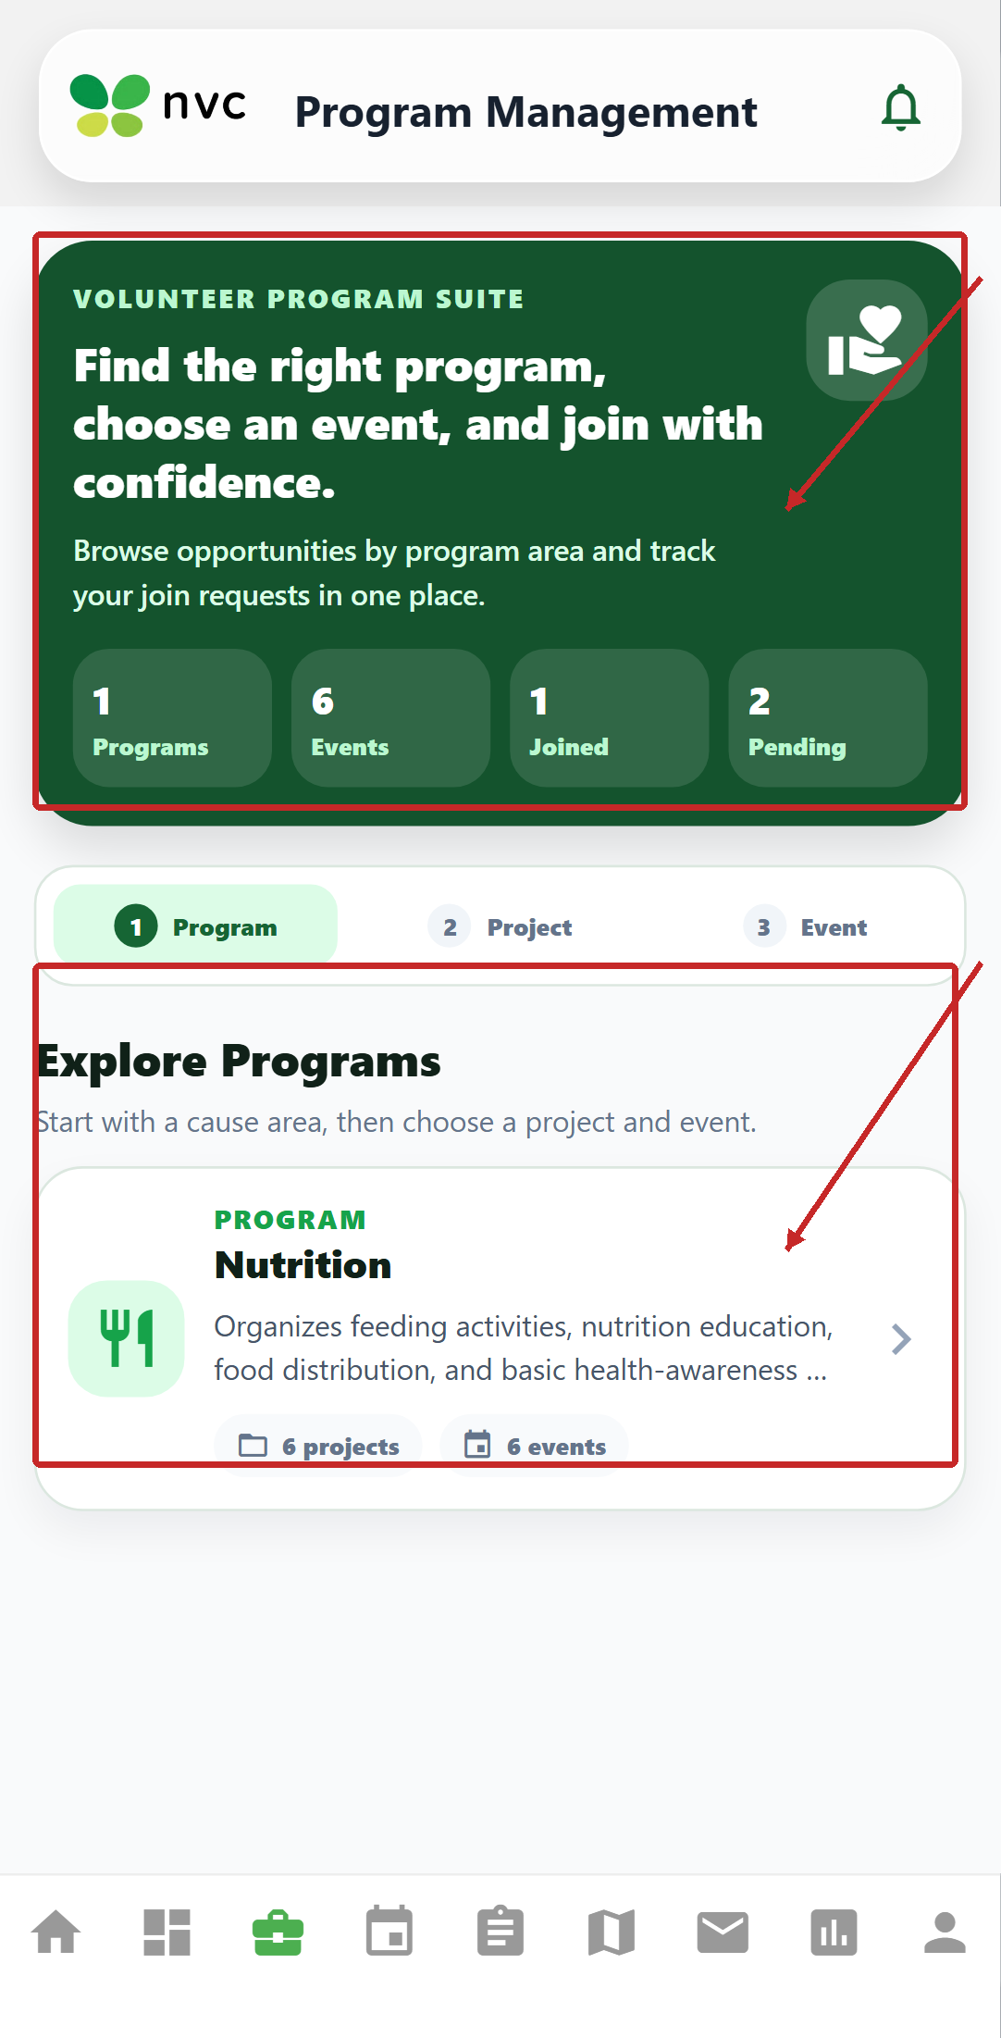
The volunteer follows the Program → Project → Event path, checks counts, and opens the program card to choose an available activity.
PROCESS PHOTO • PROCESS 5B — EVENTS AND REQUIREMENTS
Volunteer Events matching screen
Check the event date, location, capacity, and requirements before submitting an application or join request.
PROCESS PHOTO • PROCESS 5
Volunteer application and matching tutorial
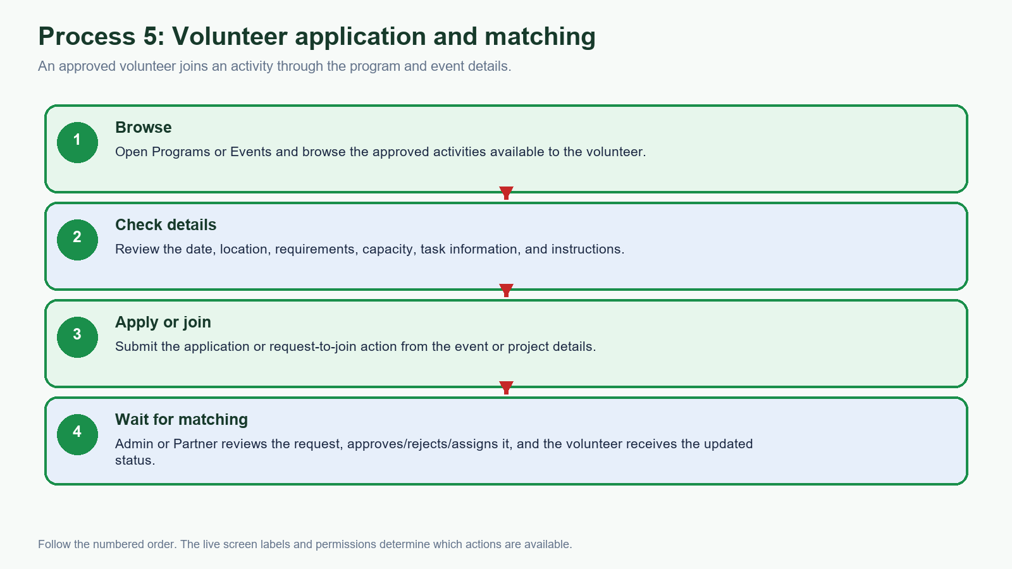
The volunteer checks event requirements before applying or requesting to join, then waits for the Administrator or Partner decision and assignment.
PROCESS PHOTO • PROCESS 6A — ASSIGNED TASKS
Volunteer My Tasks screen
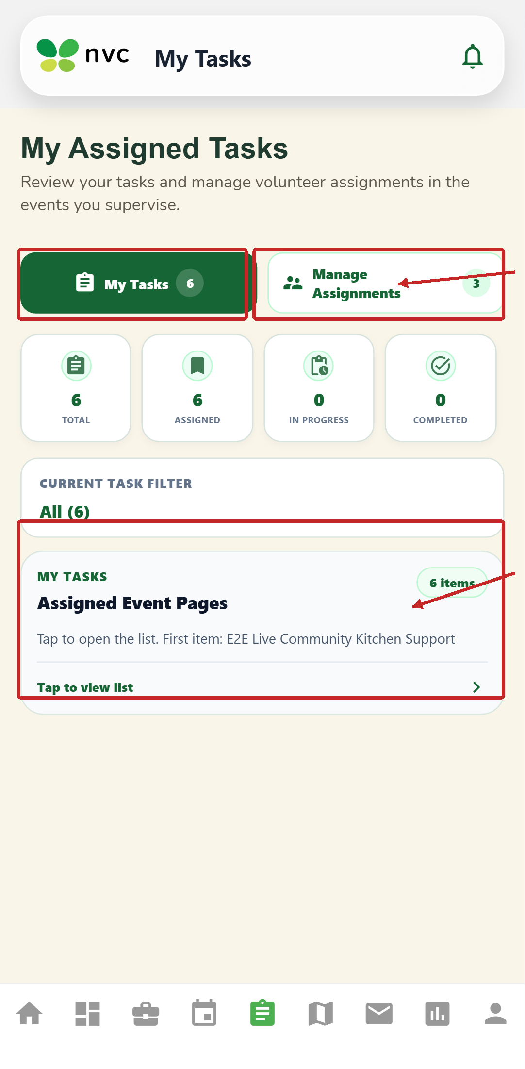
Open My Tasks to see assigned work, task counts, progress, and the assigned event list. Open the item to continue with attendance or completion actions available to the role.
PROCESS PHOTO • PROCESS 6
Activity and task completion tutorial
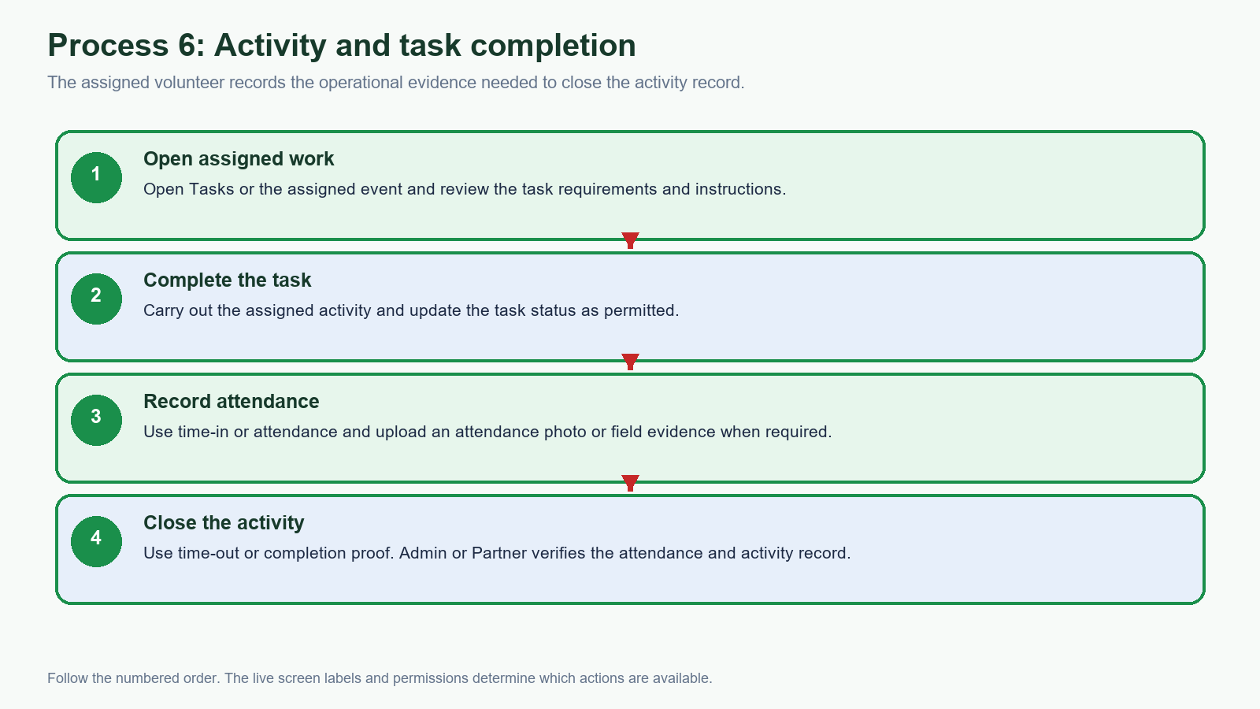
The volunteer completes assigned work, records attendance and evidence, and submits completion proof for Administrator or Partner verification.
PROCESS PHOTO • PROCESS 7
Partner coordination tutorial
The Partner coordinates project delivery through Messages and the project workspace while monitoring volunteers, tasks, attendance, and outcomes.
PROCESS PHOTO • PROCESS 8A — VOLUNTEER REPORTS
Volunteer My Reports screen
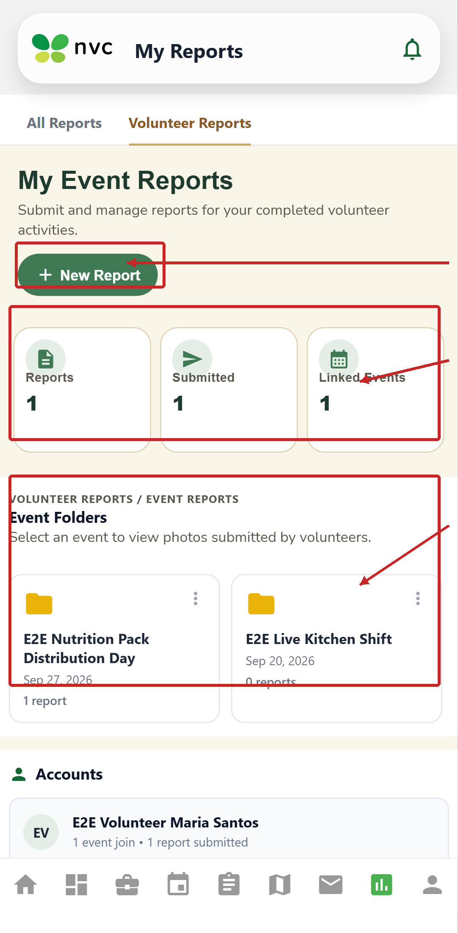
Open My Reports, select New Report for a completed activity, and use the event folders to review linked evidence and submitted reports.
PROCESS PHOTO • PROCESS 8
Reports and documentation tutorial
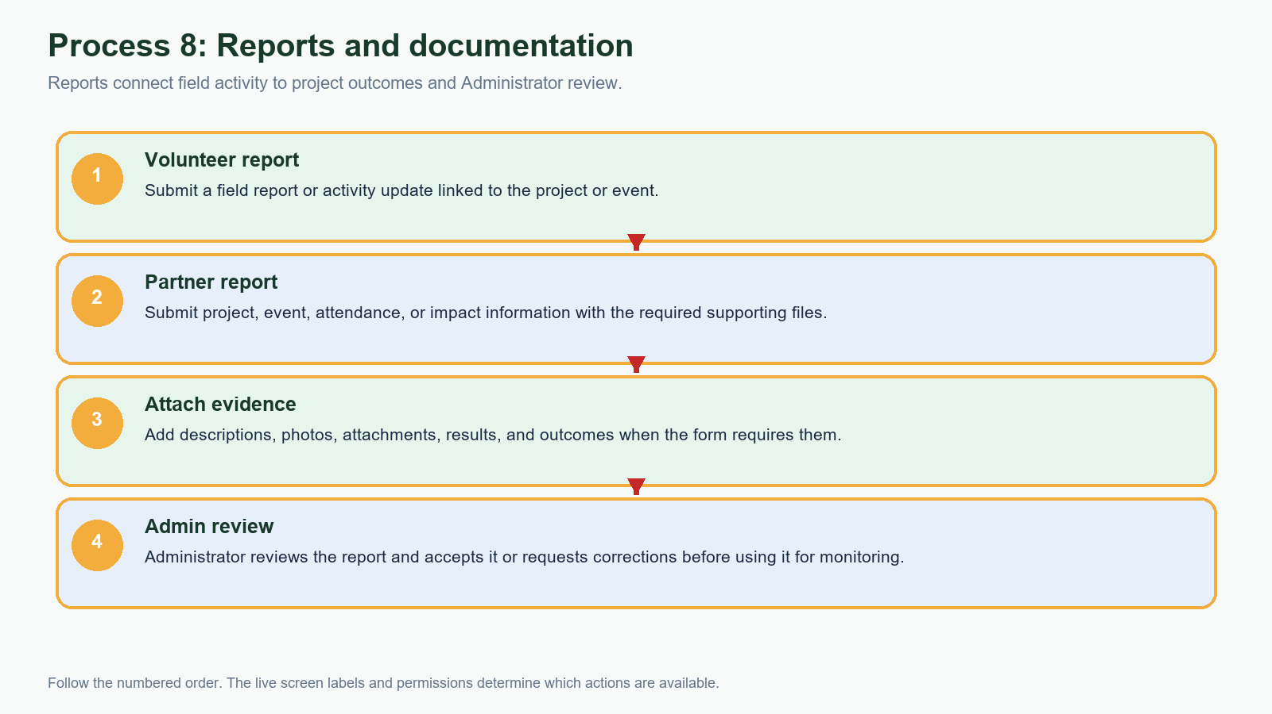
Volunteer and Partner reports are submitted with the appropriate evidence; the Administrator reviews the report and requests corrections when needed.
PROCESS PHOTO • PROCESS 9A — PARTNER MONITORING
Administrator Partner Management monitoring screen
Use Partner Management to monitor active partners, pending applications, partnered projects, and approved proposals before reviewing reports and impact data.
PROCESS PHOTO • PROCESS 9
Administrator monitoring and impact review
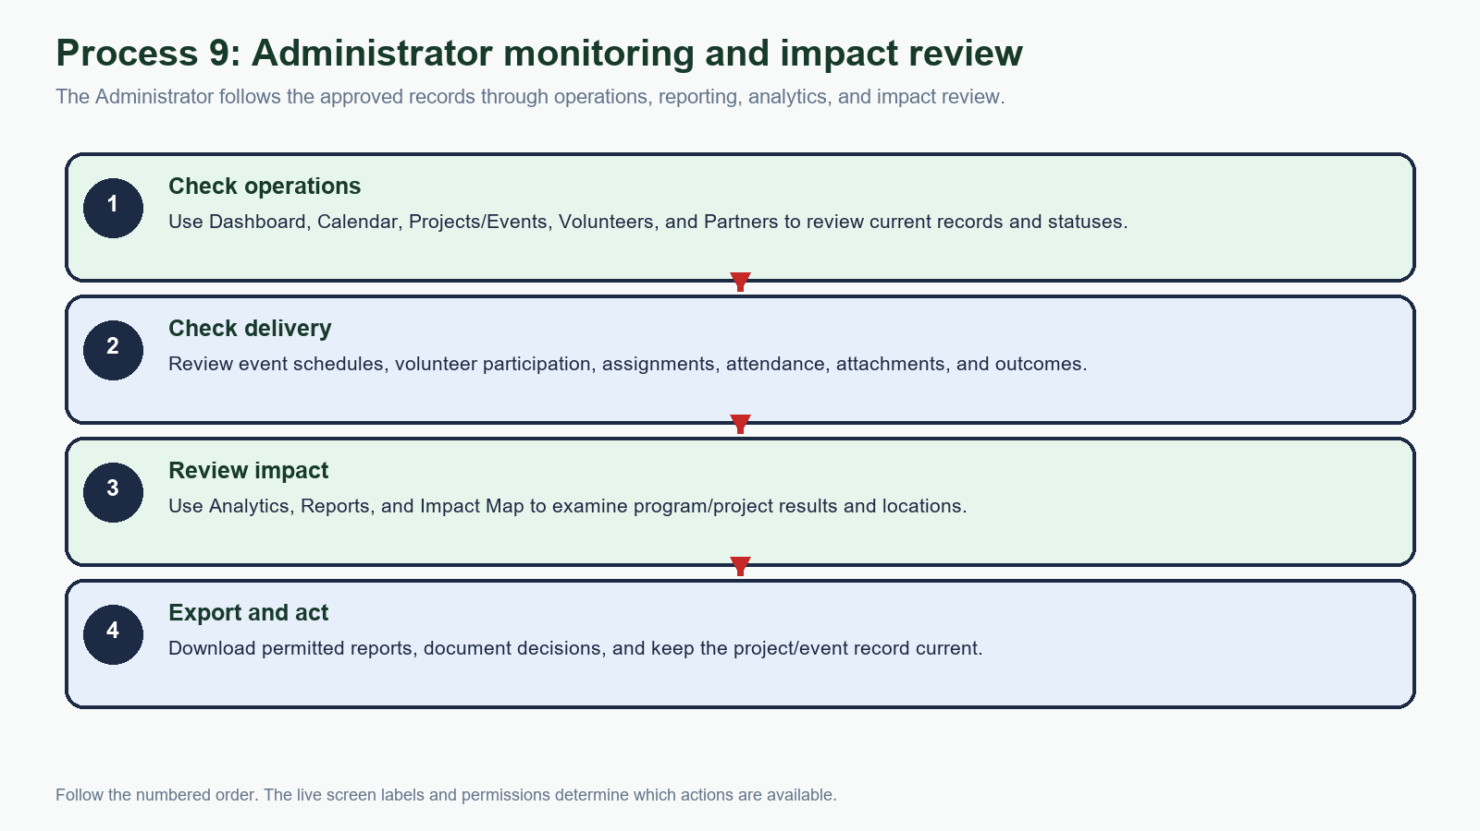
Use the Administrator tools in sequence: operational records first, then delivery evidence, Analytics/Reports/Impact Map, and permitted exports.
PROCESS PHOTO • PROCESS 9 — SCREEN REFERENCE
Administrator Dashboard monitoring screen
The Administrator starts from Dashboard, checks event records, and continues to Analytics, Reports, Impact Map, Volunteers, or Partners for review and exports.
PROCESS PHOTO • PROCESS 10
Communication and notifications tutorial
Messages, Event GC, Contacts, and the notification entry point keep role participants informed about approvals, assignments, reports, and status changes.
PROCESS PHOTO • PROCESS 11
Web and mobile synchronization tutorial
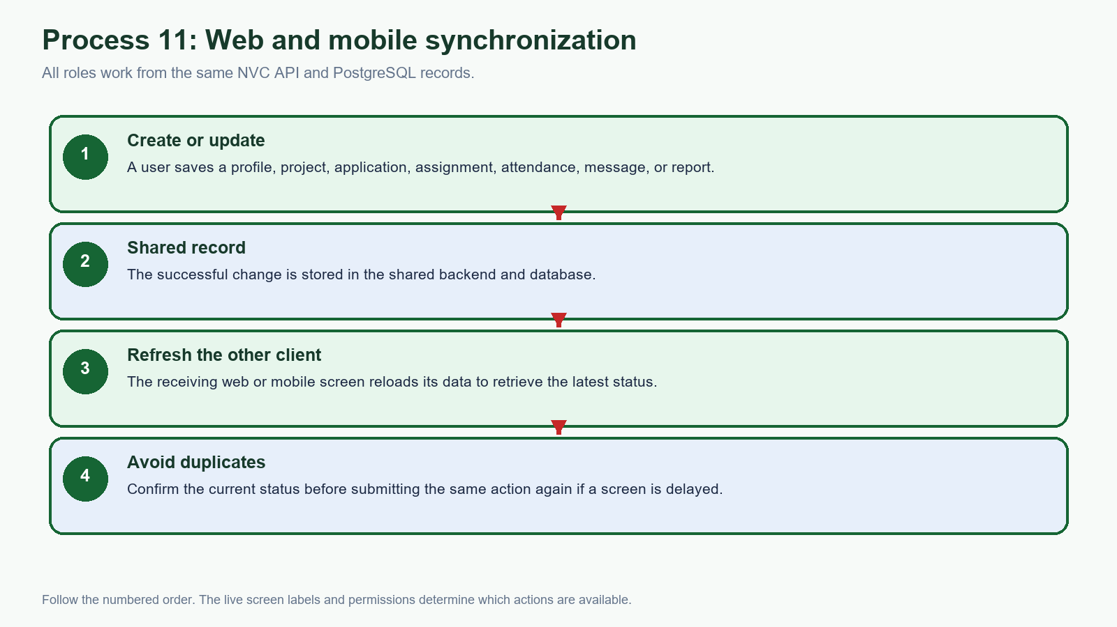
Save the change, refresh the receiving screen, and confirm the shared status. The full client/backend relationship is shown in Figure 1.

2. Getting started

2.1 Sign in
- Open the NVC web portal in a supported browser, or open the Android/mobile app.
- Enter the e-mail, username, or phone number registered to your account.
- Enter your password and select Log In.
- If the system requests verification, complete the current OTP or verification step sent through the configured channel.
- After authentication, the system opens the navigation appropriate to your role: Administrator, Volunteer, or Partner.
If sign-in fails: Check the account identifier, password, backend connection/status, and account approval status. Do not repeatedly submit a code or password when the system reports that the account is pending or not found.

2.2 Navigation patterns
Web portal | Mobile / Android
Use the left sidebar to open Dashboard, Programs, Projects/Events, Calendar, Volunteers, Partners, Impact Map, Messages, Analytics, Reports, Profile, and Settings as allowed by the role. | Use the bottom navigation icons for Home, Dashboard/Programs, Events or Projects, Tasks/Reports, Impact Map, Messages, Reports/Analytics, and Profile. The active icon is shown in green.
The account area at the top right contains the active profile and session actions. | The bell icon opens notifications. Page headers identify the current feature.

3. Administrator web portal
Administrators use the desktop web portal to coordinate the full program lifecycle. Work from the current record displayed on screen and refresh after a committed change when another role has just updated the same project or event.

3.1 Dashboard and daily review
- Open Dashboard from the left sidebar.
- Review the Google Calendar area, current month, event cards, and upcoming activities.
- Use Sync Calendar when the organization needs the latest configured calendar events.
- Open View Details on an event card to move into the related project or event workspace.
ANNOTATED SCREEN 02 • ADMINISTRATOR
Dashboard overview
Figure 2. the desktop dashboard exposes the sidebar, calendar synchronization, and event details The red boxes and arrows identify the control or information described in the surrounding steps.

3.2 Programs and projects
- Open Programs to see the program summary and active program cards.
- Select Add Program to create a new program, then complete the required title, description, pillar, dates, and supporting details.
- Open All Projects/Events to review project workspaces and event schedules.
- Within a project workspace, maintain events, volunteer requirements, tasks, attendance, attachments, and outcomes.
- Save each change, then confirm that the status and dates shown in the workspace match the intended record.
ANNOTATED SCREEN 03 • ADMINISTRATOR
Programs and Add Program
Figure 3. the Programs page provides a summary and the Add Program entry point The red boxes and arrows identify the control or information described in the surrounding steps.

3.3 Volunteers and partners
- Volunteers — review pending applications and documents, approve or reject applications, view profiles, and assign volunteers to projects or events.
- Partners — review organization applications and documents, approve or reject registrations, and open partner project workspaces.
- Impact Map — filter project/event pins and open a location or project detail.
- Messages — communicate with volunteers and partners; keep project-specific updates in the related conversation where possible.

3.4 Analytics and reports
- Use Analytics for volunteer, program/project, and event metrics and summaries.
- Use Reports for report submissions, uploads, project/event/attendance metrics, and download/export actions.
- Treat exported files as operational records and store them only in an approved location.

4. Volunteer mobile app
The mobile app is the volunteer’s field workspace. The bottom navigation remains available while moving between Home, programs/events, tasks, messages, reports, the impact map, and profile.

4.1 Home and notifications
- Open Home to see the NVC mission card, impact highlights, and current landing content.
- Select the bell to review notifications about applications, assignments, events, and messages.
- Use the bottom navigation to move to Programs or Events when looking for an activity.
ANNOTATED SCREEN 04 • VOLUNTEER
Volunteer Home
Figure 4. the Home screen highlights the mission, notification entry point, and bottom navigation The red boxes and arrows identify the control or information described in the surrounding steps.

4.2 Find and join a program or event
- Open Programs to browse available programs and projects.
- Open Events to search or review scheduled activities, then open the event/project details.
- Check the date, location, requirements, and available volunteer roles before selecting the join or application action.
- After submitting, monitor the application or joined status from the event/project details and notifications.

4.3 Messages, tasks, and reports
- Messages — search conversations, open Event GC or Contacts, and use the compose control to start a permitted conversation.
- My Tasks — review assigned events, task requirements, status, attendance, and photo/report submission actions.
- My Reports — view reports and submit or upload field information connected to the project or event.
ANNOTATED SCREEN 05 • VOLUNTEER
Messages and contacts
Figure 5. the Messages screen contains search, compose, message, event-group, and contact entry points The red boxes and arrows identify the control or information described in the surrounding steps.

4.4 Maintain the volunteer profile
- Open Profile from the bottom navigation.
- Review the role, account information, registration details, skills, certifications, affiliations, and location shown for the account.
- Select Edit Profile to update allowed personal, skills, availability, or location fields.
- Save the change and confirm the updated value appears after the profile refreshes.
ANNOTATED SCREEN 06 • VOLUNTEER
Volunteer profile
Figure 6. the profile page provides Edit Profile, account overview, status, and joined/completed event information The red boxes and arrows identify the control or information described in the surrounding steps.

5. Partner mobile app
The partner interface is designed for organization-led project delivery. Partner accounts can remain pending until an administrator reviews the registration and supporting documents.

5.1 Partner Home and registration status
- Open Home to see the partner space, organization greeting, registration/approval status, and mission information.
- If Registration is Pending, wait for administrator review or follow the application message requesting changes.
- Use the mission and program content to confirm that the organization is working in the intended NVC program context.
ANNOTATED SCREEN 07 • PARTNER
Partner Home and registration status
Figure 7. the Partner Home screen shows organization status and the shared mission content The red boxes and arrows identify the control or information described in the surrounding steps.

5.2 Projects, events, volunteers, and reports
- Open Programs to review program management and available project/proposal actions.
- Open Projects to view the organization’s project list and open a project workspace.
- Create or edit project and event information, volunteer requirements, tasks, attendance, attachments, and outcomes as permitted.
- Use Reports to view or submit project/event/attendance information and supporting files.
- Use Messages to coordinate with administrators and volunteers, especially when a project or proposal needs clarification.
ANNOTATED SCREEN 08 • PARTNER
Partner messages and contacts
Figure 8. the partner messaging workspace provides search, compose, event-group, and contact entry points The red boxes and arrows identify the control or information described in the surrounding steps.

5.3 Maintain the organization profile
- Open Partner Profile and review the organization/account information, registration details, contact/location details, and approval status.
- Select Edit Profile to update permitted organization information or supporting details.
- Save and verify the approval or registration status after the change is committed.
ANNOTATED SCREEN 09 • PARTNER
Partner profile
Figure 9. the profile page provides Edit Profile, account details, registration information, and approval status The red boxes and arrows identify the control or information described in the surrounding steps.

6. Detailed role hand-offs

6.1 Volunteer participation flow
- Volunteer signs up, completes the verification step when requested, and submits the required registration and supporting information.
- Administrator reviews the profile and documents, then approves, rejects, or requests changes.
- Approved volunteer browses programs/events and submits a join or application request.
- Administrator or partner reviews the request and confirms the assignment.
- Volunteer completes assigned tasks and attendance, then submits photos or a field report when required.
- Administrator or partner reviews the report and the record becomes part of the project outcomes and analytics.

6.2 Partner project flow
- Partner registers the organization and provides the required accreditation or registration information.
- Administrator verifies the organization and changes the registration status when the review is complete.
- Partner submits a project proposal or opens an approved project workspace with scope, location, schedule, and volunteer requirements.
- Administrator reviews the proposal and approves, rejects, or requests a revision.
- After approval, the partner runs project events, coordinates volunteers, records attendance, and submits reports/outcomes.

6.3 Administrator coordination flow
- Review pending volunteer and partner accounts and confirm that required profile, identification, accreditation, or registration documents are present.
- Approve, reject, or request changes to the account; approved users can access the role portal.
- Create or manage programs/projects, or review a partner proposal before it becomes an approved project workflow.
- Create or coordinate events, requirements, tasks, volunteer applications, assignments, and attendance.
- Review reports and outcomes, then use Analytics, Reports, and Impact Map to monitor the organization’s program impact.
Refresh point: Because the web and mobile clients use the same backend, a record created by one role should be available to another role after the receiving screen refreshes or reloads its data.

7. Synchronization and troubleshooting

7.1 Web/mobile synchronization
- A profile edit, application, assignment, attendance entry, message, report, or project change is saved to the shared backend when the action succeeds.
- If another client still shows the old value, use the page refresh/reload action or leave and reopen the screen.
- Do not create a duplicate record while waiting for a delayed refresh; confirm the current status first.

7.2 Common issues
Symptom | What to check
User cannot sign in | Identifier and password, account approval status, backend connection, and whether the account is using the correct role path.
Page is blank or still loading | Check connectivity, wait for the initial data load, refresh once, then reopen the screen. Report the screen name if it remains blank.
Application or assignment is not visible | Confirm that the previous action succeeded, refresh the receiving screen, and check the status/notification.
Map or calendar is empty | Check filters, dates, location data, and the configured map/calendar connection; empty results can be a valid filtered state.
Upload fails | Check file type/size, connection, required project/event link, and storage availability. Do not keep retrying a duplicate upload without checking the record.

7.3 Security and privacy
- Use only your own account and the least-privileged role needed for the task.
- Never share passwords, OTPs, session tokens, reset links, or trusted-device information.
- Redact names, e-mail addresses, phone numbers, identification documents, and private messages before sharing a screenshot.
- Log out on a shared computer or device and keep exported reports in an approved location.

8. Quick reference
Role | Start here | Common next actions
Administrator | Dashboard | Sync calendar; open event details; Programs; Projects/Events; Volunteers; Partners; Reports; Analytics.
Volunteer | Home | Programs; Events; Tasks; Messages; Reports; Impact Map; Profile.
Partner | Home | Programs; Projects; Messages; Reports; Impact Map; Partner Profile.

Support checklist: When reporting a problem, include the role, screen name, action taken, visible status/message, approximate time, and a redacted screenshot. Never include credentials or raw personal data.

Source and maintenance note
This manual was assembled from the current NVC codebase, system sitemap, role navigation, and demonstration screenshots captured from the local web/mobile interface. Update the manual when role permissions, navigation labels, or approval rules change materially.

