**Synergy Analyses for Mixed Radiation Fields That Induce Non-Targeted Effects**

Dae Woong Ham1, Binglin Song1, Jian Gao3, Julien Yu1, and Rainer K. Sachs1,2

1 Department of Mathematics, University of California at Berkeley

2 Corresponding Author. Rainer K. Sachs, [sachs@math.berkeley.edu](mailto:sachs@math.berkeley.edu), 510-658-5790

3 Department of Statistics, University of California at Berkeley

1. Abstract

Synergy analysis compares the dose-effect relationship of an agent mixture, such as a mixed radiation field, to the individual dose-effect relationships (IDERs) of the mixture components. It is often taken for granted that synergy means an observed effect larger than the effect calculated by simply adding IDER values. But it has long been known that if mixture component IDERs are highly curvilinear this simple effect additivity criterion is wrong, and many replacements have been suggested in the literature. If high charge and energy (HZE) ions induce non-targeted effects, corresponding IDERs are highly curvilinear at low doses, simple effect additivity is an inappropriate no-synergy/no-antagonism baseline, and a replacement is needed for planning and interpreting future mixture experiments involving many HZE.

We consider a replacement based on a non-linear ordinary differential equation and clarify the formalism by giving a detailed *in silico* re-analysis of previously published and analyzed experimental information on HZE induced chromosome aberrations. Suitable IDERs are developed, compared to published models of the same data, and used in synergy analyses, including 95% confidence intervals, for illustrative HZE mixtures.

Lengthy appendices give a broad survey of the different synergy analysis methods currently used in biology, emphasizing aspects relevant to radiobiology. For example certain methods are applicable to mixed radiation fields some of whose components are themselves mixed beams due to interactions with intervening matter before hitting the biological target.

It is not yet known whether future mixed beam experiments with a large number of components will sometimes show statistically significant synergy. If they do, combinatorial complexity issues could become a major roadblock in NASA planning for extended missions outside low-earth orbit.

# 2. Introduction

NASA has been concerned about possible synergy when mixed radiation fields produce biological damage (reviewed, e.g., in [Norbury, Schimmerling et al. 2016],[Siranart, Blakely et al. 2016]), and there is evidence that synergism sometimes occurs (e.g. [Bennett, Cutter et al. 2007]).

We will use a chromosome aberration (CA) data set to illustrate mathematical synergy analysis, emphasizing the following points: mathematical aspects of synergy and antagonism for mixed radiation fields; the possibility that high charge and energy (HZE) radiations induce non-targeted effects (NTE) due to inter-cellular interactions; and the curvilinearity of dose-effect relationships when NTE are important. NTE may be important at very low doses; throughout this paper “very low” dose is taken to mean 0≤ dose < 0.005 Gy.

A mixed radiation field consists of N≥2 components. Each 1-ion component, when acting by itself, has a dose-response relation consisting of background plus radiogenic contributions. We will call the radiogenic contribution the component’s individual dose response relation (IDER); thus by definition IDERs are always zero at zero dose. Usually it will also be assumed IDERs have continuous first and second derivatives at all relevant doses. For example, unless explicitly stated to the contrary, a linear IDER with threshold is excluded in any general statement because it has one point where the first derivative is discontinuous and the second derivative is infinite.

As in the paragraphs above, there will be a number of special conventions, terms and acronyms in this paper, including some new acronyms such as “IDER”. The examples used most frequently in the paper, the least familiar ones, and some mathematical notation are summarized in a glossary and a list of mathematical symbols (Appendices A1.1 and A1.2).

## 2.1. Background

NTE IDERs, incorporating NTE in addition to more standard targeted effects (TE), have recently been suggested for HZE radiation induction of some endpoints [Cucinotta, Kim and Chappell 2013]. The endpoints include murine Harderian Gland tumorigenesis (reviewed in [Chang, Cucinotta et al. 2016]) and CA in human fibroblasts (reviewed in [Cacao, Hada et al. 2016]). At low doses NTE IDERs differ very substantially from being linear. They are highly curvilinear or fail to have continuous first and second derivatives. This behavior will be emphasized throughout this paper.

### 2.1.1. Mathematical Synergy Analysis when IDERs are Curvilinear

Mathematical synergy analysis compares an observed mixture dose-effect relationship (MIXDER) with an appropriate baseline MIXDER that defines absence of synergy and antagonism [Foucquier and Guedj 2015]. The baseline MIXDER is obtained by mathematical manipulations of the component IDERs [Berenbaum 1989].

Most biologists take for granted the simple effect additivity baseline MIXDER, obtained by using each component’s individual dose, which is some fraction of the total mixture dose, to calculate the component’s individual effect, and then simply adding up all the contributions from all the components to give the baseline MIXDER defining absence of synergy or antagonism. However, it has been known for a very long time [Fraser 1872; Loewe and Muischnek 1926] that, when individual components of an agent mixture have highly curvilinear IDERs, rather than approximately linear-no-threshold IDERs, the simple effect additivity baseline no-synergy/no-antagonism MIXDER is usually quite inappropriate (reviewed in [Geary 2013; Foucquier and Guedj 2015; Piggott, Townsend et al. 2015; Tang, Wennerberg et al. 2015]).

One problem with simple effect additivity is that, as reviewed in [Berenbaum 1989], it typically violates what is called the “sham mixture” principle: mentally dividing the dose of one agent into two parts and then applying synergy analysis to this sham mixture should give the same answer as just using the total dose. Fig. 1 panel Ashows a schematic, illustrative example where simple effect additivity violates the sham mixture principle. Later in the present paper we will give examples of mixed fields where using simple effect additivity gives a dubious or even flatly incorrect definition of no-synergy/no-antagonism. When IDERs are highly curvilinear*,* an alternative to simple effect additivity is typically needed.

|  |  |
| --- | --- |
|  | **Fig. 1. Simple effect additivity is not appropriate for**  **mixtures of components with highly curvilinear IDERs.**  Panel **A.** Consider a hypothetical case where a 1-ion beam has pure quadratic IDER *E*=*βd*2 with *β=*1Gy-2(black line). Regard the beam as a 50-50 mixture of two 1-ion beams, both of which happen to have the same dose response curve as the original beam. Then for total mixture dose *d,* each of the two beams contributes dose *d/2* and thus has effect *E*/4. Using simple effect additivity thus gives baseline no-synergy/no-antagonism MIXDER *E*/2 rather than the value *E* required by the sham mixture principle.  This violation of the sham mixture principle is symptomatic of unrealistic synergy analyses for actual mixtures. For example, suppose every IDER for a mixture is highly convex, as in panel **A**. Then the simple effect additivity baselinewill be an unrealistic underestimate (like the red curve).  If instead every IDER is concave (panel **B**) then simple effect additivity is likely to be an unrealistic overestimate. |
| Panel **B** shows results for hypothetical 1-ion dose response curves *Ek(dk)*=1-exp(*-αkdk*) with *k*=(1,2), *α1*=4 per Gy, and *α2*=2 per Gy. Instead of being approximately the average of the two IDERs the simple effect additivity baseline dose effect relation for a 50-50 mixed ion beam of the two ions (red curve) becomes larger than that for either ion by itself even though it is supposed to characterize absence of synergy. Such problems with simple effect additivity are well known in pharmacometrics, toxicology, evolutionary ecology and other fields. | |

One alternative to simple effect additivity is incremental effect additivity [Siranart, Blakely et al. 2016]. “Incremental” refers to the fact that an ordinary differential equation (ODE) is used to quantify incremental effect additivity. Intuitively speaking: incremental effect additivity deals with IDER and MIXDER slopes; an IDER slope of course defines a linear relation between a sufficiently small dose increment and the corresponding effect increment [Lam 1987]; thus by analyzing sufficiently small increments one can circumvent the curvilinearities that render simple effect additivity unusable. This incremental approach has become practical because computers have become adept at solving non-linear ODE.

### 2.1.2. A Data Set that will be Emphasized as an Example

This paper includes a re-analysis of previously published and analyzed data: the 82-6 fibroblast CA data in [Hada, Chappell et al. 2014] and [Cacao, Hada et al. 2016] for whole genome equivalent (WGE) simple exchanges induced by HZE or γ-ray irradiation. This will be called our “main-example” data set. Our re-analysis does not present new data; the re-analysis is entirely *in silico.* The re-analysis emphasizes mathematical synergy analysis, rather than the biophysical or translational implications of the data.

The doses were effectively instantaneous (“acute”). The only shielding was from matter unavoidably in the beam; no extra shielding was intentionally added. Evidence that at very low HZE doses NTE produce CA in these fibroblasts was given in [Cacao, Hada et al. 2016]. The re-analyses did not revisit this question; instead we assumed NTE were in fact operative at very low doses and focused on the implications for mathematical synergy analysis.

Similar 82-6 fibroblast experiments at Brookhaven NASA Space Radiation Laboratory (NSRL) are ongoing. These sometimes use additional kinds of ions (such as protons), or use ion mixtures. The results have not yet been published and are not considered in this report. However, we have aimed at providing a suitable framework for systematic synergy analysis of the mixture experiments, using information on their component IDERs from [Hada, Chappell et al. 2014], [Cacao, Hada et al. 2016], and/or the additional 1-ion experiments.

## 2.2. Methods and Limitations of Mathematical Synergy Analysis

### 2.2.1. Many Methods

In biology, there are now many different mathematical approaches to analyzing synergy. Generally no two of these approaches are fully equivalent. Some of the approaches are described, reviewed and compared in [Zaider and Rossi 1980; Berenbaum 1989; Zaider 1990; Lam 1994; Chou 2006; Lorenzo and Sanchez-Marin 2006; Zhou, Bennett et al. 2006; Boedeker and Backhaus 2010; Brun and Greco 2010; Tallarida 2012; Geary 2013; Foucquier and Guedj 2015; Piggott, Townsend et al. 2015; Tang, Wennerberg et al. 2015; Siranart, Blakely et al. 2016; Sollazzo, Shakeri-Manesh et al. 2016]. To avoid confusion, which is rife in this area, it is important to characterize carefully the particular approach used [Foucquier and Guedj 2015].

All current approaches to mathematical synergy analysis, including a new approach introduced in Appendix A4, have substantial limitations. Because such limitations are sometimes soft-pedaled, we discuss most of the major ones at some length, in the paper and/or in the paper’s appendices.

### 2.2.2. Limitations of Mathematical Synergy Analysis

For example, one major limitation is that, as already mentioned, mathematical synergy analysis produces only a baseline MIXDER. Mixture component interactions can produce synergy or antagonism, i.e. deviations from the baseline. Mathematical manipulations of IDERs are needed to define synergy but cannot predict it [Lam 1994]. If there is significant synergy or antagonism, biophysical insights and/or multiple mixture experiments, not just mathematical manipulations of IDERs, are needed to characterize mixture effects [Zaider and Rossi 1980; Berenbaum 1989; Geary 2013; Kim, Rusek et al. 2015; Norbury, Schimmerling et al. 2016]. A related limitation is that *in silico* synergy analysis becomes less and less important as fundamental biophysical understanding of mixture effects grows (Fig. 2).

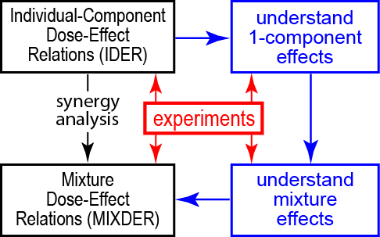**Fig. 2. Investigating mixture effects: a long hard road or a temporary shortcut.** Eventually, but almost certainly not soon, synergy analysis of mixed radiation field effects, based solely on mathematical manipulations of IDERs (leftmost downward arrow), will be replaced by biophysically-based predictions that incorporate whatever synergy or antagonism actually occurs (blue path). For the time being, optimizing mathematical synergy analysis, a much simpler, faster and cheaper shortcut, is important.

As will be discussed, there are other major limitations. For example, most current synergy analysis methods emphasize a single scalar endpoints, not more complicated endpoints such as a dose-dependent function of time to tumor.

## 2.3. Preview

*2.3.1. Outline*

This paper calculates baseline no-synergy/no-antagonism MIXDERs for mixture experiments whose HZE components have NTE IDERs. The paper will illustrate incremental effect additivity by applying it to our main-example data set, the CA data specified in sub-section 2.1.2. The emphasis is on an appropriate mathematical synergy analysis in a situation where there is evidence that NTE are important, so that IDERs highly curvilinear at very low doses are needed.

…..Appendices give a broad overview of current synergy analysis, emphasizing mathematical and statistical aspects relevant or potentially relevant to radiobiology. For example Appendix A4.4 on the mixtures of mixtures principle discusses the implications for synergy analysis of the fact, reviewed, e.g., in [Cucinotta, Kim and Chappell 2013; Norbury, Schimmerling et al. 2016] that each individual component of a mixed beam is usually itself a mixture by the time it hits its target, due, for example, to self-shielding in an animal. The appendices also review earlier work that helped motivate the new “differential synergy analysis” defined and described in Appendix A4. This earlier work includes linear isobole mathematical synergy analysis [Berenbaum 1989], here reviewed in Appendix A2, and incremental IDER calculations [Lam 1987].

### 2.3.2. IDERs Used.

By modifying the NTE models in [Cacao, Hada et al. 2016], we developed IDERs to analyze our main-example data. Our models have the following properties: they are “smooth” (have continuous derivatives of all orders) and thus have finite slope everywhere; they are monotonic increasing; and they have the curvilinearity properties shown in Fig. 3. Once developed, our IDERs will be calibrated, compared to the IDERs in [Cacao, Hada et al. 2016], and then used to illustrate various aspects of synergy analysis.

|  |
| --- |
| **Fig. 3. IDER slope, concavity, and convexity.**  IDERs of many different shapes are used in biology. The IDERs we will use in our main-example calculations, shown schematically in the figure, are smooth. They have positive first derivative at all relevant doses, i.e. the slope is >0 so the IDERs are monotonically increasing. The slope at the origin is very large, but finite. The IDERs have negative second derivative, and therefore a concave shape, at doses so low that NTE putatively dominate. At higher doses, the second derivative becomes positive (convexity), then very slightly negative (very slight concavity), then nearly zero at large doses. This near-linearity at large doses substantially simplifies some of our later calculations. In general, as discussed in Appendix A4, IDER behavior at large doses can be less convenient in a number of different ways.  For our main-example data the steep rise at very low doses is inferred indirectly, not observed directly: effects observed directly at larger doses (≥ 1 cGy) appear to be higher than a linear no-threshold model can account for. |

# 

# 3. Methods

## 3.1. Customized Software

We used the free, open-source computer language R [Matloff 2011], initially designed for statistical calculations but now rapidly gaining acceptance among modelers [IEEE 2014]. Our customized source codes are available, no strings attached, at <https://github.com/rainersachs/NASAfibroblastCA> and also at <https://github.com/DavidHam97/NASA2>.

## 3.2. IDERs

### 3.2.1. Notation, IDER Derivatives, and IDER Curves

In this paper, mixed *N*-beam irradiation with dose *dj* of component beam *j* (*j*=1, …, *N*) is considered. Component IDERs are denoted *Ej(dj),* or sometimes *E(d).* Sometimes biophysical parameters such as LET are used to characterize the different components and replace the label *j*. Each IDER used in our main-example synergy analysis calculations, like the curves shown in Fig. 3, obeys the smoothness and monotonic increase conditions of sub-section 2.3.2. Being for radiogenic effects these IDERs also obey *Ej(0)=0*. However, calibrating these IDERs also involves estimating a background *Y0* from data at zero dose.

Appendices A3 and especially A4 give many results for situations where one or more of the smoothness and monotonic increase conditions of sub-section 2.3.2 do not hold. For example, differential synergy analysis (Appendix A4) is especially useful in situations where a mixture component acting on its own has an IDER that can only approach from below but never reach an effect, with that effect being smaller than the maximum mixture effect of interest.

### 3.2.2. Relevant Ion Characteristics and the IDERs in [Cacao, Hada et al. 2016]

The main-example data considered in this paper was modeled previously, in [Cacao, Hada et al. 2016], with three kinds of models, Linear, NTE1, and NTE2. The Linear model does not incorporate NTE but the other two incorporate both TE and NTE.

All three models were motivated by Katz’ parametric track structure approaches which relate heavy ion action to the action of gamma rays via analyzing delta-ray tracks. The Katz approaches and some generalizations or alternatives are reviewed, e.g., in [Katz 1988; Cucinotta, Nikjoo et al. 1999; Goodhead 2006; Cucinotta, Kim, Chappell et al. 2013; Hada, Chappell et al. 2014; Cacao, Hada et al. 2016]. Our present paper emphasizes IDERs that modify the NTE term of the NTE2 IDERs in [Cacao, Hada et al. 2016]. For later comparisons, we now review the equations of these NTE2 IDERs. More details on, motivations for, and intuitive or biophysical explanations of these NTE2 equations and related equations are in the above references.

The NTE2 IDERs used the biophysical parameters in Table 1.

|  |  |  |  |  |  |  |
| --- | --- | --- | --- | --- | --- | --- |
| **ion** | **16O** | **28Si** | **48Ti** | **56Fe** | | |
| *Z* | 8 | 14 | 22 | 26 | | |
| *E/u* (MeV) | 55 | 170 | 600 | 600 | 450 | 300 |
| *L* (keV/μm) | 75 | 100 | 125 | 175 | 195 | 240 |
| *Zeff2/β*2* | 595 | 690 | 770 | 1075 | 1245 | 1585 |
| *dmax* (Gy) | 0.4 | 1.2 | 0.6 | 0.8 | 0.4 | 0.8 |

**Table 1. Dose and Track Parameters.**

*Z* is atomic number. *E/u* is kinetic energy per atomic mass unit. *L* isstopping power *LET∞*, *Zeff* is the effective ion charge, almost equal to Z for the ions and *E/u* values shown. *β\** is ion speed relative to the speed of light. Values given here, rounded to be divisible by 5, are from GERMcode (reviewed in [Kim, Rusek et al. 2015]), from [Hada, Chappell et al. 2014], from the supplement to [Cacao, Hada et al. 2016], and from the standard formula for *Zeff* [Kraft, Kramer et al. 1992]. *dmax* is the maximum dose for that ion in the main-example data set.

The NTE2 model calculates effect as a sum of three terms: background *Y0*; an NTE contribution, here denoted by *ENT;* and a TE contribution *ET*. Different ions are characterized by their values of *L* and (*Zeff*/*β\**)defined in the caption to Table 1. The NTE2 model equation has the form

(1) 

We define the NTE2 IDER to be the sum of the last two terms (i.e. with background subtracted out). For the ions in Table 1, the NTE contribution *ENT* dominates the TE contribution *ET* at very low doses.

The NTE contribution was taken to have a discontinuity [Cacao, Hada et al. 2016]. It jumps straight up, at an “ultra-low” dose *d0* smaller than any non-zero dose that is likely to be used for such data in the foreseeable future,from 0 to an LET-dependent height. The jump height *η(L)* was taken to dependon ion LET *L* (Table 1, second to last row) by the following equation

(2) .

Here *η0* and *η1* are dose- and ion-independent adjustable parameters estimated from the data. In [Cacao, Hada et al. 2016] *d0* was taken to be 0, but it could equally well have been take as any other dose that is ultra-low in the sense specified above, in analogy to the method used in [Cucinotta and Chappell 2010]. The full NTE term was taken as

(3) 

Here: *I* jumps with infinite slope from 0 to 1 at any ultra-low dose; *F* is ion fluence, with the numerical factor 6.242 applicable when *d* is in Gy and *L* in keV/μm; and *H* is the number of track core intersections with an 82-6 fibroblast cell nucleus that is considered to have cross sectional area *A*=162 *μ*m2.

In [Cacao, Hada et al. 2016] the TE contribution added to the above NTE contribution to get the NTE2 IDER was given by

(4) 

In Eq. (4) the dose-independent, ion-dependent quantity *σ* is given by:

(5) .

Eq. (5) contains three real, positive dose- and ion-independent adjustable parameters: *σ0, κ*, and *m*. References such as [Katz 1988; Cucinotta, Nikjoo et al. 1999; Goodhead 2006; Cucinotta, Kim, Chappell et al. 2013; Hada, Chappell et al. 2014; Cacao, Hada et al. 2016] interpret *σ0* as an effective cross section of the biological target, interpret *P* as a probability, explain Eq. (5), and motivate it. In Eq. (5) *αλ* is the linear coefficient of the linear-quadratic fit to the gamma-ray dose-effect relationship for the same endpoint, here WGE simple CA per 100 cells. A separate calculation gave *αλ* = 0.041±0.0051 Gy-1. The effective cross section *σ0* and the parameter *κ* have to be estimated using data. In the calculations most relevant to the present paper, *m* was fixed at *m*=2 by the biophysical argument that it takes two DNA DSB to make one simple CA.

The relevant calibrations in [Cacao, Hada et al. 2016] thus determined 5 adjustable parameters which are positive numbers that are independent of dose and ion, *Y0*, *η0*, *η1,* σ0, and *κ*. After calibration, the models were considered applicable to any ion, with given charge Z (for present purposes 8≤Z≤26), atomic mass number u, and any speed that is not too large or small. An example of the resulting IDERs is shown in Fig. 4.

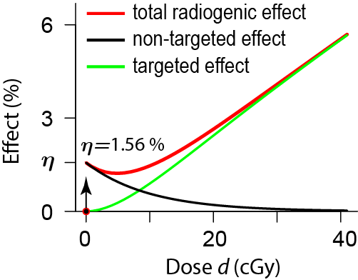**Fig. 4. Some properties of the NTE2 model*.*** Shown is a red curve for the total radiogenic effect, CA per cell, of Si ions between 0 and 40 cGy, here calculated by using the results of [Cacao, Hada et al. 2016] when they applied their NTE2 model to the main-example data set. In the NTE2 IDERs the total radiogenic effect is the sum of NTE and TE contributions (black and green curves). The two properties most relevant for the discussion of IDERs in our paper are the following. First, NTE are modeled as jumping, at an ultra-low dose smaller than 1 mGy, from 0 to *η* with infinite slope (arrow) and then decaying back to 0 (black curve). As a result the total radiogenic effect is decreasing rather than increasing at doses between the ultra-low dose and ~5 cGy. The second relevant property is that at doses larger than about 10 cGy, where the NTE2 model predicts TE are starting to dominate NTE, the TE curve (green) has a positive slope that is almost constant.

For other ions of interest here, the NTE2 model gives qualitatively similar curves.

### 3.2.3. Smooth Non-Targeted Effect (SNTE) IDERs

Our incremental effect additivity synergy analysis requires smooth monotonically increasing IDERs (sub-section 3.2.1). The NTE2 IDERs in [Cacao, Hada et al. 2016] does not, as can be seen in Fig. 4, meet these conditions so we developed substitute IDERs. The main-example data considered (sub-section 2.1.2) are not informative about any details at very low doses. They do suggest NTE which lead to a large average positive slope at very low doses, whose cumulative influence builds up a CA frequency *ENT* sufficiently large to be detectable above background and noise at doses ≥ 0.01 Gy (Figs. 3 and 4). To take into account IDER shape in a way consistent with the concavity found in mechanistic models for NTE for other endpoints [Brenner, Little et al. 2001] the discontinuous NTE contribution was replaced by a smooth non-targeted (SNT) contribution:

(6) 

In this equation the dose *d0* is a nominal value < 1 mGy which controls how rapidly effect *E* rises in the very low dose region (Fig. 5). We used *d0*=0.01 mGy in most of our calculations. Numerical explorations show that the final results are insensitive to *d0* as long as *d0* is much less than 10 mGy, the lowest dose at which data is available in our main-example data set. In Eq. (6) we use the same symbol and equation for *η(L)* as were used for the conceptually similar quantities in [Cacao, Hada et al. 2016].

|  |
| --- |
| **Fig. 5. IDER shape at very low doses.** The figure shows modeled NTE contributions to total effect for Si ions (*L=*100). Red lines are for Eq. (3), used in [Cacao, Hada et al. 2016], where the slope at dose=0 was taken to be infinite. The subsequent decrease at higher doses, shown in Fig. 4, is here barely visible at 1 mGy where the red line has dipped slightly below the horizontal line at height *η(L)*. The three black curves are for our smoothed model, Eq. (6), with the respective *d0* values, from left to right, of 0.02, 0.1, and 0.5 mGy. Our final results are essentially unchanged if any value of *d0* ≤0.1 mGy is used. The black curves are monotonic increasing at all doses; they approach *η(L)* and zero slope as dose increases*.* The value for *η(L)* after model parameter calibration is different for the red and black curves, but the y-axis has here been linearly re-scaled to facilitate comparison of the curves. |

In addition to thus replacing the discontinuous function *I* by a smooth function*,* Eq. (6) also differs from Eq. (3) by omitting the factor exp(-*H*). We reasoned that even at doses above a few mGy intercellular signaling still occurs and produces some effect, which at doses where TE dominate is just a small perturbation that cannot be disentangled experimentally from the overall effect. The NTE1 model in [Cacao, Hada et al. 2016], which ultimately turned out to be their preferred model according to information criteria, also omits this exp(-*H*) term.

For the targeted contribution *ET* our IDER model uses Eq. (5) above that was used in the NTE2 model, setting *m*=2 and *αλ* = 0.041±0.0051 Gy-1.

To summarize, our IDERs *E(d; L, Zeff*/*β*)* for radiogenic effect, which we shall call the Smooth Non-Targeted Effect (SNTE) model IDERs, is defined by the following equations:

(7) 

Here: *L* and Zeff/*β\** are given by Table 1 (so that *β\** is ion speed relative to the speed of light); *η(L)* depends on two adjustable parameters *η0* and *η1* via Eq. (2) just as in [Cacao, Hada et al. 2016]; *d0* has the nominal ultra-low value 0.01 mGy; *F* is fluence; *H* is hit number for a 82-6 fibroblast cell nucleus; and *σ*, given by Eq. (5) from [Cacao, Hada et al. 2016], involves two adjustable dose- and ion-independent parameters, *σ0* and *κ*. Like the NTE1 and NTE2 models in [Cacao, Hada et al. 2016], the SNTE model thus includes both targeted and non-targeted effects.

We have used same symbols as in [Cacao, Hada et al. 2016] for our 5 adjustable parameters: *Y0*, *η0*, *η1*, σ0, and κ. Their biophysical interpretations are roughly similar to those for the adjustable parameters in [Cacao, Hada et al. 2016]. However the correspondence is not exact because Eq. (7) differs from the models in [Cacao, Hada et al. 2016] and, as discussed next, our calibration of the adjustable parameters uses a somewhat different approach, needed to apply our IDERs in synergy analyses. *E(d; L,* Zeff/*β*)* defined by Eq. (7) meets all the requirements of sub-section 3.2.1 above, including smoothness, monotonic increase, and *E(0; L,* Zeff/*β*)=0.*Eq. (7) differs from the *m=2* NTE2 equation only via the following replacement of the non-targeted term:

(8) 

### 3.2.4. IDER Calibration

As in [Cacao, Hada et al. 2016] *Y0* was considered to be the same for all 6 HZE ions. We here calculate *Y0* from the observed number of CA scored in all dose-zero (control) cells in all HZE experiments combined. Then with *αλ* held fixed at its average value 0.041 per Gy, *Y0* held fixed at its (very small) average value, and *m=2,* the remaining 4 adjustable parameters (i.e. *η0*, *η1*, σ0, and *κ*) were calibrated from non-zero dose data in the main-example data set. We used inverse variance weighted non-linear least square regression with the Levenberg-Marquand algorithm. In addition a variance-covariance matrix was obtained for later use in error analyses of baseline MIXDERs.

In order to check that our insistence on monotonic increasing IDERs is acceptable, we compared our calibrated IDERs visually with corresponding NTE2 IDERs from [Cacao, Hada et al. 2016], which are not monotonic. The figures are shown in Appendix A2.1. An additional comparison was made by using information criteria.

### 3.2.5. Akaike and Bayesian Information Criteria

We calculated the Akaike information criterion (AIC) [Shuryak 2016] and the Bayesian information criterion (BIC) [Cacao, Hada et al. 2016] for the SNTE model. The results were compared with the AIC and BIC for the NTE1 and NTE2 models in [Cacao, Hada et al. 2016]. Our calculations of AIC and BIC for the NTE1 and NTE2 equations used the models and parameters in [Cacao, Hada et al. 2016] but were re-calculated to take into account our way of calibrating models, emphasizing radiogenic IDERs, with background subtracted out.

## 3.3. Synergy Calculations: Simple vs. Incremental Effect Additivity

After parameter calibration of our IDERs we used them in synergy analyses for mixed field exposures.

### 3.3.1. Notation

Consider acute irradiation with a mixed beam of *N*≥2 different radiation qualities. The dose proportions *rj* that the different qualities contribute to total dose ** obey the equations

(9) 

In our subsequent calculations *rj* will always, for convenience, be independent of dose. Dose independent proportions *rj* model one typical pattern for acute irradiation at NSRL. The assumption of dose-independent proportions implies that any one of the *dj* can be considered a control variable on essentially the same footing as the total dose *d* since *dj* determines *d,* via *d=dj/rj* with *rj*>0, and thereby determines each *di=ridj/rj.* However we will distinguish sharply between the dose control variables *d* and *dj* vs. total mixture effect considered as a control variable, which in our analyses is sometimes used to determine the control variables *d* and *dj*, instead of being determined by them.

The IDERs *Ej=* *Ej(dj)* of all components will be assumed known explicit functions of dose or, almost equally useful for our purposes, high quality numerical approximations. It will also be assumed that the background parameter *Y0* is the same for the mixture as for any of its components, and we will again work mainly with radiogenic, not with background + radiogenic, effects.

### 3.3.2. Synergy Definitions Part 1: Simple Effect Additivity S(d)

Using the notation in sub-sections 3.2.1 and 3.3.1 the baseline simple effect additivity MIXDER, denoted by *S(d)*, is:

(10) 

*S(d)* defines absence of synergy or antagonism in the sense of simple effect additivity.

### 3.3.3. Inverse Functions

Inverse functions (sometimes called compositional inverse functions) are needed when using effect, rather than dose, as the independent variable. They play a prominent role in various approaches to mathematical synergy analysis (Appendix 2). The inverse of a monotonically increasing function undoes the action of the function. For example, for x>0, so the positive square root function is the inverse of the squaring function; note that the inverse of *x2* is not *x-2*. As another example exp[ln(*x*)] = *x* for *x>0,* and ln[exp(*y*)] = *y* so the functions exp and ln are inverses of each other.

### 3.3.4. Synergy Definitions Part 2: Incremental Effect Additivity I(d)

Suppose we have a mixture of *N* components with each component IDER smooth and monotonically increasing for all doses less than some positive dose, whose value can be different for different components. It follows that each component IDER has an inverse function *Dj,* defined for all sufficiently small non-negative effects *I,* such that *Dj*(*I(d))=d.*

The incremental effect additivity baseline MIXDER *I(d)*, where *d* is total mixture dose,is defined in [Siranart et al. 2016] as the solution of the following initial value problem for a first order, typically non-linear, ODE:

(11) 

with *rj=constant>0* (sub-section 3.3.1). Solving this ODE initial value problem defines the incremental effect additivity baseline MIXDER *I(d*). Appendix sub-section A2.4.1 outlines the proof that under our assumptions there is a unique, monotonically increasing solution at least for all sufficiently small positive values of *d*.

In Eq. (11), the square bracket with its subscript indicates the following calculations. First find the slope of the *jth* IDER curve as a function of individual dose *dj*. Then evaluate *dj* using the inverse function *Dj* with the argument of *Dj* being the effect *I* already present due to the influence of all the components acting jointly. Using  in Eq. (11) instead of the seemingly more natural  is the key assumption made. Using  would merely lead back to simple effect additivity *S(d)*, as proved in Appendix sub-section A2.4.3.

Eq. (11) can be interpreted as follows. As the total mixture dose *d* increases slightly, every individual component dose *dj* has a slight proportional increase since *ddj/dd = rj>0.* Therefore every mixture component contributes some incremental effect. The size of the incremental effect is determined by the state of the biological target, specifically by the total effect already contributed by all the components collectively (and not by the dose the individual component has already contributed). In this way different components appropriately track changes of slope both in their own IDER and in the other IDERs. Incremental effect additivity has a number of conceptual and practical advantages over other replacements for simple effect additivity (Appendix A4)

### 3.3.5. Computational Implementation

Mathematical synergy analysis is applied using the IDERs with *Ej(0)=0,* and then the background *Y0* is added back in to the calculated baseline no-synergy/no-antagonism MIXDER for potential comparison to observed mixture results. Computing *I(d)* for mixtures required using a 1-dimensonal root finder within a numerical ODE integrator. Full details on these calculations are available in the annotated R script GCRfibroCA.Rmd on GitHub.

## 3.4. Uncertainties in Mixture Effects

### Mathematical synergy analysis requires not only a way to calculate a baseline MIXDER defining no-synergy/no-antagonism but also a method of estimating uncertainties for the baseline MIXDER from mixture component IDER uncertainties. Taken together these two elements constitute a default hypothesis useful for statistical significance tests on mixture observations. Without such tests, it is sometimes unclear if an unexpectedly large or small observed result does or doesn’t call for a follow-up experiment. NASA guidelines strongly emphasize 95% confidence intervals (CI). We used Monte Carlo simulations [Binder 1995] to calculate 95% CI for I(d).

Because it is known that neglecting correlations between calibrated parameters tends to overestimate how large CI are (web supplement to [Siranart, Blakely et al. 2016]), we used standard sampling techniques based on variance-covariance matrices. In the Monte Carlo calculations we had to make ad-hoc adjustments for cases where *κ* or *σ0*were not > 0*.* This occurred about 3% of the time and did not affect the CI significantly. Details are encapsulated in the customized source codeGCRfibroCA.Rmd available on GitHub. To see how much the estimated CI increased when correlations were neglected, we added a calculation where independence of calibrated parameters was assumed instead.

# 4. Results

## 4.1. Preview

We will use the SNTE IDERs of sub-section 3.2.3. We start by calculating the background effect *Y0*. Then we calibrate the four adjustable IDER parameters (*η0*, *η1*, σ0, and κ). Then we compare our results to results in [Cacao, Hada et al. 2016]. Finally, our calibrated SNTE IDER are used to illustrate mathematical synergy analysis.

## 4.2 Parameters

### 4.2.1. Parameter Calibration

For the HZE experiments in [Hada, Chappell et al. 2014] there were a total of 7401 zero-dose, control cells in the experiments for 5 HZE ions, and a total of 6 WGE equivalent simple CA scored (M. Hada, private communication). Adding in 1008 control cells for Ti ion experiments with no CA scored (web supplement to [Cacao, Hada et al. 2016]) gave an estimate of background effect as *Y0 =* 6/8409=71∙10-5 per cell. This number is so small that it did not significantly influence any of our results. Next, the data for non-zero doses in HZE experiments was used to calibrate the 4 IDER parameters *η0*, *η1*, *σ0*, and *κ*. The results are shown in the SNTE row of Table 2. For the SNTE model all four parameters were significant at the 0.1 level, three at the 0.01 level, and two at the 0.001 level.

**Table 2. Values of the Parameters**

|  |  |  |  |  |
| --- | --- | --- | --- | --- |
| Model | *η0* | *η1* (*μ*/keV) | σ0 (micron2) | *κ* |
| SNTE | 1.5e-4±2.2e-5 (<1e-3) *** | 3.5e-3±9.0e-4 (<1e-3) *** | 4.2±1.4 (<0.01) ** | 469±247 (0.064) |
| NTE1 | 1.1e-4±9.0e-5 (<0.299) | 7.0e-3±5.6e-3 (<0.256) | 6.12±1.66 (<0.021)* | 796±287 (<1e-4) *** |
| NTE2 | 4.7e-4±2.6e-4 (<0.152) | 1.1e-2±3.5e-3 (<0.036)* | 6.75±1.67 (<0.016)* | 590±236 (<1e-4) *** |

In the table the following conventions and abbreviations are used. (a) Powers of 10 are indicated by “e”; for example 1.5e-4=0.00015. (b) Standard errors are indicated by ±. (c) Parentheses show significance levels, with asterisks emphasizing levels as follows: * ≤ 0.05; ** ≤0.01; *** ≤10-3.

### 4.2.2. Parameter Variance-Covariance Matrix and Parameter Correlations

The variance-covariance matrix found for the four SNTE IDER parameters is shown in Table 3.

|  |  |  |  |  |
| --- | --- | --- | --- | --- |
| parameter | *η0* | *η1* (*μ*/keV) | σ0 (micron2) | *κ* |
| *η0* | 4.80e-10 | 1.94e-08 | 9.10e-06 | 2.08e-03 |
| *η1* (*μ*/keV) | 1.94e-08 | 8.17e-07 | 5.33e-04 | 1.05e-01 |
| σ0 (micron2) | 9.10e-06 | 5.33e-04 | 1.87 | 3.13e+02 |
| *κ* | 2.08e-03 | 1.05e-01 | 3.13e+02 | 6.10e+04 |

**Table 3. Variance-Covariance.** Entries in the table are rounded off to three significant figures. The “e” entries mean powers of 10, e.g. 1.92e-8 = 1.92x10-8.

The parameter correlation matrix is shown in Table 4.

|  |  |  |  |  |
| --- | --- | --- | --- | --- |
|  | *η0* | *η1* | σ0 | *κ* |
| *η0* | 1 | 0.98 | 0.30 | 0.38 |
| *η1* | 0.98 | 1 | 0.43 | 0.47 |
| σ0 | 0.30 | 0.43 | 1 | 0.93 |
| *κ* | 0.38 | 0.47 | 0.93 | 1 |

**Table 4. Pairwise Parameter Correlations.**

In this case, all correlations happen to be positive. For example, the strong positive correlation between *η0* and *η1* was expected intuitively because the only way *η0* and *η1* appear in the SNTE IDERs is via the combination *η0L*exp(-*η1L*). Thus this combination is anchored in the data and its fluctuations will tend to be small. If *η0* is above (respectively below) average then holding the combination constant requires an above (respectively below) average value of *η1*, i.e. a positive correlation helps anchor the combination in the data.

## 

## 4.3. Comparison to NTE1 Models in [Cacao, Hada et al. 2016]

### Visual comparisons to the model preferred in [Cacao, Hada et al. 2016] are shown in Fig. 6.

### **Fig. 6. Comparing with a Previous Model.** The IDERs for our calibrated model (red curves) are compared with the IDERs (blue dotted curves) that were found to result from the NTE1 model identified as the preferred NTE model in [Cacao, Hada et al. 2016]. Points are the observed values. Rows 2 and 4 zoom in on the low dose range, 0-15 cGy, of the rows above them. It is seen that overall the NTE1 model and our SNTE model are similar.

Results for the information criteria, AIC and BIC, are shown in Table 5

|  |  |  |
| --- | --- | --- |
| Model\IC | AIC | BIC |
| NTE1 | 229.69 | 239.45 |
| NTE2 | 277.24 | 287.00 |
| SNTE | 200.99 | 210.75 |

**Table 5. Akaike and Bayesian Information Criteria.** Smaller values, here those in the last row, are preferred. Only differences between the rows are relevant. As in [Cacao, Hada et al. 2016], our calculations indicate that the NTE1 model is preferred over the NTE2 model. For details on the calculations see the script GCRfibroCA.Rmd available on GitHub.

## 

## 4.4. Synergy Analyses for 2-ion and 6-ion mixtures

With our IDERs calibrated, the next step was to carry out synergy analyses. Sub-section 4.4 works entirely with the mean values shown in Table 2. Discussing uncertainties in MIXDERs is postponed till sub-section 4.5.

### 4.4.1. An Example of a 2-Ion Mixture.

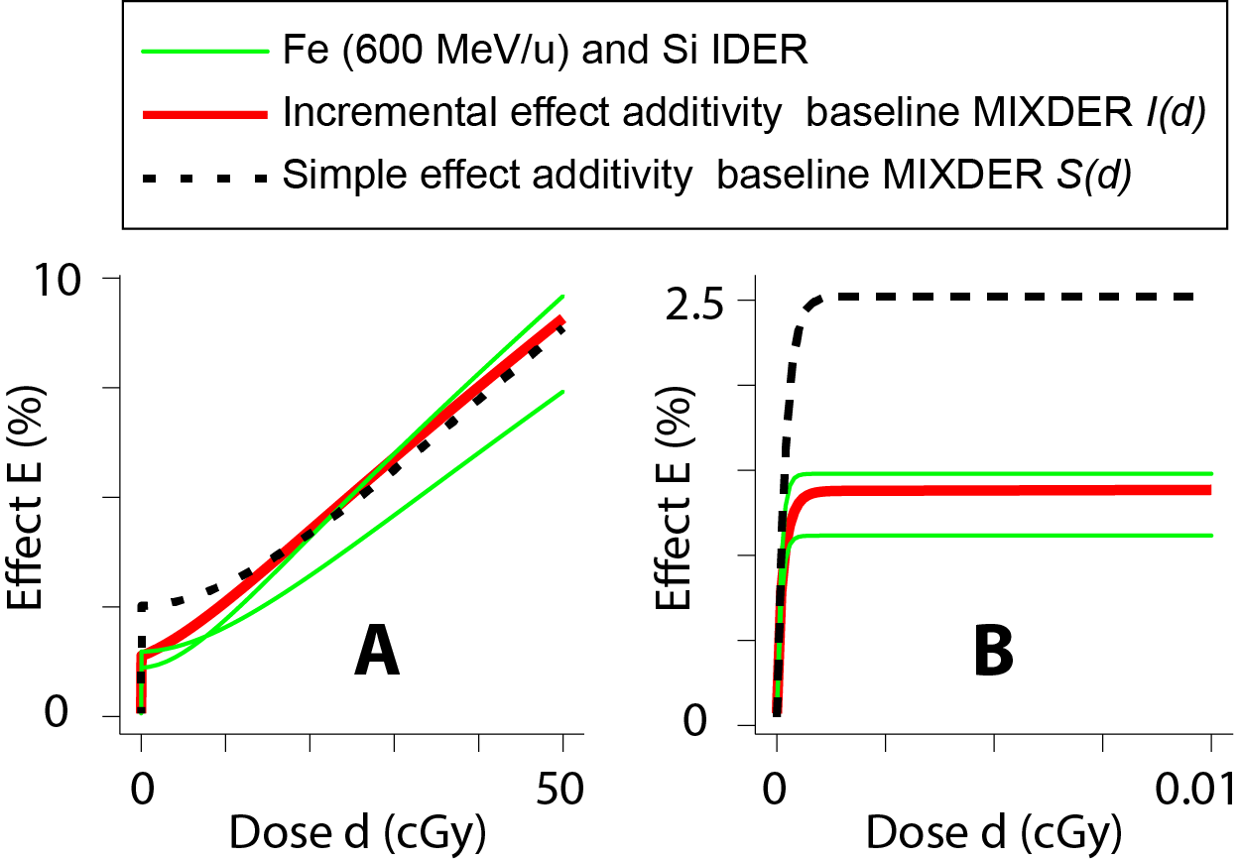F**ig. 7. Synergy Analysis for a Si-Fe Mixed Beam**. The figure shows baseline no synergy/no-antagonism curves (black dashed and red solid) for a 50-50 mixture of Si (170 MeV/u, *L=*100 keV/μm) and Fe (600 MeV/u, *L=*175 keV/μm). The endpoint is WGE simple CA. Panel A shows the overall curves up to the maximum mixture dose considered in the present paper, 0.5 Gy. Panel B zooms in by a factor of 5,000 to show details about the mathematical model at doses too small for CA data to be available.

Green lines show the IDER curves that would result if the entire dose were given to one of two ion beams instead of being split 50-50. Here the Fe IDER is the one that is lower at 50 cGy but higher at very low doses.

It is seen in panel B that the NTE part of *S(d)*, which dominates the effect at ultra-low doses, shows saturation at about the sum of the two IDER NTE contributions, rather than their average, whereas the NTE part of *I(d)* saturates near to the larger of the two. We will show that for a mixture of many HZE ions, corresponding patterns lead to strong differences between simple and incremental effect additivity baselines.

Two aspects of this 50-50 Si-Fe mixture that will be emphasized later are the following.

● The choice *r1*=0.5(so that *r2*=0.5 also)was arbitrary. If one wants to check experimentally whether mixing the two beams ever leads to statistically significant synergy or antagonism one would have to calculate a few more cases, say *r1*=0.2, *r2*=0.8 and *r1*=0.8, *r2*=0.2. When we set out to give examples involving N>2 ions we were unpleasantly surprised to find that, due to the many possible choices of the *rj*, the number of possible examples grows very rapidly as N increases. Worse, there is no systematic way to choose any particular example. Thus the 6-ion example given in the next sub-section is not chosen in any systematic way, and apparently could not be chosen systematically without giving a very large number of examples.

● Systematic synergy analysis requires known IDERs as a starting point. The only IDERs (or data) for our main-example data set are for a primary beam consisting of HZE with Z≥8, so our mixture examples perforce involve only HZE primary beams with Z≥8.

### 4.4.2. An Example of Mixtures with More Than 2 Ion Beams.

Fig. 8 gives another example of mixtures. It illustrates a problem with simple effect additivity due to its tendency to overestimate baseline MIXDERs when IDERs are highly concave (Fig. 1B). In Fig. 8 it specifies that at low doses effects much larger than any component would produce if acting by itself with the total mixture dose are not synergistic

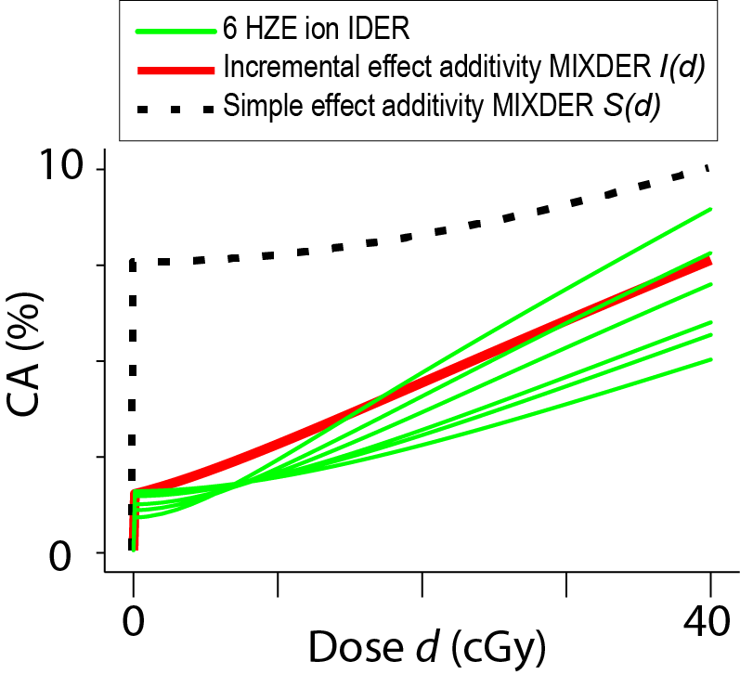**Fig. 8.** The figure shows results for a mixture of all 6 ions in the main-example data set (Table 1), with each ion contributing 1/6 of the total dose *d*. The two baseline no-synergy/no-antagonism MIXDERs for WGE simple CA are shown (red line and dashed black line). The green lines show the six component IDERs; at 40 cGy the curve height is inversely correlated with LET, with Oxygen (*L*=55 keV/*μ*) highest and Fe for Energy 300 MeV/u (*L*=240 keV/*μ*) lowest, and at low doses the order is reversed.

It is seen that simple effect additivity specifies a baseline MIXDER without saturation of NTE. As in Fig. 7, incremental effect additivity specifies saturation of NTE effects at the height of the component IDER with the largest low dose NTE height (here the height for the Fe ions with the highest LET, *L*=240 keV/*μ*).

Calculations not shown indicate that if a mixture consists of many more than 6 HZE ions the difference at low doses between *S(d)* and all the component IDERsbecomes much larger, with *S(d)* specifying absurdly high effects as defining absence of synergy.

## 4.5. 95% CI for *I(d)*

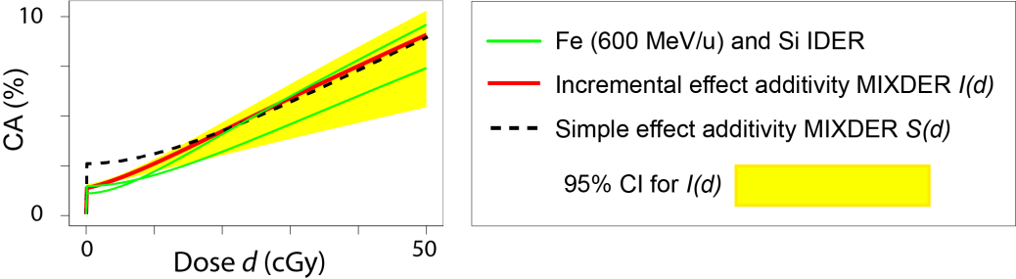We used Monte Carlo simulations to calculate 95% CI for the incremental effect additivity baseline no-synergy/no-antagonism MIXDER of the two-ion mixture of Fig. 7, taking into account parameter correlations. The results are shown in Fig. 9.

**Fig. 9. 95% CI.** It is seen that the two baseline no-synergy/no-antagonism dose effect relations have statistically significant differences only for doses less than about 0.05 Gy.

We also calculated 95% CI for the 6-ion mixture of Fig. 8. In order to estimate how much neglecting parameter correlations overestimates the 95% CI, we compared two alternative calculations (described in Methods, sub-section 3.4). Fig. 10 shows the preliminary results.

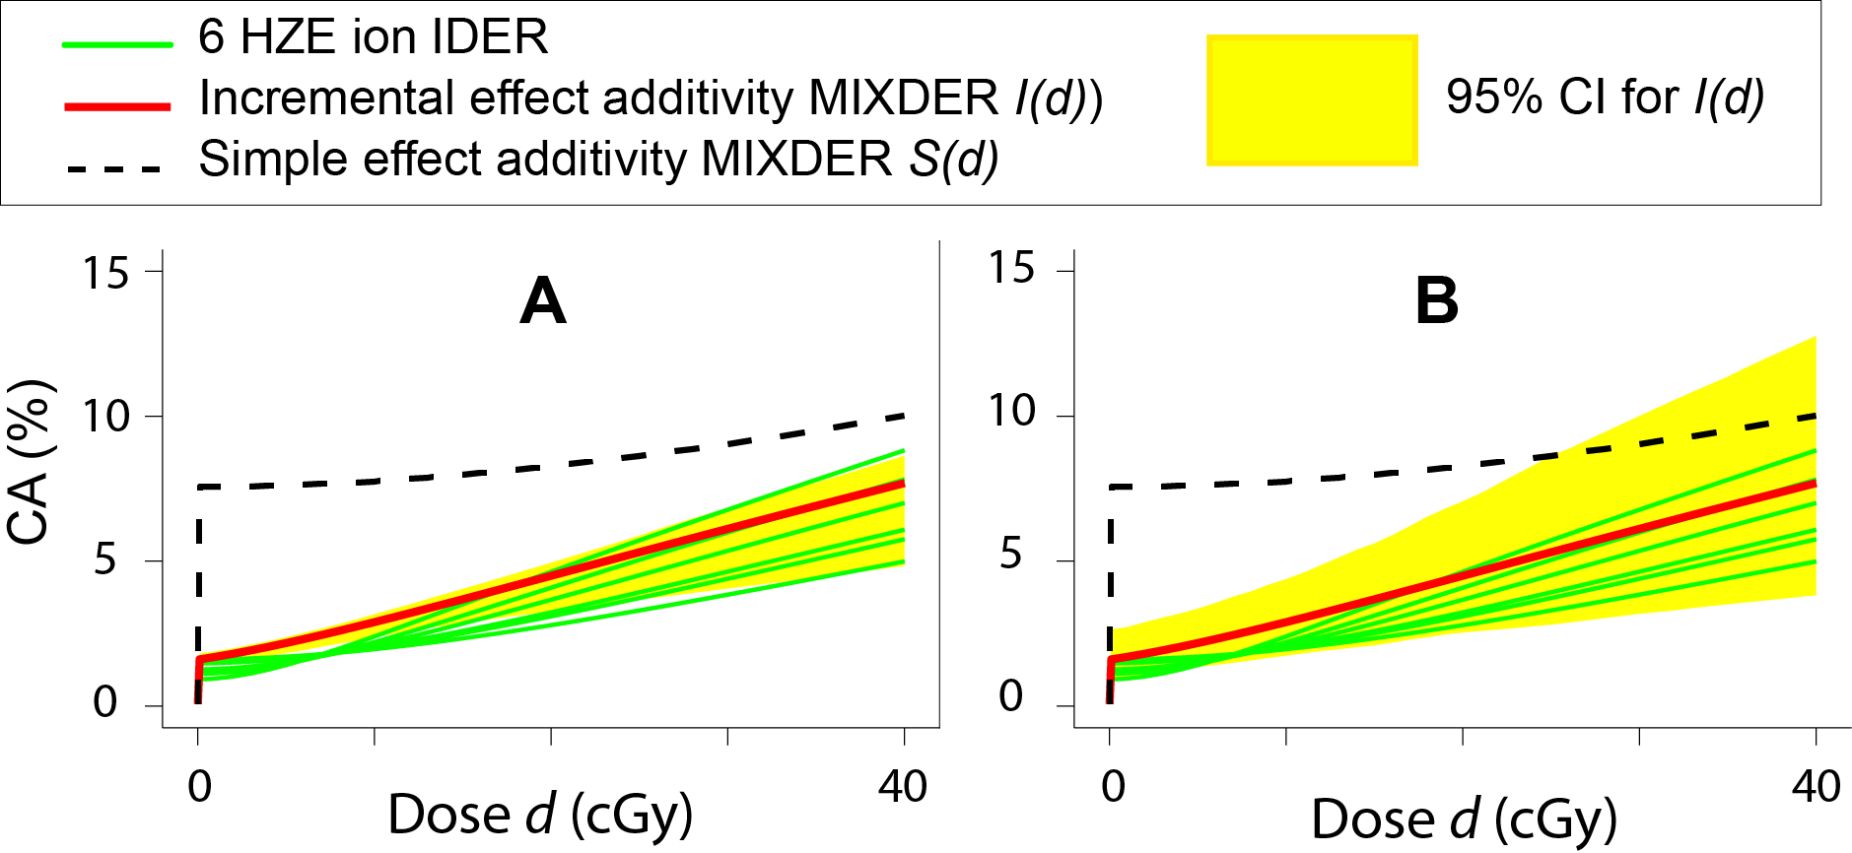**Fig. 10. CI for *I(d).*** Panel A shows calculated 95% CI if parameter correlations are taken into account. Panel B shows calculated 95% CI if the parameters are instead assumed independent. It is seen in panel A that the difference between *I(d)* and *S(d)* can be statistically significant for a mixture composed of multiple HZE ions. Panel B shows that neglecting parameter correlations in the Monte-Carlo calculations gives a much larger 95% CI. At *d*=40 cGy, panel B overestimates the 95% CI in panel A by a factor of ~ 2.35.

## 4.6. Summary

Using our SNTE models in mathematical synergy analyses illustrated two main points to which we will return in the Discussion: assuming non-targeted effects are important, *I(d)* gives a markedly different, more reasonable, no-synergy/no-antagonism baseline than does *S(d)* when mixtures of many HZE are considered; and there are a bewildering number of potentially inequivalent mixtures whenever more than a few ions are involved.

# 5. Discussion

## 5.1 Mathematical Synergy Analysis

For the foreseeable future radiobiologists will continue to use mathematical synergy analysis for planning mixed radiation field experiments, for interpretation of observed effects due to mixed radiation fields, and for intuitive insights.

### 5.1.1. Mathematical Synergy Analyses when Simple Effect Additivity is not Applicable

As has long been known, a baseline no-synergy/no-antagonism simple effect additivity baseline *S(d)* should be avoided in mathematical synergy analysis of mixtures whose component IDERs are highly curvilinear. Figs. 1, 8, and 10 give examples of situations where comparing observed mixture effects to *S(d)* is misleading as regards synergy or antagonism. The common assumption that synergy can always defined as an effect greater than *S(d)* is wrong, as documented in the Introduction section.

This paper and its appendices attempt to cover what radiobiologists should know about substitutes for *S(d)*. Appendix 2 gives a survey of relevant current thinking about synergy; Appendix 3 discusses an example of synergy analysis for protracted chronic irradiation situations; Appendix 4 describes differential synergy analysis, and gives arguments that it should become the standard replacement for simple effect additivity.

### 5.1.2. Using Intentionally Simplified Mixtures In Mathematical Synergy Analysis

Due to the kind of data in the main-example data set, the mixtures considered in the Results section all assume acute dosing, no extra shielding intentionally placed in front of the target, and only HZE ions with Z≥8 in the primary beam. Importantly, such mixtures are intentionally simplified, so simplified that they cannot be representative of any mixture striking any astronaut organ during any interplanetary voyage. As we will discuss, experiments involving intentionally simplified mixtures can address some biophysical questions which experiments involving more complicated mixtures, with many different ions in the primary beam and extra shielding intentionally added between primary beam and target, cannot address.

## 5.2. Comments on Our Results

Appendices apart, this paper concerns a specific example of mathematical synergy analysis. It uses incremental effect additivity *I(d)* in a synergy analysis of the main-example (fibroblast CA) data set of sub-section 2.1.2. Our synergy analysis started with the smooth, monotonically increasing IDERs of the SNTE model, constructed specifically to be applicable to synergy analyses of mixtures. Based on a published analysis of the same data set [Cacao, Hada et al. 2016] the SNTE IDERs contain a term representing NTE, important at very low doses.

….The SNTE IDERs were compared to the 1-ion models NTE1 and NTE2 in [Cacao, Hada et al. 2016], whose discontinuous IDERs precludes their use in synergy analyses based on incremental effect additivity *I(d).* When considering radiogenic effects (with background subtracted out) all three models have 4 adjustable parameters, 2 for NTE and 2 for TE. Each of the 4 parameters has roughly, though not exactly, the same biophysical interpretation in all 3 models. Information criteria ranked the three models as SNTE being preferred and NTE1 second; the ranking of NTE1 over NTE2 is in agreement with the ranking given in [Cacao, Hada et al. 2016].

When the adjustable parameters were calibrated using the main-example data set, the three values for any one parameter differed by factors of 2 or less between our SNTE model and the NTE1 model. However, significance levels differed strongly. For the SNTE model, the two NTE parameters were both significantly different from zero at the p≤10-3level, one TE parameter had p<0.01, the other TE parameter had p<0.1. For the NTE1 model only the TE parameter *κ* had p<10-3 and neither of the two NTE parameters were different from zero at the p≤0.1 level.

We draw the following two conclusions from these results. (a) As yet unpublished data on ongoing experiments will be a key test of the 1-ion models as well as providing some mixture data. (b) Even considered as just a mathematically convenient 1-ion model, the SNTE model is not at all inferior to either of the NTE models in [Cacao, Hada et al. 2016]. Therefore using the SNTE model to illustrate mathematical synergy analysis methods that can replace simple effect additivity is warranted.

Calibrated SNTE IDERs were used to calculate the incremental effect additivity baseline no-synergy/no-antagonism MIXDERs *I(d)* in examples. It was found that: non-targeted effects saturate at the same height as does the IDER of that mixture component which has maximum saturation height; and that *I(d)* tends to lie nested between the IDER curves of the individual components. These two properties show *I(d)* to be a reasonable baseline MIXDER even though all the component IDERs are highly curvilinear.

For simple effect additivity, however, saturation of non-targeted effects occurs only at the sum of all the component saturation heights. This sum was unrealistically high for a six-ion mixture; it can become absurdly high if there are hundreds of HZE in the mixture. The intuitive reason for this result on simple effect additivity is that all our HZE IDERs are highly concave in the very low dose region and, as we have discussed in the caption to Fig. 1B and elsewhere, simple effect additivity tends to overestimate baseline MIXDERs whenever the mixture IDERs are concave.

We calculated a parameter variance-covariance matrix; Somewhat unexpectedly, all its elements were >0. We then calculated 95% CI for *I(d)*, taking into account the correlations among calibrated parameter pairs by using Monte Carlo simulations based on the variance-covariance matrix. As expected, the CI was substantially smaller than that estimated by unrealistically neglecting correlations – smaller by a factor ~2.4 in an example of a 6-ion mixture. Such CI allow estimating the statistical significance of any observed deviations from the *I(d)* baseline.

## 5.3. Intentionally Simplified vs. Intentionally Complicated Ion Mixtures

We agree with the approach recommended in [Norbury, Schimmerling et al. 2016], that intentionally simplified mixtures should continue to be part of NASA’s research, in parallel with other experiments using intentionally complicated mixtures that aim to be representative of radiation fields encountered on an interplanetary voyage.

### 5.3.1. Experiments with Beams Too Simple to be Representative

Almost all past experiments on GCR, including highly informative and influential ones such as those on mouse Harderian gland tumorigenesis, other animal experiments and CA involve comparatively very simple beams. Many ongoing experiments, and many planned ones, also involve intentionally simplified beams. For example, experiments where the primary beam is a nearly monoenergetic 1-ion beam are very common. No such beam can be made representative, not even by introducing extra shielding in front of the target. The beams used in the main-example data set, which have substantially helped characterize properties of non-targeted effects, are an extreme example. All primary beams were monoenergetic 1-ion; all the experiments involved acute exposures to HZE with Z≥8; the amount of matter between primary beam and target was kept as low as possible. The radiation field at the target is then drastically different in many ways from that incident on an organ of an astronaut inside a spacecraft during an interplanetary voyage.

### 5.3.2. Some Advantages of Intentionally Simplified Beams

Using such simplified, non-representative beams has advantages. We mention two. First, there is now some evidence that NTE caused by HZE are significant, while NTE caused by low-LET ions such as fast protons and helium ions are minor or absent. Any beam that aims to be representative has only a small proportion of its primary beam dose in the HZE. Investigating properties and consequences of NTE with primary beams consisting entirely of HZE and thus not being representative at the target whatever shielding is used is indicated, rather than using beams designed to be representative and thus having only a small proportion of the total dose in the HZE that are tentatively believed to cause the effect of interest.

A second example is that systematic mathematical synergy analysis requires first finding the IDER of each component, and thus can be facilitated by using the extensive literature on 1-ion beam IDERs. For a mixture that aims to be representative and therefore has a large number of different components in the primary beam, an equal number of preliminary 1-component experiments would in principle be required to decide whether the observed mixture effects show synergy, antagonism, or neither. Thus systematic synergy analysis of experiments using beams that aim to be representative have to be much more elaborate than experiments on mixtures for all of whose components there is already data in the literature.

More generally, the kind of beam optimal for analyzing any specific endpoint depends on many different factors. To insist that only beams that aim to be representative be used would often clash with other requirements. Allowing intentionally simplified beams allows needed flexibility.

### 5.3.3. Variability of GCR Mixtures

Consider a large group of cells, e.g. an astronaut’s lung, as being the radiation target during an interplanetary voyage, since cells interact during cancer growth. How important is variability in the mixtures that strike the target? The following two points deserve consideration.

* The number of radiation fields that might differ as regards cancer risk is very large. As detailed in sub-section 4.4.2 above, when we tried to find a manageably small set of mixtures to illustrate our synergy analyses results using mixtures with N=6 components, our efforts were frustrated by an apparently unavoidable problem of combinatorial complexity. The number of different possible mixture proportion vectors (*r1,r2,* ***...,*** *rN*) for dividing total mixture dose *d* into component doses *dj=rjd* was too large. *In silico* calculations are many orders of magnitude faster than experiments, so we were able to consider many different mixtures rapidly and thereby noticed this combinatorial complexity problem. The problem rapidly becomes worse as N increases.
* There are many sources of variability for the mixtures a target encounters during interplanetary voyages (ICRP137 [Smith, S. et al. 2013]). Among the most important are spacecraft shielding anisotropies and astronaut self-shielding. How sensitively cancer risks depend on this variability is not known. Perhaps some highly specific combination of ions cooperates synergistically; perhaps instead almost all complicated mixtures that contain many protons and some GCR have comparable risk per unit dose.

With very many mixtures possible, the amount of mixture variability uncertain, and the consequences of mixture variability largely unknown, caution in characterizing what is meant by a representative mixture seems advisable. The issue of combinatorial complexity will presumably become more prominent as the number of NASA mixture experiments grows.

## 5.4. Conclusions

### 5.4.1 Outlook

If in fact there is no major synergy or antagonism then mixture results can be predicted from observed mixture component IDERs. The daunting complexity problem, that in general a result on a mixture cannot be extrapolated even to another mixture with the same total dose and with the same components but with different proportions *rj*, is largely circumvented. Conversely if synergy plays a major and ill-understood role, then, with hundreds of mixture components being involved, and thus with a very large number of mixtures to investigate, NASA is likely to need a long, hard, expensive program (Fig. 2) to enable interplanetary missions compliant with current guidelines.

### 5.4.2. Summary

* Synergy analysis will continue to be used to plan experiments involving mixed radiation fields, to interpret the results of such experiments, and to interpret observations made during NASA missions. It should always include calculations that give confidence intervals.
* The plethora of different possible mixtures that tended to confound our *In silico* synergy analyses suggest that there may not be any mixed radiation fields which are representative of more than a very small minority of the mixtures that any specific target will encounter during any extended-duration interplanetary space voyage. The fact that neither spaceships nor astronauts are spherically symmetric reinforces the suggestion.
* There are many different methods of mathematical synergy analysis. These have been developed over many years in many different fields of biology to supplement or replace simple effect additivity.
* If non-targeted effects are important the simple effect additivity no-synergy/no-antagonism baseline MIXDERs at low doses should be ignored or used only with care.
* When individual dose-effect relations for components of a mixture are all monotonically increasing, a new method introduced in Appendix 4, “differential synergy analysis” has some advantages over all other common methods of mathematical synergy analysis.
* Importantly, if it can be established that there is in fact no extra carcinogenesis due to synergistic effects among the components of the mixtures occurring during NASA voyages, NASA’s planning will in principle be simplified quite substantially. If, on the contrary, synergy is found for some but not all relevant mixtures studied, combinatorial complexity of possible mixture choices presents a formidable obstacle to planning extended-duration space voyages for humans.

### Acknowledgements:

RKS is grateful for support from NASA grant NNJ16H221. DWH, BS, JG, and JY are grateful for support from the UC Berkeley undergraduate research apprenticeship program (URAP).

**Appendix A1. Glossaries.** This section briefly explains some acronyms, terminology and mathematical symbols. The items in red type, used very frequently in the paper, will be unfamiliar to most readers.

|  |  |
| --- | --- |
| **A1.1** | **Acronyms and Terminology** |
| **AIC and BIC** | Akaike and Bayesian information coefficients. See sub-section 3.2.4 |
| **Baseline MIXDER** | A Mixture Dose-Effect Relationship which defines absence of synergy or antagonism in some specific approach to mathematical synergy analysis |
| **CA** | Chromosome aberrations |
| **Concave** | The opposite of convex, with which it is frequently confused. See Fig. 1 |
| **Convex** | A standard mathematical term that can be used to describe curve shapes. Fig. 1 gives a description adequate for present purposes |
| **Default hypothesis** | A formal hypothesis describing a baseline no-synergy/no-antagonism MIXDER and also a way to calculate baseline mixture effect uncertainties when IDER uncertainties are known |
| **DIDER** | An IDER that is Differentially-defined using the ODE initial value problem Eq. (A4.1) |
| **Differential synergy analysis** | Mathematical synergy analysis which uses both incremental effect additivity *I(d)* and DIDERs |
| **Explicit function** | Roughly, a function *f(x)* built from the standard functions used in introductory calculus – e.g. . Specifically, an “elementary” function, as defined in math texts |
| **IDER** | Individual Dose Effect Relationship for a single ion. See subsection 3.2 for examples. |
| **Incremental**  **effect additivity** | ODE method, defined in Eq. (11), of calculating a mixture dose-effect relationship *I(d)* from the component IDERs, with *I(d)* then used as the definition of no synergy or antagonism |
| ***I(d)*** | Abbreviation both for the incremental effect additivity default hypothesis and for the corresponding baseline MIXDER calculated using Eq. (11) |
| **Inverse function** | For a continuous monotonically increasing function *F(x), D(F(x))=x* for all *x* in the domain of *F* defines the inverse function *D(F).* For example exp and ln are inverses of each other |
| ***L*** | Stopping power, LET∞. Relevant values are in Table 1 |
| **Main-example** | The fibroblast CA data set described in sub-section 2.1.2 |
| **MIXDER** | Mixture Dose-Effect Relationship |
| **LQ** | Linear-quadratic; Appendix A3 |
| **NTE** | Non-Targeted Effects due to inter-cellular interactions. “Bystander effects” |
| **NTE2** | IDERs used in [Cacao, Hada et al. 2016]. See sub-section 3.2.2 |
| **ODE** | Ordinary Differential Equation(s) |
| **Sham mixture principle** | The mixture of an agent with itself should have as a baseline MIXDER the agent’s own IDER. See Fig. 1 and also Appendix A2.2 |
| **SNTE model** | Smooth Non-Targeted Effect model. Our main model. Its IDERs are given by Eq. (7) |
| **TE** | Targeted Effects, i.e. early effects on a cell that are not due to nearby cells being irradiated |
| **Very low dose** | 0 ≤ dose < 5 mGy |
| **Ultra-low dose** | 0 ≤ dose < 0.5 mGy |
| **WGE** | Whole Genome Equivalent (sub-section 2.1.2) |

|  |  |
| --- | --- |
| **A1.2** | **Symbols and Equations** |
|  | The linear coefficient of the LQ approximation to CA induced by gamma radiation. See Eq. (5) |
| *α* | Usually the linear coefficient of LQ approximation; used in Appendix A3 |
| *β\** | The velocity of an ion divided by the velocity of light |
| *β* | Usually the quadratic coefficient of LQ approximation; used in Appendix A3 |
| *d0* | A nominal dose where the SNTE IDER slope due to NTE has already become much smaller than the initial slope at the origin. See Eq. (6) and Fig. 5 |
| d*Ej*/d*dj* | The slope of an IDER. Used, e.g., in Eq. (11) |
| *Dj(Ej)* | The compositional inverse function of an IDER *Ej(dj)*. Discussed in sub-section 3.3.3 |
|  | dose of a mixture component as a fixed fraction *rj* of total mixture dose *d* . See sub-section 3.3.1 |
| *Ej(dj)* | IDER for the jth component of a mixture. See sub-section 3.2.1 |
| *E(d)* | IDER |
| *η0, η1* | Adjustable parameters that control the height of NTE effects. See sub-sections 3.2 |
| *η(L)* | NTE effect maximum height, a function of LET *L*. See sub-section 3.2 |
| *I(d)* | Incremental effect additivity MIXDER and default hypothesis, Eq. (11) |
| κ | An adjustable parameter. See sub-section 3.2 |
| *NSNT* | In Eq. (6), the slope due to NTE |
| *rj* | Fixed ratio of component dose to total mixture dose, |
| *S(d)* | Simple effect additivity MIXDER and default hypothesis, Eq. (10) |
| *Zeff* | Effective ion charge. Used in Table 1 and in Eq. (5) |

# 

# Appendix A2. Synergy Analysis for Monotonically Increasing IDERs

## A2.1. Precise Quantification vs. Generality

As qualitative, general concepts “synergy” and “antagonism” are used heavily in radiobiology; this usage will no doubt continue for a long time to come. However, no quantitative, precisely defined synergy analyses applicable to a substantial fraction of situations where the vague qualitative concept of synergy is used are available or will become available in the foreseeable future [Ashford 1981; Geary 2013; Piggott, Townsend et al. 2015]. The limitations of simple effect additivity *S(d)* restrict its use to a few special cases. Known mathematically precise, sufficiently general versions of synergy analysis to replace *S(d)* are not known.

However, if all component IDERs for a mixture are monotonically increasing (or if all are monotonically decreasing), precise versions of synergy/antagonism are available and are usually preferable to simple effect additivity *S(d)*. These precise quantifications include the linear isobole dose additivity equation, often used in various fields of biology (reviewed in [Berenbaum 1989; Foucquier and Guedj 2015]). They also include quite a few additional approaches. At the cost of restricting attention to monotonic IDER mixtures, one gets well defined, useful mathematics.

For the endpoint emphasized in the main text, IDERs monotonically increasing over the entire dose range of interest provide reasonable fits (Section 4). Figs. A2.1 and A2.2 visually compare our monotonically increasing IDERs for the main-example data set with the NTE2 model curves of [Cacao, Hada et al. 2016], which are not monotonic, being decreasing for low doses and increasing for larger doses.

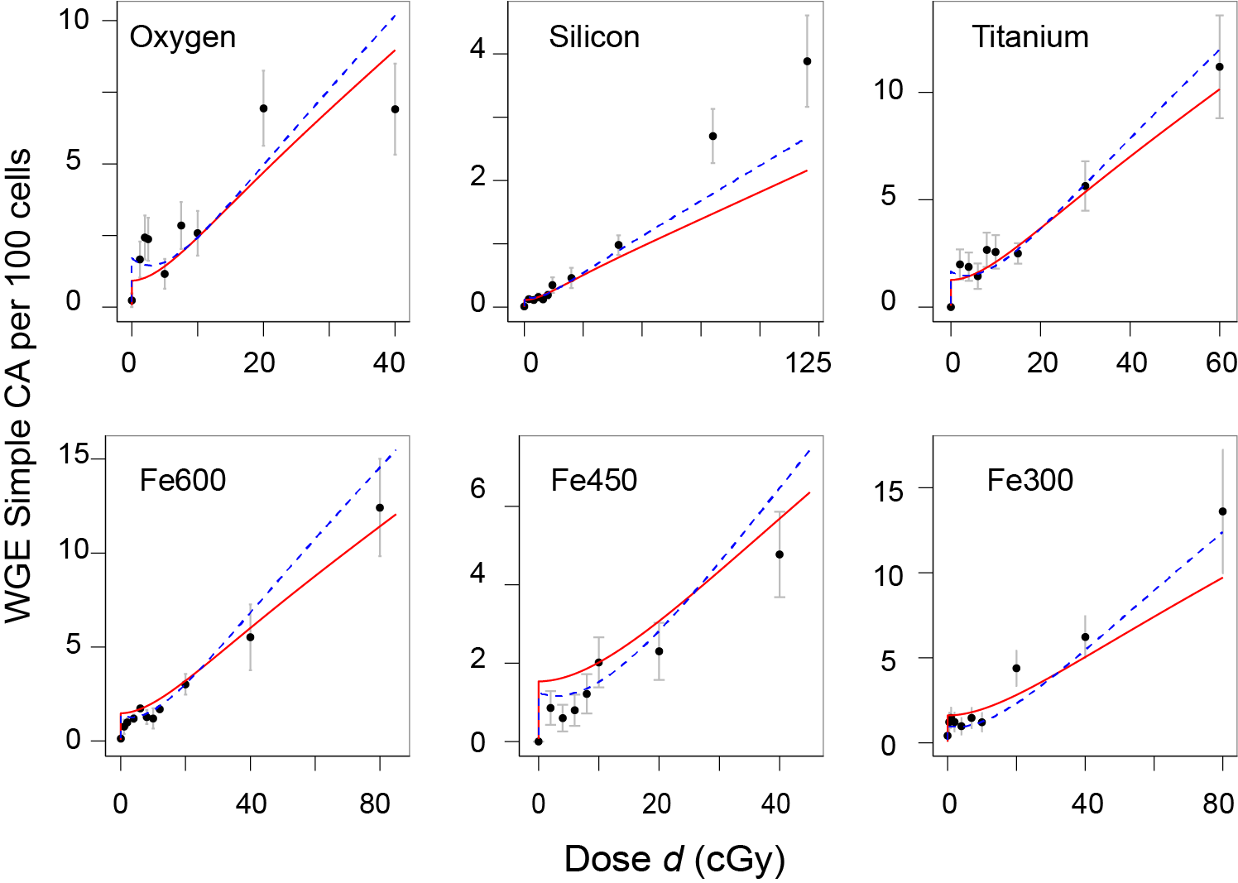**Fig. A2.1. Monotonically Increasing IDERs vs. IDERs that are not Monotonically Increasing**

The figure compares our monotonically increasing IDERs (solid red curves) for the main-example data set with the NTE2 model curves of [Cacao, Hada et al. 2016] (shown as dashed blue curves), which are decreasing in the dose range from ultra-low doses to about 5 cGy. Visually, the monotonically increasing IDERs are not inferior, as was expected from numerical results on information criteria.

**Fig. A2.2. Zooming in on Smaller Doses**

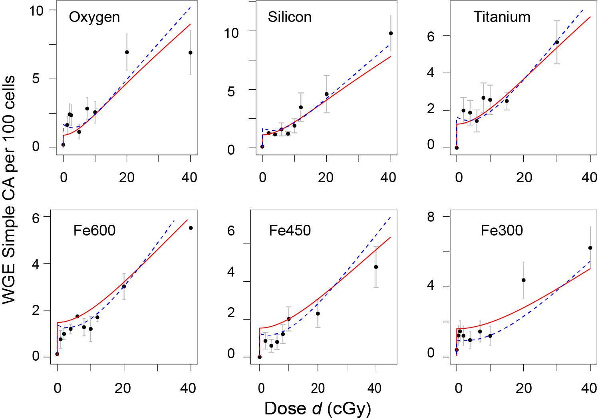 The figure zooms in on doses ≤ 40 cGy, so that the region between 0 and 5 cGy can be seen more clearly. It again compares our IDERs (solid red curves) for the main-example data set with the NTE2 model curves of [Cacao, Hada et al. 2016] (shown as dashed blue curves).

For experiments on tumorigenesis surrogate endpoints at NSRL, HZE doses of less than 50 cGy are the doses of main interest.

Appendix 2 assumes monotonically increasing IDERs throughout. Appendix 4 will introduce a new approach to mathematical synergy analysis which uses a somewhat less restrictive condition than monotonically increasing IDERs.

## A2.2. Barenbaum’s Approach

A famous pharmacology paper [Berenbaum 1989] reviews, extends, and advocates an approach to mathematical synergy analysis applicable to mixtures each of whose IDER is monotonically increasing. The approach is based on the following considerations.

### A2.2.1. Some Assumptions and Motivations

Assuming that each IDER for the components of a mixture is known and essentially no further information is available, one can define a reasonable default hypothesis, characterizing absence of synergy or antagonism, about the mixture effect. The default hypothesis includes two components: a baseline MIXDER defining absence of synergy/antagonism; and a method of estimating uncertainties for the baseline MIXDER from corresponding IDER information.

Such default hypotheses are useful first steps in understanding mixture effects (Fig. 2 of the main text). They are less reliable than predictions based on biophysical understanding of agent interactions but typically much faster, simpler, and cheaper [Berenbaum 1989; Greco, Bravo et al. 1995; Geary 2013; Norbury, Schimmerling et al. 2016].

The default hypotheses, in the Berenbaum approach, are typically not mechanistic: they use mathematical manipulations of IDERs, not additional biophysical insights specific to the endpoint being analyzed [Berenbaum 1989; Greco, Bravo et al. 1995]. The reasoning is that biophysical insights should be used in devising IDERs, but that subsequently intermingling the temporary synergy-analysis shortcut (Fig. 2, main text) and the long biophysical-understanding path (Fig. 2, blue arrows) would merely undermine the shortcut’s practical advantages without adequately replacing the long path.

### *A2.2.2. The Sham Mixture Principle*

The sham mixture principle, that the mixture of an agent with itself always has as a baseline no synergy/antagonism MIXDER the agent’s own IDER, is required in Barenbaum’s general approach (other researchers disagree, as discussed in A2.3.4 below). Incremental effect additivity *I(d)*, defined by Eq. (11) of the main text, does always obey the sham mixture principle, as proved at the end of Appendix A2.4.2. below. Simple effect additivity *S(d)* does not obey the sham mixture principle (Fig. 1 of the main text). Therefore, in the Barenbaum approach, *S(d)* cannot be used for mathematical synergy analysis. An obvious exception occurs if, in some special situation, *S(d)* gives essentially the same answer as using a synergy definition that obeys the principle. For example, when all *N* IDERs for a mixture have the linear-no-threshold form, *Ej(dj)=Ajdj* with *Aj* a positive constant, all synergy definitions, including *S(d)* and *I(d),* have baseline MIXDERs  whether or not they violate the sham mixture principle when applied to curvilinear IDERs (here *rj* are the dose fractions, defined in sub-section 3.3.2 of the main text). When all approaches give essentially the same answer, there can be no objection to using the simplest, namely *S(d)*. Less trivial examples were given in [Siranart, Blakely et al. 2016]. These were mixtures with some component IDERs being concave and others being convex, where accidental cancellations between *S(d)* under- and over-estimates resulted in *S(d)* being almost equal to *I(d).*

## A2.3. Examples of Synergy/Antagonism Definitions

### A2.3.1. Isobole Synergy Analysis

By far the most commonly used synergy definition based on the ideas in A2.2 is the linear isobole method (reviewed in [Chou 2006; Brun and Greco 2010; Lee 2010; Tallarida 2012; Geary 2013; Foucquier and Guedj 2015]). This method requires monotonically increasing IDERs for the components of a mixture. It computes from IDERs a default total mixture dosefor any given mixture effect *E*. If a mixture experiment shows that using a dose smaller than the default dose is sufficient to produce *E* then there is by definition synergy. Intuitively the idea is that there must have been some kind of extra cooperation between components that enables a small dose to produce an unexpectedly large effect *E*. Similarly if a dose larger than the default dose is needed to produce *E* then by definitionantagonism is present.

In the notation of sub-section 3.3.2 of the main text, the default total mixture dose *d* is calculated by the following equation:

(A2.1) 

For sufficiently small mixture effect *E* there is always a unique solution *d(E)* of Eq. (A2.1). The proof is the following. For *d* very small, the left hand side of Eq. 1 is larger than the sum on the right, which is independent of *d*. The right hand side is greater than zero; it remains fixed as *d* is gradually increased, while the left side decreases continuously and monotonically, eventually approaching 0. So there must be exactly one solution *d*.

A “minimax” limitation of linear isobole synergy analysis occurs in the following kind of situation, which is common in practice. Suppose some of the IDERs have finite maxima which they can never exceed for any dose of interest. Among these IDERs there must be at least one, which we can take to be *EN(dN)* without essential loss of generality, whose maximum is no larger than any of the other maxima. Call that minimum maximum *Eminimax*. Suppose there is at least one other IDER in the mixture which either has no maximum at all or has a maximum larger than *Eminimax*. Then values *E* of the total mixture effect greater than *Eminimax* are of interest but *DN(E)* is undefined for such *E* and thus Eq. (A2.1) cannot be used to calculate *d.* The *N*th IDER not only refuses to play linear isobole but also spoils the game for everybody else. In practice this minimax limitations sometimes limits the range of *d* to such small values that linear isobole synergy analysis becomes virtually useless.

In addition to this practical limitation of the linear isobole default hypothesis there is a conceptual issue. Barenbaum attempted to prove Eq. (A2.1) from the sham mixture principle. However his proof is now known to be incorrect ([Grabovsky and Tallarida 2004; Bosgra, van Eijkeren et al. 2009], reviewed in [Tallarida 2012; Foucquier and Guedj 2015]).

Curvilinear isobole formalisms (reviewed in [Tallarida 2012]) take into account Berenbaum’s error. However they also have drawbacks [Geary 2013], which preclude their application to complex mixtures of HZE ions [Siranart, Blakely et al. 2016].

### A2.3.2. Two Other Approaches to Synergy Analysis

In radiobiology synergy is often analyzed by a dual radiation action approach [Zaider and Rossi 1980]. The approach uses linear-quadratic (LQ) dose-effect relations. For one acute dose an LQ IDER is the sum of a term linear in dose and another quadratic in dose:

(A2.2) 

where *α* and *β* are non-negative constants at least one of which is non-zero. A generalization of Eq. (A2.2) to protracted dosing, such as fractionation or chronic low dose rate exposures, is discussed in Appendix section A3 below but for the time being we consider only the acute dosing case.

The dual radiation action approach applies only to mixtures each of whose components has an LQ IDER. For such mixtures it predicts the baseline MIXDER is LQ. The approach differs from Barenbaum’s general approach, described in Appendix subsection 2.2 above, in many ways, including the following:

(a) Mechanistic biophysical arguments are used to obtain the parameters *α* and *β* for the baseline no-synergy/no-antagonism LQ MIXDER.

(b) This baseline MIXDER does not obey the sham mixture principle unless *β*=0.

(c) It is assumed, explicitly or implicitly, that synergy or antagonism must always be defined as deviations from the simple effect additivity baseline that Barenbaum deprecates.

(d) The terminology used differs strongly from that of Barenbaum. For example, a single radiation field having an LQ IDER with *β*>0 is said to be synergistic with itself whereas Barenbaum’s definitions imply self-synergy can never occur. The various terminological discrepancies are merely verbal differences arising from comparing different fields such as radiobiology and pharmacology. They are not in themselves actual scientific disagreements; but they are extraordinarily confusing.

LQ IDERs do not incorporate NTE, so the dual radiation action approach to synergy analysis was not used in the main text. Details on and examples of the approach are given, e.g., in [Zaider and Rossi 1980; Bird, Zaider et al. 1983; Zaider 1990; Berenbaum 1991; Furusawa, Aoki et al. 2002; Suzuki, Miura et al. 2002].

Independent action [Lam 1994] is another approach that also allows self-synergy. In general its usefulness is restricted not only by the condition of IDER monotonic increase but also by an additional restriction: if one mixture component, acting on its own, can never exceed some finite upper limit no matter how large the dose, then the same must hold for all the other components, with the same upper limit.

*A2.3.3. Asymmetrical Approaches to Synergy Analysis*

A number of approaches to synergy, including some variants of curved isobole approaches, are asymmetrical: the baseline MIXDER for combining *r1* of agent 1 with *r2* of agent 2 can be different than that for combining *r2* of agent 2 with *r1* of agent 1. This makes sense when agent 2 is somehow clearly subordinate to agent 1, as can occur in adjuvant therapy. However, asymmetrical approaches cannot be used for mixed radiation fields with many different components, all of which are on the same footing.

## A2.4. Some Properties of Incremental Effect Additivity *I(d)*

Incremental effect additivity *I(d)*, defined by Eq. (11) of the main text, was originally suggested by, and designed to improve on, the linear isobole approach of Appendix subsection A2.3.1 above. Essentially, Eq. (11) is considering effect, rather than dose, as the basic independent variable, as is also often done [Durante 2014a], for different reasons and with different equations, in radiobiological discussions of relative biological effectiveness (RBE).

Incremental effect additivity *I(d),* like some other replacements for simple effect additivity *S(d)* in the literature, always obeys the sham mixture principle [Siranart, Blakely et al. 2016], in contrast to *S(d)*. Unlike most other replacements *I(d)* is in principle applicable to mixtures with very heterogeneous IDERs. For example, one could in principle use Eq. (11) for a single mixture where some IDERs of each of three qualitatively different shapes are involved.

1. IDERs having a concave shape, as shown in Fig. 1 of the main text.
2. LQ IDERs, Eq. (A2.2), where the quadratic component obeys *β*>0. These IDERs are convex.
3. Hill function IDERs with Hill coefficient <1 such as the function shown in Fig. fA4.1 below. These functions are sigmoidal (“S-shaped”). They are often used for agent mixtures in pharmacometrics, toxicology, evolutionary ecology and other fields [Greco, Bravo et al. 1995; Chou 2006; Foucquier and Guedj 2015]

We will now discuss some mathematical properties of incremental effect additivity. We start with an existence and uniqueness theorem for *I(d).* Then we review mixtures whose component IDERs are so similar the ODE initial value problem (11) for *I(d)* can be solved without resort to computer numerical integration. Then we prove that *I(d)* always obeys the sham mixture principle. Finally we characterize the difference between *I(d)* and simple effect additivity in terms of baseline MIXDER slopes.

### A2.4.1. Solutions of Eq. (11): Existence, Uniqueness and Properties

The right hand side of the ODE in Eq. (11) is the sum of a finite number *N* of terms. Each term comes from one component of the mixture. In the relevant computations, each component of the mixture has an IDER that obeys the requirements of sub-section 3.2.1 as regards smoothness, finiteness of slope, and monotonic increase.

Picard’s theorem [Coddington and Levinson 1955] guarantees existence and uniqueness for the initial value problem (11). Specifically there is some number A>0 such that in the interval [0,A) there is one and only one solution and that solution is smooth. In our cases, the interval can be extended to an interval [0, *Eminimax*), where *Eminimax* is defined in Appendix sub-section A2.3.2.

### A2.4.2. Mixtures Whose Component IDERs Have Constant Relative Potency

Two agents with respective IDERs *E1*(*d1*) and *E2*(*d2*) are said to have “constant relative potency” (or said to be “similar”) if there is some relative potency constant *P>0* such that *E2*(*d2*) = *E1*(*Pd2*). Then *E1*(*d1*)= *E2*(*P-1d1*). The intuitive interpretation is that for all relevant doses, agent 2 is *P* times as potent in producing the effect as agent 1. For example if both IDERs are LQ, they have constant potency ratio if *α2d2*+*β2d22*= *α1Pd2*+*β1P2d22* for all *d2*, which implies *α2* =*Pα1* and *β2*= *P2β1.* For mathematical, historical, and practical reasons IDERs with constant relative potency are important in synergy (and other) analyses [Berenbaum 1989]. Mathematically, the case of a mixture all of whose IDERs have constant relative potency covers almost all situations where incremental effect additivity *I(d)* can be evaluated as an explicit function of mixture dose *d* instead of using numerical ODE integration.

Specifically, suppose the following: g*(d)* is a smooth function for 0≤d<∞ with *g(0)=0*; *g(d)* has limit Emax for *d* approaching infinity, where 0 < Emax ≤ ∞; and the derivative g*′ > 0* for all *d.* Suppose in a mixture of *N* components each IDER obeys *Ej(d) =g(Pjd)* for some “potency constant” *Pj* > 0. Then all the IDERs are pairwise similar and the following holds.

*Theorem. I(d)=g(w),* where *w* = [Σ*rjPj*]*d*

*Interpretation.* The intuitive interpretation is that *M=*Σ*rjPj* can be regarded as an average potency *M* using the discrete probability distribution *rj*, and thus *w* is average potency times total mixture dose.

*Proof of the Theorem.* All pairs of IDERs are similar since *Ej(d)= g(Pjd)=g((Pjd/Pi)Pi)=Ei(Pjd*/*Pi*). The compositional inverse *G(E)* of *g* is defined for any *E* in the interval [0,Emax) and the compositional inverse *Dj* of *Ej* is given by *Dj(E) =* (1/*Pj*)*G(E)*. For *I(d)* we therefore have, denoting the derivative function for *Ej* by *Ej*′,

(A2.3) 

Using Eq.(11) now gives

(A2.4) 

Here the last implication follows from Picard’s theorem on the uniqueness of the solution of the initial value problem for an ordinary differential equation [Coddington and Levinson 1955]. The reader may wish to trace the steps of the theorem’s proof using toy examples so simple that all the individual steps can also be carried out explicitly, such as *g=x2, g=2x+x2, g=x/(1+x),* or *g=ln(x+1)*.

Forlinear isobole synergy analysis a corresponding theorem has been known for a long time. It is discussed, e.g., in [Berenbaum 1989], which gives more details on the intuitive interpretation of the weighted sum *P.*

Any sham mixture, where all the IDERs are identical, is an example of constant relative potency, with *Pj*=1*=M*. Therefore the theorem above implies that *I(d)* always obeys the sham mixture principle.

### A2.4.3. Simple Effect Additivity Defined Incrementally

Suppose we have a mixture each of whose components has an IDER *Ej(dj)* that obeys the requirements of subsection 3.2.1 in the main text: it is zero at dose=0, smooth, and has positive slope for some half open dose interval [0, *Aj*) with *Aj*>0. Recall that the simple effect additivity baseline MIXDER is defined by

(A2.5) 

Then we can define *S(d)* by a slope equation equivalent to (A2.5) in some half open dose interval [0, *A*) with *A*>0, and this slope equation can be compared to the baseline incremental effect additivity *I(d)* MIXDER defined in subsection 3.3.3 of the main text by

(A2.6) 

In fact, differentiating Eq. (A2.5), using *Ej(0)*=*0,* using *dj=rjd* and using the inverse function definition *dj=Dj(Ej)* gives

(A2.7) 

Eq. (A2.7) is equivalent to Eq. (A2.5) on some interval [0, *A*) with *A*>0 by Picard’s theorem and the fact that the number of summands is finite. In Eq. (A2.7) the subscript on the square brackets could have been omitted, since the derivative function is by definition a function of *dj* but the comparison of Eq. (A2.6) and (A2.7) pinpoints the fact that the sole difference between *S(d)* and *I(d)* comes from the fact that for *I(d)* the incremental contributions are determined by the biophysical system variable *I,* rather than by the control variable *d* which the system has no way to sense directly.

## A2.5. Summary

As useful qualitative concepts synergy and antagonism are very general. They indicate that a mixture effect seems different than the effect one might have expected from looking at the component IDERs. The only quantification that has comparable generality is simple effect additivity *S(d)*, which is usually inappropriate unless all mixture components have linear no-threshold IDERs. To look for other quantitative versions of synergy/antagonism that are as general as the qualitative concepts or simple effect additivity is quite hopeless [Ashford 1981; Foucquier and Guedj 2015]. To get useful quantifications one has to impose extra conditions on the IDERs. Appendix A2 discussed some of the most commonly used extra conditions, emphasizing monotonic increase of all mixture component IDERs. We described some of the synergy quantifications most commonly used as alternatives to simple effect additivity, e.g. the linear isobole approach.

# 

# Appendix A3. Synergy Analysis for Chronic Low Dose Rate Radiation Fields

## A3.1. General Comments.

Dose protraction consists of a series of acute dose fractions, or of a chronic non-zero low dose rate which need not be constant in time, or of any combination of the two. In interplanetary space astronauts will experience chronic GCR irradiation protracted over several years (reviewed, e.g., in [Durante 2014b; Kim, Rusek et al. 2015; Norbury, Schimmerling et al. 2016]), whereas the acute irradiation considered up to this point is so rapid compared to other relevant processes such as radiation damage repair that it can be considered instantaneous. The chronic GCR dose rate in the absence of shielding and excluding solar particle events is roughly 0.2 Gy per year, but this number depends on the solar cycle stage and other factors; current shielding configurations have a drastic effect on the HZE charge and energy spectra but are not effective in reducing estimated carcinogenesis risks from HZE.

Thus radiobiological synergy analyses will eventually have to be extended to mixtures whose components have IDERs appropriate for highly protracted dosing. We are a long way from understanding such IDERs for GCR radiations. We do not know the relevant radiation target sizes or relaxation times or the importance of NTE. We do not even know if we should consider IDERs or consider instead a function of dose and dose rate as co-equal variables, as can occur in a dynamic steady state [Lubin, Boice et al. 1995]. We do not know if protracting a given dose over a long time will decrease damage, as is often found in radiobiology, or actually increase it, as is sometimes found, especially for high LET radiations (reviewed, e.g., in [Stevens, Bradley et al. 2014]). There are also discrepancies between accelerator experiments and interplanetary exposures. Exposure above low earth orbit is chronic in the absence of a solar particle event; experiments often involve fractionation instead of chronic irradiation and even the dose rate averaged over the entire experiment may be much higher than the chronic interplanetary GCR dose rates. Until these factors are better understood we do not know what kind of IDERs to assign to mixture components in a protracted dosing situation, let alone what default hypotheses should be used in mathematical synergy analyses.

In section A3 we will now give one proof of principle example to show that synergy analysis can sometimes be carried out for protracted dosing mixtures. The example does not attempt to answer the above questions. It assumes an answer to the questions and shows how synergy analysis works under that assumption. We will review known IDERs that assume protraction decreases effects in a specific way and discuss the mathematical properties of these IDERs. Then we will specialize to the case of a constant dose rate. We will conclude by giving examples of baseline no-synergy/no-antagonism MIXDER for a mixture whose components have such IDERs.

## A3.2. LQ IDERs with Generalized Lea-Catcheside Dependence on Dose Timing

### A3.2.1. The G function

Radiobiologists often use a standard dose-protraction LQ (linear-quadratic) formula for the effect accumulated by time *t*>0 due to an irradiation that started at time *t=0.* The formula, which can be used to incorporate the influence of repair and of damage-damage interactions during dose protraction, is the following:

(A3.1) 

Here *α*, *β*, and λ are non-negative constants with all 3 positive unless explicitly stated to the contrary. *R(t)* is the dose-rate at time *t* and

(A3.2) **

is the dose accumulated by time *t. G* is the generalized Lea-Catcheside functional. This functional *G*, and various special cases of *G*, have been introduced by many different research groups using many different arguments (reviewed, e.g., in [Sachs, Hahnfeldt et al. 1997]).

### A3.2.2. Intuitive Interpretations of the Generalized Lea-Catcheside Functional

A sometimes useful intuitive interpretation of *G* in Eq. (A3.1) in terms of dual radiation action is the following. Assume the part of the total effect contributed by the *β* term comes from potentially damaging lesions that are, in competing processes, be repaired or interact bilinearly to make irreparable lesions. We have three different times: *t* > *w > s* > 0. The intuitive interpretation of the double integral is the following, reading from right to left. A small increment *R(s)ds* of dose arrives at an early time *s*. This increment *R(s)ds* makes some potentially damaging lesions. The increment of these potentially damaging lesions is proportional to *R(s)ds* with a fixed proportionality constant, say *C*. Some of these potentially damaging lesions are repaired during the time between *s* and *w*, so that only a fraction exp[*-λ(w-s)*] remains at later time *w*; here the factor exp[*-λ(w-s)*] results from a simple repair model called linear repair with per-capita rate constant *λ*. The potentially damaging lesions remaining at time *w* can then interact bilinearly with potentially damaging lesions due to the later arriving dose increment *R(w)dw* to make an irreparable effect. Adding all the contributions from all intermediate times *s* and *w* by double integrationwe get a value proportional to irreparable effect added by time *t*. The constant *β* is given by *β*=*C*2*B*, where *B* is the proportionality factor for the production of irreparably harmful lesions per pair of potentially harmful ones.

### A3.2.3. Properties of G

*G* in Eq. (A3.1) does not depend on the magnitude of the dose, just its time course. Specifically, if *R*(t)=CR(t)* for some constant scaling factor *C*>0, then *d*(t)=Cd(t)* but a short calculation shows *G*(t)=G(t).* For a single acute exposure the term exp[*-λ(w-s)*] in Eq. (A3.1) is exp[*-λ(w-s)*]=1 since *t* > *w > s* > 0. Integration then shows *G=1* so *E(t)* has the LQ form (A2.2) with time dependent dose:

(A3.3) 

For finite dose rate instead of the Dirac delta function dose rate corresponding to a single acute dose, it can be shown that *G* obeys 0< *G* <1, so that spreading a given dose over a finite time interval always does decrease the effect, as expected from the intuitive interpretation of the previous subsection, rather than increasing the effect.

## A3.3. Constant Chronic Dose Rate

For time *T*>0, consider irradiation with a constant dose rate *R>0* during the interval (0,*T*), with *R=0* otherwise. Thus *T* could represent the duration of a space voyage beyond low earth orbit, where GCR dose rate is approximately constant during transit, or represent irradiation time during a chronic dosing experiment. In the case of HZE irradiation, at a rate of about 0.2 Gy/year, during a prolonged interplanetary space voyage, one might have *T=* 1 yr. *Tλ* is a “dimensionless duration”; it is *ln*2 times the duration *T* of irradiation divided by the half-life of repairable lesions subjected to linear repair.

In the case of constant dose rate the LQ equation with dose protraction functional *G*, Eq. (A3.1),simplifies to

(A3.4) 

so going back and forth between dose and time is very easy here. Moreover, the double integral for *G* can be carried out explicitly to get results we will need for synergy analyses, as follows:

(A3.5) 

which implies

(A3.5.5) 

Also, taking the time derivative of *E(t)* in Eq. (A3.5) gives

(A3.6) 

For *t*≪1/*λ*, Eq. (A3.6) appropriately reduces to the acute irradiation limit, namely

(A3.7) 

Eq. (A3.6) shows that *dE/dt* is positive everywhere in the interval (0,*T),* so *E(t)* increases monotonically, which implies there must exist some inverse function τ such that *t= τ(E).* The function *τ(E)* has a vivid intuitive interpretation as a biodosimetry function which estimates how long an astronaut has been in orbit by counting his or her chromosome aberrations [Sigurdson, Ha et al. 2008; Maalouf, Durante et al. 2011; Beinke, Barnard et al. 2013; George, Rhone et al. 2013].

## A3.4. Dose Rate Sparing

We next give a graph, Fig. A3.4.1 that summarizes some implications of the results in sub-section A3.3 above. Like the lung cancer relative risk graphs in [Lubin, Boice et al. 1995] for underground miners exposed for years to chronic levels of radiation from radon daughters, our graph here shows the effect *E* for the entire irradiation duration *T* at various total dose levels *d=RT*. It takes advantageof the fact that in Eq. A3.5.5 with *d* fixed, *T* and *λ* do not appear separately, only their product, the dimensionless duration *Tλ*

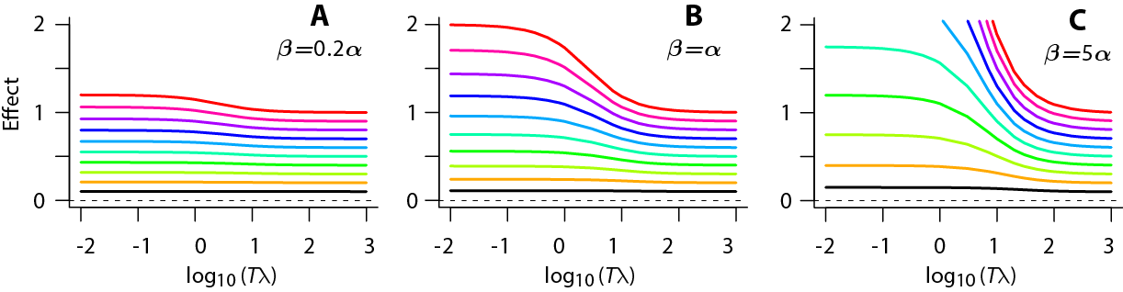**Fig. A3.4.1. Dose rate sparing.** The figures show total effect for total doses that run from d=0.1 Gy (black lowest curve in each panel) in equal steps to 1 Gy (red uppermost curve). The scale of the vertical axis is governed by the value of *α.* The curves shown assume that for this endpoint *α*=1 per Gy. The following properties of Eqs. (A.3.1) and (A.3.5) can be seen from the graphs.

* For *Tλ* ≤10-2 the slope is almost zero and the effect is at its largest for that dose and that parameter set. This is the acute (short duration) limit. Since the Lea-Catcheside *G* factor approaches 1 in that limit, one must have *E=αd*+*βd2.* For example if *α=1, β= 1, d=1* (red topmost line in panel B) one sees that to good approximation the height is *αd*+*βd2*=2.
* For *Tλ* ≥103, the curves are decreasing toward a lower limit of about *αd*. Manipulation of Eq. (A3.3.5) shows that in fact this is the exact value for *Tλ* approaching infinity. In terms of section A3.2, the intuitive explanation is that if the dose rate is small enough a repairable lesions is always repaired before it can interact with a later-arriving repairable lesion to make irreparable damage, so the entire *β* term in the LQ equation drops out leaving only the dose-rate independent term *αd*. The decrease, when going from left to right along a curve, from *E*=*αd*+*βd2* to *E*=*αd* is called “dose rate sparing” or “the direct dose-rate factor”.

Frequently used standard LQ models for many endpoints, when applied to HZE radiations, often give results similar to panel A in Fig. A3.4.1: the curves are so nearly horizontal one may as well ignore the beta term entirely. However, for low LET radiation induction of leukemias one can instead have, in the dose range 0-2 Gy, *α/β* ≪ 1 Gy [Little 2009] so that dose rate sparing is pronounced, as in panel C.

In contrast to the dose rate sparing there is theoretical and experimental evidence (reviewed, e.g. in [Lubin, Boice et al. 1995; Brenner and Sachs 2003; Stevens, Bradley et al. 2014]) that HZE action may (for many endpoints, dose rates and doses of interest) give qualitatively different results whereby effect increases as radiation duration increases for a given fixed dose, corresponding to an “inverse” dose-rate factor instead of a direct one. In such cases Eq. (A3.1), for LQ IDERs with generalized Lea-Catcheside *G* factor, cannot be used*.* And mathematical models quite different from LQ models, e.g. models incorporating NTE such as those in [Cacao, Hada et al. 2016] and [Shuryak, Fornace et al. 2017], are often now being used . Here our interest is mainly in producing proof of principle calculations illustrating how synergy can be analyzed even when dosing is protracted and dose-effect relations are highly curvilinear. These calculations are given in the next subsection.

## A3.5. Examples of Baseline No-synergy/no-antagonism MIXDERs

We now can calculate and compare baseline MIXDERs for mixed radiation fields each of whose components has an IDER of the form (A3.5). For the incremental approach we assume that for a small increment of time *dt*, each component contributes an incremental effect *dEj=rj(dEj/dt)dt,* where *dEj/dt* is given by Eq. (A3.6) evaluated at that time when that component acting by itself would have produced the total effect *I* that both components acting together have already produced. This definition just transfers the arguments used to motivate incremental effect additivity synergy analyses to the case where small increments of time, rather than small increments of total mixture dose are considered. Formally the compositional inverse functions *τj* discussed below Eq. (A3.6) are used to find the appropriate time for each component.No explicit forms for *τj* are available. However, in computer calculations a 1-dimensional root finder can readily give high precision numerical versions of *τj*: the complications sometimes attendant on finding roots are not present because *E(t)* and thus its inverse *τ(E)* are always monotonically increasing in our case. We will assume the repair rates of the two radiations are the same on the grounds that these rates are primarily a property of the biological target.

As an example, suppose in an NSRL experiment we have a mixture of low LET ion radiation 1 (e.g. high energy protons) with high LET radiation 2 and the endpoint is a surrogate for radiogenic excess relative risk for leukemia. As in mixture guidelines for recent NASA calls we will take 80% of the total dose to be due to the low LET radiation, i.e. *r1=0.8* and *r2=0.2*.We will assume chronic irradiation at constant dose rate for one week. For the dose rate *R* we will assume 0.5 Gy per week, i.e. 40 cGy total of low LET radiation mixed with 10 cGy total of high LET radiation over the course of the week.

For the low LET radiation a possible choice of *α* and *β* in Eq. (A3.7), judging from leukemias in the atom-bomb victims, is *α1=0*, *β1*=2 Gy-2 [Little 2009; Hsu, Preston et al. 2013]. The scale of the y axis in the figures we shall show is essentially arbitrary. One might calculate effect, or effect in %, or effect divided by some reference effect) so a uniform re-scaling of all four LQ coefficients (*α1, β1, α2, β2)* makes no essential difference to the baseline MIXDERs or their relation to the IDERs in the figures we shall show. Thus a numerical value of one non-zero LQ coefficient, e.g. *β1* here can be chosen arbitrarily without essential loss of generality.

For the high LET radiation, on the usual argument that for such radiation irreparable one-track action probably dominates, we will choose *β2*=0; for *α2* we choose a nominal value *α2=*5 Gy-1; then the values of *λ2* and *R2* become irrelevant and need not be specified. Fig. A3.5.1 shows baseline no-synergy/no-antagonism curves for this mixture assuming various values of the repair rate *λ1*.

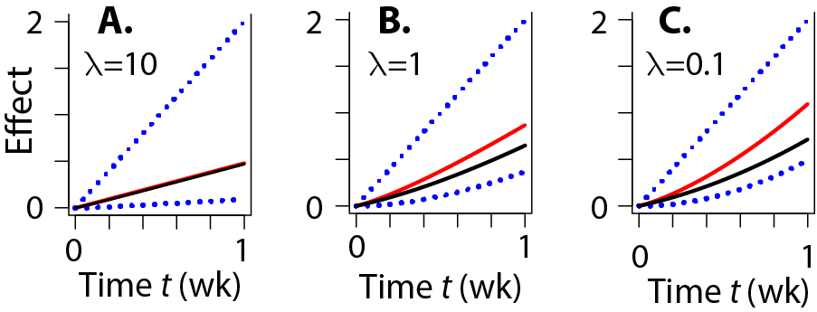**Fig. A3.5.1. Baseline MIXDERs.** The figure shows incremental effect additivity curves (red lines) and simple effect additivity curves (black lines) for a mixture of a high LET ion component and a low LET component. The IDERs, i.e. the curves that would have resulted were the total dose given entirely to one or the other component, are shown as dotted blue lines.

Even for this very simple choice of the two IDERs, no explicit analytic expression is available, so the calculation was done with the customized script Lea.R that is available on GitHub. This script was first tested by applying it to a mixture which happened to be explicitly soluble. Then it was applied to the high-LET low-LET mixture.

Panel A shows a typical result for a repair rate that is not much smaller than those normally assumed. It is trivial from the point of view of illustrating differences between *I(d)* and *S(d)* because both mixture components are effectively LNT: the high LET component IDER is exactly LNT and the low LET IDER might as well be LNT because the dose rate is so low compared to the repair rate that the quadratic term is negligible. Panels B and C show cases of unusually slow repair rate, as could perhaps occur due to some cause – e.g. a state of chronic irritation by ROS or RNS [Cucinotta, Kim and Chappell 2013], reviewed in [Shuryak 2017]. These panels show differences between *I(d)* and *S(d)*.

In trying to decide what further figures to use to illustrate our mixture results we again found too many possibilities. Even when concentrating on 2-component mixtures to avoid the previously discussed confounding factor of having too many possible sets *rj* for dividing total mixture dose *d* into component doses *dj=rjd*, the fact that there are essentially4 other relevant parameters (*α1, β1, λ1*=*λ2, α2,* and *β2*, where only 3 of the 4 LQ coefficients count because of possible y-axis rescaling mentioned above) prevented any systematic choice of a few “representative” mixtures. The script Lea.R for our calculations, freely available on GitHub, therefore did not attempt to consider the even more numerous possibilities that would arise for mixtures with more than 2 different ions entering the beam upstream of shielding.

Fig. A3.5.2 shows two more examples; its caption gives some intuitive interpretations.

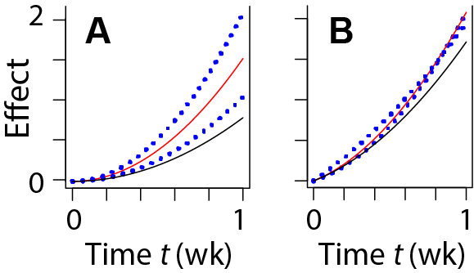**Fig. A3.5.2. Other Mixtures.** The figure gives results for two components having the parameters shown in the table: It shows the time-incremental effect additivity baseline no-synergy/no-antagonism MIXDERs (red lines) and the simple effect additivity no-synergy/no-antagonism MIXDER (black lines). The IDERs, i.e. the curves that would have resulted were the total dose given entirely to one or the other component, are shown as dotted blue lines.

|  |  |  |  |  |  |
| --- | --- | --- | --- | --- | --- |
| panel | ion | *α* | *β* | *λ* | *rj* |
|  |  | Gy-1 | Gy-2 | week-1 |  |
| **A** | 1 | 0 | 8.4 | 0.05 | 0.5 |
|  | 2 | 0 | 4.2 | 0.05 | 0.5 |
| **B** | 1 | 1.2 | 6 | 0.05 | 0.8 |
|  | 2 | 2.6 | 2.6 | 0.05 | 0.2 |

The fact that the simple effect additivity baseline MIXDER falls below both component IDERs is due to the fact that when all mixture components are convex, as is the case for the mixture here, the simple effect additivity baseline is an underestimate. Fig. 1A of the main text shows that such underestimates can be traced back to the failure of simple effect additivity to obey the sham mixture principle. Panel B shows a case where the two component IDERs cross.

## A3.6 Summary

We have given explicit, reasonably realistic examples of how one can do synergy analyses for protracted mixture exposures. Our examples only apply to one very specific kind of component IDERs, which all had to be LQ with linear repair of potentially damaging lesions. We emphasized chronic irradiation at constant dose rate. Our treatment also involved a number of implicit assumptions. For example the time constant for resolution of potentially damaging lesions by either repair or transformation into irreparable lesions was assumed to be so short that one such lesion does not ever suffer a second hit. Conceptually it is clear that it should be possible to generalize the LQ example at least somewhat, but that has not been done and thus may involve unexpected difficulties.

# A4. Differential Synergy Analysis

## A4.1. Definition of Differential Synergy Analysis

### A4.1.1. Differentially-Defined IDERs (DIDERs)

Prior to the availability of computers which can rapidly provide accurate numerical solutions to non-linear ODE, it was natural to specify IDERs by giving effect as an appropriate explicit function *E=E(d)* of dose, as in our main text here, in [Cacao, Hada et al. 2016], and in many other papers. We suggest that nowadays it is often preferable to specify IDERs via their slope as a function of *E* itself, by solving an ODE initial value problem of the form

(A4.1) 

In Eq. (A4.1) *F* is a function having a continuous first derivative, chosen to approximate whatever is known or mechanistically inferred about IDER slopes, which are often easier to model than IDERs themselves. Differentially-defined IDERs (DIDERs) are IDERs defined by Eq. (A4.1). Unless explicitly stated to the contrary we will always assume *F(E)* is > 0 for all relevant values of *E,* so that the solution *E(d)* of Eq. (A4.1) is monotonic increasing and there exists an inverse function with *d=D(E).*

One motivation for taking *F* as a function of *E* rather than a function of *d* is that *E,* unlike *d,* is a state variable, determined by the changing biophysical state of the target system as dose and effect accumulate [Lam 1994]. Moreover, mechanistically analyzing how a small increment of effect interacts with effects caused by earlier dose increments is sometimes easier than mechanistically analyzing the entire effect of the entire dose [Lam 1987]. Also, Eq. (A4.1) facilitates sometimes using *E* instead of *d* as a predictor variable.

*A4.1.2. Differential Synergy Analysis*

Using both DIDERs and incremental effect additivity together gives what we shall call “differential synergy analysis”. Thus differential synergy analysis uses the ODE for the putatively known DIDERs of the *N* components of a mixture:

(A4.2) .

Then it uses a different ODE, the one in the initial value problem (11) for incremental effect additivity *I(d)*, to calculate a baseline for absence of synergy or antagonism:

(A4.3) 

Combining Eqs. (A4.2) and (A4.3) gives

(A4.4) 

DIDERs and incremental effect additivity work smoothly together. Moreover Eqs.(A4.2) and (A4.3) deal directly with effect slopes, which makes available the powerful methods of the qualitative theory of ODE [Brauer and Nohel 1989] -- analyzing effect slope without attempting to actually integrate the ODE.

Generally speaking, differential synergy analysis improves on the other known alternatives to simple effect additivity in a number of ways. It does share the disadvantages (and advantages) that all mathematical synergy analysis approaches have (Fig. 2 in the main text).

Appendix A4 analyzes motivations, examples, theorems, interpretations, advantages, disadvantages, applications, and generalizations related to DIDERs, and to the role of DIDERs in differential synergy analysis.

A4.2. DIDERs with Explicit Solutions

Over the years, radiobiologists have developed IDER equations given by explicit (as opposed to numerical) equations to fit various biophysically motivated and/or experimentally observed curve shapes. Examples include multi-target, multi-hit equations, amorphous track structure equations, LQ equations, various generalizations of LQ equations, equations incorporating NTE, etc. For DIDERs one instead starts with the slope *F(E)*. Often no explicit equation for *E(d)* itself can be found. Finding *E(d)* involves using a standard ODE integrator such as the function ode() in the package deSolve of the computer language R and results in a numerical version of *E(d).* Subsequent calculations then either just use this numerical form to get further numerical results or use the qualitative theory of ODE [Brauer and Nohel 1989], which involves analyzing slopes.

Sub-section A4.2.1 will show by examples that there are, however, many cases where the DIDER initial value problem (A4.1) can be solved explicitly. Explicit DIDERs, and methods for generating them, are often useful, in helping understand numerical DIDERs, when debugging customized software, and to supplement results obtained from the qualitative theory of ODE. Sub-section A4.2.2 will give an example.

*A4.2.1. Examples of Explicit DIDERs*

In Eq. (A4.1) suppose *F(E)* is an *Nth* degree polynomial with *N* real roots, all non-zero and distinct from each other. Then:

(A4.5) 

where *c* is a real constant>0 so the roots are –*ak*. In this case one can always use the method of partial fractions to integrate the ODE (A4.1) and obtain *d* as a function of *E.* Sometimes the inverse function *E(d)* can be expressed explicitly. For example when *N=1* and *a*>0 the solution *E(d)* obtained by integrating and using an inverse function involves an exponential:

(A4.6) 

*E(d)* is then similar to an LQ curve with both *α* and *β* positive in the following respects: for doses so small terms cubic or higher in dose can be neglected, *E(d)* is LQ with α=*ca* and β=(*c*/2)α; *E(d)* is strictly convex, with positive second derivative, for all doses (Fig. A4.1 below); *E(d)* does not approach ∞ as some finite value is approached by *d*; and *E(d)* is unbounded, approaching ∞ as *d* approaches *∞.*

As another example, for *N=2* with *a, b, c>0* one has:

(A4.7) 

In this case *E(d)* approaches *b* as *d* approaches *∞* and, depending on the choice of parameters, the curve can be concave or sigmoidal (Fig. A4.1).

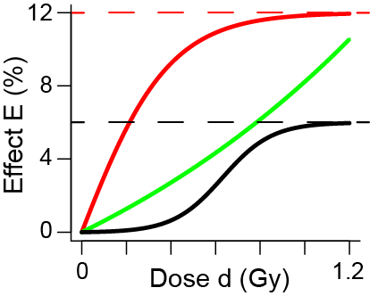 **Fig. A4.1. DIDER curve shapes.** All three curves are monotonically increasing with finite positive slope at all doses. The green curve is described explicitly by Eq. (A4.6) with *a=10* and *c=0.6*. It has properties similar to an LQ curve; at low doses it is LQ, with α= 6% per Gy and α/β=10/3 Gy. The black curve and red curves are described by Eq. (A4.7) with upper limits *b*=6% or 12% respectively. The black curve has *a=0.02* and has *c=1.5*; it is sigmoidal, with a point of inflection. The red curve has *a=13* and has *c=0.2*. It is concave. The criterion for concavity vs. sigmoidicity is *a>b* vs. *a<b.* It is seen that one can readily find DIDERs with explicit *E(d)* functions and various qualitatively specified shapes.

*A4.2.2. DIDER Non-Linearity*

The IDERs we used in the main text to reanalyze the main-example data set involved adding two terms, for NTE and TE respectively. A corresponding approach when using DIDERs is to add two slopes, but one must then take into account non-linearities. Specifically, suppose the slope *F(E)* in Eq. (A4.1) is modeled as a sum of two terms:

(A4.8) 

Then *E(d)* is in general not merely the sum of the two DIDERs defined by



Intuitively speaking, *F1(E)* and *F2(E)* “interact” with each other. For example consider the following case.

(A4.9)*….*

Using the methods of the preceding subsection we find

(A4.10) 

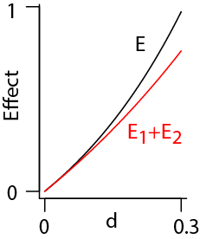So *E(d)>E1(d)+E2(d)*, as shown in the Figure.

In fact, this inequality holds whenever both *F1(E)* and *F2(E)* are positive monotonic increasing functions for all relevant *E.* The intuitive reason, using the qualitative theory of ODE, is roughly the following.For *E* the slope at each point is larger than for either of the two components so it leads the solution to larger values of *E* faster than for either component. Because all the slopes are monotonic increasing functions of effect, this leads to an ever increasing lead of *E* over *E1+E2.*

The result *E(d)>E1(d)+E2(d)* contrasts with the result where a slope is determined by functions of dose. For any integrable functions *F1(d)* and *F2(d)* we have

(A4.11) 

Here the second implication follows from the fact that all 3 effects are 0 at d=0.

A4.3. Using DIDERs to Circumvent the Minimax Limitation

A key disadvantage of many synergy analysis approaches designed to replace simple effect additivity is that in many situations the method is applicable only in a neighborhood of the origin (i.e. of dose=0=effect) too small to cover all the mixture doses and effects relevant to the observations. The present sub-section reviews this limitation and shows by an example how differential synergy analysis can circumvent the limitation. Circumventing the limitation is the most important practical advantage of differential synergy analysis. Before giving details on the circumvention method we give in sub-section A4.3.1 an example from a different field, population dynamics, which suggested to us that differential synergy analysis should be introduced.

*A4.3.1. The Logistic Model*

Readers interested in applications of differential synergy analysis but not interested in its motivations, should skip this sub-section.

It is instructive to compare IDERs with population dynamics equations. Elementary population dynamics [Edelstein-Keshet 2005] studies the size *N(t)* of a population as a function of time t≥ 0, with *N(t)*≥0 and *N(0)*>0. Population size *N* can be seen as somewhat analogous to effect *E*, and time *t* as analogous to dose *d*. The analogy is not wholly appropriate since *N(0)>0* instead of *E(0)= 0* but provides useful insights none the less.

The logistic ODE for a growing population [Edelstein-Keshet 2005] uses two real constants: a “carrying capacity” *K*> 0; and a “Malthusian growth rate” *r.* We shall here take *r>0.* The ODE is

(A4.12) .

In view of the analogies *N ↔ E* and *t ↔ d* the ODE Eq. (A4.12) is fully analogous to the DIDER ODE *dE/dd=F(E)* with the slope *rN*[1-*(N/K)*] analogous to the slope *F(E).*

It is seen from Eq. (A4.12): (a) that the slope *rN*[1-*(N/K)*] is negative if and only if *N>K*; and (b) for *N*≪*K* one has the equation of exponential growth *dN/dt=rN.* Fig. A4.2 shows typical solutions of Eq. (A4.12) for *N(0)* less than, equal to, or greater than the carrying capacity *K* respectively.

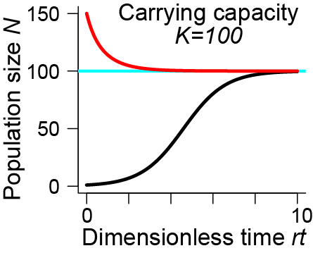

**Fig. A4.2. Logistic Population Growth or Decay.** The red line is for initial population of 150, larger than the carrying capacity of 100. The black curve is for initial population 1.

It is seen that in all cases the solution is almost *K* for large values of time. The interpretation is the following. As population grows from small numbers (black curve) its initial exponential growth is slowed by environmental limitations such as scarcity of food, water, space, habitat, etc. The size approaches but cannot exceed the carrying capacity. If for some reason different earlier dynamics produced a population at *t=0* exceeding *K,* there is a rapid decrease (red curve) due, e.g., to famine, disease, or war.

The ODE (A4.12), analogous to an DIDER, can be solved to get a result analogous to more standard IDERs:

(A4.13) 

Eqs. (A4.12) and (A4.13) are equivalent but using (A4.12) facilitates powerful qualitative approaches, intuitive as in the discussion above, or mathematical [Brauer and Nohel 1989], which are not evident in Eq. (A4.13).

For our purposes the key point is the following. In a normal situation, the population approaches but does not exceed the carrying capacity. The same factors that lead to this limitation are operative in abnormal situations where the population starts out larger than the carrying capacity. They can be measured and modeled even in these abnormal situations.

*A4.3.2. A Key Advantage of Differential Synergy Analysis*

In almost all synergy analyses methods designed to replace simple effect additivity, the problem that sometimes one component of a mixture when acting on its own can never exceed a certain level, while other components, and thus the mixture, can exceed that level, can play an important role. For example the minimax limitation discussed in sub-section A2.3.1 sometimes renders linear isobole synergy analysis virtually useless [Siranart, Blakely et al. 2016]. The analogy with population dynamics indicates the way to circumvent this problem: using a DIDER whose slope is defined even for effects larger than those the agent can produce on its own.

For example consider two IDERs defined as follows:

(A4.14) 

As always, effect=0 when dose=0. Then in Eq. (A4.2) for the two DIDERs the ODE read

(A4.15) 

The initial value problem for incremental effect additivity is thus

(A4.16) 

It follows from the qualitative theory of differential equations [Brauer and Nohel 1989] that *I* is monotonically increasing and approaches a finite limit *IL* determined by setting the slope in Eq. (A4.16) equal to zero:

(A4.17) 

Here we chose the positive solution since *I* > 0.

Fig.A4.3 shows an example of the solution of Eq. (A4.16) obtained by numerical integration. This solution supplies the differential synergy analysis no-synergy/no-antagonism baseline MIXDER. For comparison the figure shows the two DIDERs, Eq. (A4.15).

**Fig. A4.3. Circumventing the minimax restriction.**

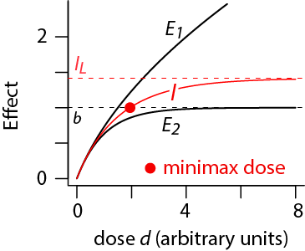The figure shows the case *a*=3, *b*=1, *r1*=0.5, *r2*=0.5 in Eqs. (A4.15) and (A4.3) It schematically indicates a number of instructive properties as follows.

* The MIXDER *I(d)* is well defined for all doses, is monotonically increasing, and, like the DIDERs of the components, is convex.
* Agent 2, acting by itself, cannot produce effects larger than *b*, no matter how large its dose, and its effect approaches *b* as its dose approaches infinity. These facts can be inferred directly from the fact that the DIDER slope, *F2* in Eq. (A4.15), is *b*-*E2.*
* The DIDER for Agent 1, acting by itself, is concave for all doses, as can be seen by differentiating *F1* in Eq. (A4.15). The DIDER approaches infinity for dose approaching infinity –roughly speaking the DIDER is about *constant/E1* for large *E1* and integrating explicitly shows that in this approximation *E1* is proportional to *d11/2*.
* Importantly in the 50-50 mixture, agent 1drives the MIXDER above *b* at a dose of about 2 (red dot). Thereafter agents 1 and 2 are acting in opposite directions, contributing positive and negative slopes respectively.
* The result of this conflict is that the MIXDER gradually approaches the limit *IL* calculated in Eq.(A4.17) (red horizontal dashed curve).
* The fact that in such cases the MIXDER can be calculated even for effects larger than the horizontal black dashed line is sometimes extremely important in realistic calculations. In this case the linear isobole approach to synergy gives a baseline no-synergy/no-antagonism MIXDER (not shown) quite similar to the red curve below the red dot. But then, as discussed in section A2, the linear isobole approach refuses to go further, even when higher doses are of more interest, e.g. if the region below the red dot refers to modeled NTE effects at doses too low for the NTE effects to be observable.

In calculations where one mixture component has a maximum effect that other mixture components can exceed, differential synergy analysis appears to be, due in part to the extra range for the MIXDER exemplified in Fig. A4.3 more useful than any other substitute for simple effect additivity. Differential synergy analysis also has a number of other useful properties, discussed below.

*A4.3.3. A Gap in the Argument*

However, we have been quite unable to solve the problem of finding conditions on IDERs that are both necessary and sufficient for being able to apply differential synergy analysis (or even just incremental effect additivity). Differential synergy analysis as defined above is clearly not applicable in many situations where simple effect additivity, for all its faults, can readily be computed. On the other hand it is clear that some of the requirements we have imposed on IDERs, e.g. the requirement that *F(E)* in Eq. (A4.1) be positive, are too restrictive.

The mathematical aspects of trying to find appropriate IDER requirements are tricky. For example, with *ξ* a positive constant *F(E)=ξ(1+E2)* gives, as integrating *dE/(1+E2)* shows, the DIDER *E*=tangent(*ξd*). In the interval [0, π/2*ξ*) the DIDER is completely well behaved. However, as *d* approaches π/2*ξ* from below, *E* approaches infinity, as shown in Fig. A4.4. An IDER that approaches ∞ at finite dose is not useful in any analysis we know of, and attempts to use differential synergy analysis on a mixture one of whose components has IDER tangent*(ξd)* give strange results. So one should presumably exclude such possibilities, while somehow not excluding any useful possibilities.

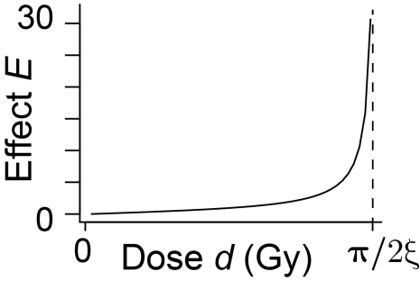

**Fig. A4.4.** The hypothetical IDER *E*=tan(*ξd*) could cause problems in a mixture calculation.

A4.4. The Mixtures of Mixtures Principle

*A4.4.1. Mixtures of Mixtures*

An interesting advantage of differential synergy analysis is that it obeys what we shall call the mixture of mixtures principle. In NASA studies, mixtures whose components are themselves mixtures are important (reviewed in [Norbury, Schimmerling et al. 2016]). Pharmacological practice indicates that mathematical synergy analysis is then still applicable. A drug whose active ingredient is a single chemically pure compound can nonetheless act in complicated ways: on various organs in various locations at various concentrations by various mechanisms after transformation in the body to various other compounds [Ashford 1981]. So it is essentially already a mixture as far as its physiological effects are concerned. But if an IDER for such a compound is known, and the compound is one component of a mixture, then pharmacometric mathematical synergy analyses routinely treat the component on the same footing as a different compound which has essentially just one simple physiological effect; indeed in many cases one does not know if the action of a chemically pure compound is very complex or very simple.

So if a drug is some standard mixture of various active compounds and its IDER is known the drug can also be considered as single agent which can become one component of a mixture. This then implies a constraint on the definition of synergy. For a single acute treatment, a mixture of agents, some of which are themselves mixtures, must have the same baseline MIXDER defining absence of synergy and antagonism, as any other regrouping of the same components in the same amounts. As with the sham mixture principle, imposing the mixture of mixture principle excludes a number of synergy approaches in the literature. Some approaches always obey the mixture of mixtures principle. We will show that differential synergy analysis is an example. Other approaches sometimes violate the mixture of mixtures principle. We will show that simple effect additivity is an example.

*A4.4.2. Differential Synergy Analysis Always Obeys the Mixture of Mixtures Principle.*

Note from Eq. (A4.4) that the slope of the baseline MIXDER *I(d)* is just a sum , which can be grouped, regrouped and shuffled like any other sum. This remark and Picard’s existence/uniqueness theorem for ODE initial value problems are enough to show that differential synergy analysis always obeys the mixture of mixtures principle.

For an illustrative specific example suppose we have three mixtures, *Mk*, and 3 agents with monotonic increasing unbounded DIDERs that are well defined and smooth for all non-negative doses. Normally in differential synergy analysis such DIDERs are defined, as discussed in connection with Eq. (A4.2), by choosing a slope *F(E)* as a function of effect using biophysical arguments and integrating . However, some readers may find useful the following even more specific sub-case of three DIDERs given in reverse order: first the DIDER *E* as a function of dose *d* with explicit inverse function *D,* then slope *dE/dd* as a function of *d,* and finally the slope function *F(E)* which could have, and normally would have, been chosen by biophysical arguments to define the DIDER but was instead calculated from *E(d), D(E),* and *dE/dd* as follows.

(A4.18) 

Now suppose we have 3 mixtures *Mj*whose respective dose fraction constants *rj* of a mixture dose have the following pattern: M1=A1/2 +A2/2, M2=.4A1+.6A2, M3=1/6A1+5/6M2 should work also

(A4.19) 

Here, if *d* is the total mixture dose for any of the three mixtures, the component doses are given by Eq. (9) of the main text as:. For *M1*, *N=3* and *rj=(1/3, 1/3, 1/3);* for *M2*, *N=2* and *rj=(1/2, 1/2);* for *M3*, *N=4* and *rj=(1/6, 1/6, 1/3,1/3).*

Then the mixture *M3*, one of whose components is the mixture *M2*, is just the mixture *M1* in disguise, since:

(A4.20) .

Applying the same manipulations to  shows that the baseline MIXDER has the same slope for mixture *M1* and the mixture of mixtures *M3.* By Picard’s existence and uniqueness theorem the baseline MIXDERs themselves are equal for all doses and effects, verifying the mixture of mixtures principle holds for all non-negative doses and effects. Since the MIXDER slope is always positive, the MIXDER is monotonic increasing.

Wholly similar calculations lead to the same conclusion for any mixture having a finite number of components, with each DIDER being well defined, smooth, monotonic increasing, and unbounded for all non-negative doses. For DIDERs less well behaved at large doses and large effects, similar calculations can be used to show that baseline MIXDERs are well defined in some, perhaps small, half open dose interval including the origin, and to show that such MIXDERs obey the mixture of mixtures principle on appropriately restricted domains.

*A4.4.3. An Example of a Failure to Obey the Principle*

In this section we will show by an example that using the baseline simple effect additivity MIXDER instead of differential synergy analysis can violate the mixture of mixtures principle. Consider again the example given by Eqs. (A4.18)-(A4.20). For our next calculation we do not need inverse functions or slopes, only the three DIDERs in their *E(d)* form:

(A4.21) 

Denote the baseline MIXDER for mixture *M1* by *I1(d)* and that for *M3* by *I3(d)*.A straightforward calculation using the definition, Eq. (10) for simple effect additivity shows that

(A4.22) 

Since *E1* and *E2* are strictly convex the difference in Eq. (A4.22) is positive for all doses > 0, as can be checked by using Eq. (A4.21). Thus simple effect additivity sometimes violates the mixture of mixtures principle. Additional calculations, not shown here, lead to two further conclusions: the violation of the principle by simple effect additivity is the generic case for that synergy definition; and there are other synergy approaches in use that also typically violate the principle. As far as we know, all synergy definitions that obey the sham mixture principle also obey the mixture of mixtures principle and vice-versa. Whether there is a theorem that states this equivalence must always hold, or instead there is a counter example, is an open question.

A4.5. Invariance Under Transformations of Dose Variables

Suppose we have DIDERs as follows:

(A4.23) 

Then, in differential synergy analysis, using the notation of the main text subsection 3.3.1 and Eq. (11) the incremental effect additivity baseline MIXDER *I(d)* is defined as a function of total mixture dose *d* by

(A4.24) 

When *f* and *g* are required to be positive, *I* is monotonic increasing since *ddj/dd=rj*>0, and we can think of Eq. (A4.24) as determining *d* from *I* rather than vice versa.

Sometimes in analyzing IDERs such as *E2* it is desirable to consider a transformation of the dose variable. Changing units corresponds to a linear transformation. Non-linear transformations are useful, for example, if one is trying to incorporate a dose-dependent RBE, or if an important part of the IDER is approximately exponential over some dose interval *(A, B)* with *A>0* so that using *d*=A*exp(*d/A)* on that interval facilitates analyses.

So suppose *h* is a smooth, monotonic increasing function with *h(0)=0* and

(A4.25) 

Here *H* is the inverse function. A definition of synergy should give the same baseline MIXDER whether we use *d2* or *d2\**. Intuitively that should hold in differential synergy analysis, which regards effect as the basic variable: if effect is the basic variable, then it should not matter how we describe the dose of the second ion, as long as *d2\** remains a monotonic increasing function of effect. We now prove that in fact using *d2*\* does give the same final result for *I.* We take total mixture dose *d* to remain the same biophysical quantity, i.e. *d=d1+H(d2*)*. For example if *d* and *d1* are in Gy but *d2* is transformed to mGy then *d2*=h(d2)=*103*d2*, so *d=d1+*10-3*d2* and has units of Gy. Given the constant *r1,* and thereby given the constant *r2=1-r1*, any one of the four quantities *d, d1,* *d2,* and *d\** determines the other three. We have:

(A4.26) 

Therefore

(A4.27) 

By Eq. (A4.27) we have an ODE initial value problem:

(A4.28)

By Picard’s theorem there is a unique solution to this ODE initial value problem so, in view of Eq. (A4.24), *I*(d)=I(d)*, as was to be shown.

In proving Eq. (A4.27) only manipulations involving *d2* and *E2* were involved. It follows that simultaneously transforming the dose axes of both IDERs, using functions *h1* and *h2* that can be different, also preserves the baseline MIXDER. Similarly, the result generalizes to an *N* component mixture, with each component having its own transformation *hj* (with the identity transformation *d*j=dj* of course allowed).

A4.6. A Strategy for Synergy Analysis.

*A4.6.1. Preliminary Comments*

Simple effect additivity is always available for synergy analyses; in practice it is always used to help plan for mixture experiments and to interpret mixture data. Because simple effect additivity has known limitations, we recommend the following strategy. Whenever the some component of a mixture has highly curvilinear IDER, supplements to simple effect additivity should be sought. Whenever differential synergy analysis can be applied it should be used as a supplement. Some other synergy approach should be used as an additional supplement when there are biophysical reasons for doing so. If differential synergy analysis cannot be applied, e.g. if not all of the IDERs are monotonically increasing, other supplements to simple effect additivity should be used unless all IDER are, to good approximation, linear-no-threshold.

*A4.6.2. Problems with Differential Synergy Analysis and Incremental Effect Additivity*

Although differential synergy analysis is being recommended as the preferred substitute for simple effect additivity its limitations should not be underestimated. We next summarize the limitations, already discussed in various earlier sub-sections, of the incremental effect additivity no-synergy/no-antagonism baseline *I(d)* which is an essential component of differential synergy analysis.

*I(d)* shares the limitations of all reasonably general mathematical synergy analyses approaches; for example it does not use biophysical insights and it is usually just a real-valued function of dose, not a more complicated mathematical object that could take into account complex endpoints such as probability distributions of time to tumor. Generally, *I(d)* applies only to differentiable and monotonically increasing IDERs; the exceptions to the monotonic increasing requirement discussed below are in the nature of exceptions rather than being generally applicable. Computing *I(d)* usually involves heavy use of computer calculations. The heavy emphasis on numerical methods instead of explicit functions is somewhat unfamiliar; it makes global results that hold for all relevant values of parameters hard to find; it means that claimed results cannot be checked or constructively criticized by other groups unless all customized source codes are made freely and conveniently available. There is, at least as yet, no standardized, critically tested consensus protocol for using and interpreting *I(d)*.

## 

## Differential Synergy Analysis Preliminary Notes

If NTE are important and we consider a mixture that, when it reaches the target cells, contains many different HZE ions, *S(d)* cannot be used (Fig. ). mathematical synergy analysis that uses both DIDER and incremental effect additivity *I(d)* can be used*.*

*A4.6.3. Advantages of Differential Synergy Analyses Preliminary Notes*

* domain of applicability circumvents the *Eminimax*complication, occurring at high effect values, mentioned in A2.3.1 on isobole synergy analysis. It thereby often allows differential synergy analysis over a larger dose range, and for higher effect values, than isobole synergy analysis can handle. In some applications this dose and effect range extension is very important, though it was not needed in our mathematical synergy analysis of the fibroblast CA data set described in sub-section 2.1.2, which is particularly simple in this respect.
* reasonable results
* E as the more important variable.
* obeys sham mixture, mixture of mixtures principles, non linear rescaling of dose axis, heterogeneous
* It implies monotonic increase at sufficiently small doses. if monotonically increasing easy to manipulate numerically

A4.7. Generalizations Preliminary Notes

We do not know how far one can go in generalizing differential synergy analysis. Here we give an example which was a pleasant surprise and make a few remarks on other generalizations.

*A4.7.1. The Case of an Effector and a “Mild” Inhibitor*

Suppose we have an agent which can produce an effect and an inhibitor which can reduce the effect when present but does nothing at all when no effect is present, e.g. one HZE radiation and a harmless dietary anti-oxidant. None of the synergy definitions discussed above can answer the relevant question --is an observed MIXDER higher or lower than one would have guessed. However if we characterize the effector and inhibitor by DIDER in the sense of Eq. (A4.8) one can generalize differential synergy analysis as indicated by the following example to get an answer. Suppose the effector is described by a smooth positive slope given by the derivative with respect to radiation dose *d* as a function of effect as is done for DIDER, for example with α> 0,

(A5.1.1.eeee) 

Inhibitor dose *d2* will be in some units other than Gy, e.g. mg/kgm. Suppose the inhibitor slope is defined by the following equation.

(A5.1.2.eeee) 

This is the equation of exponential decay if *E2>0.* The implicit assumption here is that *λ* has already been measured, e.g. by experiments with some different agents that can produce the same effect as the effector being analyzed. When both agents were radiation beams and used to make a mixed radiation beam, we used the notation that for total radiation dose *d, d1=r1d, d2=(1-r1)d*; we took *r1* constant for convenience. Thus the appropriate notation now is that, in a mixture of effector and inhibitor, radiation dose *d=d1* and inhibitor dose *d2=r2d*, where *r2* has the appropriate units. For mathematical convenience we again assume *r2* is constant, and, as before, dropping this constancy assumption would not alter the final results or interpretations in any important way.

After these acrobatics, everything should work nicely: the effector keeps making effect and the inhibitor, once it has something to inhibit, keeps fighting the effector. The equation of incremental effect additivity for total effect *E* reads



There are two typical kinds of solution, according as *λ\** is >1 (large admixture of a strong inhibitor) or

*λ\** <1 (small admixture of a weak inhibitor). These are shown in panels A and B respectively.

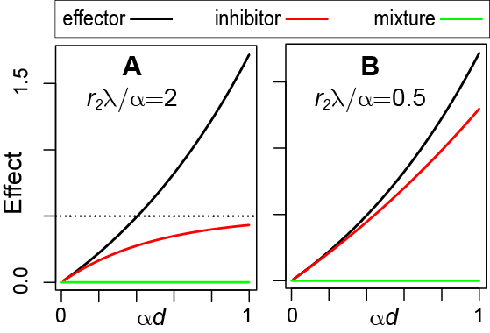

lambda* in figure

many effectors and many inhibitors.treats in a symmetric way

*A4.7.2. Other Generalizations*

*A4.7.3. Mixtures with a Dead Band IDER*

[Radivoyevitch, Hlatky et al. 2012]

**Bibliography**

1. Ashford JR. "General models for the joint action of mixtures of drugs." Biometrics **37**(3): 457-474. (1981).

2. Beinke C, S Barnard, H Boulay-Greene, A De Amicis, S De Sanctis, F Herodin, . . . M Abend. "Laboratory intercomparison of the dicentric chromosome analysis assay." Radiat Res **180**(2): 129-137. (2013).

3. Bennett PV, NC Cutter and BM Sutherland. "Split-dose exposures versus dual ion exposure in human cell neoplastic transformation." Radiat Environ Biophys **46**(2): 119-123. (2007).

4. Berenbaum MC. "What is synergy?" Pharmacol Rev **41**(2): 93-141. (1989).

5. Berenbaum MC. "Concepts for describing the interaction of two agents." Radiat Res **126**(2): 264-268. (1991).

6. Binder K. Introduction: General Aspects of Computer Simulation Techniques and Their Applications in Polymer Physics. Monte Carlo and Molecular Dynamics Simulations in Polymer Science. K. Binder. Oxford, Oxford University Press. (1995)

7. Bird RP, M Zaider, HH Rossi, EJ Hall, SA Marino and N Rohrig. "The sequential irradiation of mammalian cells with X rays and charged particles of high LET." Radiat Res **93**(3): 444-452. (1983).

8. Boedeker W and T Backhaus. "The scientific assessment of combined effects of risk factors: different approaches in experimental biosciences and epidemiology." Eur J Epidemiol **25**(8): 539-546. (2010).

9. Bosgra S, JC van Eijkeren and W Slob. "Dose addition and the isobole method as approaches for predicting the cumulative effect of non-interacting chemicals: a critical evaluation." Crit Rev Toxicol **39**(5): 418-426. (2009).

10. Brauer F and J Nohel. The Qualitative Theory of Ordinary Differential Equations. New York, Dover. (1989)

11. Brenner DJ, JB Little and RK Sachs. "The bystander effect in radiation oncogenesis: II. A quantitative model." Radiation Research **155**(3): 402-408. (2001).

12. Brenner DJ and RK Sachs. "Domestic radon risks may be dominated by bystander effects--but the risks are unlikely to be greater than we thought." Health Phys **85**(1): 103-108. (2003).

13. Brun YF and WR Greco. "Characterization of a three-drug nonlinear mixture response model." Front Biosci (Schol Ed) **2**: 454-467. (2010).

14. Cacao E, M Hada, PB Saganti, KA George and FA Cucinotta. "Relative Biological Effectiveness of HZE Particles for Chromosomal Exchanges and Other Surrogate Cancer Risk Endpoints." PLoS One **11**(4): e0153998. (2016).

15. Chang PY, FA Cucinotta, KA Bjornstad, J Bakke, CJ Rosen, N Du, . . . EA Blakely. "Harderian Gland Tumorigenesis: Low-Dose and LET Response." Radiat Res **185**(5): 449-460. (2016).

16. Chou TC. "Theoretical basis, experimental design, and computerized simulation of synergism and antagonism in drug combination studies." Pharmacol Rev **58**(3): 621-681. (2006).

17. Coddington EA and N Levinson. Theory of ordinary differential equations. NY, McGraw-Hill. (1955)

18. Cucinotta FA and LJ Chappell. "Non-targeted effects and the dose response for heavy ion tumor induction." Mutat Res **687**(1-2): 49-53. (2010).

19. Cucinotta FA, MH Kim and LJ Chappell. Space Radiation Cancer Risk Projections and Uncertainties – 2012. Hanover, MD; <http://ston.jsc.nasa.gov/collections/TRS>, NASA Center for AeroSpace Information. (2013)

20. Cucinotta FA, MH Kim, LJ Chappell and JL Huff. "How safe is safe enough? Radiation risk for a human mission to Mars." PLoS One **8**(10): e74988. (2013). ***PMC3797711***

21. Cucinotta FA, H Nikjoo and DT Goodhead. "Applications of amorphous track models in radiation biology." Radiat Environ Biophys **38**(2): 81-92. (1999).

22. Durante M. "New challenges in high-energy particle radiobiology." Br J Radiol **87**(1035): 20130626. (2014a). ***PMC4064605***

23. Durante M. "Space radiation protection: Destination Mars." Life Sci Space Res (Amst) **1**: 2-9. (2014b).

24. Edelstein-Keshet L. Mathematical Models in Biology. Philadelphia, SIAM. (2005)

25. Foucquier J and M Guedj. "Analysis of drug combinations: current methodological landscape." Pharmacol Res Perspect **3**(3): e00149. (2015). ***PMC4492765***

26. Fraser TR. "Lecture on the Antagonism between the Actions of Active Substances." Br Med J **2**(618): 485-487. (1872). ***PMC2295227***

27. Furusawa Y, M Aoki and M Durante. "Simultaneous exposure of mammalian cells to heavy ions and X-rays." Adv Space Res **30**(4): 877-884. (2002).

28. Geary N. "Understanding synergy." Am J Physiol Endocrinol Metab **304**(3): E237-253. (2013).

29. George K, J Rhone, A Beitman and FA Cucinotta. "Cytogenetic damage in the blood lymphocytes of astronauts: effects of repeat long-duration space missions." Mutat Res **756**(1-2): 165-169. (2013).

30. Goodhead DT. "Energy deposition stochastics and track structure: what about the target?" Radiat Prot Dosimetry **122**(1-4): 3-15. (2006).

31. Grabovsky Y and RJ Tallarida. "Isobolographic analysis for combinations of a full and partial agonist: curved isoboles." J Pharmacol Exp Ther **310**(3): 981-986. (2004).

32. Greco WR, G Bravo and JC Parsons. "The search for synergy: a critical review from a response surface perspective." Pharmacol Rev **47**(2): 331-385. (1995).

33. Hada M, LJ Chappell, M Wang, KA George and FA Cucinotta. "Induction of chromosomal aberrations at fluences of less than one HZE particle per cell nucleus." Radiat Res **182**(4): 368-379. (2014).

34. Hsu WL, DL Preston, M Soda, H Sugiyama, S Funamoto, K Kodama, . . . K Mabuchi. "The incidence of leukemia, lymphoma and multiple myeloma among atomic bomb survivors: 1950-2001." Radiat Res **179**(3): 361-382. (2013).

35. IEEE. (2014). "Institute of Electric and Electronic Engineers: Top 10 Programming Languages." Retrieved 03/12/2015, from <http://spectrum.ieee.org/computing/software/top-10-programming-languages>.

36. Katz R. (1988). "Radiobiological Modeling Based On Track Structure. Quantitative Mathematical Models in Radiation Biology, ed. J. Kiefer." Retrieved December, 2016, from <http://digitalcommons.unl.edu/physicskatz/60>.

37. Kim MH, A Rusek and FA Cucinotta. "Issues for Simulation of Galactic Cosmic Ray Exposures for Radiobiological Research at Ground-Based Accelerators." Front Oncol **5**: 122. (2015). ***PMC4455530***

38. Kraft G, M Kramer and M Scholz. "LET, track structure and models. A review." Radiat Environ Biophys **31**(3): 161-180. (1992).

39. Lam GK. "The interaction of radiations of different LET." Phys Med Biol **32**(10): 1291-1309. (1987).

40. Lam GK. "A general formulation of the concept of independent action for the combined effects of agents." Bull Math Biol **56**(5): 959-980. (1994).

41. Lee SI. "Drug interaction: focusing on response surface models." Korean J Anesthesiol **58**(5): 421-434. (2010). ***PMC2881515***

42. Little MP. "Cancer and non-cancer effects in Japanese atomic bomb survivors." J Radiol Prot **29**(2A): A43-59. (2009).

43. Loewe S and H Muischnek. "Ueber Kombinationswirkungen. I. Mitteilung Hilfsmittel der Fragestellung." Archiv for Experimentelle Pathologie und Pharmakologie **114**: 313-326. (1926).

44. Lorenzo JI and P Sanchez-Marin. "Comments on "Isobolographic analysis for combinations of a full and partial agonist: curved isoboles"." J Pharmacol Exp Ther **316**(1): 476-478; author reply 479. (2006).

45. Lubin JH, JD Boice, Jr., C Edling, RW Hornung, G Howe, E Kunz, . . . et al. "Radon-exposed underground miners and inverse dose-rate (protraction enhancement) effects." Health Phys **69**(4): 494-500. (1995).

46. Maalouf M, M Durante and N Foray. "Biological effects of space radiation on human cells: history, advances and outcomes." J Radiat Res **52**(2): 126-146. (2011).

47. Matloff N. The Art of R Programming. San Francisco, No Starch Press. (2011)

48. Norbury JW, W Schimmerling, TC Slaba, EI Azzam, FF Badavi, G Baiocco, . . . CJ Zeitlin. "Galactic cosmic ray simulation at the NASA Space Radiation Laboratory." Life Sci Space Res (Amst) **8**: 38-51. (2016).

49. Piggott JJ, CR Townsend and CD Matthaei. "Reconceptualizing synergism and antagonism among multiple stressors." Ecology and Evolution: **5**(7): 1538–1547. (2015).

50. Radivoyevitch T, L Hlatky, J Landaw and RK Sachs. "Quantitative modeling of chronic myeloid leukemia: insights from radiobiology." Blood **119**(19): 4363-4371. (2012).

51. Sachs RK, P Hahnfeldt and DJ Brenner. "The link between low-LET dose-response relations and the underlying kinetics of damage production/repair/misrepair." International Journal of Radiation Biology **72**(4): 351-374. (1997).

52. Shuryak I. "Mechanistic Modeling of Dose and Dose Rate Dependences of Radiation-Induced DNA Double Strand Break Rejoining Kinetics in Saccharomyces cerevisiae." PLoS One **11**(1): e0146407. (2016). ***PMC4711806***

53. Shuryak I. "Quantitative modeling of responses to chronic ionizing radiation exposure using targeted and non-targeted effects." PLoS One **12**(4): e0176476. (2017). ***PMC5404850***

54. Shuryak I, AJJ Fornace, Jr., K Datta, S Suman, S Kumar, RK Sachs and DJ Brenner. "Scaling Human Cancer Risks from Low LET to High LET when Dose-Effect Relationships are Complex." Radiat Res. (2017).

55. Sigurdson AJ, M Ha, M Hauptmann, P Bhatti, RJ Sram, O Beskid, . . . JD Tucker. "International study of factors affecting human chromosome translocations." Mutat Res **652**(2): 112-121. (2008). ***PMC2696320***

56. Siranart N, EA Blakely, A Cheng, N Handa and RK Sachs. "Mixed Beam Murine Harderian Gland Tumorigenesis: Predicted Dose-Effect Relationships if neither Synergism nor Antagonism Occurs." Radiat Res **186**(6): 577-591. (2016).

57. Smith M, K S., H Andrews, V Arkhangelsky, H Ing, M Koslowksy, . . . VA Shurshakov. Assessment of radiation exposure of astronauts in space. Annals of the ICRP. C. H. Clement. **42(4)**. (2013)

58. Sollazzo A, S Shakeri-Manesh, A Fotouhi, J Czub, S Haghdoost and A Wojcik. "Interaction of low and high LET radiation in TK6 cells-mechanistic aspects and significance for radiation protection." J Radiol Prot **36**(4): 721-735. (2016).

59. Stevens DL, S Bradley, DT Goodhead and MA Hill. "The influence of dose rate on the induction of chromosome aberrations and gene mutation after exposure of plateau phase V79-4 cells with high-LET alpha particles." Radiat Res **182**(3): 331-337. (2014).

60. Suzuki S, Y Miura, S Mizuno and Y Furusawa. "Models for mixed irradiation with a 'reciprocal-time' pattern of the repair function." J Radiat Res **43**(3): 257-267. (2002).

61. Tallarida RJ. "Revisiting the isobole and related quantitative methods for assessing drug synergism." J Pharmacol Exp Ther **342**(1): 2-8. (2012). ***PMC3383036***

62. Tang J, K Wennerberg and T Aittokallio. "What is synergy? The Saariselkä agreement revisited." Frontiers in Pharmacology **6**: 181. (2015).

63. Zaider M. "Concepts for describing the interaction of two agents." Radiat Res **123**(3): 257-262. (1990).

64. Zaider M and HH Rossi. "The synergistic effects of different radiations." Radiat Res **83**(3): 732-739. (1980).

65. Zhou G, PV Bennett, NC Cutter and BM Sutherland. "Proton-HZE-particle sequential dual-beam exposures increase anchorage-independent growth frequencies in primary human fibroblasts." Radiat Res **166**(3): 488-494. (2006).