x y

ANALYSIS OF DATA ON RADON-EXPOSED MINERS TO CALIBRATE THE TE+NTE MODEL AND APPLY IT TO SPACE MISSIONS

Data on radon-exposed miners (Lubin et al, Health Phys. 69(4):494-500; 1995) are relevant for calibrating models for risk estimation during space missions because these data: (1) represent human carcinogenesis induced by high-LET radiation; and (2) cover a wide range of doses and also a wide range of medium-long exposure durations which are relevant for missions in space. Extensive animal data (in rats) are also available for radon-induced carcinogenesis, which allows a comparison between humans and animals.

**{Shuryak, 2017 #262}Fitting the model to human radon data**

Here we fitted the proposed TE+NTE carcinogenesis model to radon-exposed miner data (Lubin et al) with the main goal of estimating model parameter q: the radiation dose rate at which NTE are 50% induced. The implicit assumption here was that the q estimate from miners can eventually be applied to astronauts in space. Good warning. Orients the reader early!.

We extracted from Lubin et al. the following data: (1) mean dose (and SD) for each of 6 dose categories (<50 WLM, 50-100 WLM, …, ≥ 800 WLM)), (?) and converted dose from WLM to Gy using conversion factors from Nikezic et al (Journal of Environmental Radioactivity 89 (2006) 18-29); (2) radon exposure duration (and SD); and (3) estimated log[RR] and its SD, where RR is the relative risk of lung cancer compared with a reference group which was exposed for ~1.6 years (this was done by measuring data points on graphs).

We then fitted the dose rate dependent risks model (described in detail in the attached pdf file) to this data set by least squares, by minimizing the sum of squared differences between observed and predicted log[RR] values. To estimate uncertainties on each model parameter, we used a Monte Carlo procedure: (1) the model was fitted to 10,000 randomly perturbed data sets, where each of the three variables (dose, exposure duration and log[RR]) were randomly drawn from the normal distribution with mean and SD values equal to the observed values for the given variable; and (2) histograms of best-fit values of each parameter across the 10,000 simulations were generated and 95% CIs were estimated from these histograms. may want to get varcovar matrices and do correlated MC?

The model described the data adequately, for example by accounting for the observed pattern that the inverse dose rate effect is most prominent at high doses. The main finding from this analysis was that **q was small: 0.36 mGy/day (95% CI: 0.042, 0.98).** Interestingly, this dose rate is quite similar to what would be expected for heavy ion exposures during a Mars mission (Durante, Life Sciences in Space Research, 20014, 2-9). In other words, during space missions NTE may be substantially activated (~50%) and should not be ignored in risk estimation for astronauts.

**Applying the results of radon analysis to acute-exposure mouse carcinogenesis data from Dr. Fornace to estimate what would occur at low dose rates**

The task here was to use the knowledge gained about the dose rate dependence of NTE in human radon data (especially parameter q) to extrapolate acute-exposure heavy ion-induced mouse intestinal carcinogenesis data (from Dr. Fornace) down to low dose rates such as those relevant for space travel. This involved the following assumptions:

1. Parameter q (the dose rate at which NTE are 50% induced) can be transferred from human radon data to mouse data.
2. Parameters c1 (background tumors) and c4 (TE tumor induction) can be taken from acute mouse exposure data.
3. Parameters kNTE (NTE contribution) and Kdec (decay rate for NTE signals when

radiation stops) are mouse-specific and remain to be estimated.

Therefore, to complete this task we needed to estimate kNTE and Kdec. Although these parameters are not individually known, we can estimate their ratio kNTE/Kdec from the acute exposure data (Dr. Fornace's mouse data), because this ratio is present in the model equation for the effect at acute doses (see attached pdf file). The ratio kNTE/Kdec = 4.7.

Furthermore, we assumed that the inverse dose rate effect (the ratio of cancer yields for an infinitely protracted exposure / an acute exposure) magnitude can in principle be transferrable from human radon data to mouse data. At a dose of 0.1 Gy the inverse dose rate effect in the human radon data was about 1.6.

Consequently, for the two parameters (kNTE and Kdec) we now had two equations: (1) the ratio kNTE/Kdec is 4.7, and (2) inverse dose rate effect at 0.1 Gy - the lowest tested dose in the acute exposure mouse data, where the NTE contribution is expected to be the highest – is 1.6. Using these equations we solved for the parameters: kNTE = 0.038 1/days, Kdec = 0.0081 1/days. These results (especially Kdec) suggest that NTE signals can persist for a long time (years) after radiation has stopped – this is consistent with studies showing delayed effects (inflammation, DNA damage) in bystander cells and/or animals irradiated with low doses of high-LET radiation.

**Substituting the parameter estimates to extrapolate mouse carcinogenesis data to low dose rates**

The results of such a substitution are shown in the following graph. Here the red curve represents model predictions for the ratio of cancer yields for an infinitely protracted exposure / an acute exposure; the blue curve applies to the ratio of cancer yields for an exposure with dose rate equal to q / an acute exposure; and the green line shows 1. The blue curve is relevant for space travel because the dose rates there are similar in magnitude to our q estimate.

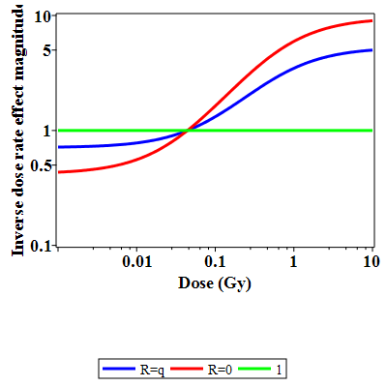

The graph illustrates that at very low doses, the dose rate effect becomes < 1, i.e. turns into a direct dose rate effect rather than an inverse one. This occurs because complete activation of NTE does not happen at such low doses. Conversely, at very high doses, the dose rate effect becomes > 1 (inverse) because full NTE activation occurs, and protracting the time the cells remain activated magnifies the NTE.

The dose at which the dose rate effect “switches” from direct to inverse is about 0.03 Gy with these parameter values. By comparison, in radon-exposed rat data (Kaiser et al, Radiat Environ Biophys (2004) 43:189–201) this “switch” occurs at somewhat higher doses: somewhere between 25 and 100 WLM, which roughly corresponds to 0.2 to 0.8 Gy.

**Application to risks in astronauts**

Assuming that the dose response for low LET radiation (e.g. gamma rays) is linear and low dose rate sparing can be dealt with by using DDREF=1.5 as done in BEIR VII, we can calculate the radiation effects ratio (RER) for high LET / low LET radiation risks at different dose rates as well as at different doses. These RER values can then be used for risk estimation in astronauts if they are multiplied by human low LET radiation risks from BEIR VII. The graph below shows numerical examples of RER for Si ions, based on our analysis described above which used human radon data and mouse acute exposure data.

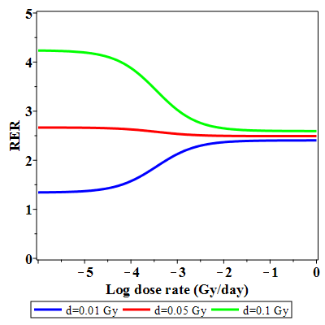

Here it is evident that according to this modeling approach, the RER for heavy ions depends on both dose and dose rate. It is smallest (closest to 1) at low doses and low dose rates.

**Implications**

If this analysis is reasonable, the following important implication can be made: **for doses / dose rates relevant for space missions, the dose rate effect (compared with acute exposures) might be close to 1** – perhaps somewhat less (direct) or somewhat more (inverse), but probably not dramatically different from 1.